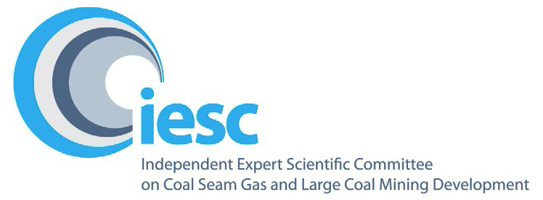

# 2023-2024

# Annual Review of Activities

**An overview of the activities of the Independent Expert Scientific Committee on Unconventional Gas Development and Large Coal Mining Development from July 2023 to June 2024**

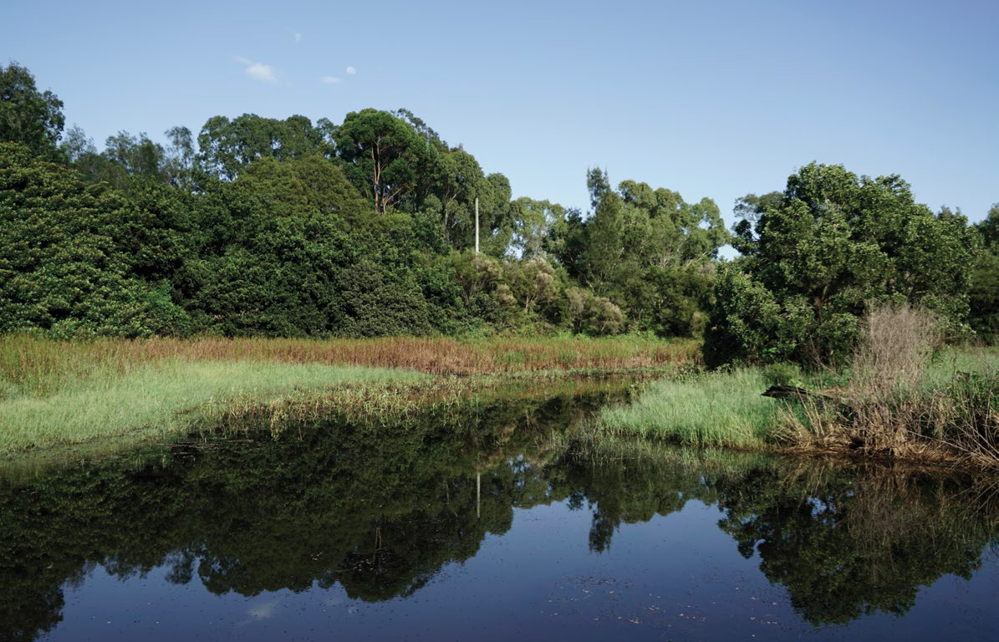

**© Commonwealth of Australia 2024**



*2023-24 Annual Review of Activities* is licensed by the Commonwealth of Australia for use under a Creative Commons Attribution 4.0 International licence with the exception of the Coat of Arms of the Commonwealth of Australia, the logo of the agency responsible for publishing the report, content supplied by third parties, and any images depicting people. For licence conditions see <https://creativecommons.Org/licenses/by/4.0/>

This report should be attributed as 'Independent Expert Scientific Committee on Unconventional Gas Development and Large Coal Mining Development: *2023-24 Annual Review of Activities,* Commonwealth of Australia'.

This publication is funded by the Australian Government Department of Climate Change, Energy, the Environment and Water. The views and opinions expressed in this publication are those of the authors and do not necessarily reflect those of the Australian Government or the Minister for the Environment.

**Contact details**

For information about this report or about the work of the IESC, please contact:

IESC Secretariat  
Office of Water Science  
Department of Climate Change, Energy, the Environment and Water  
GPO Box 3090  
CANBERRA ACT 2601

Email: [IESCSecretariat@dcceew.gov.au](mailto:IESCSecretariat@dcceew.gov.au)

The report can be accessed at <http://www.iesc.gov.au/>

**Images**

Front cover: Hunter Valley Wetlands © Copyright Department of Climate Change, Energy, the Environment and Water; and Narran Lake Nature Reserve © Copyright Department of Climate Change, Energy, the Environment and Water. Photographer Dragi Markovic.

Back cover: Hunter Valley Wetlands © Copyright Department of Climate Change, Energy, the Environment and Water.

All other images © Department of Climate Change, Energy, the Environment and Water

**Table of Contents**

1. Message from the Chair 4

2. Highlights 5

3. Members 6

4. Meetings 9

5. Scientific advice 11

6. Information Guidelines and Explanatory Notes 14

7. Research 16

8. Engagement 18

## Message from the Chair

Dr Chris Pigram AM, FTSE
IESC Chair

I am pleased to present the Independent Expert Scientific Committee on Unconventional Gas Development and Large Coal Mining Development (IESC) 2023-2024 Annual Review of Activities.

Throughout 2023-24 we appreciated the opportunity to continue engaging in legislative reforms of the *Environment Protection and Biodiversity Conservation Act 1999* (EPBC Act). On 15 December 2023, the *Nature Repair (Consequential Amendments) Act 2023* amended the EPBC Act to expand the lESC's remit to all unconventional gas developments, and for the IESC to continue under its new name.

In Canberra on 8-9 November 2023, the IESC celebrated the notable achievement of holding its 100th meeting. I would like to thank all current and former IESC members for their contributions to the IESC since its establishment and recognise the important statutory role that the IESC has played since 2012. Since its establishment, the IESC (including the interim IESC) has now provided 164 pieces of advice.

We met 10 times in 2023-24, including 9 virtual meetings and one in-person meeting, held in Canberra. We provided 7 pieces of scientific advice to government during the year.

Through 2023-24, we continued to expand our range of publicly available resource material, publishing our updated *Information guidelines for proponents preparing coal seam gas and large coal mining development proposals* (Information Guidelines), 3 new Explanatory Notes and a range of material associated with our multistage metagenomic research.

The IESC is supported by the Office of Water Science (OWS), within the Australian Government Department of Climate Change, Energy, the Environment and Water (DCCEEW), through the provision of secretariat support and scientific expertise. On behalf of the IESC, I thank the OWS for its continued dedication to supporting the activities of the committee.

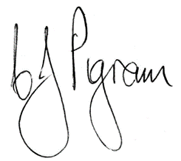

**Dr Chris Pigram AM, FTSE**

IESC Chair

## Highlights

An infographic of the IESC 2023-2024 highlights. Highlights were hold 10 committee meetings, providing 7 pieces of scientific advice on proposed resource development projects, publishing 4 resource documents, holding 2 public consultation periods, completing a metagenomic research project and 2 IESC Chair meetings. 


## Members

The IESC consists of a maximum of 8 members. Members are leading scientists in their fields and have extensive scientific qualifications and expertise in geology, hydrogeology, hydrology, ecology and ecotoxicology.

#### Dr Chris Pigram AM FTSE – Chair, Geology

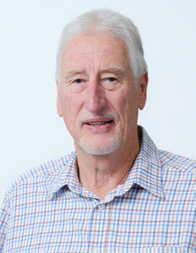

Dr Pigram is a geologist with over 50 years' experience and is a leader in research and management of minerals, marine and petroleum geoscience programs, and geospatial and earth monitoring. Dr Pigram was formerly the CEO of Geoscience Australia, where he held the role for seven years. Consequently, he has extensive experience in managing the interface between science and government and in stakeholder engagement

#### Professor Wendy Timms, Geology and hydrogeology



Professor Timms has extensive geology, hydrogeology and engineering expertise with over 25 years of professional experience. She has engineering project and research experience at coal, gas, uranium, metals and potash sites in Australia, Asia and Canada. Wendy is Professor of Environmental Engineering at Deakin University, teaching geology for geotechnical engineering and leading research in geological carbon sequestration, water tracer technology, and groundwater hydrology. She has published over 220 technical reports and more than 70 peer-reviewed journal papers and served as Vice-President of the International Association of Hydrogeologists.

#### Dr Jenny Stauber, Ecotoxicology



Dr Stauber has 45 years of research experience in the fields of ecotoxicology, water quality, contaminant environmental risk assessment and human toxicology. She serves as an expert ecotoxicologist on a wide range of advisory panels for national and international agencies. Dr Stauber is an Adjunct Professor at La Trobe University. She is a Fellow of the Australian Academy of Technology and Engineering and a Fellow of the Australian Academy of Science.

#### Professor Jenny Davis, Ecology



Professor Davis has expertise in freshwater biodiversity and wetland conservation, with more than 200 published papers and reports. She was awarded the Limnology Medal for excellence in freshwater research in 2006. Professor Davis co-chairs the Wetlands Working Group of the International Association for Ecology (INTECOL). She is a member of the Research Institute for Environment and Livelihoods at Charles Darwin University.

#### Professor Rory Nathan, Hydrology

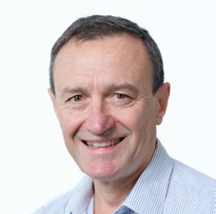

Professor Nathan has over 35 years' experience in engineering and environmental hydrology and is currently Professor of Hydrology and Water Resources at the University of Melbourne. He has made a substantial contribution to industry best practice in a range of engineering and environmental fields, particularly in the characterisation of hydrologic risk, the assessment of hydrologic impacts, and hydrologic model development and application.

#### Dr Andrew Boulton, Ecology

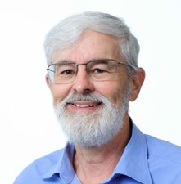

Dr Boulton's research spans river and groundwater ecology, especially in semi-arid areas, with four books and over 130 peer-reviewed articles. He has been on international and national panels to assess riparian zone policies, environmental flows, groundwater- dependent ecosystems and biodiversity of intermittent rivers. Dr Boulton is Adjunct Professor in Ecosystem Management at the University of New England and has held academic positions at other national and international universities.

#### Associate Professor Phil Hayes, Hydrogeology



Associate Professor Hayes is a geoscientist, hydrogeologist and groundwater modeller with over 25 years' experience in Australia, the United Kingdom and South America. He has worked across sectors from water resource management and groundwater protection to impact prediction and mitigation for mining, oil and gas, contaminated land, infrastructure, and nuclear waste. He is Associate Professor of Water Resources at the University of Queensland, leading research at the interface between reservoir engineering and hydrogeology, and in groundwater modelling uncertainty analysis.

#### Dr Juliette Woods, Hydrogeology



Dr Woods has 28 years of national and international experience in hydrogeology across academia, industry and government. Her career spans environmental management, mining assessments, water allocation planning, climate change, salinity, and the mathematics of modelling. She co-leads a groundwater modelling team which advises the SA Government on water policy and environmental impact assessment. Some of her recent work focuses on the western Great Artesian Basin, uncertainty analysis in practice, and interactions between surface water, groundwater and floodplain ecology.

## Meetings

In 2023-24, the IESC predominantly met virtually, holding 9 virtual meetings. Additionally, the IESC met once in person, to recognise its 100th meeting, in Canberra on 8-9 November 2023. The infographic on this page gives a timeline and overview of items discussed. Additional meeting information is available in the published [Minutes](http://iesc.environment.gov.au/about-us/meeting-minutes) on the IESC website.

### IESC meeting dates and subject matter, 2023–24

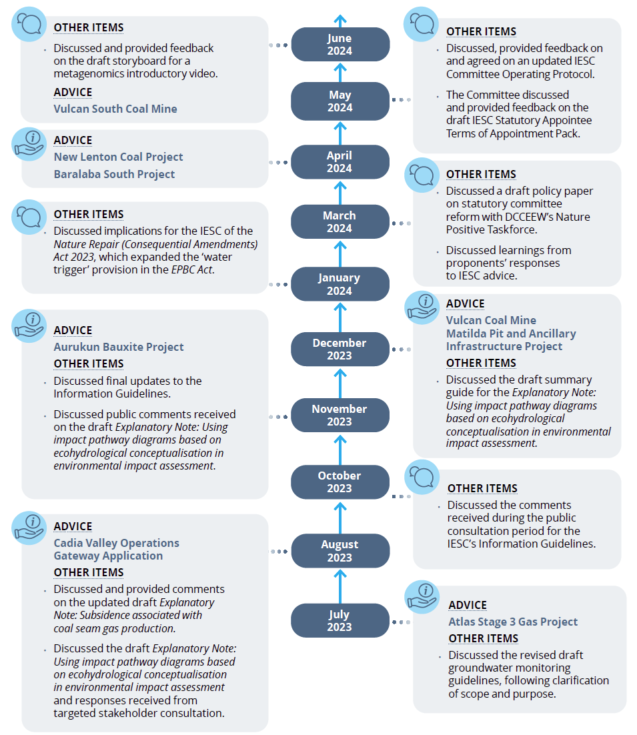

### Guest presentations

Guests from a range of organisations and disciplines are invited to IESC meetings to present on topics of interest to the IESC. These presentations increase the IESC's collective scientific understanding of the potential impacts of proposed unconventional gas and coal mining development on water resources.

#### Guest presentations in 2023-24

* Presentation on plant DNA in alluvial aquifers - Loren Pollitt, Office of Water Science
* Presentation on alluvial aquifer ecosystem response - Tess Nelson, Office of Water Science
* Presentation on the National Environmental Standard for Data and Information Standard - Jane Coram, Environment Information Australia
* Presentation on climate change, water and NT shale gas regions - Dr Dylan Irvine, Charles Darwin University
* Presentation on risk assessment of chemicals associated with unconventional gas development - Dr Lisa Golding, CSIRO
* Presentation on the EPBC Act and the water trigger - Cormac Farrell and Natasha Amerasinghe, Department of Climate Change, Energy, the Environment and Water

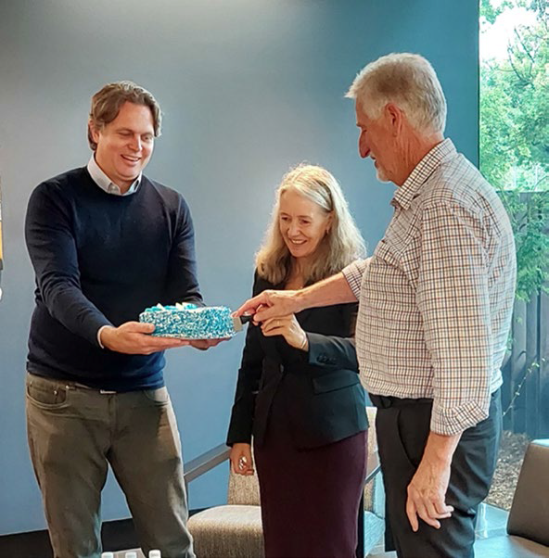

IESC Chair Dr Chris Pigram, Office of Water Science Director Dr Des Owen and former IESC member Jane Coram celebrating the IESC’s 100th meeting in Canberra

## Scientific advice

IESC [scientific advice](https://www.iesc.gov.au/advice/scientific-advice) helps increase transparency and strengthens the scientific basis of regulatory decisions by identifying potential impacts of unconventional gas and coal mining developments. The IESC considers all potential impacts on water resources. This includes the effects on groundwater, surface water, water quality and quantity, ecosystems and ecological processes.

#### Process for IESC scientific advice

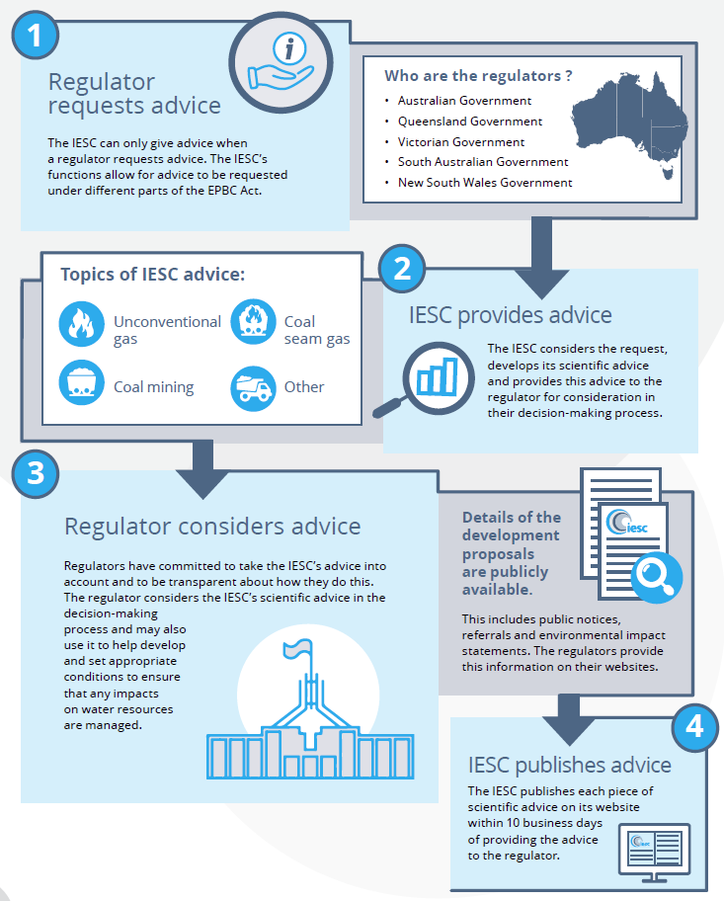

In 2023-24 , the IESC provided 7 pieces of scientific advice on development proposals. Since the establishment of the interim IESC in 2012, the IESC has provided 164 pieces of advice to government regulators.

#### Development proposals on which the IESC has provided scientific advice since 2012

Note: CSG = coal seam gas

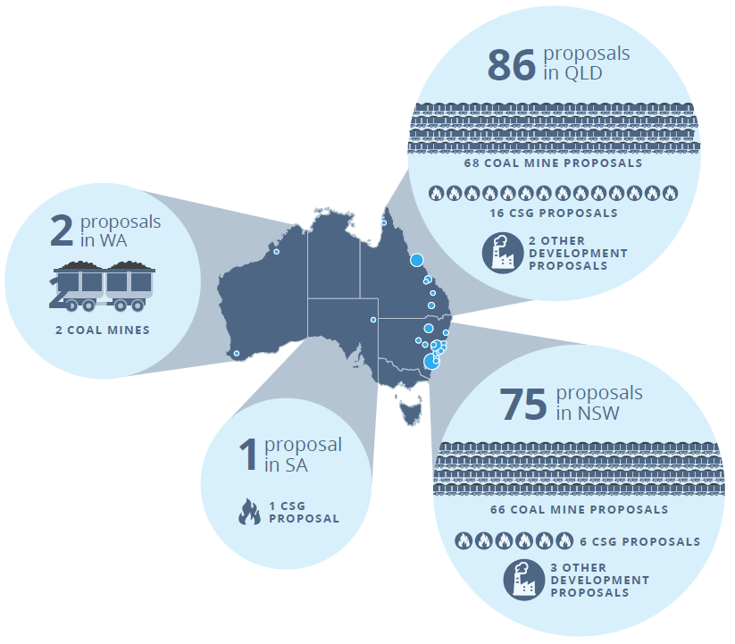

#### Development proposals on which the IESC provided scientific advice, 2023-24

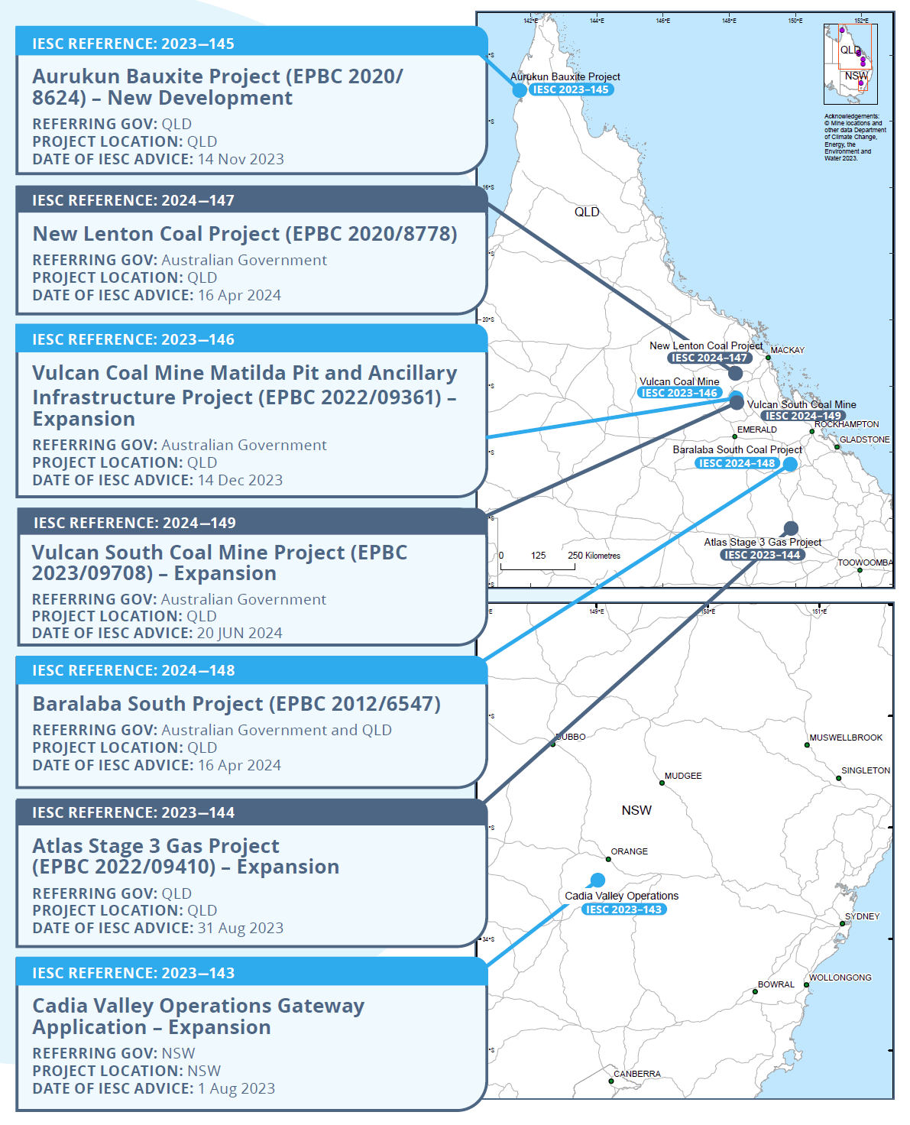

## Information Guidelines and Explanatory Notes

In 2023-24, the IESC finalised and published several additional resources to assist industry and regulators with environmental assessments. These documents complement the existing suite of resources, providing guidance on the suggested information and data to be included in an environmental impact assessment.

These documents were developed before amendments to the EPBC Act expanded the IESC's remit to all types of unconventional gas developments.

To ensure that the suite of resources remains current, the IESC regularly reviews and updates its existing resource documents. New resource material is also developed in areas where the IESC considers there to be a need.

### Information Guidelines review

In 2023–24, the IESC completed its updated [Information guidelines for proponents preparing coal seam gas and large coal mining development proposals](https://www.iesc.gov.au/publications/information-guidelines-independent-expert-scientific-committee-advice-coal-seam-gas).

The review of the Information Guidelines commenced in 2021 and the published version incorporates comments from 2 open public consultation periods. Public consultations were held in late 2021 and mid-2023.

The 2024 update was initiated to ensure that recent advances in theory and leading practice are considered and incorporated. This includes further information on:

* numerical models as decision-support tools
* the use of ecohydrological conceptual models which integrate hydrological and ecological components to show likely impact pathways
* using metagenomic approaches such as environmental DNA to characterise ecological communities in surface and groundwaters.

The updated version also provides additional and clearer guidance on specific technical aspects and how the Information Guidelines align with the broad range of supporting Explanatory Notes.

The 2024 version builds on the risk-based approach of undertaking a risk assessment early in an environmental assessment process, which allows investigations of potential impacts and selection of management options commensurate with the project's risk profile.

The checklist of specific information requirements has been updated to help proponents address each aspect of assessing risk materiality. The aim of the checklist is to ensure all crucial environmental information is obtained and provided before a project undergoes assessment.

The updated Information Guidelines were published on the IESC website in February 2024.

### Information Guidelines Explanatory Notes

Explanatory Notes supplement the Information Guidelines and contain a greater level of detail about specific topics. They also contain case studies and practical examples of how to collect and present relevant information. Each Explanatory Note is accompanied by a summary guide to provide a short, simplified outline of the main points.

Although the Explanatory Notes have been written with a focus on coal seam gas and large coal mining developments, they also have broader applicability across a range of other resource industries.

A number of Explanatory Notes have already been published:

* [Information Guidelines Explanatory Note: Uncertainty analysis for groundwater modelling](https://www.iesc.gov.au/publications/information-guidelines-explanatory-note-uncertainty-analysis) provides a range of approaches available to proponents and regulators in understanding and interpreting uncertainty analysis for groundwater modelling to assist in decision-making.
* [Information Guidelines Explanatory Note: Assessing groundwater-dependent ecosystems](https://www.iesc.gov.au/publications/information-guidelines-explanatory-note-assessing-groundwater-dependent-ecosystems) reviews tools and methods for groundwater-dependent ecosystem assessment to help proponents choose the most effective approach.
* [Information Guidelines Explanatory Note: Deriving site-specific guideline values for physico-chemical parameters and toxicants](https://www.iesc.gov.au/publications/information-guidelines-explanatory-note-deriving-site-specific-guidelines-values) introduces the use of a water and sediment quality management framework to assist with the design of appropriate monitoring programs for measuring physico­chemical parameters and toxicants from which site-specific guideline values can be developed.
* [Information Guidelines Explanatory Note: Characterisation and modelling of geological fault zones](https://www.iesc.gov.au/publications/information-guidelines-explanatory-note-characterisation-modelling-geological-fault-zones) provides a range of approaches available to proponents to determine the role faults may play in impeding or propagating pressure and groundwater flow impacts from proposed development projects.

### New Explanatory Notes in 2023-24

In 2023-24, the IESC published 3 new Explanatory Notes:

[**Subsidence associated with underground coal mining**](https://www.iesc.gov.au/publications/information-guidelines-explanatory-note-subsidence-underground-coal-mining)

This Explanatory Note provides tailored guidance and up-to-date robust scientific methodologies and tools for consultants and assessors dealing with project proposals for assessing the risk and magnitudes of subsidence (surface deformation) and its environmental impact due to large coal mining developments.

#### [Subsidence associated with coal seam gas production](https://www.iesc.gov.au/publications/information-guidelines-explanatory-note-subsidence-associated-with-coal-seam-gas-production)

This Explanatory Note provides tailored guidance and up-to-date robust scientific methodologies and tools for assessing the risk and magnitudes of subsidence (one source of surface movement) and its environmental impact due to coal seam gas development. It has been targeted at prospective consultants and assessors dealing with coal seam gas project proposals.

#### [Using impact pathway diagrams based on ecohydrological conceptualisation in environmental [impact assessment](https://www.iesc.gov.au/publications/information-guidelines-explanatory-note-using-impact-pathway-diagrams-based-ecohydrological-conceptualisation-environmental-impact-assessment)](https://www.iesc.gov.au/publications/information-guidelines-explanatory-note-using-impact-pathway-diagrams-based-ecohydrological-conceptualisation-environmental-impact-assessment)

This Explanatory Note promotes the use of impact pathway diagrams based on ecohydrological conceptualisation in environmental impact assessment to map sources, pathways and receptors of impacts arising from, for example, large coal mines and coal seam gas developments. Because of the IESC's legislated role, this Explanatory Note focuses on potential water-related impacts, but the benefits and approaches of such conceptual modelling apply equally to assessment of environmental impacts of other activities.

#### Groundwater monitoring guidelines

The IESC progressed seminal work for an Explanatory Note on groundwater monitoring guidelines. In light of ongoing Nature Positive reforms, and similar guidelines already in circulation at state and national levels, the IESC paused further development of this product. The IESC thanks all of the organisations and individuals who have provided comments on the work to date.

## Research

In 2017, the IESC recommended [research priorities](https://www.iesc.gov.au/research) to the Australian Government. Under these priorities, the IESC has commissioned projects to strengthen the science underpinning regulatory decisions on unconventional gas and large coal mining developments.

### Completed research projects in 2023-24

In May 2024, the IESC completed its multistage metagenomic research project.

This research project evaluated the effectiveness of different sampling methods and the feasibility for proponents to use environmental DNA (eDNA) to assess groundwater invertebrates (stygofauna) and microbes in aquifers that may be impacted by coal mining and coal seam gas developments. Conventional methods for collecting and processing samples from alluvial and fractured-rock aquifers in New South Wales were compared with metagenomic approaches.

The study addressed a number of key questions relating to sampling protocols for environmental impact assessments:

* Is it necessary to purge a bore before sampling?
* Is netting/bailing sufficient for sampling stygofauna or is pumping required? If pumping is required, what is the optimal volume?
* Is metabarcoding or metagenomics feasible for routine bioassessments?
* Is eDNA or eRNA feasible for bioassessments?
* What else is required for bioassessments?
* Should methods be adjusted for aquifer type?

The research project was split into 3 stages and produced in 4 publications:

[Bioassessment of groundwater ecosystems I. Sampling methods and analysis of eDNA for microbes and stygofauna in shallow alluvial aquifers](https://www.iesc.gov.au/sites/default/files/2024-05/bioassessment-groundwater-ecosystems-1.pdf)

**Stage 1** evaluated methods for sampling stygofaunal and microbial communities in shallow alluvial aquifers, including assessing the suitability of eDNA-based approaches for use in routine monitoring and assessment of groundwater biota.

[Bioassessment of groundwater ecosystems II. Sampling methods and analysis of eDNA for microbes and stygofauna in shallow sandstone aquifers](https://www.iesc.gov.au/sites/default/files/2024-05/bioassessment-groundwater-ecosystems-2.pdf)

**Stage 2** built on the Stage 1 report by exploring the suitability of sampling methods, including eDNA-based approaches, for characterising the biota in shallow sandstone aquifers.

[Bioassessment of groundwater ecosystems III. A comparison of eDNA metabarcoding and metagenomics for assessing groundwater communities](https://www.iesc.gov.au/sites/default/files/2024-05/bioassessment-groundwater-ecosystems-3.pdf)

**Stage 3** built on the earlier stages by exploring the more technical aspects of eDNA analysis for characterising the biota in shallow aquifers. Specifically, this stage explored methods to improve the quantitative comparison of eDNA samples and compared the metabarcoding approach used in Stages 1 and 2 with metagenome analysis of the same samples.

[Fact sheet: Approaches to biomonitoring for groundwater ecosystems: Methods for sampling and using DNA for assessing mining impacts on groundwater ecosystems](https://www.iesc.gov.au/sites/default/files/2024-05/fact-sheet-approaches-biomonitoring-groundwater-ecosystems.pdf)

A fact sheet was developed to summarise the project's findings on how different sampling and analysis methods may influence assessment of the impacts of mining on groundwater ecosystems (biota and water chemistry).

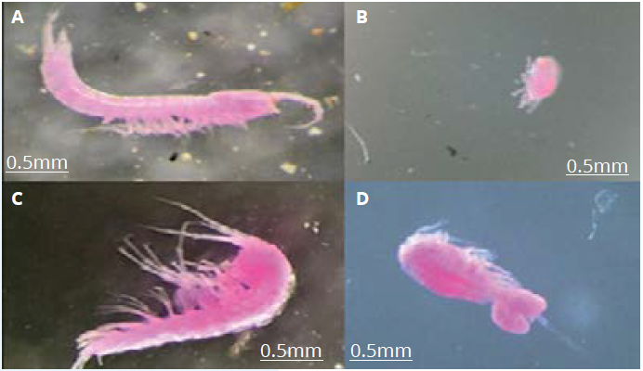

Examples of stygofauna (stained pink using rose bengal): A) Bathynellidae, B) Acarina, C) Amphipoda, D) Cyclopoida (Photo: K Korbel 2022)

## Engagement

The IESC continues to promote its work and published resource material by meeting with interested parties through various stakeholder engagement activities.

### Chair meetings

The IESC Chair meets with interested parties to promote the role of the IESC.

In 2023-24, the IESC Chair met with:

* Mr James Purtill, Queensland Mine Rehabilitation Commissioner – February 2024
* Professor Karen Hussey, Chair, Emissions Reduction Assurance Committee – March 2024

### EPBC Act reform

The IESC provided input into the EPBC Act reform work being undertaken by the Department of Climate Change, Energy, the Environment and Water. This included:

* Presentations by the Nature Positive Taskforce for Environmental Legislative Reform and Establishment of an EPA team at the IESC's November meeting in Canberra and virtually at the February and June meetings.

