Approaches to biomonitoring for groundwater ecosystems:

Methods for sampling and using DNA for assessing mining impacts on groundwater ecosystems

# Purpose

The purpose of this fact sheet is to summarise the findings of studies (Korbel et al. 2024a; Korbel et al. 2024b; Hose et al. 2024) commissioned by the IESC to explore how different sampling and analysis methods may influence the assessment of the impacts of mining on groundwater ecosystems (biota and water chemistry). This will help proponents adopt suitable methods for environmental impact assessments (EIAs) of developments likely to impact groundwater resources.

## Background: groundwater ecosystems

Most groundwaters are living ecosystems with microbes and invertebrates (stygofauna) that are essential to providing clean water. Coal mining and coal seam gas (CSG) developments have the potential to change groundwater quality and quantity. These alterations can impact groundwater biota and the ecosystem services that they provide.

Microbes are rarely considered in EIAs, despite their importance for water quality. The analysis of DNA in the environment, termed ‘environmental DNA’ (eDNA) can be useful for assessing groundwater microbes and other biota.

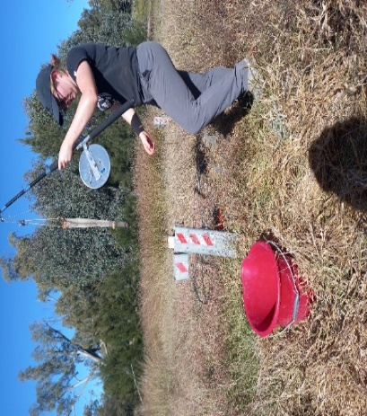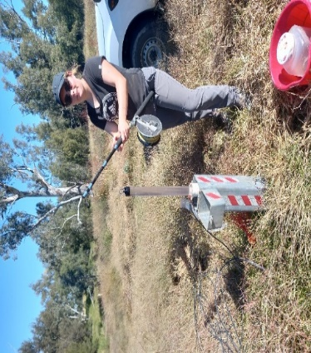

Sampling methods: bailer (left) and net sampling (right) for collection of stygofauna (Photo: G Hose 2022)

# Scope of work

The studies were conducted in two aquifer types: (1) the Namoi River alluvial aquifer, in a region of current and proposed coal mining and coal seam gas (CSG) activity; and (2) the fractured sandstone aquifers of the Sydney Basin. Stygofauna and microbes were collected using ‘traditional’ nets and bailers and using a motorised pump, with additional water pumped for chemical analyses and characterisation of stygofaunal and microbial communities using eDNA.

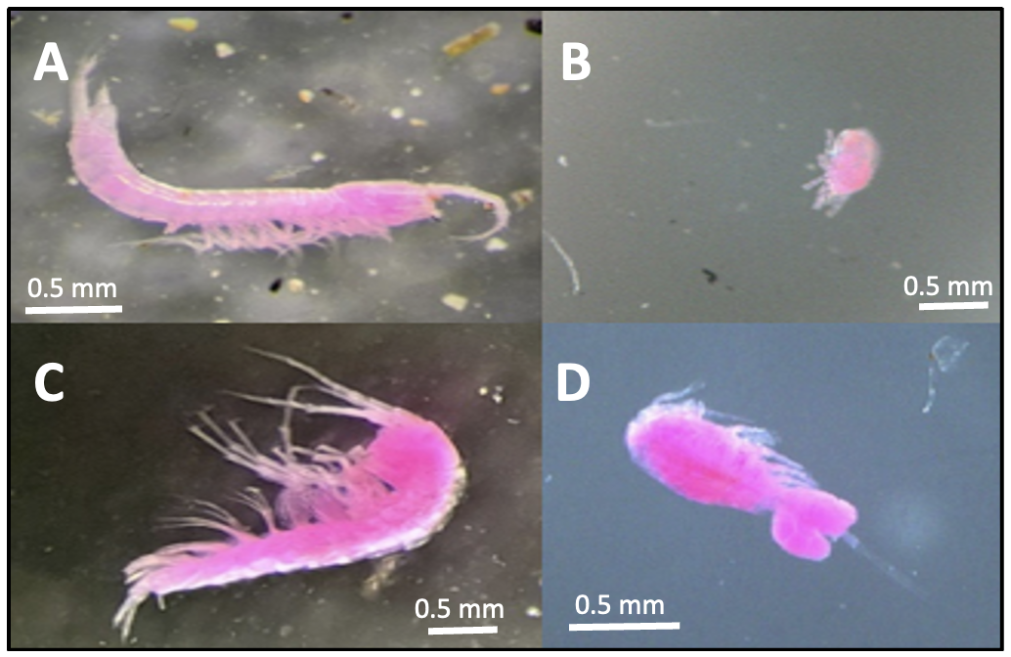

Examples of stygofauna (stained pink using rose Bengal (DSITI 2015)): A) Bathynellidae, B) Acarina, C) Amphipoda, D) Cyclopoida (Photo: K Korbel 2022)

The studies aimed to answer the following questions related to EIA sampling protocols:

* Is it necessary to purge a bore?
* Is netting/bailing sufficient for sampling stygofauna or is pumping required? If pumping is required, what is the optimal volume?
* Are metabarcoding or metagenomics feasible for routine bioassessments?
* Are eDNA or eRNA feasible for bioassessments?
* What else is required for bioassessments?
* Should methods be adjusted for aquifer type?

# Results

## Biotic communities

Using both traditional and eDNA methods combined, the stygofauna richness (number of different taxa) was similar between aquifer types: alluvial (12 taxa) and fractured rock (13 taxa). Over 80 microbial orders were identified, with taxa providing ecosystem services such as nitrogen and carbon cycling.

## Is purging required for assessments?

### Water chemistry and eDNA

A common requirement for groundwater sampling is that bores are purged before collecting water for chemical analysis (Sundaram et al. 2009). Similar issues arise with groundwater biota (Korbel et al. 2017); however, not all sampling methods currently in use involve purging bores (DSITI 2015).

Results from this study consistently indicated that purging by pumping at least three bore volumes (or until confident that bore water is not being collected) is necessary for water chemistry and eDNA sampling.

If bores are not purged, the sample will only characterise the bore and not represent the water chemistry and biota of the wider aquifer ecosystem.

### Stygofauna

Ecologists generally investigate richness and total and relative (proportional) abundance of individuals for EIAs.

As some species favour bore environments, their total abundance can be artificially high in samples that only contain bore water. This means that relative abundances of taxa in samples from unpurged bores do not represent abundances of those taxa in the aquifer (Korbel et al. 2017).

Sampling bores for stygofauna without purging will likely underestimate overall richness and miss some key taxa; however, it may be used to give an indication of stygofauna presence in pilot studies.

## Is netting/bailing sufficient for stygofauna sampling or is pumping required?

The use of nets to sample stygofauna richness in unpurged wells is the most widely prescribed method for sampling stygofauna as part of EIAs (DSITI 2015; WA EPA 2021). Pumping (and sieving the pumped water) is also a common method for sampling stygofauna.

In our studies, collections with nets and bailers failed to record common groundwater taxa in some bores and overestimated total abundances within the aquifer. Our results show that ***pumping is required*** for a thorough assessment of stygofaunal richness, as found previously (Hancock and Boulton 2009).

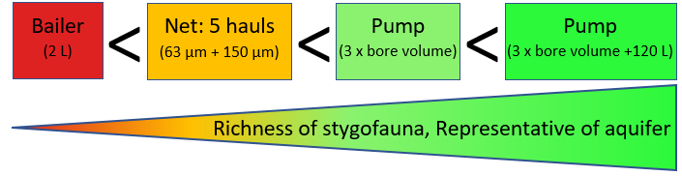

Richness of stygofauna collected increases with sampling method

Our studies indicated that nets may be useful for detecting the general presence of stygofauna taxa (non-specific) in pilot investigations.

However, for estimating total ***richness*** and to detect ***specific taxa***:

* The volume pumped (post-purge) influences the richness recorded.
* A minimum of 150 L of water should be pumped (using a high-flow pump) and combined with the purge sample to detect maximum richness.

For estimating ***abundance***:

* Bores must be purged before sampling for total and relative abundances.
* 150 L should be pumped to estimate total stygofauna abundance.

## Feasibility of genomic approaches for monitoring

eDNA can be analysed using either metagenomics (also known as shotgun sequencing) or metabarcoding. Metagenomics involves sequencing and analysing the entire genetic material present in a sample rather than specific genes or regions. Metagenome sequences are compared to databases to determine the function of the genes. Metabarcoding uses small fragments of taxonomically informative DNA to characterise the diversity and structure of a community.

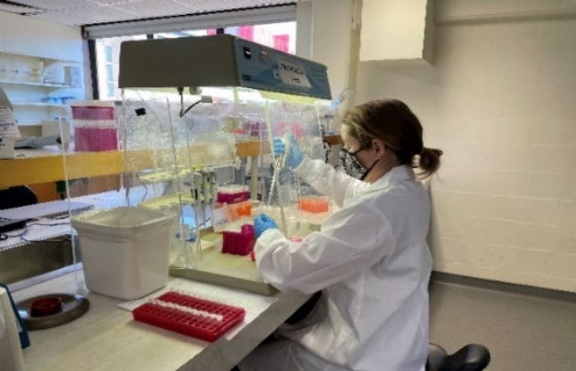

Extraction of DNA from frozen membranes (Photo: K Korbel 2022)

## Feasibility of metagenomics

Analysis of metagenomes showed differences in the functional assemblages of samples from alluvial and fractured rock aquifers and from pre- and post-purge bore samples. Analyses using different gene reference databases all responded similarly. Metagenome and metabarcoding data were similar in their ability to discriminate samples based on taxonomic composition.

Metagenome analysis provides a very large amount of information on the functional genes present in a sample, which is more detailed than can be inferred from metabarcoding analyses. However, the analysis is more complex and costly than metabarcoding (Table 1).

***We recommend that metabarcoding is currently sufficient for routine monitoring***, as the benefits of metagenome analysis do not yet outweigh the additional cost and analytical effort. However, as the cost and complexity of metagenomics analyses decrease, the methods will be more accessible and will be a powerful tool for routine monitoring.

Table 1: Main differences between metagenomics and metabarcoding for use in monitoring and assessment

| **-** | Metagenomics | Metabarcoding |
| --- | --- | --- |
| Laboratory processing | Single step (DNA extraction) | Multiple steps (DNA extraction, PCR) |
| Bioinformatics | Requires bioinformatic specialist, with additional support and analysis | Requires bioinformatic specialist |
| Data generated | Very detailed, functional and composition information | Detailed taxonomic composition, relative abundances |
| Quantitative | Yes | No |
| Cost | High  (60 samples ~ $20,000 to sequence) | Moderate  (60 samples ~ $8,000 to prepare and sequence) |

## Feasibility of eDNA and eRNA metabarcoding

eDNA is quite stable in the environment and provides a record of organisms that are or have been present at a site. eRNA is short-lived and provides a measure of recent activity at a site. eRNA will not indicate dead or transient species but is more difficult to preserve and transport.

eRNA and eDNA analyses of the same samples differed slightly in their composition (as expected) but both showed differences between sites and pre- and post-purge samples. Due to lower cost and greater ease of transport and sample processing, we recommend that ***analysing eDNA is more feasible than analysing eRNA for routine use*** in groundwater ecosystem assessments (Table 2).

Table 2: Main differences between eDNA and eRNA for use in monitoring and assessment

|  |  |  |
| --- | --- | --- |
| **-** | eDNA | eRNA |
| When to collect | After bore purged | After bore purged |
| Ease of transportation | Easy (-20°C) | Difficult (-80°C) |
| Ease of processing | Easy: 1 kit | Harder: 2–3 kits |
| Sequencing success rate | High | Low (poor recovery) |
| Number of orders detected in our study | 80 (high diversity) | 41 (lower diversity) |
| What samples tell us | Represents active, dormant, dead and transient biota | Represents biota active at time of sampling only |

### eDNA for microbial diversity

***eDNA proved useful for the analysis of groundwater microbes and their functions****.* As expected, prokaryotes (organisms whose DNA is not contained within a cell nucleus, e.g. bacteria) differed with water chemistry and environmental conditions. This sensitivity highlights their utility as a potential indicator of environmental change. We recommend that analysis of microbial eDNA and functions be included in comprehensive monitoring programs.

### eDNA for stygofauna diversity

Our study indicated that sampling eukaryote (organisms whose cells contain nuclei, e.g. most plants and animals) communities using eDNA does not always detect all stygofauna present, particularly Crustacea. However, eDNA is useful for detecting small, cryptic species that may be missed by conventional sampling.

We recommend that ***a thorough assessment of stygofauna diversity should combine***:

* complete traditional whole-organism sampling and analysis, including unpurged waters
* eDNA analysis of post-purge waters.

## Biomonitoring

Environmental factors that can influence the natural distribution of groundwater biota should be measured as part of routine monitoring programs. For example, fine sediment can inhibit the presence of stygofauna. Natural factors such as this should be considered, along with human impacts, as a reason for the absence of fauna at a site.

Our study indicated that nitrogen, oxygen, oxidation state and sediment size (Table 3) were variables that most strongly correlated with differences in stygofauna and microbes among bores and should be recorded as part of monitoring programs.

Table 3: Important environmental variables for monitoring

| - | - | Sediment size | Presence of trees | Nitrogen species | DO/Redox pH | Major ions |
| --- | --- | --- | --- | --- | --- | --- |
| Stygofauna | Morphological identification | P |  | P | P |  |
|  | eDNA (composition) | P | P | P | P |  |
| Microbes | eDNA (composition) |  |  | P | P | P |
|  | eDNA (function) |  |  |  | P |  |

## Recommended sampling procedures

Table 4: Suitability of methods, by type of sample, for sampling groundwater biota in shallow (<35 m) alluvial and fractured sandstone aquifers provides details on the types of sampling, reliability of methods and estimated time taken to complete sampling in the field for pilot, baseline and biomonitoring studies.

We provide the following recommendations for characterising groundwater biotic communities:

### Stygofauna

* Multiple sampling approaches should be used (i.e., eDNA and traditional).
* eDNA alone is insufficient for assessing Crustacea but is effective for detecting cryptic taxa often missed by traditional identification.
* Bailers alone are insufficient for characterising the diversity of stygofauna for any study type (Table 4: Suitability of methods, by type of sample, for sampling groundwater biota in shallow (<35 m) alluvial and fractured sandstone aquifers).
* Net samples using coarse (150 µm) and fine (63 µm) mesh nets do not consistently record all stygofauna present, but may be useful for pilot studies.
* Pumping at least 150 L is recommended to collect close to 100% of the stygofauna richness at a site.
* Pumping at least 60 L after purging is required when information on the relative abundance of stygofauna taxa is required.
* Combining eDNA with morphological identification methods provides the most comprehensive assessment of richness.

### Metabarcoding for microbes and stygofauna

* Purging is critical for eDNA microbial sampling.
* eDNA samples can be preserved using DESS (dimethyl sulfoxide–ethylenediaminetetraacetic acid–sodium chloride) and processed later.
* eDNA is the only reliable technique for characterising the composition and function of groundwater microbial communities.
* eDNA is currently more feasible than eRNA (Table 2).
* Metabarcoding may not capture all stygofauna present; a combination of eDNA and traditional methods is recommended to assess stygofauna.

Table 4: Suitability of methods, by type of sample, for sampling groundwater biota in shallow (<35 m) alluvial and fractured sandstone aquifers

| Study type | Approx time* | Sampling method | Water chemistry | Stygofauna presence/  absence | Stygofauna richness | Stygofauna relative abundance | eDNA – microbial | eDNA – eukaryote# |
| --- | --- | --- | --- | --- | --- | --- | --- | --- |
| I. Pilot study (net or pump) | 60 mins | Net: 5 hauls of 63-µm & 150-µm mesh nets (unpurged)  Additional: bailer (eDNA) | ü  (Unlikely to represent aquifer water) | ü | - | - | - | ü |
| - | - | **OR**  Pump bore volume only | - | ü | - | - | - | ü |
| II. Baseline study (pump used) | 30 mins | a. Purge & sieve 2–3 x bore volume† | - | ü | ü  (~80%) | - | - | - |
| - | - | b. Sample water (post-purge) | ü | - | - | - | ü | ü |
| III. Biomonitoring (pump used) | 70 mins | a. Purge & sieve 2–3 x bore volume† | - | ü | ü  (~80%) | - | - | - |
| - | - | b. Sample water (post-purge) | ü | - | - | - | ü | ü |
| - | - | c. Pump & sieve 150 L^ | - | ü | ü  (~100% combined with purge sample) | ü  (when **not** combined with purge sample) | - | - |

#eDNA should not be used as a standalone method for stygofauna identification. *Indicative time for sampling method, dependent on substrate, flow and depth. †Purge volume recommended by Sundaram et al. 2009 ^Where this volume is greater than 3 x bore volume. Percentages indicate the proportion of the total taxa richness occurring at a site that is typically recovered using that sampling approach.

# Further research

## Are low-flow pumps adequate for sampling?

This study used a high-flow pump for all sampling. Research is required to determine if low-flow pumps can also achieve a representative sample of aquifer biota. This has implications for sampling equipment requirements.

## How can we reliably detect stygofauna using eDNA?

Collecting and sequencing taxa to build a comprehensive reference library is essential if eDNA is to be used to characterise stygofauna communities. Understanding how DNA is shed by taxa and its fate, along with research on alternative sampling and metabarcoding methods, is required before eDNA can replace whole-organism collections for assessing stygofauna communities.

## What is the impact of repeated sampling on biota?

Time between sampling events can impact the richness and abundance of biota recorded, particularly for stygofauna (Korbel et al. 2017). If monitoring is too frequent, sampling may become ineffective. The minimum time between sampling events should be investigated.

## How many bores need to be sampled to represent biota in a given region?

In a given aquifer, we need to know how many bores should be sampled to adequately describe the biotic community. Queensland guidelines recommend 40 samples from a minimum of 10 bores (DSITI 2015). Western Australian guidelines recommend a minimum of 10 sites (WA EPA 2021). However, the often high degree of endemism among stygofauna has consequences for the sampling effort required (Hancock and Boulton 2009; Eberhard et al. 2009).

# References

Korbel K et al. 2024a. Bioassessment of groundwater ecosystems I. Sampling methods and analysis of eDNA for microbes and stygofauna in shallow alluvial aquifers. Report prepared for the Independent Expert Scientific Committee on Unconventional Gas Development and Large Coal Mining Development through the Department of Climate Change, Energy, the Environment and Water. Commonwealth of Australia.

Korbel K et al. 2024b. Bioassessment of groundwater ecosystems II. Sampling methods and analysis of eDNA for microbes and stygofauna in shallow sandstone aquifers. Report prepared for the Independent Expert Scientific Committee on Unconventional Gas Development and Large Coal Mining Development through the Department of Climate Change, Energy, the Environment and Water. Commonwealth of Australia.

Hose GC et al. 2024. Bioassessment of groundwater ecosystems III. A comparison of eDNA metabarcoding and metagenomics for assessing microbial communities. Report prepared for the Independent Expert Scientific Committee on Unconventional Gas Development and Large Coal Mining Development through the Department of Climate Change, Energy, the Environment and Water. Commonwealth of Australia

Sundaram B et al. 2009. Groundwater sampling and analysis: a field guide. Geoscience Australia. Record 2009/27. Available at: [https://pid.geoscience.gov.au/dataset/ga/68901](https://pid.geoscience.gov.au/dataset/ga/68901%20)

Korbel K et al. 2017. Wells provide a distorted view of life in the aquifer: implications for sampling, monitoring and assessment of groundwater ecosystems. Scientific Reports, 7, 40702.

DSITI (Department of Science, Information Technology and Innovation) 2015. Guideline for the environmental assessment of subterranean aquatic fauna. Queensland Government. Available at: www.publications.qld.gov.au/dataset/subterranean-aquatic-fauna

WA EPA 2021 (Western Australian Environmental Protection Authority). Technical guidance: Subterranean fauna surveys for environmental impact assessment. EPA, Western Australia. Available at: www.epa.wa.gov.au/policies-guidance/technical-guidance-subterranean-fauna-surveys-environmental-impact-assessment

Hancock PJ and Boulton AJ 2009. Sampling groundwater fauna: efficiency of rapid assessment methods tested in bores in eastern Australia. Freshwater Biology, 54, 902 917.

Eberhard SM et al. 2009. Exploring the relationship between sampling efficiency and short-range endemism for groundwater fauna in the Pilbara region, Western Australia. Freshwater Biology, 54, 885 901.

For full reports see: www.iesc.gov.au