Bioassessment of groundwater ecosystems
II. Sampling methods and analysis of eDNA for microbes and stygofauna in shallow sandstone aquifers

© Commonwealth of Australia, 2023.

Bioassessment of groundwater ecosystems II. Sampling methods and analysis of eDNA for microbes and stygofauna in shallow sandstone aquifers is licensed by the Commonwealth of Australia for use under a Creative Commons Attribution 4.0 International licence with the exception of the Coat of Arms of the Commonwealth of Australia, the logo of the agency responsible for publishing the report, content supplied by third parties, and any images depicting people. For licence conditions see https://creativecommons.org/licenses/by/4.0/
This report should be attributed as ‘Bioassessment of groundwater ecosystems II. Sampling methods and analysis of eDNA for microbes and stygofauna in shallow sandstone aquifers, Commonwealth of Australia, 2024’.
On 15 December 2023, the Nature Repair (Consequential Amendments) Act 2023 amended the EPBC Act to expand the IESC’s remit to all unconventional gas developments. This publication was developed prior to these amendments of the EPBC Act commencing.
This publication is funded by the Australian Government Department of Climate Change, Energy, the Environment and Water. The views and opinions expressed in this publication are those of the authors and do not necessarily reflect those of the Australian Government or the Minister for the Environment and Water.
Citation
Korbel K, McKnight K, Greenfield P, Angel B, Adams M, Chariton A and Hose GC 2024. Bioassessment of groundwater ecosystems II. Sampling methods and analysis of eDNA for microbes and stygofauna in shallow sandstone aquifers. Report prepared for the Independent Expert Scientific Committee on Unconventional Gas Development and Large Coal Mining Development through the Department of Climate Change, Energy, the Environment and Water. Commonwealth of Australia.
Contact details
For information about this report or about the work of the IESC, please contact:
IESC Secretariat
Office of Water Science
Department of Climate Change, Energy, the Environment and Water
GPO Box 787
CANBERRA ACT 2601
The report can be accessed at http://www.iesc.environment.gov.au/
Images
Front cover: Groundwater sampling at bore GW080166 | Location: Somersby, NSW | Photo credit: Z Whetters
Back cover: Groundwater sampling at bore GW075092 | Location: Glenbrook, NSW | Photo credit: G Hose
All other images © Department of Climate Change, Energy, the Environment and Water unless specified otherwise.
Bioassessment of groundwater ecosystems
II. Sampling methods and analysis of eDNA for microbes and stygofauna in shallow sandstone aquifers
Sampling approaches to understand the impacts of coal seam gas and large coal mining development on stygofaunal and microbial assemblages in groundwater

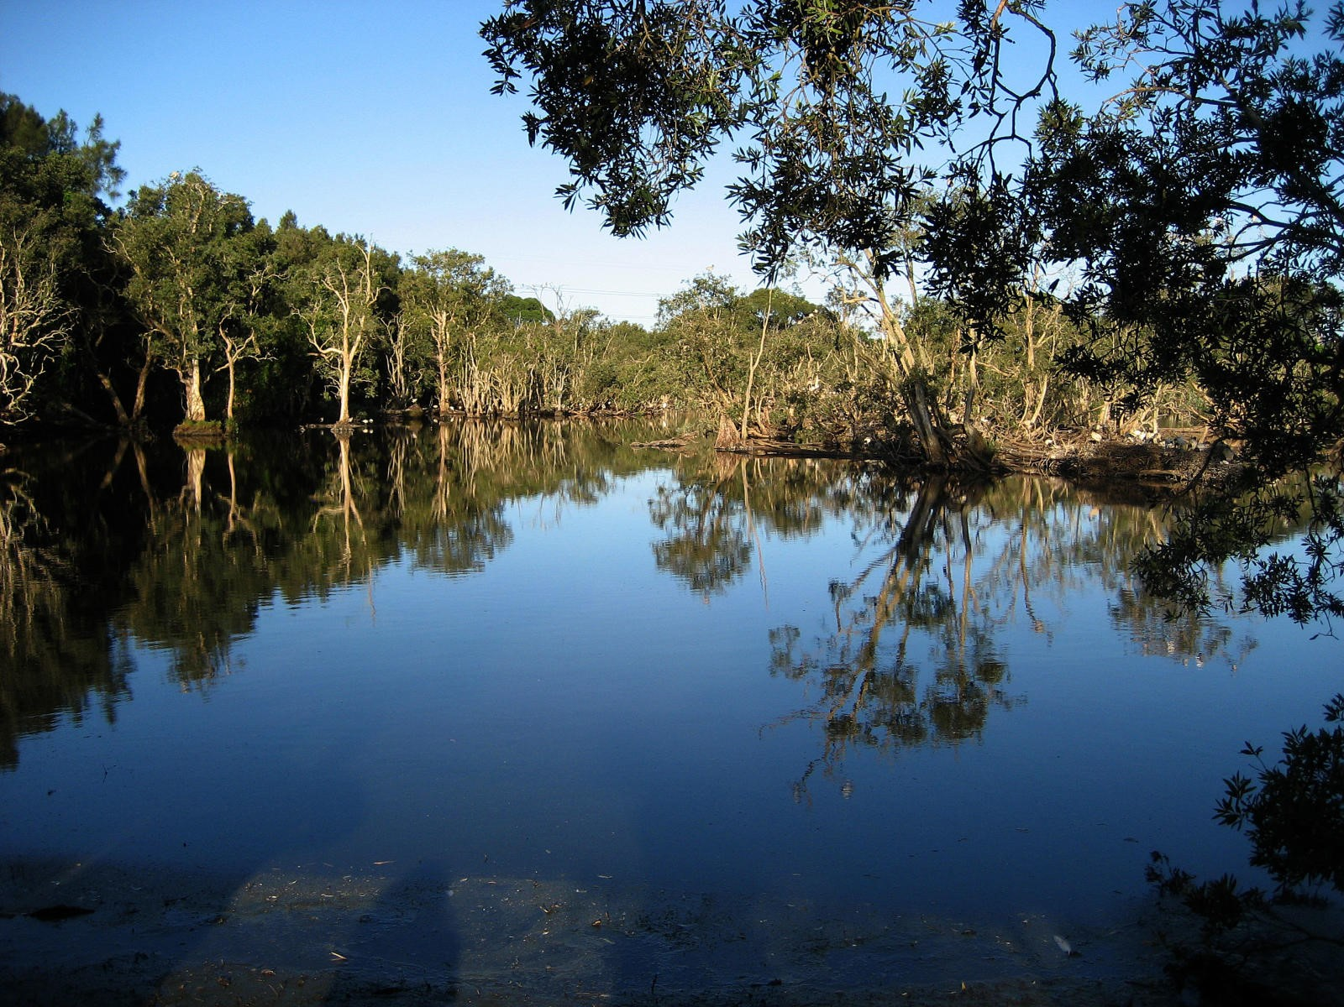

Contents
Executive summary 1
1. Introduction 3
1.1 Fractured sandstone aquifers 3
1.2 Project aims and report structure 4
1.2.1 Aim and core research questions 4
1.2.2 Report structure 4
2. Field, laboratory and analysis methods 6
2.1 Project study area and sample sites 6
2.2 Field methods and procedures 7
2.2.1 Sampling stygofauna for morphological identification 9
2.2.2 Molecular sampling and preservation of DNA samples 9
2.2.3 Groundwater quality sampling 10
2.3 Laboratory methods 10
2.3.1 Groundwater quality analyses 10
2.3.2 Morphological identification of stygofauna 10
2.3.3 Metabarcode analysis (eDNA) 10
2.3.4 Bioinformatics 11
2.3.5 Data analysis 11
3. Results and discussion 13
Site attributes and water quality 13
3.1.1 Variation in water quality 18
3.2 Stygofauna (using morphological identification) 23
3.2.1 General findings 23
3.2.2 Richness 24
3.2.3 Abundance 30
3.2.4 Summary of methods for stygofaunal community analysis 34
3.3 Metabarcode sampling and analysis 36
3.3.1 Prokaryote assemblages 36
3.3.2 Eukaryote assemblages 41
3.3.3 Use of preservatives for eDNA samples 49
3.4 Comparison of metabarcoding with whole-organism methods for stygofauna 52
3.5 Associations of groundwater biota with water chemistry and site attributes 54
3.5.1 Stygofauna 54
3.5.2 Molecular methods 56
3.5.3 General discussion of environmental influences on biota 60
3.6 Feasibility of sampling methods 62
3.6.1 Expert working groups 62
3.6.2 Potential costs for processing eDNA 66
3.6.3 Summary: feasibility of sampling methods for routine biomonitoring 67
4. Summary and recommendations 68
4.1 Summary of main findings 68
4.1.1 Water quality 68
4.1.2 Stygofauna 68
4.1.3 Metabarcoding (eDNA) 69
4.2 Recommended sampling approaches 69
4.2.1 Site characterisation and water quality 69
4.2.2 Scenario 1: Pilot study to detect aquatic community present 70
4.2.3 Scenario 2: Baseline study to scope biota prior to works 71
4.2.4 Scenario 3: Pre- and post-development biomonitoring 72
4.3 Future work 73
Acknowledgments 74
Reference list 75
Appendices 81
Appendix 1. Primers and PCR conditions for eDNA 81
Appendix 2. 16S/18S bioinformatic methods 83
Appendix 3. Summary of 16S mtDNA (Crustacea) optimisation 84
Appendix 4. Stygofauna raw counts – whole-organism collection and morphological taxonomy 88
Appendix 5. Cumulative abundance of stygofauna per site 96
Appendix 6. Stygofauna abundance by sampling method 98
Appendix 7. Water quality data 99

Executive summary
Human activities threaten the integrity of aquatic ecosystems globally. Subterranean aquatic ecosystems are particularly at risk. They contain a hidden but unique and potentially vulnerable array of microbes, invertebrates and (occasionally) vertebrates that are susceptible to environmental change and impacts from activities on the surface. Groundwaters provide a reliable source of water, which is made clean and available partly by the ecosystem services provided by subterranean organisms (Griebler et al. 2019).
Large coal mining (LCM) and coal seam gas (CSG) activities have a significant yet often contentious place in Australian society and economy. These activities potentially influence groundwater hydrology (e.g., drawdown, altered groundwater pressures) and physical and chemical aspects of groundwater, during and after resource extraction. The resulting impacts on aquifer water quality and quantity often alter the composition and function of groundwater communities and their ecosystem services.
Sampling and identifying groundwater microbes and invertebrates (stygofauna) are challenging. As a result, microbial assemblages, in particular, are seldom considered in environmental impact statements despite their importance in biogeochemical processes and water purification. The analysis of DNA shed in the environment, termed ‘environmental DNA’ (eDNA), is a powerful, rapid, non-invasive and potentially cost-efficient tool that may address many of the challenges associated with characterising groundwater microbial and stygofauna communities.
Stage 1 of this project compared sampling approaches to characterise the microbes and stygofauna in shallow alluvial aquifers, including assessing the suitability of eDNA-based approaches for use in routine monitoring and assessment (Korbel et al. 2022a). The aim of this study (Stage 2) is to extend that work by exploring the suitability of those approaches for characterising the biota in shallow fractured rock (here, sandstone) aquifers. Specifically, this study sought to assess associations between groundwater quality and the composition of stygofaunal and microbial assemblages and assess the effectiveness of various sampling protocols and their feasibility for routine groundwater biomonitoring. The study also sought to compare results from the fractured sandstone aquifer with those from an alluvial aquifer (Stage 1).
The study was undertaken in the fractured sandstone aquifers of the Sydney Geological Basin, specifically in the lower Blue Mountains and Kulnura/Mangrove Mountain region. Stygofauna and microbial communities were sampled from 15 bores (between 6 m and 44 m below ground) that accessed the shallow, unconfined aquifers within the Hawkesbury Sandstone. Samples of groundwater were collected using ‘traditional’ net and bailer methods, as well as sampling with a motorised pump, before and after purging. Samples were analysed for stygofauna using morphological analyses, and microbes (prokaryotes) and higher organisms (eukaryotes including stygofauna) using eDNA. Water chemistry and site attributes were also recorded.
Sampling stygofauna using bailers and nets generally did not collect the full diversity of stygofauna present at a site. A combination of pre-purge sampling (using nets or pump) and pumping of at least 150 L of groundwater is necessary to maximise the likelihood that samples reflect the diversity and relative abundances of fauna in the aquifer. eDNA did not always identify the known stygofauna richness at each site. Therefore, a combination of traditional ‘whole-organism’ analysis in addition to eDNA is recommended where thorough assessment of stygofauna is required. Although not expressly tested, the outcomes of this study are consistent with existing sampling guidelines (e.g., DSITI 2015; WA EPA, 2016) that require multiple samples from a site, and samples from multiple sites, to adequately characterise the stygofauna within an aquifer.
eDNA was also used to characterise the microbial (prokaryotic) community within the aquifers and is recommended where knowledge of the microbial community and its functional capabilities is required or desirable.
Importantly, water quality and prokaryote and eukaryote communities in bores, in most cases, differed from those collected after the bore was purged. These results indicate that purging bores is necessary before collecting samples for microbial eDNA, water quality analyses and stygofaunal abundance. Analysis of microbial communities in terms of the biogeochemical processes (functions) that they can provide (using the FAPROTAX program) did not show a clear difference between samples collected at different pump volumes.
Compositions of stygofauna, prokaryote and eukaryote assemblages were associated with different water quality and environmental variables. All groups responded to gradients associated with concentrations of nitrogen species (particularly ammonia, total Kjeldahl nitrogen (TKN) and nitrate). Stygofauna and eukaryote groups were influenced by the volume of sediment collected in a sample (typically there were fewer stygofauna in samples that contained large volumes of fine sediment). Prokaryotes were most strongly influenced by concentrations of sulfate and different forms of nitrogen. Compositions of microbial communities expressed in terms of their putative functions were influenced by nitrogen species and the depth below ground from which the sample was collected.
In this study, we trialled dimethyl sulfoxide–ethylenediaminetetraacetic acid–sodium chloride (DESS) as a preservative for eDNA samples. Our analyses indicate that when DESS is added to groundwater samples shortly after collection, samples can be stored at ambient temperature for at least nine days before processing without a significant change in the prokaryote and eukaryote assemblages in those samples.
From this study, we provide recommendations for sampling groundwater to efficiently collect the maximum diversity of stygofauna and characterise biotic communities using eDNA, with a view to metabarcoding analysis of eDNA being used as a tool for routine monitoring, particularly microbial communities. Specifically, we recommend:
- Bores should be purged or otherwise sampled to ensure that water quality samples represent the aquifer conditions.
- Purging a bore is critical to collecting a representative sample of prokaryotes using eDNA.
- Bailers alone are insufficient for detecting the presence of stygofauna within sites.
- Net samples collected following an approach similar to the WA EPA (2016) protocol may, but do not consistently, capture a large proportion of the stygofauna taxa at a site.
- A combination of netting and pumping or pumping only is recommended to maximise the stygofauna richness collected at a site.
- eDNA and whole-organism sampling should both be used to characterise stygofauna communities, because our analyses of eDNA did not always detect stygofauna that were collected in whole-organism samples but eDNA was better than traditional sampling for detection of smaller, cryptic species.
- Analysis of eDNA effectively characterises microbial assemblages, and taxa can be related to important ecological and biogeochemical functions.
- eDNA within water can be preserved onsite using DESS, allowing sample processing up to nine days from collection. This greatly increases the feasibility of using eDNA for monitoring biological communities in remote areas.
These recommendations are consistent with existing sampling protocols for some states of Australia and have been derived in consultation with industry practitioners.

- Introduction
The Independent Expert Scientific Committee on Unconventional Gas Development and Large Coal Mining Development (IESC) is a statutory body under the Environment Protection and Biodiversity Conservation Act 1999 (Cth) (EPBC Act) and provides advice to the Australian Government Environment Minister on priorities for research. One identified priority is improving the understanding of potential risks associated with large coal mining (LCM) and coal seam gas (CSG) developments to groundwater as a resource and to groundwater health. This report presents results of the second stage of a project commissioned by the IESC on the suitability of various sampling methods for completing groundwater biota surveys and biomonitoring within aquifers.
Stage 1 of this project (Korbel et al. 2022a) provides details on the assessment and monitoring methods for microbial and stygofauna in shallow alluvial aquifers. The Stage 1 study compared numerous sampling strategies (e.g., unpurged versus purged samples, different sample volumes) and sampling techniques and methods (e.g., nets, bailers, pumps, environmental DNA (eDNA), environmental RNA (eRNA)) within alluvial aquifers to help inform the IESC, regulators and environmental managers of the most practical and cost-effective strategies to accurately characterise biotic communities within groundwater ecosystems.
Stage 2 of the study builds on the Stage 1 report to further understand the implications of sampling techniques for biomonitoring. This report continues the investigation into sampling techniques used in Stage 1, but within fractured sandstone aquifer ecosystems. Furthermore, the feasibility of sampling methods is investigated by exploring preservation methods for DNA samples and testing the practicality of methods with industry. The reports are vital to developing robust groundwater ecosystem monitoring programs which can be used as a measure of how industries, including CSG and LCM, might impact groundwater ecosystems.
  - Fractured sandstone aquifers
Fractured aquifers are present in much of eastern Australia and are often located in areas where mining activities occur. Within these aquifers, water moves predominantly along the bedding planes, with joints and fractures providing vertical movement of waters between these bedding planes in the consolidated bedrock material. Water paths within fractured sandstone aquifers are typically narrow, ranging from millimetres to centimetres. It is the size of the fractures that is important for hydraulic conductivity, which controls energy and matter fluxes within aquifers (Gibert 2001). These fractures also provide habitat for stygofauna, with the types and sizes of fauna present very much dependent on the size of the fractures; high abundances of fauna are linked to larger pore spaces (Hancock and Boulton 2008; Korbel and Hose 2015).
Stygofauna communities within fractured rock aquifers of eastern Australia appear to be less diverse than those in Western Australia (Eberhard et al. 2009; Halse et al. 2014). Nonetheless, the Triassic Hawkesbury sandstones to the north of Sydney contain a diverse stygofauna community (Asmyhr and Cooper 2012; Hose and Lategan 2012). Several surveys associated with mining (predominantly coal) have uncovered the stygofauna communities in these fractured rock aquifers, with common taxa including copepods, syncarids, rotifers, tardigrades, ostracods, isopods, gastropods and mites (e.g. Cardno 2014a; Cardno 2014b; Hose 2008; Hose 2009). It appears, however, that fauna are limited to shallow zones (<~100 m below ground level) within these fractured aquifers (Hose 2008; Hose 2009; Hose et al. 2015).
There are no known groundwater microbial community surveys or stygofauna diversity studies conducted within the Blue Mountains sandstone aquifers, although there have been several surveys of shallow waters within hanging swamps in these regions. Within the Hunter Valley fractured sandstone region, there have been a limited number of studies. Some surveys are associated with mining developments, although many of these studies have been completed in alluvial aquifers. Thus, knowledge of both microbes and stygofauna within the fractured rock aquifers of these regions is lacking.
  - Project aims and report structure
    - Aim and core research questions
This project is the second stage of an investigation into approaches for biomonitoring groundwater ecosystems. Stage 2 follows the methods and sampling strategies employed in Stage 1 (Korbel et al. 2022a) and involves sampling groundwater biota and water quality from 15 bores in shallow fractured sandstone aquifers of the Hawkesbury-Nepean and Hunter River catchments, New South Wales (NSW). The sampling regime is underpinned by the need to establish robust and feasible methods that can be used to increase the information on groundwater ecosystems that is provided by proponents in an environmental impact statement (EIS) for assessment of a proposed CSG or LCM development.
Three main outcomes of the Stage 1 report were used to inform and adjust the sampling strategies for Stage 2. These were:
- eDNA was considered more reliable and practical for biomonitoring than eRNA in Stage 1; thus no RNA samples were collected in Stage 2.
- Stage 1 identified the most appropriate primers for groundwater eukaryote and prokaryote community analysis; these primers underwent further optimisation steps in Stage 2.
- Extracellular DNA from sediments was not analysed in Stage 2, due to the poor performance of this technique to produce results in Stage 1.
The project scope included components that were defined by three core research questions, all related to shallow (<45 m) fractured rock aquifers:
- Are there differences in the richness and assemblage composition of biota collected using different sampling protocols? And, following from Stage 1, do we see the same differences when comparing the results from the sampling regime in fractured sandstone and alluvial aquifers (Stage 1).
- Are there consistent associations between groundwater quality and environmental variables and the taxonomic and inferred functional composition of stygofaunal and phreatic microbial assemblages in sandstone aquifers?
- Is it feasible for field practitioners to collect and process samples for metagenomic (eDNA metabarcoding) approaches in routine groundwater biomonitoring for potential impacts of LCM and CSG activities?
- In addition to the three core research questions, the following question relating to sampling feasibility was addressed:
- Is there a suitable technique of chemical preservation for groundwater samples collected for analysis using molecular approaches?
    - Report structure
This report is divided into four sections. This first section provides background to the project and its aims. The second section details the sampling regime and provides a summary of the field, laboratory and data analysis methods used in the study (for full details see the Stage 1 report, Korbel et al. 2022a). The third section presents the results and discussion in the context of the research questions. The fourth section provides a summary of project findings and recommendations for the approach to groundwater monitoring.

- Field, laboratory and analysis methods

2.1 Project study area and sample sites
A field study was undertaken in February 2022 in the shallow fractured sandstone aquifers of the Hawkesbury-Nepean and Hunter River catchments, NSW. These locations were identified for this study because (1) there is an extensive network of bores that access the shallow Hawkesbury Sandstone and that were suitable and available for sampling; and (2) there is existing knowledge of these groundwater ecosystems, particularly in the Hunter River catchment (Hose and Lategan 2012; Hose et al. 2019).
The Hawkesbury-Nepean and Hunter River catchments form part of the Sydney Basin (Figure 1) and support a large area of National Park, various agricultural activities and horse studs. The study area experiences mean maximum temperatures of 28°C and mean minimum temperatures of 2.6°C (Narara Research Station and Katoomba (BOM 2022)). Rainfall is greatest in late summer and early autumn; however, a La Niña event was occurring during the sampling period which brought extended periods of rainfall and flooding to the east coast of Australia (BOM 2022).
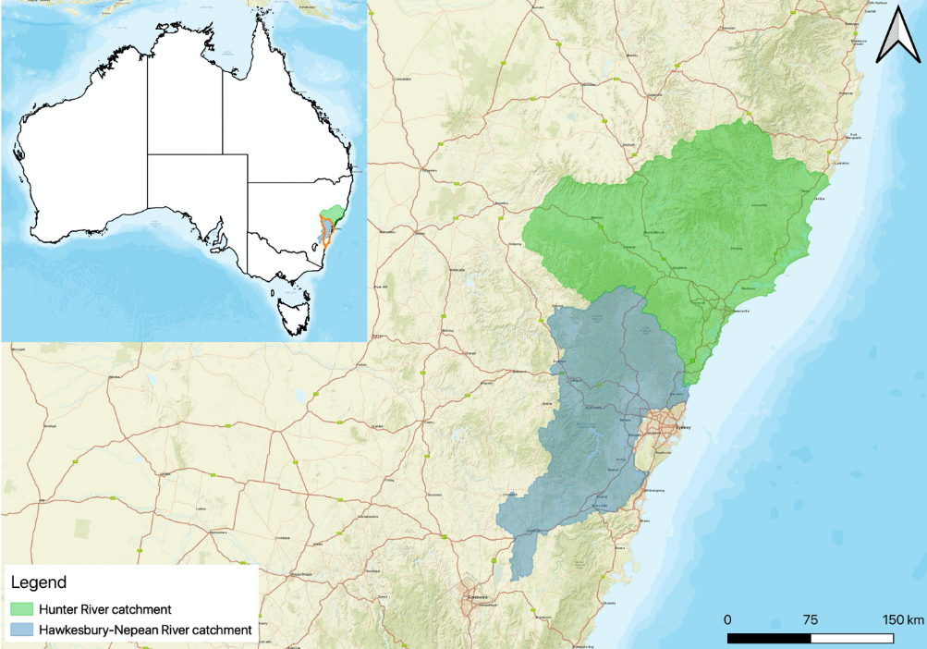
Figure 1. Map showing the Hawkesbury-Nepean and Hunter River catchments, where the study was undertaken
The inset map shows the location of the Hawkesbury-Nepean and Hunter River catchments within the Sydney Basin (orange) and Australia.
A total of 15 monitoring bores, accessing the shallow sandstone aquifer, were sampled in the Hawkesbury-Nepean and Hunter River catchments (Figure 2). Bores were selected based on depth and limited to those constructed of PVC casings that were completely enclosed except for discrete sections with vertical slots allowing the entrance of groundwater from the aquifer. To ensure bores were accessing the same aquifer and were comparable to those in Stage 1, bore selection targeted those with discrete slotted sections between 6 m and 44 m below ground.
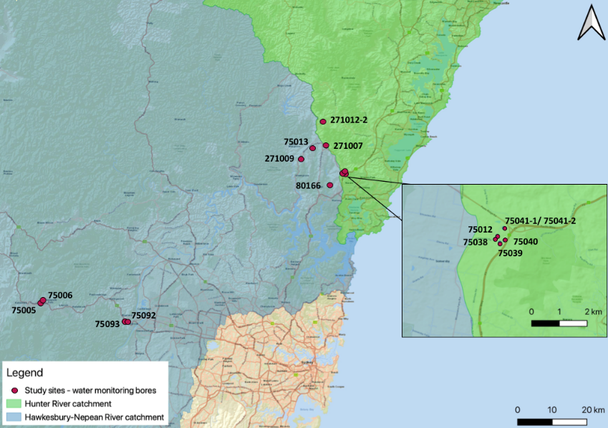
Figure 2. Map showing the location of the 15 bores sampled in the study
Five-digit bore numbers refer to GW0xxxxx and six-digit bore numbers to GWxxxxxx WaterNSW bore identification numbers (see WaterNSW, Continuous water monitoring network)

2.2 Field methods and procedures
To address the research questions, sampling focused on collection of microbial and stygofaunal communities using traditional and eDNA sampling, as well as water quality analysis. Methods for collection followed those applied in Stage 1 of the project, with some change in scope based on Stage 1 results. Specific changes were:
- Analysis focused on eDNA only and did not include comparisons with RNA. The question about RNA analysis was answered in Stage 1 and further RNA analysis was considered unnecessary.
- eDNA analyses focused on three genes targeting prokaryotes (16S ribosomal DNA (rDNA)), eukaryotes (18S rDNA) and Crustacea (16S mitochondrial DNA (mtDNA)).
- Sediment samples were not collected for separate eDNA analysis. Sampling in Stage 1 often did not yield sufficient eDNA from collected sediment to make this approach viable for routine analysis.
- Additional methods for preserving samples for eDNA analysis were employed in Stage 2. These are considered important when sampling in remote areas, as times for processing water samples without preservation may be a practical limitation for this sampling method.
For additional details on methods, sampling techniques and molecular analysis, refer to the Stage 1 report.
Groundwater sampling procedures for each bore are briefly summarised in Table 1. Additionally a range of site and sample attributes were quantified (Table 2). Methods for collection were based on Korbel et al. (2013a, 2013b, 2017) and are the same as the Stage 1 report.
Table 1. Field sampling procedures and order, with additional sampling methods undertaken at each sample site
Sample type | Sampling procedures and order | Analyses
1. Bore sample | a. Sterile, non-metallic bailer used to collect 2 L of ‘bore’ water in a sterile container for molecular methods | ‘Bore sample’ for eDNA analysis targeting 16S rDNA, 18S rDNA and mt16S rDNA
 | b. Sterile, non-metallic bailer used to collect additional 4 L of ‘bore’ water | ‘Bore sample’ analysed for water quality: electrical conductivity (EC), pH, temperature, dissolved oxygen (DO), total nitrogen (TN), total phosphorus (TP), nitrate plus nitrite (NOx), ammonia, total organic carbon (TOC), dissolved organic carbon (DOC), orthophosphate, total and dissolved metals, and redox-sensitive ions
 | c. Stygofauna ‘bore’ sample (bailer, net haul and sieve) | 2 L passed through 63 μm sieve (to collect stygofauna)
Lowered and hauled 63 μm mesh stygofaunal net five times
Lowered and hauled 150 μm mesh stygofaunal net five times
2. Pump 30 L | d. Motorised inertia pump used to extract 30 L of water (Sundaram et al. 2009) | Sieved (63 μm) pumped water to ascertain which stygofauna were missed by net hauls
 | e. 2 L water pumped into a sterile container | Immediately after 30 L was pumped, a 2 L water sample was collected for molecular methods (as in 1a above)
3. Aquifer samples | f. Motorised inertia pump used to extract 150 L of water, which purges the bore by removing two to three times the bore volume | Water collected and sieved (63 μm mesh) in five 30 L buckets; each consecutive 30 L sample was preserved separately for stygofauna ‘aquifer’ community sample  Sediment collected for physical characterisation and volume estimated
 | g. 2 L water pumped into a sterile container | Analysed for ‘aquifer’ water quality (as in 1b above)
 | h. 2 L water pumped into a sterile container | ‘Aquifer sample’ for eDNA analysis (as in 1a above)
 | i. Extra 5 L water pumped (for a subset of five bores) into a sterile container | ‘Aquifer sample’ for chemical preservation experiment and eDNA analysis (targeting 16S rDNA and 18S rDNA)
Table 2. Categorisation of sediment volume and type
Variable | Scale used
Volume of sediment* | 1 = Very low (<100 mL sediment)  2 = Low (100–500 mL sediment)  3 = Medium (500 mL – 2 L)  4 = High (2–5 L)  5 = Very high (>5 L)
Sediment categories** (indicating mode particle size) | Very fine sand (0.062–0.125 mm)  Fine sand (0.125–0.25 mm)  Medium sand (0.25–0.5 mm)  Coarse sand (0.5–1 mm)  Organic sediment
*Indicative sediment volumes used as an ordinal variable in analyses. **Based on the Wentworth (1922) scale and used as discrete categorical variables in analyses.

2.2.1 Sampling stygofauna for morphological identification
Stygofauna were sampled using bailers, weighted nets and pumping methods. Net, bailer and pump samples were taken prior to purging three times the bore volume. Additional samples were collected every 30 L until a total of 180 L had been pumped. All samples were preserved in 100% ethanol. Equipment was cleaned between sites using a combination of bleach and ethanol. For full details, see the Stage 1 report.

2.2.2 Molecular sampling and preservation of DNA samples
Water samples for molecular analysis (eDNA) were collected as outlined in the Stage 1 report; however, no additional sediments were collected for the analysis of extracellular DNA. Water samples were filtered within 7 hours of collection. An additional 5 L water sample was collected in a sterile container at a subset of five sites after 180 L had been pumped. These additional samples were used to test preservation methods.
The additional 5 L samples were stored at 4°C and processed within 5 hours of collection by shaking water to resuspend any sediments and then decanting it into six 600 mL aliquots in sterile glass bottles. Five aliquots were preserved by adding 400 mL of dimethyl sulfoxide–ethylenediaminetetraacetic acid–sodium chloride (DESS) following the methods of Oberprieler et al. (2021). The unpreserved aliquot and one of the preserved aliquots were filtered onto sterile membranes on the same day as collection (day 0). The remaining samples were stored at ambient temperature and processed on subsequent days, with a single sample filtered on days 1, 2, 5 and 9 after collection. Filter membranes were processed for eDNA analysis as outlined in the Stage 1 report.

2.2.3 Groundwater quality sampling
Water samples were collected as detailed in the Stage 1 report. Samples were taken from the pre-purged 2 L bailer sample and the 180 L aquifer sample (150 L after purging). Field measurements of dissolved oxygen (DO), electrical conductivity (EC), pH, temperature and oxidation-reduction potential (ORP) were taken using a Pro Quatro hand-held multi-parameter water quality probe (YSI Inc., Ohio, USA) before and after purging. As part of quality assurance / quality control (QA/QC) procedures, the water quality probe was calibrated as per manufacturer’s instructions.
Further water quality sampling for total nitrogen (TN), total phosphorus (TP), nitrate + nitrite (NOx), ammonia, total organic carbon (TOC), dissolved organic carbon (DOC), orthophosphate, sulfate, ferrous iron and total and dissolved metals was performed. See the Stage 1 report for full details of field sampling and analysis of water quality parameters. As part of the QA/QC procedures, duplicate samples were taken for DOC, TOC and metal analysis. Field blanks were performed for all analyses using ultrapure water, following the same protocol as the groundwater sampling.

2.3 Laboratory methods

2.3.1 Groundwater quality analyses
All water quality analyses were conducted at CSIRO (Lucas Heights, NSW) and ALS (Sydney), as detailed in the Stage 1 report.

2.3.2 Morphological identification of stygofauna
Processing stygofauna samples followed the standard operating procedure, whereby rose bengal stain was added, and stygofauna removed using flotation with Ludox® colloidal silica solution (Sigma-Aldrich Pty Ltd, Castle Hill, Australia). Samples were then manually sorted and identified under a microscope by experienced groundwater ecologists. As part of QA/QC procedures, 10% of samples were verified by different operators, and sample residues (i.e., after flotation) were screened to ensure that no fauna were missed. For more details, see the Stage 1 report.

2.3.3 Metabarcode analysis (eDNA)
DNA extraction was performed using 0.25 g (filter paper and sediment) with DNeasy PowerSoil Pro Kit (QIAGEN, Hilden, Germany) (see the Stage 1 report). The quality and purity of isolated DNA in all samples were then checked using a spectrophotometer.
All molecular methods (e.g., polymerase chain reaction (PCR) processes and primers used) followed the Stage 1 report’s methods and are summarised in Appendix 1. Samples were arranged on plates with a blank well in each column, and random interspersed positive and negative controls to prevent systematic bias. The 16S mtDNA PCR method was modified by adjusting the reaction mixture, cycle number, and annealing temperature within the PCR method until maximum DNA amplification was achieved (noted by quantitative PCR (qPCR) curves and gel electrophoresis determination).
Once the primer pools were pooled into equimolar concentration (final concentration 50 ng/µl to 60 ng/µl), they were purified using AMPure beads. Samples were sequenced by the Ramaciotti Centre, UNSW, using Illumina MiSeq (PE 250) after passing QA/QC checks that included screening DNA quality and quantity.

2.3.4 Bioinformatics
All metabarcode sequence data were processed using custom software designed by Paul Greenfield (CSIRO/Macquarie University) (see Korbel et al. (2017) and Sutcliffe et al. (2017) for details). Sequence data from the 18S rDNA and the 16S mtDNA (isolating crustaceans) were compared to determine the most suitable primer set for stygofauna detection and combined into a comprehensive dataset to compare with traditional stygofauna collections. For full details of bioinformatics, see Appendix 2. Additional cleaning of datasets included the removal of samples that had a total sequence count of less than 5,000 reads, the removal of rare operational taxonomic units (OTUs) (found at only one site), adjustments of counts in samples based on the number of positive controls found at individual sites, and the removal of all counts fewer than 10 within a sample.
For 16S rDNA compositional data, inferred functional profile data were obtained using the FAPROTAX program (Louca et al. 2016), which assigns bacterial OTUs to functional groups.

2.3.5 Data analysis
Principal component analysis (PCA) was used to visualise differences in water quality among bores and sample volumes, and correlations with water quality parameters and bores. Paired t-tests were used to compare individual water quality variables in pre- and post-purge samples.
Differences in assemblage data (stygofauna, eDNA assemblages) were visualised using non-metric multidimensional scaling (nMDS). Relative abundance data for OTUs were square root transformed (Hellinger transformation) and similarity among samples estimated using the Bray-Curtis similarity. 18S rDNA data were also analysed using a presence/absence transformation of the sequence read number.
Differences among sample volumes were analysed using permutational multivariate analysis of variance (PERMANOVA) (Anderson 2001) with a nested design with sampling bore as a random factor and sample volume as a fixed factor, nested within bore. Data from preserved DNA samples were compared among preservation periods using PERMANOVA with a nested design with sampling bore as a random factor and preservation time as a fixed factor, nested within bore. Analysis of similarity (ANOSIM) (Clarke and Green 1988) was also used to compare differences between sample groups.
Differences among sample groups were analysed using similarity percentage analysis (SIMPER) to determine taxa responsible for (dis)similarities between sample groups, using a Bray-Curtis dissimilarity matrix.
To visualise the composition of microbial communities, relative abundances of the top 30 orders by total sequence counts (representing any order comprising greater than 2% of the total composition at any individual site) were plotted. Additionally, microbial orders were assigned to functional groups using functional annotation of prokaryote taxa (FAPROTAX) (Louca et al. 2016).
Relationships between environmental variables (including water chemistry) and biotic communities were modelled using distance-based linear models (DistLM) (Anderson et al. 2008). In DistLM analysis, biological data are first regressed against environmental variables separately (termed marginal tests), and then the best suite of variables is selected using stepwise selection based on the r² values. Biological data were square root transformed prior to analysis. Environmental data were normalised before analysis, and strongly correlated (r>0.90) variables were removed prior to analysis, based on draftsman plots (Clarke and Ainsworth 1993). PRIMER-e version 6.1.11 (PRIMER-e Ltd, Plymouth, UK) was used to complete all multivariate analyses, with univariate analyses completed in Minitab version 17 (Minitab Inc., Pennsylvania, USA). The significance level (α) for univariate and multivariate inferential tests was set at 0.05.
All data are publicly available on completion of this study via the Macquarie University Research Data Repository (18S rDNA DOI: 10.25949/21965393; 16S rDNA DOI: 10.25949/21965408; 16S mtDNA DOI: 10.25949/21965414).

- Results and discussion

Site attributes and water quality
Fifteen bores were sampled across the Hawkesbury-Nepean and Hunter River catchments. All bores accessed the shallow unconfined aquifers within the Hawkesbury Sandstone, with a mean slot depth ranging from 8.0 m to 42.5 m below ground level (Table 3). Land uses at or adjacent to the bores were a mixture of native vegetation, National Park, low-density urban/residential, and mixed agriculture. Irrigated cropping was not evident based on field observations, although a dam was present at one site (75013).
There was no significant difference in the mean values of DO, temperature and EC between 2 L and 180 L samples (paired t-tests, p=0.30, p=0.95 and p=0.54, respectively). However, there was a significant difference between pH (p=0.001) (Figure 3), with a lower mean pH in the purged samples. This likely reflects the influence of surface chemistry changes due to the interaction of bore water with air in the bore. Mean DO was higher in the unpurged samples, though not significantly.
Mean concentrations of DOC and TOC in the unpurged 2 L samples were higher than in the 180 L samples; however, neither difference was significant (Figure 4). The standard errors around mean DOC and TOC were large due to the variability in the sample concentrations (Figure 4). DOC concentrations in unpurged (2 L) samples from bores 75039 and 75038 were one to two orders of magnitude higher than in the other samples, and this large variability likely caused the lack of significant difference between DOC concentrations in purged and unpurged samples. Concentrations of both DOC and TOC were higher in the 2 L than the 180 L samples, at 60% and 50% of sites, respectively. TOC measurements were impacted by excessive turbidity which meant that only 30% of all samples could be reliably analysed. The overall higher DOC and TOC in the unpurged samples is likely due to organic material (such as ants, spiders, slugs or even vegetation) falling into the bore. The likelihood of this happening is influenced by bore construction, particularly the presence of caps over the bore casing and the type and height above ground of bore casings. DOC in groundwaters often increases following rain as infiltrating water transports carbon from the unsaturated to the saturated zone (e.g., Saccò et al. 2021). However, this is likely to be consistent across all sites and is unlikely to explain the very large DOC concentrations at some sites, which correlate with observations of large amounts of organic material in the bores.
There were no significant differences in the concentrations of total nitrogen or nitrogen species between the unpurged 2 L and purged 180 L samples across all 15 sampled bores (paired t-tests, p>0.05). Nitrite was at or below the instrumental detection limit for all samples. Reactive phosphorus concentrations were at or below the instrumental detection limit in 80% of samples, so no statistical testing was performed. Mean total phosphorus was four times higher in the 180 L samples than the 2 L samples but this was not significant (paired t-test, p=0.06) due to the variability in the measured data (concentrations spanning two orders of magnitude, Figure 5). The reason for the higher phosphorus concentrations in some aquifer samples compared to their related bore samples is unclear.
La Niña climate conditions prevailed across eastern Australia throughout 2021–22, bringing repeated heavy rain events to much of the region. Combined rainfall at Mangrove Creek Dam (Kulnura) on the Kulnura/Mangrove Mountain Plateau in February 2022 and the previous three months was 679 mm (BOM 2022), compared to the long-term monthly average for that period of 333 mm. Similarly, at Faulconbridge, located between the Blue Mountains sites, rainfall from November 2021 to February 2022 was 851 mm, compared to the long-term average for the same period of 522 mm (BOM 2022).
A likely consequence of the high rainfall is the rising of water tables and input of fresh rainwater to the aquifers, leading to changes in groundwater quality (Barbieri et al. 2021). It might be expected that water quality in the aquifers was more variable as a consequence of the rainfall than it might be under lower rainfall conditions. Furthermore, rainwater may be entering both the bores and the aquifers simultaneously, making pre- and post-purge samples more similar.
A summary of water quality data is provided in Appendix 7.

Table 3. Bore and sample attributes
Bore ID | Date sampled | Minimum slot depth (m bgl) | Maximum slot depth (m bgl) | Mean slot depth  (m bgl) | Depth to water  (m bgl) | Casing height (m) | Number trees in 250 m radius | Dominant vegetation | Sediment type* | Sediment volume* | Land use | Irrigated
75006 | 4/2/22 | 32.9 | 35.9 | 34.4 | 25.47 | 0.44 | >100 | Native vegetation | Sand | L | Urban and National Park | No
75005 | 4/2/22 | 27.8 | 33.8 | 30.8 | 22.06 | 0.47 | >100 | Native vegetation | Sand / silt | L | Urban and National Park | No
75092 | 4/2/22 | 22 | 28 | 25 | 5.62 | 0 | >100 | Native vegetation | Sand | L | Urban and National Park | No
75093 | 4/2/22 | 9 | 15 | 12 | 2.75 | 0.05 | >100 | Native vegetation | Sand | L | Urban / native vegetation / lagoon | No
271009 | 7/2/22 | 24 | 27 | 25.5 | 12.63 | 1 | 50–99 | Trees with understorey | Fine sand / silt | VH | Semi-rural | No
271007 | 7/2/22 | 29 | 32 | 30.5 | 13.66 | 1.17 | 50–99 | Grass / large trees | Fine sand / silt | H silt/ L sand | Turf farm / poultry farm / horse farm | Not visible
75013 | 7/2/22 | 21 | 24 | 22.5 | 6.49 | 0.9 | >100 | Citrus orchard | Sand | L | Cropping / native vegetation | Not visible
75012 | 7/2/22 | 41 | 44 | 42.5 | 11.04 | 0.68 | >100 | Grass | Medium / fine sand | L/VL | Crop / citrus | No
75039 | 7/2/22 | 24 | 28 | 26 | 17.62 | 0 | 50-99 | Grass | Medium / fine sand | L | Agriculture | No
75040 | 8/2/22 | 17 | 21 | 19 | 0.69 | 0 | 50-99 | Grass | Medium/ fine sand | L | Agriculture | No
75041 | 8/2/22 | 17 | 21 | 19 | 3.11 | 0 | >100 | Grass | Gravel / fine sand | VL | Agriculture | No
271012-2 | 8/2/22 | 9 | 12 | 10.5 | 3.865 | 0.92 | 30–49 | Grass | Medium sand / silt | M | Agriculture | No
80166 | 8/2/22 | 34 | 37 | 35.5 | 16.67 | 0.8 | >100 | Large trees / grass | Medium sand | VL | National Park / horse stud | No
75041/2 | 23/2/22 | 6 | 10 | 8 | 0.75 | 0 | >100 | Grass | Gravel / fine sand | L | Agriculture | No
75038 | 23/2/22 | 32 | 36 | 34 | 14.925 | 0 | 50-99 | Grass | Fine sand | L | Agriculture | No
*See Table 2 for volume and particle size ranges. VL = very low, L = low, M = moderate, H = high, VH = very high, m bgl = metres below ground level.

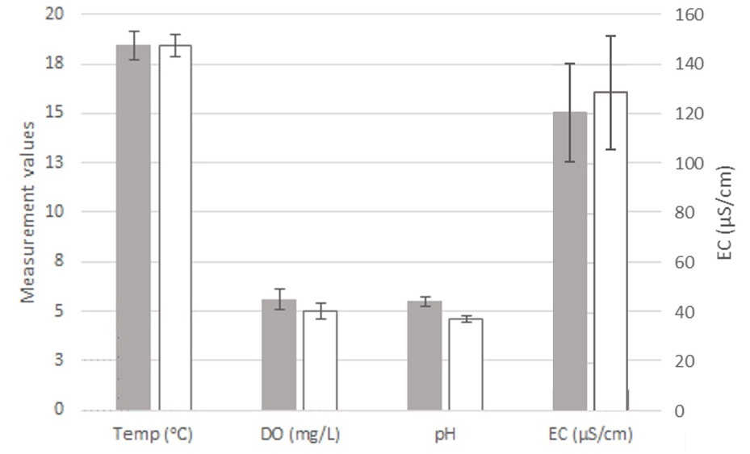
Figure 3. Mean (± standard error) physico-chemical variables measured in groundwater collected from the 15 study bores
Shaded bars are 2 L sample means; unshaded bars are 180 L sample means.
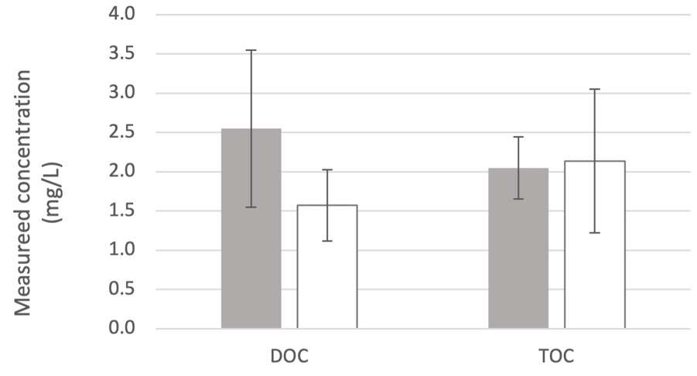
Figure 4. Mean (± standard error) dissolved organic carbon (DOC) and total organic carbon (TOC) measured in groundwater collected from the 15 study bores
Shaded bars are 2 L sample means; unshaded bars are 180 L sample means.
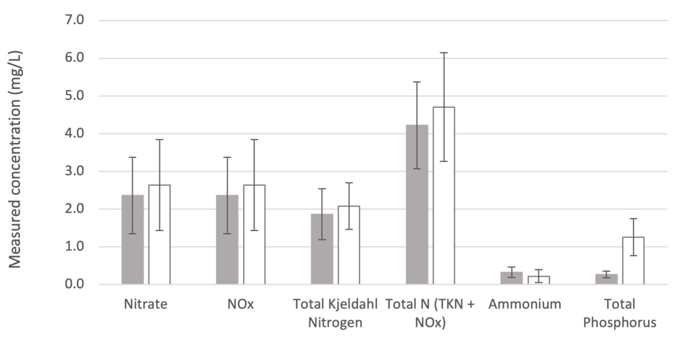
Figure 5. Mean (± standard error) nutrients measured in groundwater collected from the 15 study bores
Shaded bars are 2 L sample means; unshaded bars are 180 L sample means.

3.1.1 Variation in water quality
Physico-chemical, major ion and nutrient water quality data were reduced to 19 variables after the removal of nitrate, which was strongly correlated with other nitrogen species. The resulting PCA (Figure 6) showed large differences in water quality between sites, which were, in many cases, greater than the variation between pre- and post-purge samples from within the same site.
There were differences in water quality between pre- and post-purge samples at some sites (e.g., 75039), which is indicated by separation between open and closed symbols of the same shape and colour (Figure 6). However, pre- and post-purge samples from some sites were relatively similar (e.g., 75005, 75092) and are grouped closely in Figure 6.
PERMANOVA indicated a significant difference in water quality between bores (p=0.001) and between sample volumes (p=0.007), which may be a consequence of land use (e.g., Korbel et al. 2013b), depth to groundwater (Pabich et al. 2001) or other site attributes (e.g., Korbel and Hose 2015). Importantly, this difference in water quality between ‘bore’ and ‘aquifer’ samples demonstrates the need for purging when sampling water quality.
Among the normalised water quality variables, each contributed 4.8% to 6.2% of the dissimilarity between 2 L and 180 L samples. Of those variables, pH contributed the greatest portion (6.2%) (i.e., differed most between samples), followed by ORP (5.9%), TP (5.4%) and K (5.1%).
The PCA of the major dissolved (Figure 7) and total metal (Figure 8) concentrations did not show clear separations between pre- and post-purge samples. However, there were significant differences between pre- and post-purge samples for both datasets (dissolved metals p=0.006; total metals p=0.028).
Although dissolved Cu, Zn and Pb contributed most to the differences between pre- and post-purge samples, their relative contributions of 6.5% to 7.2% were similar to a large number of other analytes, suggesting that no single variable differed strongly between the sample groups. Each of the 16 dissolved metals included in the analysis contributed 5.95% to 7.15%. Similarly, total metals each contributed 4.6% to 5.6% to the differences between sample volumes. Al (5.6%), Ga (5.4%) and Fe (5.3%) were the analytes contributing most to the differences between pre- and post-purge samples.
Water quality conditions were similar to the few reported data from the Somersby area (Hose et al. 2016), and there were no strong environmental gradients across the sites, indicated by the relatively narrow ranges of most water quality parameters. The lack of strong gradients may be expected given that sites were chosen to be similar in terms of depth, hydrology and geology.
Water quality of the pre- and post-purge samples differed most notably in terms of dissolved and total carbon concentrations (at some sites), pH and TP, as discussed above. This emphasises the need to purge bores prior to sampling for groundwater quality.
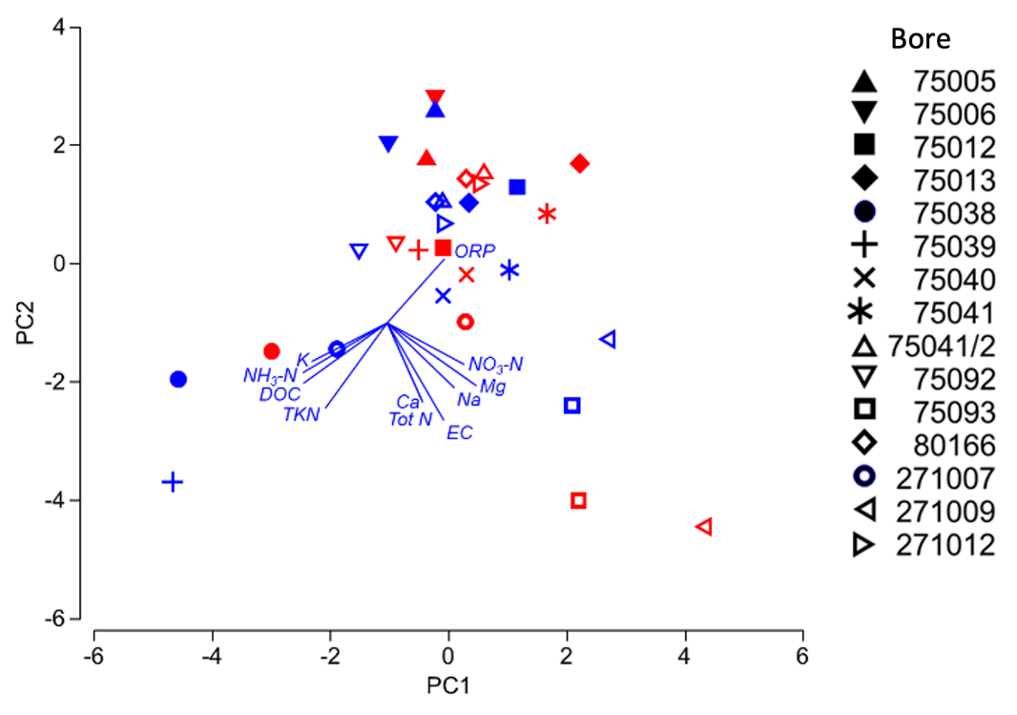
Figure 6. Principal components analysis of groundwater quality at sites in the fractured sandstone aquifers based on physico-chemical parameters, major ions and nutrients
Blue symbols = pre-purge samples, red symbols = post-purge samples. The length and direction of vectors reflect the correlation of that variable with the samples in the ordination and the direction of increasing values. Only vectors with axis correlations >0.3 are shown. PC1 explains 20.3% and PC2 explains 20.0% of the variation in the water quality data.
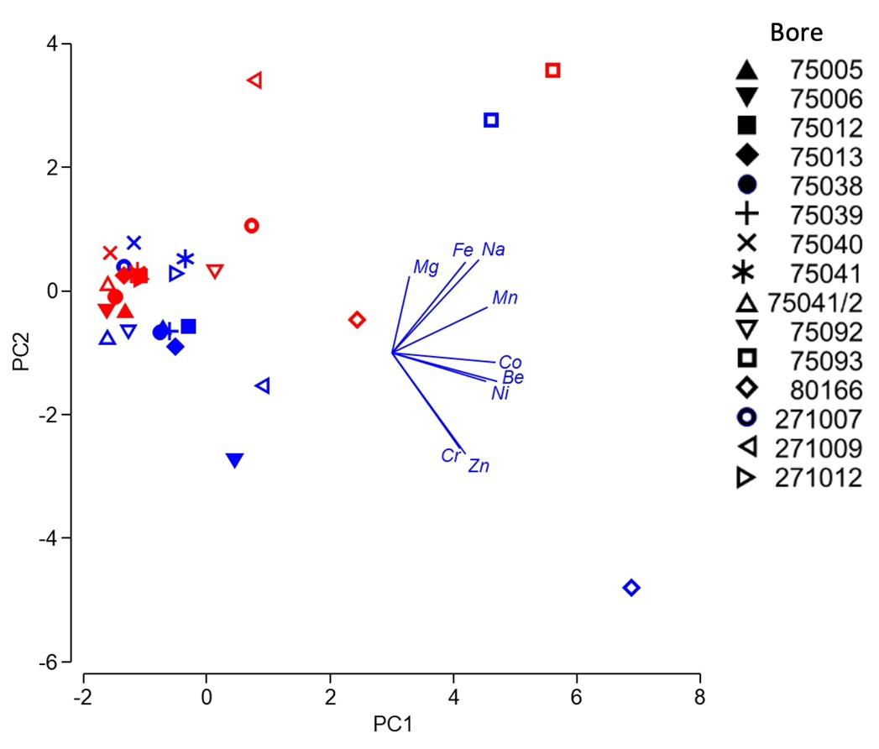
Figure 7. Principal components analysis of groundwater quality at sites in the fractured sandstone aquifers based on concentrations of major metals in filtered groundwater samples (dissolved metal concentrations)
Blue symbols = pre-purge samples, red symbols = post-purge samples. The length and direction of vectors reflect the correlation of that variable with the samples in the ordination and the direction of increasing values. Only vectors with axis correlations >0.3 are shown. PC1 explains 29.3% and PC2 explains 15.4% of the variation in the water quality data.
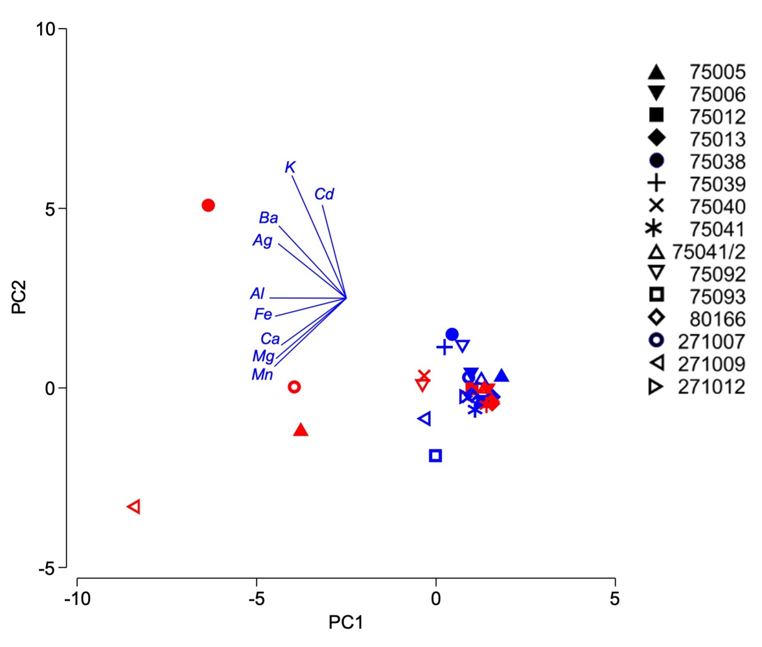
Figure 8. Principal components analysis of groundwater quality at sites in the fractured sandstone aquifers based on concentrations of major metals in unfiltered groundwater samples (total metal concentrations)
Blue symbols = pre-purge samples, red symbols = post-purge samples. The length and direction of vectors reflect the correlation of that variable with the samples in the ordination and the direction of increasing values. Only vectors with axis correlations >0.3 are shown. PC1 explains 54.1% and PC2 explains 15.8% of the variation in the water quality data.
The water quality of pre- and post-purge samples from fractured rock aquifers differed from that of samples from alluvial aquifers (Figure 9). Interestingly, there was no separation of samples from the Blue Mountains and Mangrove Mountain region within the fractured rock aquifer samples (Figure 9). The PCA ordination shows a separation of samples by aquifer type along the horizontal axis, which explains 19.8% of the variance in water quality. The variables that were most strongly correlated with this axis were DO concentrations, which were greater in the samples from the fractured sandstone aquifers; and SO4 concentrations, EC, pH and temperature, which were greater in samples from the alluvial aquifer (Figure 9).
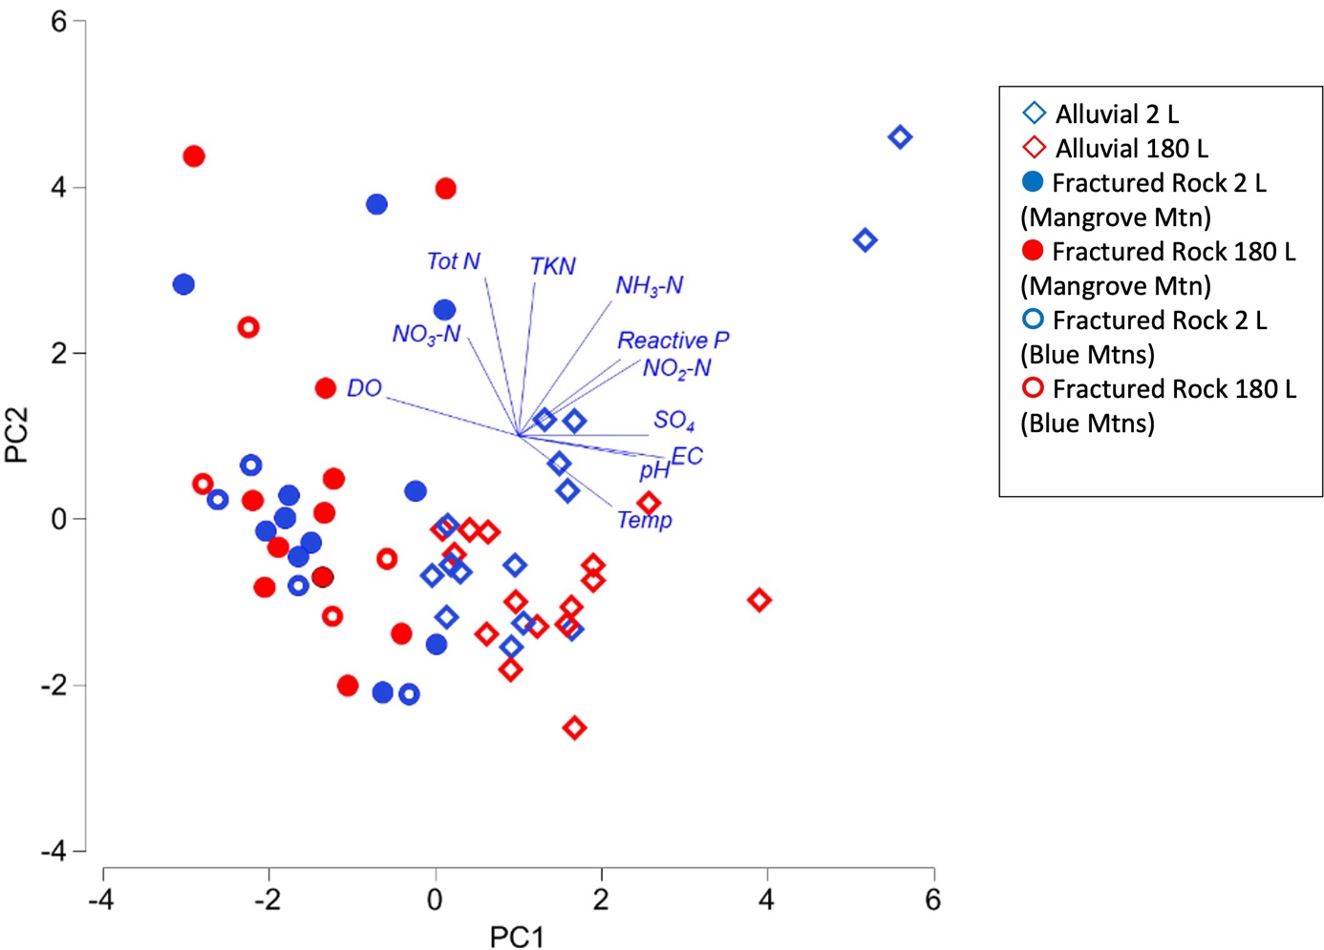
Figure 9. Principal components analysis of groundwater quality at sites in the fractured sandstone and alluvial aquifers on physico-chemical parameters, major ions and nutrients
Blue symbols = pre-purge samples, red symbols = post-purge samples. The length and direction of vectors reflect the correlation of that variable with the samples in the ordination and the direction of increasing values. Only vectors with axis correlations >0.3 are shown. PC1 explains 19.8% and PC2 explains 15.7% of the variation in the water quality data.
Our results indicate that for water quality …
Bailing method (without purging) collects stagnant water from inside a bore that is subject to influences from the surface. This water had a different chemical signature to the post-purge water and thus does not represent the water quality of the wider aquifer.
Pumping 150 L of water provided a significantly different water chemistry signature to that of the bailer samples.
The main differences in water chemistry between pre- and post-purge samples were concentrations of DOC (in some bores), pH and total phosphorus.
Although DOC and phosphorus were the variables that consistently differed between bore water and purged water in both alluvial and fractured rock aquifers, it is apparent that the overall water quality differed between aquifer types.
Purging to remove stagnant water from the bore (which is replaced by water from the surrounding aquifer) is required to gain a representative sample of the groundwater for chemical analysis in both aquifer types.

3.2 Stygofauna (using morphological identification)

3.2.1 General findings
A total of 13,246 individuals representing 13 higher-order stygobiotic taxa were found during this sampling campaign (15 sites, all sampling methods combined) (Appendix 4). Total richness within sites ranged from zero to 11, with total abundance ranging from zero to 9,445 within sites. Bores 75041-2 and 75040 were the most taxon-rich sites, and bores 75093 and 75005 had no taxa collected. There were numerous sites that contained no crustaceans (typically present in groundwater samples). Examples of taxa collected are shown in Figure 10.
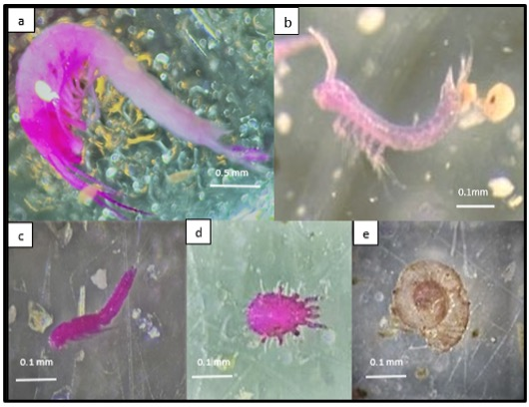
Figure 10. Examples of species found during the sampling campaign: a) Syncarida (Family A); b) Syncarida (Parabathynellidae); c) Copepoda (Harpacticoida); d) Acarina; e) Gastropoda
Specimens are pink from staining with rose bengal. Images: K Korbel
The most abundant taxon across both catchments was Nematoda (4,059), followed by Harpacticoida (2,594) and Rotifera (2,437). Over 91% of the Nematoda found in the study area (15 bores) were from a single bore (75039). Ostracoda and Gastropoda were the least abundant taxa with a total of one and three individuals found in the study area, respectively. The single Ostracoda was found at bore 75040 and Gastropoda were found at two bores (75041 and 75038). Another rare taxon in the study area was Syncarida Family A, which was only found in bore 75040. The suite of taxa collected at these sites was similar to that collected in sandstone aquifers around Somersby (Asmyhr 2013) and in the southern areas of the Sydney Basin (Hose 2008; Hose 2009). Species-level identification of stygofauna specimens is hindered by the unavailability of relevant taxonomic keys. Nevertheless, it is likely that the species collected from the Somersby sites were the same as those recorded previously from those locations. However, it is unlikely that species collected from the Blue Mountains and Somersby areas are same species or are the same as those collected from other areas of the Sydney Basin, by virtue of their isolation and the propensity for stygofauna to have narrow spatial distributions (see Harvey 2002).

Comparison of stygofaunal communities in alluvial and sandstone aquifers
Total richness within the study site for the fractured sandstone aquifers (13) was comparable to that of the alluvial aquifers (12) (Table 4). However, total abundances within the fractured rock aquifer were much higher than those of the alluvial aquifer. This is in part due to the very large numbers of Nematoda, Rotifera and Acarina individuals that were located in the fractured sandstone aquifers. As taxa within these groups do not have sole affinity with groundwater environments, not all species are likely to be obligate stygofauna. Gastropods, Notobathynella (Parabathynellidae) and syncarids (Family A) were found in the fractured rock aquifer but were not collected in the alluvial aquifer sites sampled in Stage 1. In contrast, the alluvial aquifer contained much higher abundances of Cyclopoida and Bathynellidae, with Amphipoda only found in the alluvial aquifers.
Two sites within the fractured sandstone aquifers of the Blue Mountains (bores 75005 and 75093) had no stygofauna recorded. Additionally, numerous sites in the sandstone aquifers contained no Crustacea (8 out of 15) and were instead dominated by taxa from Nematoda and Acarina. This was quite different to the alluvial aquifer, where 14 of the 15 sites contained crustaceans. These findings are consistent with studies indicating that geological substrate influences stygofauna distribution due to sizes of interstitial spaces (Mösslacher 1998; Hose et al. 2017; Korbel et al. 2019), although there is likely a suite of other environmental variables that also influence stygofauna distribution (Johns et al. 2015; Korbel and Hose 2015).
Table 4. Total abundance and richness of stygofauna in bores within alluvial and fractured rock aquifers (morphological identification)
Catchment | Aquifer type | Cyclopoida | Harpacticoida | Copepod nauplii | Parabathynellidae | Bathynellidae | Amphipoda | Family A | Ostracoda | Oligochaeta | Nematoda | Acarina | Rotifera | Platyhelminthes | Tardigrada | Gastropoda | Total richness | Total abundance
Namoi | Alluvial aquifer | 334 | 877 | 450 | 51 | 1,129 | 10 | 0 | 11 | 221 | 191 | 603 | 591 | 4 | 4 | 0 | 12 | 4,466
Hunter and Hawkesbury-Nepean | Fractured aquifer | 126 | 2,594 | 714 | 18 | 90 | 0 | 4 | 1 | 1,721 | 4,059 | 1,399 | 2,437 | 27 | 52 | 3 | 13 | 13,246

3.2.2 Richness

Comparison of bailer, net and pumping methods
Taxon richness between fractured sandstone sites varied greatly (zero to 12 higher-order taxa), and there was also high variation in the richness recorded at individual sites due to the sampling method. Pumping yielded the highest mean richness across all sites, and the highest total richness in six of the 13 bores that contained animals (Figure 11). Bailing resulted in the lowest richness in seven of the 13 bores with animals and, importantly, failed to collect any taxa at two sites where taxa were detected using other methods. Collection by netting produced the highest richness at one site, but richness was generally lower than that of pumping. When interpreting these data, it needs to be considered that pumping alone should capture all of the samples collected by nets and bailers.
There were noticeable differences in the types of taxa that each method captured. The two sites where netting and bailing detected more taxa than pumping only contained a total richness of two, consisting of Nematoda, Acarina and/or Rotifera (which may not be true stygobites). However, importantly, the bailer method was not effective in capturing any individuals of Notobathynella (Parabathynellidae), Syncarida Family A, Ostracoda, Platyhelminthes or Tardigrada (Table 5, Appendix 5, Appendix 6). Additionally netting and bailing methods did not collect Gastropoda. Thus, it is clear that pumping is the most effective method for capturing the greatest stygofauna richness within fractured aquifer systems.
The cumulative richness increased in nine of the 13 bores after initial sampling with the bailer, indicating that the bailer was not as effective as other methods (Figure 12). Cumulative sample taxa richness plateaued at different stages of sampling depending on the bore. Cumulative sample taxa richness plateaued in four of the 13 bores (where taxa were found) after the net haul sampling. The richness had plateaued after 90 L was pumped in the majority of bores (91% of bores). The exception was bore 75039, where cyclopoids were detected at the 150 L pump volume. Cumulative sample taxa richness did not increase in any bores after 150 L had been pumped (i.e., the 180 L sample contained no new taxa).
Of the 15 bores sampled, eight contained crustacean taxa with confirmed groundwater affinities. At these sites, pumping increased the chance of detecting stygobitic Crustacea. Samples from sites 75040 and 75038 only contained Harpacticoida and Bathynellidae after 90 L of pumping, and samples from 75039 only contained Cyclopoida after 150 L of pumping. Results indicated that in six of the eight sites with crustaceans, pumping a minimum of 120 L resulted in a greater richness being recorded, and richness did not increase at any site after 150 L was pumped.
Examining how sampling methods impact the detection of individual taxa illustrates some of the complexities of characterising stygofauna and indicates the need for intensive sampling with pumping to reliably estimate taxa richness and confirm the presence of specific taxa. For these reasons, our study indicates that pumping a minimum of 150 L is the most effective method to capture a representative taxa richness at bores within the sandstone fractured aquifer. These results are consistent with the results from the alluvial aquifer sampling analysis in the Stage 1 report.
Figure 11. Total richness captured using bailer, net and pump methods
Note the differences in scale between plots and that only 90 L of pump sample was collected for bore 75092.
Table 5. Stygofauna collected from the 15 study sites using bailer (2 L), net and pump (180 L) methods and identified based on morphology
Site | Sample method | Cyclopoida | Harpacticoida | Copepod nauplii | Parabathynellidae | Bathynellidae | Syncarida Family A | Ostracoda | Oligochaeta | Nematoda | Acarina | Rotifera | Platyhelminthes | Tardigrada | Gastropoda | Total richness | Total abundance
75006 | Bailer (2 L) | - | -* | - | - | - | - | - | 1 | - | -* | - | -* | - | - | 3 | 14
 | Nets (63 µm + 150 µm) | - | 1 | - | - | - | - | - | 4 | - | 8 | - | -* | - | - | 3 | 14
 | Pump (180 L) | - | 5 | - | - | - | - | - | 4 | - | 1 | - | 2 | - | - | 4 | 12
 | Total | - | 6 | - | - | - | - | - | 9 | - | 9 | - | 2 | - | - | 4 | 26
75005 | Bailer (2 L) | - | - | - | - | - | - | - | - | - | - | - | - | - | - | 0 | 0
 | Nets (63 µm + 150 µm) | - | - | - | - | - | - | - | - | - | - | - | - | - | - | 0 | 0
 | Pump (180 L) | - | - | - | - | - | - | - | - | - | - | - | - | - | - | 0 | 0
 | Total | - | - | - | - | - | - | - | - | - | - | - | - | - | - | 0 | 0
75092 | Bailer (2 L) | - | - | - | - | - | - | - | -* | - | - | - | - | - | - | 1 | 1
 | Nets (63 µm + 150 µm) | - | - | - | - | - | - | - | 1 | - | - | - | - | - | - | 1 | 1
 | Pump (90 L)# | - | - | - | - | - | - | - | 3 | - | - | - | - | - | - | 1 | 3
 | Total | - | - | - | - | - | - | - | 4 | - | - | - | - | - | - | 1 | 4
75093 | Bailer (2 L) | - | - | - | - | - | - | - | - | - | - | - | - | - | - | 0 | 0
 | Nets (63 µm + 150 µm) | - | - | - | - | - | - | - | - | - | - | - | - | - | - | 0 | 0
 | Pump (180 L) | - | - | - | - | - | - | - | - | - | - | - | - | - | - | 0 | 0
 | Total | - | - | - | - | - | - | - | - | - | - | - | - | - | - | 0 | 0
271009 | Bailer (2 L) | - | - | - | - | - | - | - | - | 1 | - | 1 | - | - | - | 2 | 3
 | Nets (63 µm + 150 µm) | - | - | - | - | - | - | - | - | 1 | - | -* | - | - | - | 2 | 3
 | Pump (180 L) | - | - | - | - | - | - | - | - | -* | - | -* | - | - | - | 0 | 0
 | Total | - | - | - | - | - | - | - | - | 2 | - | 1 | - | - | - | 2 | 3
271007 | Bailer (2 L) | - | - | - | - | - | - | - | - | 1 | 1 | - | - | - | - | 2 | 4
 | Nets (63 µm + 150 µm) | - | - | - | - | - | - | - | - | 2 | -* | - | - | - | - | 2 | 4
 | Pump (180 L) | - | - | - | - | - | - | - | - | -* | -* | - | - | - | - | 0 | 0
 | Total | - | - | - | - | - | - | - | - | 3 | 1 | - | - | - | - | 2 | 4
75013 | Bailer (2 L) | - | - | - | - | - | - | - | - | -* | -* | - | - | - | - | 1 | 1
 | Nets (63 µm + 150 µm) | - | - | - | - | - | - | - | - | -* | 1 | - | - | - | - | 1 | 1
 | Pump (180 L) | - | - | - | - | - | - | - | - | 1 | -* | - | - | - | - | 1 | 2
 | Total | - | - | - | - | - | - | - | - | 1 | 1 | - | - | - | - | 2 | 3
75013 | Bailer (2 L) | - | 3 | -* | - | - | - | - | - | -* | -* | 2 | - | - | - | 3 | 313
 | Nets (63 µm + 150 µm) | - | 292 | -* | - | - | - | - | - | -* | 16 | -* | - | - | - | 3 | 313
 | Pump (180 L) | - | 63 | 8 | - | - | - | - | - | 15 | 7 | 8 | - | - | - | 4 | 101
 | Total | - | 358 | 8 | - | - | - | - | - | 15 | 23 | 10 | - | - | - | 4 | 414
75013 | Bailer (2 L) | -* | -* | -* | - | - | - | - | 3 | 11 | 29 | 1 | - | -* | - | 5 | 1,445
 | Nets (63 µm + 150 µm) | -* | -* | -* | - | - | - | - | 46 | 430 | 213 | 699 | - | 13 | - | 5 | 1,445
 | Pump (180 L) | 36 | 1,546 | 354 | - | - | - | - | 844 | 3,273 | 369 | 1,552 | - | 26 | - | 7 | 8,000
 | Total | 36 | 1,546 | 354 | - | - | - | - | 893 | 3,714 | 611 | 2,252 | - | 39 | - | 7 | 9,445
75013 | Bailer (2 L) | -* | -* | -* | -* | -* | -* | -* | -* | 1 | 6 | 1 | -* | - | - | 8 | 289
 | Nets (63 µm + 150 µm) | 17 | 65 | 29 | -* | -* | 4 | 1 | 20 | 41 | 54 | 50 | -* | - | - | 8 | 289
 | Pump (180 L) | 51 | 401 | 256 | 2 | 1 | - | - | 11 | 83 | 38 | 25 | 21 | - | - | 9 | 889
 | Total | 68 | 466 | 285 | 2 | 1 | 4 | 1 | 31 | 125 | 98 | 76 | 21 | - | - | 11 | 1,178
75041-1 | Bailer (2 L) | - | 7 | - | 1 | - | - | - | - | 1 | 2 | - | - | -* | -* | 5 | 25
 | Nets (63 µm + 150 µm) | - | 5 | - | -* | - | - | - | - | 1 | 5 | 3 | - | -* | -* | 5 | 25
 | Pump (180 L) | - | -* | - | -* | - | - | - | - | 5 | 9 | -* | - | 1 | 2 | 4 | 17
 | Total | - | 13 | - | 1 | - | - | - | - | 7 | 16 | 3 | - | 1 | 2 | 7 | 42
271012 | Bailer (2 L) | - | - | 31 | - | - | - | - | - | 1 | 89 | 7 | - | - | - | 3 | 448
 | Nets (63 µm + 150 µm) | - | - | -* | - | - | - | - | - | -* | 312 | 8 | - | - | - | 3 | 448
 | Pump (180 L) | - | - | -* | - | - | - | - | - | 6 | 25 | 5 | - | - | - | 3 | 36
 | Total | - | - | 31 | - | - | - | - | - | 7 | 426 | 20 | - | - | - | 3 | 484
80166 | Bailer (2 L) | - | - | - | - | - | - | - | -* | -* | -* | -* | - | - | - | 0 | 0
 | Nets (63 µm + 150 µm) | - | - | - | - | - | - | - | -* | -* | -* | -* | - | - | - | 0 | 0
 | Pump (180 L) | - | - | - | - | - | - | - | 10 | 9 | 8 | 2 | - | - | - | 4 | 29
 | Total | - | - | - | - | - | - | - | 10 | 9 | 8 | 2 | - | - | - | 4 | 29
75041-2 | Bailer (2 L) | 1 | 41 | 4 | -* | 1 | - | - | 4 | 4 | 9 | 6 | -* | -* | - | 9 | 332
 | Nets (63 µm + 150 µm) | 14 | 137 | 23 | 11 | 3 | - | - | 10 | 25 | 14 | 23 | -* | 2 | - | 9 | 332
 | Pump (180 L) | 7 | 22 | 9 | 4 | 16 | - | - | 7 | 5 | 9 | 9 | 1 | -* | - | 9 | 89
 | Total | 22 | 200 | 36 | 15 | 20 | - | - | 21 | 34 | 32 | 38 | 1 | 2 | - | 10 | 421
75038 | Bailer (2 L) | - | -* | - | - | -* | - | - | 101 | 11 | 13 | 2 | -* | -* | 1 | 5 | 707
 | Nets (63 µm + 150 µm) | - | -* | - | - | -* | - | - | 467 | 29 | 68 | 15 | -* | -* | -* | 5 | 707
 | Pump (180 L) | - | 6 | - | - | 69 | - | - | 185 | 102 | 93 | 18 | 3 | 10 | -* | 8 | 486
 | Total | - | 6 | - | - | 69 | - | - | 753 | 142 | 174 | 35 | 3 | 10 | 1 | 9 | 1,193
 | Study total | 126 | 2,594 | 714 | 11 | 90 | 4 | 1 | 1,721 | 4,059 | 1,399 | 2,437 | 27 | 52 | 3 | 13 | 13,246
For each site, data are given for the number of individuals collected, with nauplii recorded but not contributing to the total richness.
Dash (-) indicates taxon not collected. *Taxon was collected by some but not all methods. #Bore 75092 had only 90 L of sample.
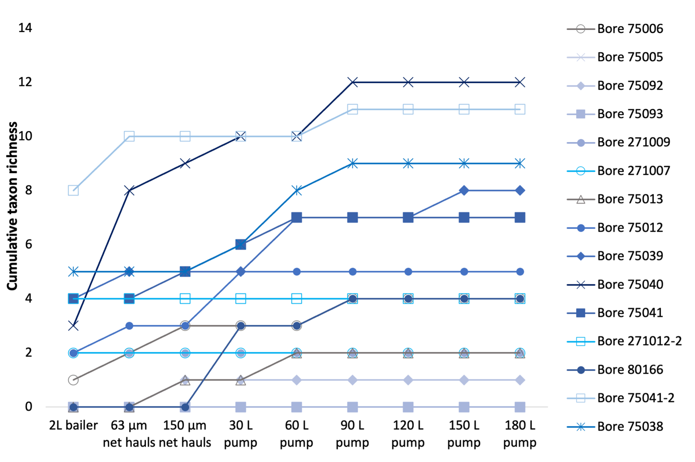
Figure 12. Cumulative sample taxa richness (number of taxa) found in each bore as sampling effort increased
Note that only 90 L of pump sample was collected for bore 75092. *Represents samples with no taxa detected. #Represents samples with no crustaceans detected.

3.2.3 Abundance

Comparison of bailer, net and pumping methods
The bailing method collected the fewest organisms at 10 of the 13 bores where organisms were found (Figure 13). The three sites where bailing had the highest number of individuals collected contained very few taxa (fewer than 5 individuals) and the taxa were not crustaceans. Samples collected with nets generally had higher total abundance than bailed samples and, in five out of 13 sites (with taxa present), contained higher total abundances than pumping. However, comparisons of abundances between sampling methods are complicated by the differences in sampling effort that each method represents. For example, the total volume collected by the bailer is consistent between sites, but the volume of water sampled using the net may vary between sites depending on the depth of the water column in the bore. Accordingly, comparisons of abundance should be made with caution, and is further justification of our recommendation that net and bailer samples be used only for assessing taxa richness and not abundance (see Section 3.2.4).
Sampling method also influenced the type of taxa collected. For example, net and bailer samples from bore 75038 did not contain Harpacticoida or Bathynellidae; these taxa were not collected until after pumping 60 L. Pumping further increased the total abundances of invertebrates collected at 11 of the 13 bores where organisms were found. Of these bores, five had more total individuals collected by pumping than by netting.
The bores with relatively few organisms collected when pumping (Figure 13) compared to netting suggests an accumulation of organisms in the bore over time at densities much higher than in the surrounding aquifer (e.g., Hahn and Matzke 2005). This strengthens the case that bore samples provide an inflated estimate of the abundance of animals in the surrounding aquifer and, as such, unpurged samples should not be relied upon when estimates of fauna abundance are required.
Abundance of individual taxa was observed to either plateau or continue to increase with volume of water sampled (Figure 13) and varied among bores within the study area. Error! Reference source not found. (Appendix 5) compares the cumulative abundance of individual taxa within each bore and present the variability in abundance and distribution of organism populations throughout the sampling period. When interpreting the most efficient sampling method and volume of water for the characterisation of stygofauna communities, it is assumed that pumping methods will capture both the bailer and netted sampling in the first 30 L sample.
Similar to Stage 1, different taxa were captured using different methods, which may be important in cases where targeting individual taxa is required. Additionally, abundances of different taxa were observed to plateau at different stages of the sampling effort or continued to increase even at the final stage of sampling (Figure 14). This was similar to Stage 1 results, for example with Harpacticoida, which in some bores was most abundant in pre-purge samples (e.g., 75039) and in others in the 180 L post-purge sample (75012 and 75041-2). Cumulative abundance plateaued at 120 L for all taxa except Nematoda, Rotifera and Harpacticoida. Distinct plateaus in abundance were observed for Parabathynellidae, Syncarida Family A, Ostracoda, Acarina, Platyhelminthes and Gastropoda, although the plateau for each taxon differed between bores (Appendix 5). Cumulative abundance in bores (total taxa) plateaued in all bores after 180 L was pumped, except for 75039 (Figure 15). This one site is responsible for the increases observed in total cumulative abundances for Nematoda, Harpacticoida, nauplii, Oligochaeta and Rotifera after a total of 150 L had been pumped. Other bores indicated that pumping 150 L was sufficient to estimate total cumulative abundances in the fractured aquifers sampled (Figure 15). Together, the data from both aquifer types highlight the heterogeneity of taxa distribution and the need for intensive sampling to assess community structure.
Previous studies have reported an increase in the abundance of small (early life stage) stygofauna in response to intense rainfall events (Reiss et al. 2019; Saccò et al. 2021). We did not see evidence of such changes in this study. For example, Copepod nauplii were only found at a small number of sites, and in most cases were at low abundances throughout this study (Table 5).
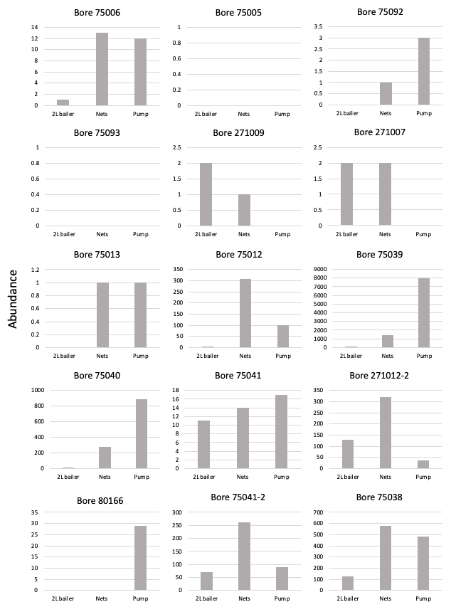
Figure 13. Total abundance of taxa found in each bore using different traditional sampling methods
Note that the scales on the y-axes differ between plots.
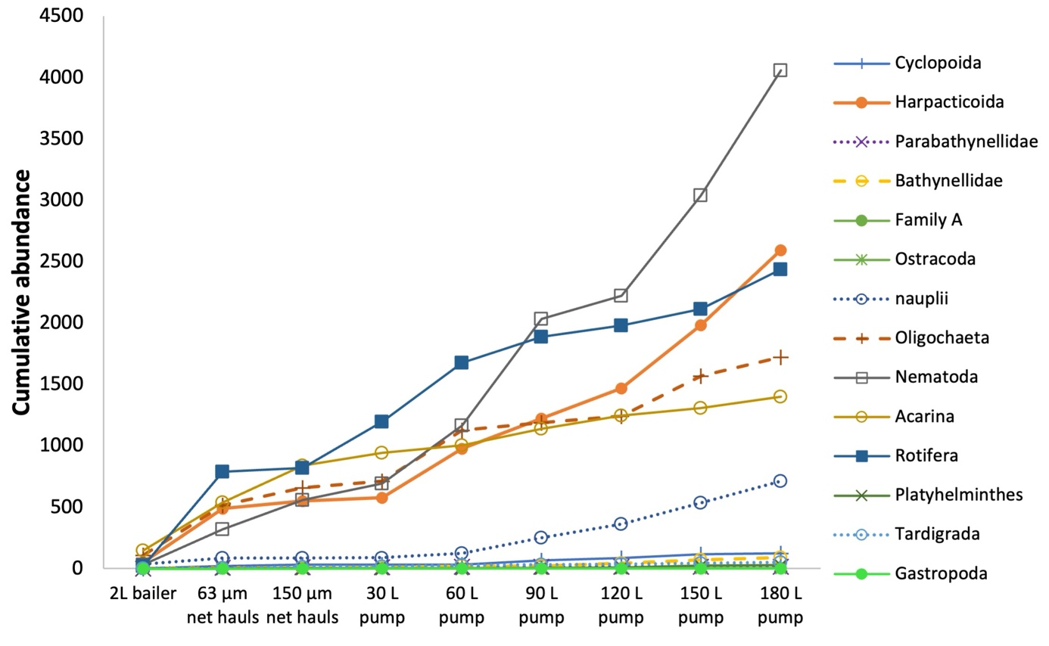
Figure 14. Cumulative abundance of individual taxa with sample volume (data combined from 15 study sites) within the study area
Note that net hauls may not reflect a consistent sampling effort between sites (see text).
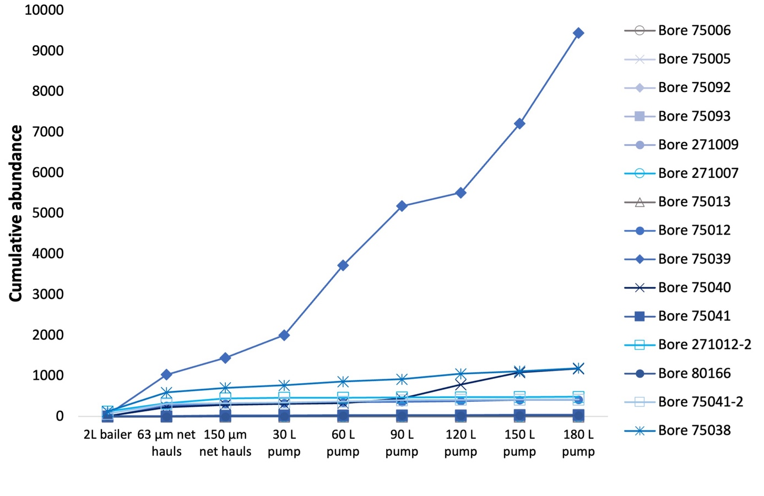
Figure 15. Cumulative sample abundance (all taxa) with sample volume in each of the 15 study sites
Note that net hauls may not reflect a consistent sampling effort between sites (see text).

3.2.4 Summary of methods for stygofaunal community analysis

Sampling for richness indicators
Table 5 summarises the community composition and abundance of stygofauna collected using different collection methods and morphological identification (all data are in Appendix 4). Richness and cumulative richness at sites, for each sampling method, are indicated in Figure 13 and Figure 14. The results from the methods are compared and discussed below.
Of the 15 study sites, taxa were collected from 13 bores, with only eight bores containing taxa considered to have definite affinity with groundwater (i.e., excluding mites and nematodes which may be found in soils). Bailing alone was the least effective method for capturing total richness and abundance and failed to capture Notobathynella (Parabathynellidae), Syncarida Family A, Ostracoda, Platyhelminthes and Tardigrada. Bailing resulted in lower estimates of total abundance of stygofauna compared to the other two methods. These results may be expected given the relatively smaller sampling effort.
Of the 13 study sites where taxa were found, bailing and netting combined resulted in a lower richness than pumping at six sites, and at two sites the richness was equal. Bailing and netting combined did not collect the full stygofauna richness of the study sites in six out of the 13 bores where taxa were found. Key crustaceans such as Harpacticoida, Cyclopoida, Copepod nauplii, Bathynellidae and Notobathynella (Parabathynellidae) were missed after bailing and netting but were subsequently captured using the pump method. Nonetheless, there were four sites where at least one stygobitic crustacean (Harpacticoida, Copepoda, Parabathynellidae, Syncarida Family A and nauplii) were not captured by pumping but were captured by bailing and/or netting. However, it is assumed that when sampling, pumping 30 L would capture all taxa that netting and bailing did in this study. Thus, for a full representation of taxa richness, it is recommended that pumping is the most efficient way to sample stygofauna.
Samples from multiple bores are recommended in order to characterise biodiversity (DSITI 2015; WA EPA 2016). Figure 16 shows the mean (±SD) cumulative taxa richness across the study area using different sampling methods. We have used a coarse level of taxonomy (including nauplii) in this analysis which likely underestimates the diversity across the region where cryptic taxa are likely to be present. The bailer sampling alone failed to collect all taxa even when samples from all sites were combined (Figure 16a). The bailer and net (63 µm + 150 µm mesh nets combined) and the purge pumping (30 L) collected all taxa (Figure 16b, c), but 15 samples were required to do so. Pumping a total of 180 L combined with pre-purge sampling indicated that the collection of 15 samples is sufficient to characterise the areas (Figure 16d). These results are not in any way prescriptive of the sampling effort required, but rather are indicative that both sampling method and number of samples will influence assessments of biodiversity within an aquifer.
The results from the sandstone aquifer are consistent with findings from the alluvial aquifer in the Stage 1 report. Both sets of results indicate that, due to the conservative approach to taxonomy and the likely presence of cryptic species, more than 15 samples are necessary to characterise aquifer diversity in the study area.
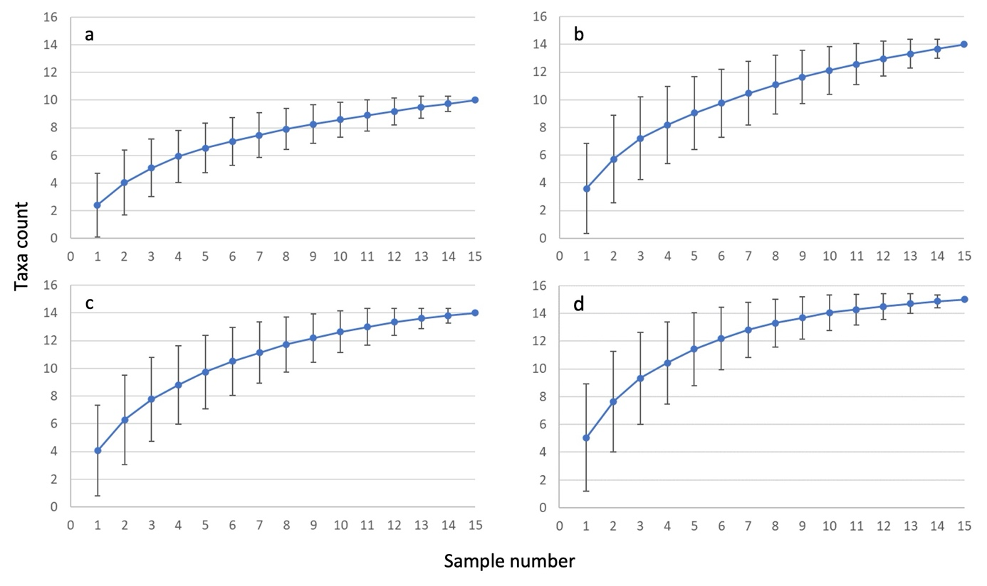
Figure 16. Mean cumulative taxa richness (±SD) with sample number in the study: a) bailer samples only; b) bailer and net (63 µm + 150 µm mesh nets) combined; c) net + bailer + purge pumping (30 L); d) net + bailer + 180 L pumping
Similar to the Stage 1 study, the combination of netting and bailing failed to capture key stygofauna taxa, with pumping proving to be the most efficient and reliable method to capture the highest diversity of stygofauna in the study sites. Importantly, the aims of the study should be considered when assessing the sampling effort required. For instance, a full biomonitoring program should include pumping the recommended 150 L to reliably estimate taxa richness. However, if the project is aiming only to identify whether stygofauna are present, netting may be sufficient for this purpose – noting that key taxa are likely to be missed (see Section 4).
As with Stage 1, we only collected stygofauna on a single occasion. Several studies have shown the importance of temporal sampling for a comprehensive assessment of groundwater biodiversity (Hancock and Boulton 2009; Eberhard et al. 2009; Hose and Lategan 2012). Just as we have shown that stygofauna diversity increases with sampling effort within a single sampling occasion, it is likely that this will extend to repeat visits to a site.
Our results indicate that for stygofauna …
Bailing underestimates taxon richness at a site, and key taxa (crustaceans) were missed using this method alone. Thus, bailing alone should not be used for determining the presence/absence of stygofauna within a site.
Netting collected more taxa than did bailing in the majority of bores.
Pumping further increased taxon richness at eight out of 13 bores (61%) that contained invertebrates, and detected crustaceans not detected by bailing or netting methods.
A minimum of 150 L should be pumped to capture total richness at close to 100% confidence.
Purging bores is necessary to accurately measure abundance and relative abundance of specific taxa.
Pumping increased estimates of total abundance of stygofauna at individual sites, and the total abundance of the majority of taxa began to plateau around 90 L.
The sampling effort required to assess diversity within an aquifer depends on sampling method and effort (number of samples). Results from this study suggest that at least 15 samples may be required to estimate aquifer diversity.
There was consistency in our findings between alluvial and fractured sandstone aquifers.

3.3 Metabarcode sampling and analysis

3.3.1 Prokaryote assemblages

Prokaryote (16S rDNA) assemblages
Nine of the 45 samples had low numbers of sequence reads and were excluded from the analysis as part of QA/QC procedures. The excluded samples included all three samples from bore 75041-1, one other pre-purge sample, and four other post-purge (180 L) samples.
A total of 151 orders of prokaryotes (after cleaning processes described in Section 2) were recorded from the sandstone aquifer samples. Of these orders, there were 44 that accounted for over 2% of the counts in at least one sample. Taxa were typical of those found in groundwaters within NSW (e.g., Korbel et al. 2017) and displayed a range of functions including nitrification, methanogenesis, sulfur oxidation and reduction, ammonia oxidation and chemoheterotrophy. There were both anaerobic and aerobic organisms found in the aquifer, as well as Archaea such as Thaumarchaeota, Methanobacteriales, Thermoprotei and Worsearchaota, which are all known to inhabit the groundwater environment.
The nMDS ordination (Figure 17) shows a separation between the 2 L (blue symbols) and 180 L (red symbols) samples, with the 30 L samples grouping in between. In some cases, samples of different volumes from the same bore were relatively similar and grouped together in the ordination (e.g., 75039, 75092) whereas samples from other bores differed markedly with volume (e.g., 75040, 75041-2). Overall, microbial communities varied significantly with sample volume (p=0.048), and pairwise tests indicated significant differences between the 2 L and 30 L samples (p=0.012). However, differences between the 2 L and 180 L and the 30 L and 180 L samples were not significant (p=0.177 and 0.385, respectively). Although permutational multivariate analysis of dispersion (PERMDISP) did not detect a significant difference in dispersion among samples between volumes (p=0.843), the apparent heterogeneity among the 180 L samples (red symbols, Figure 17) may be a cause of the lack of significant differences in the pairwise comparisons, along with the reduced number of 180 L samples for which high-quality data were available. Pairwise analysis of similarity (ANOSIM) tests, which are based on rank similarity and in which samples were grouped by sample volumes, indicated significant differences between the 2 L and 180 L samples (p=0.039), but not between the 2 L and 30 L and the 30 L and 180 L samples (p=0.211 and p=0.143, respectively).
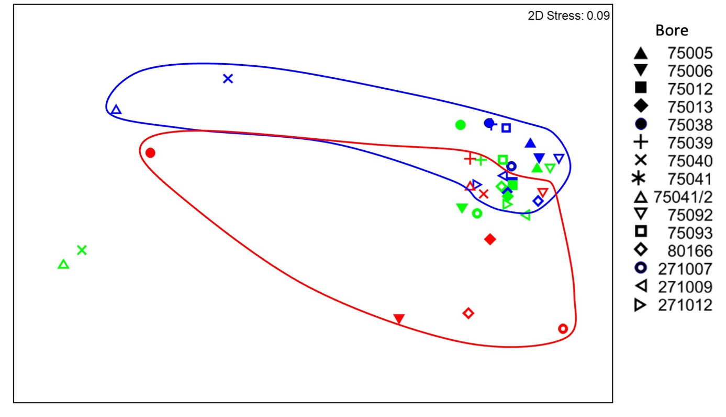
Figure 17. nMDS ordination of prokaryote assemblages characterised using 16S rDNA in groundwater samples collected at 2 L (pre-purge, blue symbols), 30 L (post purge, green symbols) and 180 L (post-purge, red symbols) extraction volumes
Coloured lines provide an outline enclosing all symbols of that colour (samples collected at the same volume).
Several studies have indicated differences in microbial communities within purged and unpurged water, attributing these differences to the ‘artificial’ bore environment (Kwon et al. 2008; Roudnew et al. 2012; Roudnew et al. 2014; Sorenson et al. 2013; Korbel et al. 2017). Consistent with the Stage 1 results (Korbel et al. 2022a), unpurged waters contain a greater variety of taxa than purged waters (Figure 18). Unpurged waters contained higher relative abundances of Springomondales (p=0.043), Mycobacteriales (p=0.000) and Micrococcales (p=0.034), as well as notable, but not statistically significantly higher, concentrations of Baccilales, Pseudonocardiales and Xanthomonadales. Additionally, Verrucomicrobiales and Bacteriovoracales were only detected in unpurged waters. Some of these taxa are known to prefer open water columns, rather than being attached to sediments (Wakelin et al. 2011).
The relative abundances of Nitrososphaerales (p=0.026), Woesearchaeota (p=0.049) and Acidobacteria_GP2 (p=0.026) were significantly higher in purged samples, and there were higher abundances of Archaea (p=0.016) in the purged waters (Figure 18). These findings are similar to those of Korbel et al. (2022a, 2017) and suggest that these taxa may be more representative of the aquifer community. Additionally, the relative abundances of Archaea may be useful as an indicator of adequately purged bores due to their well-known affinities with groundwater environments compared to surface waters (Flynn et al. 2013; Korbel et al. 2017; Korbel et al. 2022b).
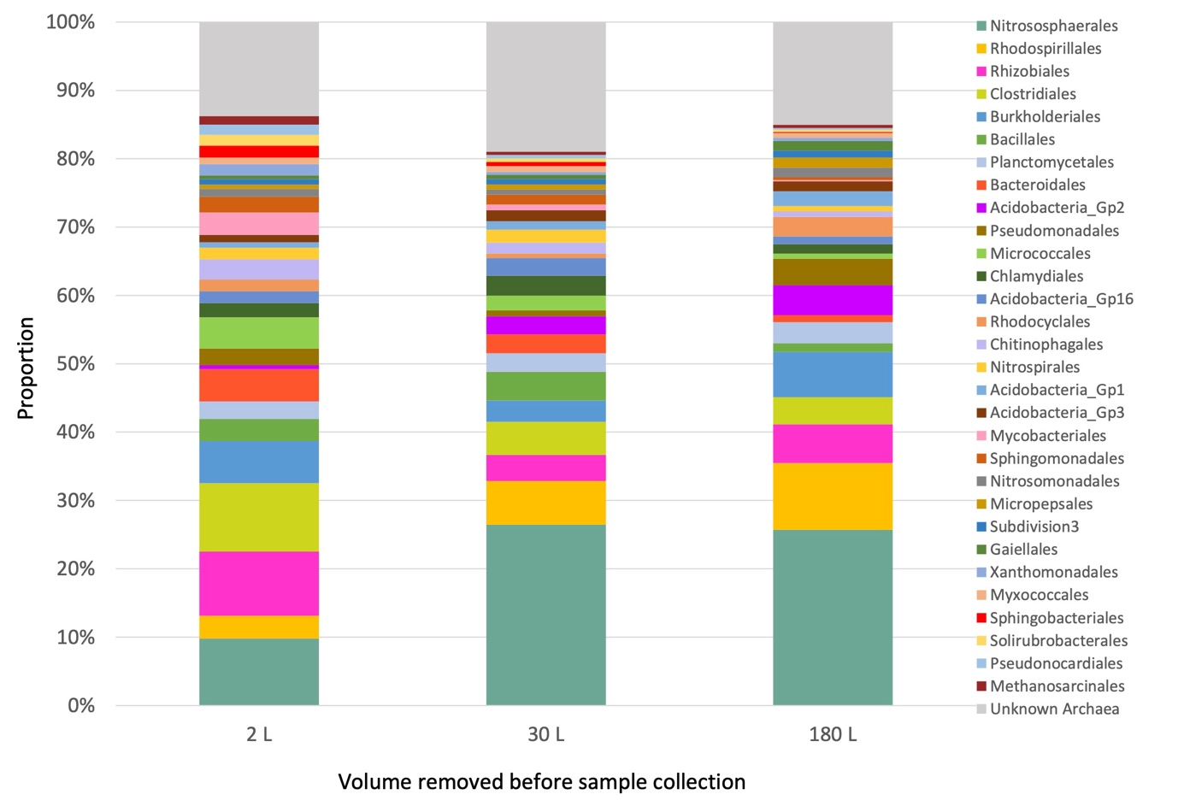
Figure 18. Microbial communities of the most abundant 30 orders identified within 16S rDNA samples collected after 2 L, 30 L and 180 L of groundwater were extracted from bores

Inferred prokaryote (16S rDNA) functional assemblages
Microbial OTUs were assigned to functions using the FAPROTAX program (Louca et al. 2016). The nMDS analysis of the functional data does not show a clear separation among samples by volume, but instead shows a large variation between sites (Figure 19). In some sites (e.g., 75038), there was relatively little difference in the functional assemblages between sample volumes, whereas samples from some other sites (e.g., 75006, 271007) had large differences in functional composition between samples. PERMANOVA indicated a significant difference in the functional assemblages between the sample volumes (p=0.025). Further pairwise tests indicated a significant difference between 2 L and 30 L samples (p=0.016), but not between other pairwise combinations (p>0.10). Pairwise ANOSIM tests indicated significant differences between the 2 L and 180 L samples (p=0.022), but not between the 2 L and 30 L and the 30 L and 180 L samples (p=0.323 and p=0.111, respectively). These results mirror those of the taxonomic analyses above.
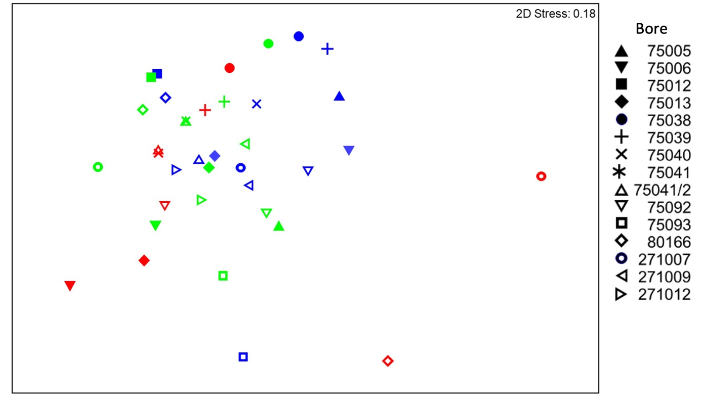
Figure 19. nMDS ordination of prokaryote functional assemblages determined using FAPROTAX based on 16S rDNA in groundwater samples collected at 2 L (blue symbols), 30 L (green symbols) and 180 L (red symbols) extraction volumes

Microbial community comparison in alluvial and fractured sandstone aquifers
There was a clear separation in microbial community structure among aquifer types (Figure 20). Samples collected from the sandstone aquifers (closed symbols) clustered toward the bottom of the ordination with little overlap with samples from the alluvial aquifer (Figure 20) of the ordination. This difference among aquifer types was significant (p=0.001). There was no clear separation between the samples from the fractured rock aquifers that were collected in the Blue Mountains and Mangrove Mountains areas. There was a clear separation between samples of different collection volumes in the alluvial aquifer, as reported in Korbel et al. (2022a), but differences among sample volumes were less evident in the samples from the fractured rock aquifers (Figure 20). Nevertheless, PERMANOVA indicated a significant difference among volumes (p=0.001), yet the aquifer type x volume interaction was not significant (p=0.149).
Functional analysis of the microbial communities showed a similar separation between samples from the different aquifers (Figure 21). As seen for the taxonomy-based analysis above, separation by sample volume was evident among the alluvial aquifer samples, but less so from among samples from the fractured rock system. Overall, there was a significant difference in functional profile between catchment types (p=0.001), and a significant difference among volumes (p=0.001), but the significant aquifer type x volume interaction (p=0.016) suggests that the nature of the differences between volumes differed in the different aquifer types. Pairwise tests indicated that all volumes differed from each other.
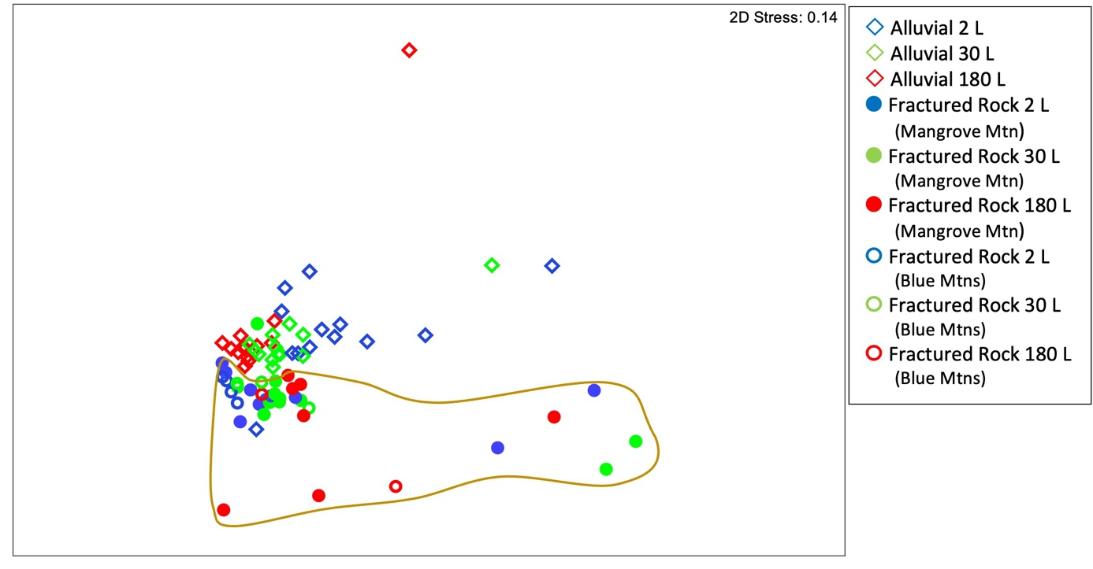
Figure 20. nMDS ordination of prokaryote assemblages characterised using 16S rDNA in groundwater samples collected at 2 L (pre-purge, blue symbols), 30 L (post-purge, green symbols) and 180 L (post-purge, red symbols) extraction volumes, within the alluvial diamond symbols) and sandstone (circle symbols) aquifers
Coloured line provides an outline enclosing all but one sample from fractured rock aquifer sites.
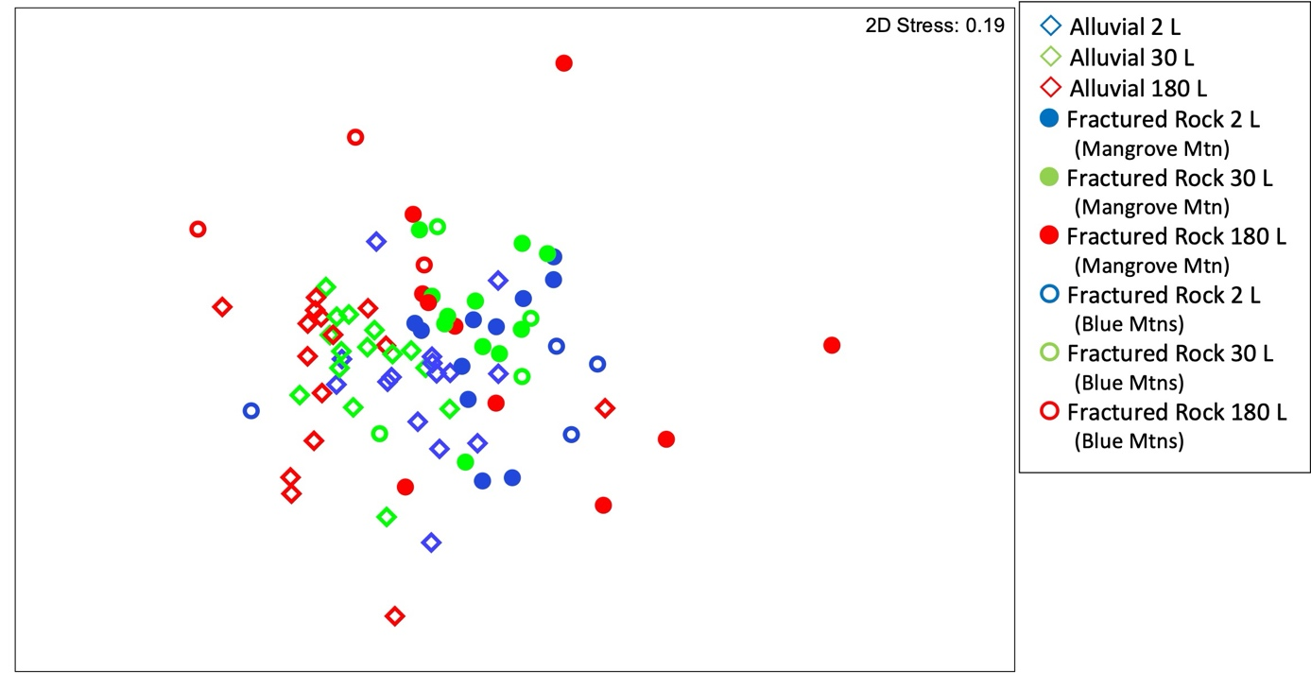
Figure 21. nMDS ordination of inferred metabolic function of prokaryote assemblages, with functional assignment using FAPROTAX based on 16S rDNA in groundwater samples collected at 2 L (pre-purge, blue symbols), 30 L (post-purge, green symbols) and 180 L (post-purge, red symbols) extraction volumes collected in alluvial (diamond symbols) and sandstone (circle symbols) aquifers
Overall, our analysis of 16S rDNA suggests that …
eDNA using 16S primers is useful for characterising microbial communities and ecosystem functions within and between aquifers.
Microbial assemblages differed markedly between bores and between aquifer types.
Samples from unpurged bores differed in composition and function from those collected in the same bore after purging.
Major rainfall events in the catchments prior to sampling are likely to have influenced the microbial communities, potentially masking the differences between purged and unpurged communities.
Purging the bore is necessary to gain a representative sample of the groundwater microbial community using ribosomal 16S primers.
Functional analysis (FAPROTAX) indicated differences in the functional composition of pre- and post-purge samples.

3.3.2 Eukaryote assemblages

18S rDNA
A total of 525 individual OTUs were detected in the sandstone aquifers of the region, representing 186 orders once data had been processed as described in the methods (Section 2). The detection of eukaryote DNA within samples was dependent on when the sample was taken from the bore. Samples that were extracted from the bore water (i.e., collected using the bailer) were more likely to amplify successfully than samples taken after 150 L of water had been purged from the bore. Only one sample from the pre-purge samples had a low number of sequence reads and was excluded from analysis. Of the samples taken after 150 L was pumped, 10 out of 15 had sufficient sequence reads to include in analysis. Presumably this is due to the higher density of biota living within the bore environment and hence greater concentration of DNA present in those samples.
The majority of taxa detected were Fungi (Figure 22). 18S rDNA also detected Cyclopoida, Ostracoda and Harpacticoida, and unidentified syncarids in a number of samples, which are all likely to be stygobitic taxa. Other common groundwater taxa present included Rotifera, Acarina, Nematoda and Oligochaeta. There was a notable absence of syncarids (found in morphological samples) detected using the 18S sequencing, which may be due to limited sequences in reference databases or low amounts of DNA of these taxa in the environment. However, smaller and more cryptic taxa such as Platyhelminthes and Tardigrada were identified in more bores using 18S sequencing than in traditional identification methods, as were Gastropoda.
The nMDS ordination (Figure 23) does not show a clear separation of samples with collection volume. However, there was a significant difference in eukaryote communities between sample volumes (p=0.001), and all pairwise comparisons of communities by pump volumes were significantly different (all p<0.031). These results are consistent with results in the Stage 1 report (Korbel et al. 2022a) and indicate that the communities within purged waters are different to those in the unpurged bore water.
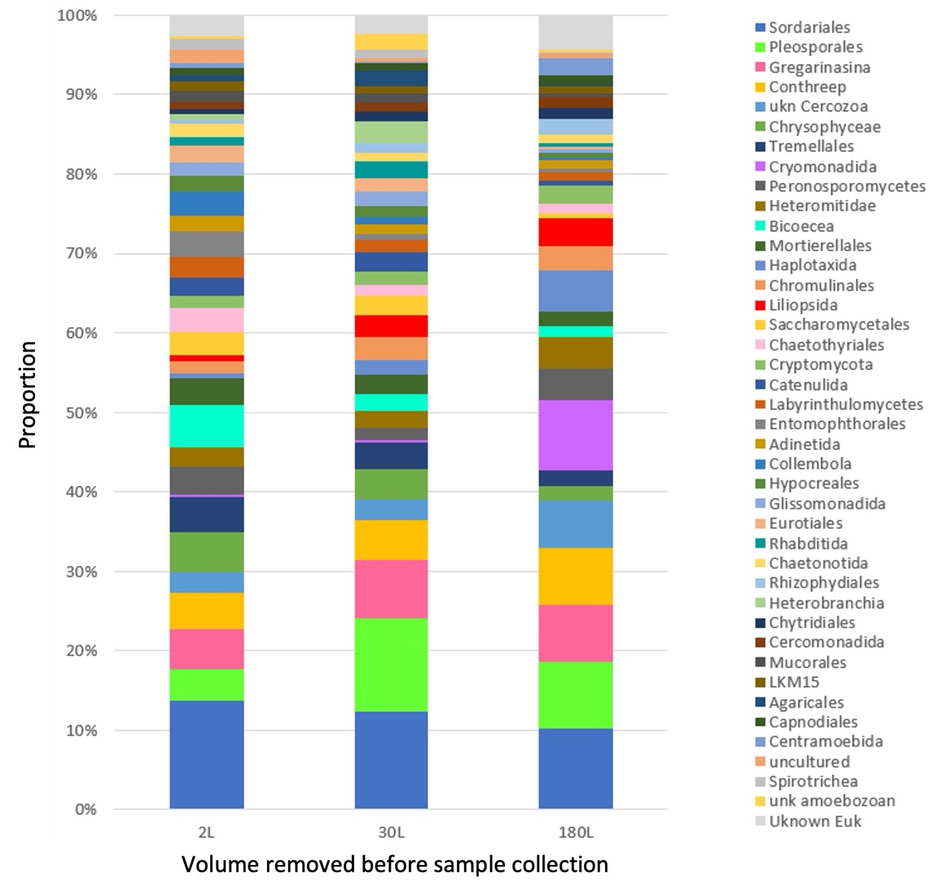
Figure 22. Eukaryotic communities of the most abundant 30 orders identified within 18S rDNA samples collected after 2 L, 30 L and 180 L of groundwater were extracted from bores
Note: using eDNA for relative abundance of eukaryotes should be treated with caution (see Saccò et al. 2022b).
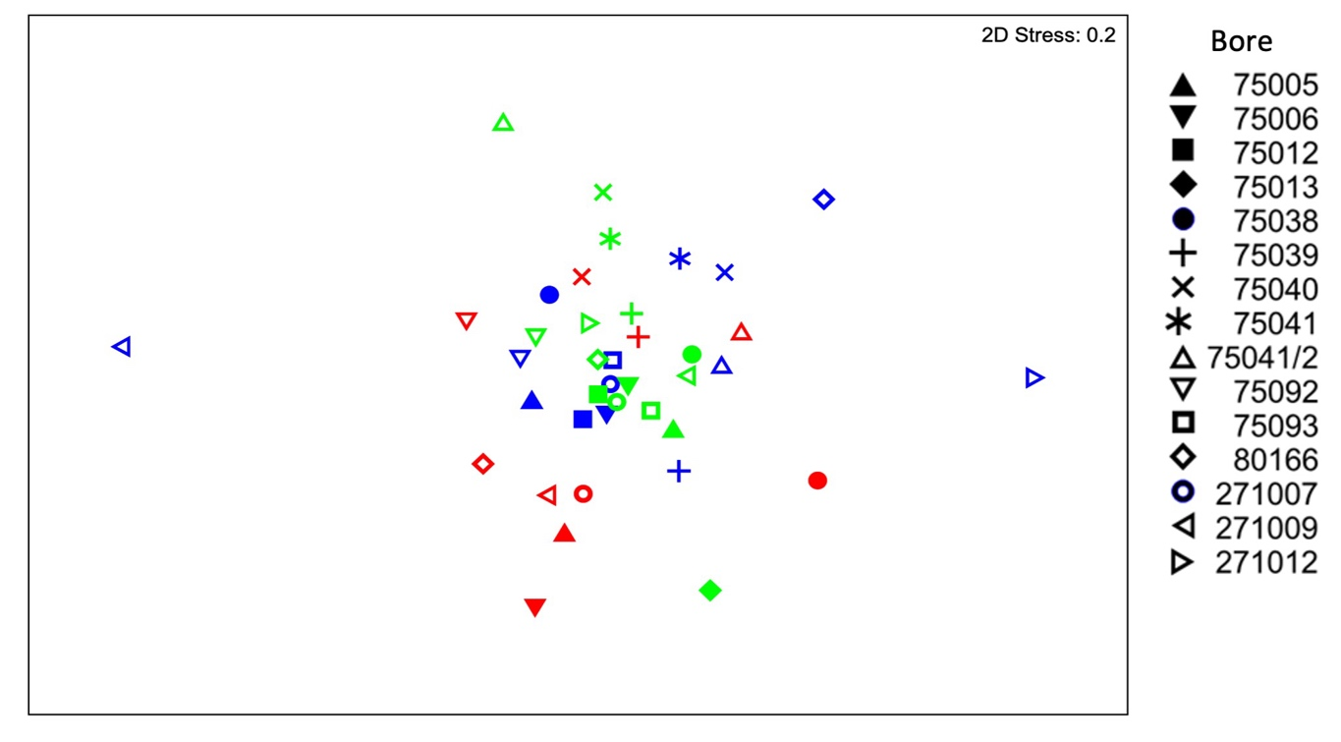
Figure 23. nMDS ordination of eukaryote assemblages characterised using 18S rDNA (All18SF/R primers) in groundwater samples collected at 2 L (pre-purge, blue symbols), 30 L (post-purge, green symbols) and 180 L (post-purge, red symbols) extraction volumes
Sequence read number was Hellinger-transformed prior to analysis.
As for the quantitative analysis of the 18S rDNA data (Figure 23), the nMDS ordination of presence/absence-transformed data also did not show clear separation among samples in terms of sample volume (Figure 24). Despite this, the PERMANOVA analysis revealed significant differences among sample volumes (p=0.017). Pairwise analysis indicated significant differences between the 30 L and 180 L samples (p=0.031), but not between other pairwise combinations (p>0.100). The lack of difference among the pre- and post-purge samples may reflect the overall heterogeneity among bores and may have been influenced by heavy rain in the months prior to sampling.
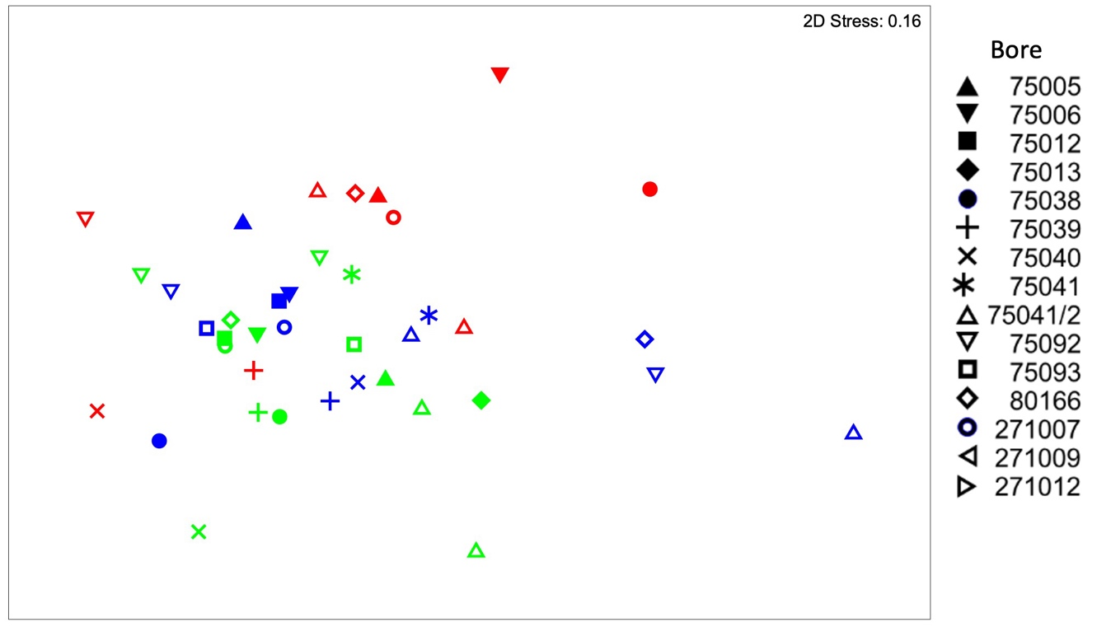
Figure 24. nMDS ordination of eukaryote assemblages characterised using 18S rDNA (All18SF/R primers) in groundwater samples after removing 2 L (pre-purge, blue symbols), 30 L (post-purge, green symbols) and 180 L (post-purge, red symbols) extraction volumes
Sequence read number was presence/absence-transformed prior to analysis.

Eukaryote community comparison in alluvial and fractured sandstone aquifers
When comparing the alluvial aquifer (Stage 1) to the sandstone aquifer eDNA samples, a clear separation in eukaryote community structure was evident in both the Hellinger-transformed relative abundance data (Figure 25), and the presence/absence-transformed data (Figure 26). In Figure 25, samples collected from the sandstone aquifers (closed symbols) cluster towards the right of the ordinations, with little overlap with samples from the alluvial aquifer. In Figure 26, samples from the sandstone aquifers (closed symbols) cluster towards the lower right of the ordinations and appear to have greater spread (indicating greater variability in composition among samples) than do the samples from the alluvial aquifer. Within each aquifer, there was separation evident among the sample collection volumes, most notably in the alluvial aquifer samples. In both the Hellinger- and presence/absence-transformed data, there were significant differences between aquifer types (p=0.001) and sample volumes (p=0.001), and the interaction between volume and aquifer type was also significant (p≤0.009). Pairwise comparisons of volumes indicated that all volumes differed significantly (p=0.001) in terms of composition from all others, except for the presence/absence-transformed data, in which 2 L samples were not significantly different from 30 L samples (p=0.101).
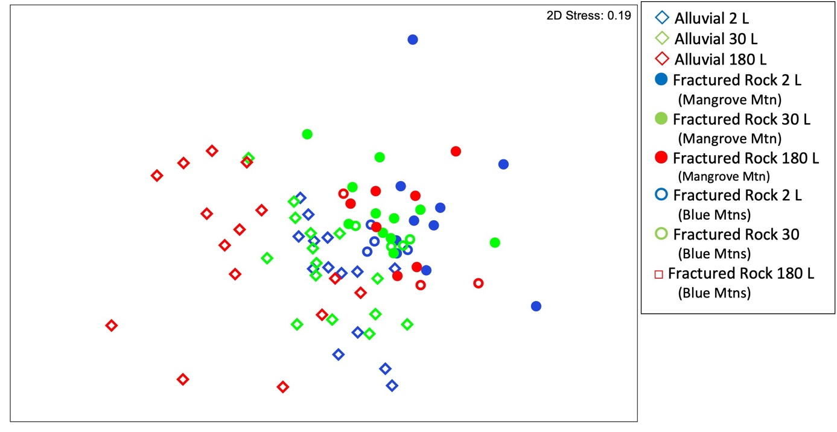
Figure 25. nMDS ordination of eukaryote assemblages characterised using 18S rDNA (All18SF/R primers) in groundwater samples collected at 2 L (pre-purge, blue symbols), 30 L (post-purge, green symbols) and 180 L (post-purge, red symbols) extraction volumes, in alluvial (diamond) and sandstone (circle) aquifers – Hellinger-transformed data
Sequence read number was Hellinger-transformed prior to analysis.
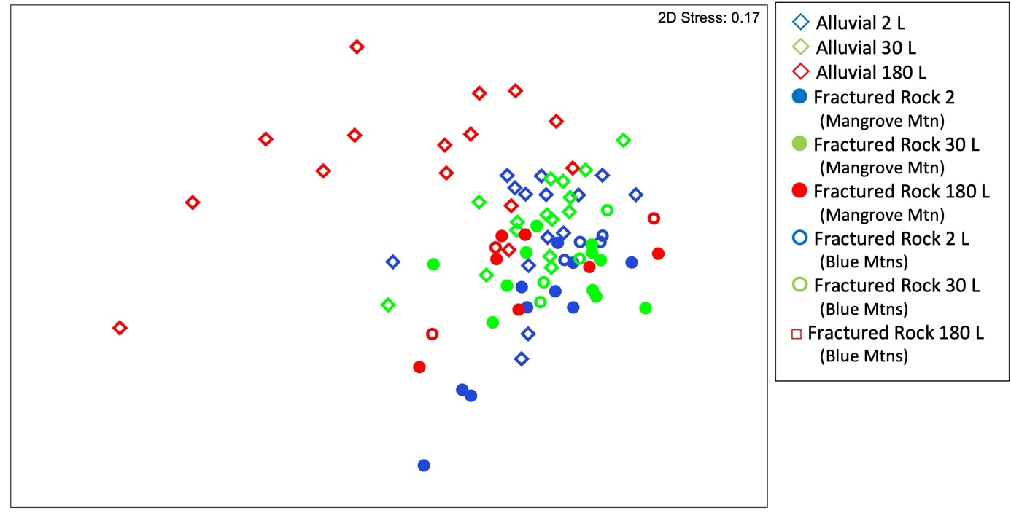
Figure 26. nMDS ordination of eukaryote assemblages characterised using 18S rDNA (All18SF/R primers) in groundwater samples collected at 2 L (pre-purge, blue symbols), 30 L (post-purge, green symbols) and 180 L (post-purge, red symbols) extraction volumes, in alluvial (diamond) and sandstone (circle) aquifers – presence/absence-transformed data
Sequence read number was presence/absence-transformed prior to analysis.
Several studies have indicated that geological structure is important for biotic communities (Korbel et al. 2019; Hose et al. 2017). Geological structure of the aquifer matrix influences the habitat space, which determines the size of the biota able to inhabit the aquifer (Korbel et al. 2019). It also affects the transmissivity of water within the aquifer, with water flow influencing the concentration of oxygen and nutrients within the groundwater, thus influencing the distribution of biota. This study confirms that stygofauna and groundwater meiofauna community structure differ between aquifer types as seen elsewhere (Hahn and Fuchs 2009; Stein et al. 2012; Johns et al. 2015).

16S mtDNA – Crustacea
Optimisation of the 16S mtDNA primer was conducted on DNA extracted from individual specimens of Bathynellidae, Amphipoda and Cyclopoida. This was conducted as the Stage 1 results indicated a low success rate for identification of crustaceans within the eDNA samples collected from alluvial aquifers, despite the traditional identification methods indicating abundant crustaceans within some samples. Changes to annealing temperatures and times of PCR cycles were tested using DNA from individual taxa as well as eDNA from sites where stygofauna were identified using traditional methods. These steps result in an increased quantity of DNA within the PCR products, which should allow increased detection of crustaceans within our samples, if they are indeed present.
As with the Stage 1 report, 16S mtDNA crustacea primer identified several terrestrial arthropod taxa. However, the primer was unsuccessful at identifying any taxa that could reliably be classified as stygofaunal Crustacea. There were several unidentified OTUs that may be related to taxa including syncarids, ostracods or copepods. However, without more reliable sequence information, this is speculative.
To better improve the detection of stygobitic crustacea within eDNA samples (using both 18s rDNA and 16S mtDNA), a number of areas need further research. These (discussed in Section 3.4) are related to the ability of eDNA to detect Crustacea, as well as the poor sequence reference databases that currently exist for stygofauna worldwide (Saccò et al. 2022b).

Sampling to indicate groundwater ‘health’ and condition
The relative abundance of crustaceans and oligochaetes within samples can be used to indicate the ‘health’ of groundwater. These indicators often rely on an accurate record of both total abundance and individual species abundance. It has been suggested that ‘healthy’ groundwaters contain abundances of crustaceans of over 50% and oligochaetes of less than 10% (e.g., Sket 1999; Hancock and Boulton 2009; Malard et al. 1996; Korbel and Hose 2011; Korbel et al. 2016; Moldovan et al. 2001; Lafont et al. 1996). Our sampling indicated that relative abundances of these key taxa differ between sampling methods in the sandstone aquifers sampled (Table 6).
The results of Stage 2 sampling in sandstone aquifers were consistent with those of the alluvial aquifer samples in Stage 1. Combined, these results indicate that relative abundances of crustaceans and oligochaetes are influenced by both sampling technique and purging. This indicates that bailer and net sampling are not appropriate methods for this indicator (Table 6) as reliable estimates of relative abundances cannot be made without purging.
For eDNA methods, additional pumping after purging did not alter results for relative abundance (see Section 3.4). However, using eDNA for relative abundances is not a recommended, due to differences in how and how much different taxa shed eDNA, as well as known issues with PCR bias (see Saccò et al. 2022b).
Table 6. Relative abundance of Crustacea and Oligochaeta in bailer, net and pump samples
Site | Relative abundance | Traditional method  2 L bailer | Traditional method  Nets | Traditional method  Nets + bailer | Pumping  Up to 30 L (pre-purge) | Pumping  90 L post-purge | Pumping  180 L post-purge | eDNA (18S rDNA)  2 L  (pre- purge) | eDNA (18S rDNA)  30 L  (pre- purge) | eDNA (18S rDNA)  180 L (post-purge)
75006 | Crustacea | 0 | 8 | 7 | 13 | 50 | 50 | 0.36 | 1.15 | 0.00
 | Oligochaeta | 100 | 31 | 36 | 33 | 0 | 0 | 0.00 | 0.00 | 0.00
75005 | Crustacea | 0 | 0 | 0 | 0 | 0 | 0 | 0.06 | 1.77 | 0.00
 | Oligochaeta | 0 | 0 | 0 | 0 | 0 | 0 | 0.00 | 0.00 | 0.00
75092 | Crustacea | 0 | 0 | 0 | 0 | 0 | 0 | 0.62 | 0.00 | 0.00
 | Oligochaeta | 0 | 100 | 100 | 100 | 100 | 0 | 0.00 | 0.00 | 0.00
75093 | Crustacea | 0 | 0 | 0 | 0 | 0 | 0 | 1.64 | 2.86 | -
 | Oligochaeta | 0 | 0 | 0 | 0 | 0 | 0 | 0.21 | 0.00 | -
271009 | Crustacea | 0 | 0 | 0 | 0 | 0 | 0 | 0.00 | 6.43 | 0.00
 | Oligochaeta | 0 | 0 | 0 | 0 | 0 | 0 | 0.00 | 0.00 | 0.00
271007 | Crustacea | 0 | 0 | 0 | 0 | 0 | 0 | 0.29 | 1.32 | 0.00
 | Oligochaeta | 0 | 0 | 0 | 0 | 0 | 0 | 0.00 | 0.00 | 0.00
75013 | Crustacea | 0 | 0 | 0 | 0 | 0 | 0 | - | 1.03 | -
 | Oligochaeta | 0 | 0 | 0 | 0 | 0 | 0 | - | 0.00 | -
75012 | Crustacea | 60 | 95 | 94 | 93 | 83 | 67 | 8.94 | 1.28 | -
 | Oligochaeta | 0 | 0 | 0 | 0 | 0 | 0 | 0.00 | 0.00 | -
75039 | Crustacea | 0 | 0 | 0 | 0 | 19 | 28 | 0.00 | 0.57 | 0.00
 | Oligochaeta | 7 | 3 | 3 | 3 | 2 | 17 | 0.00 | 0.00 | 0.00
75040 | Crustacea | 0 | 41 | 40 | 41 | 87 | 71 | 0.00 | 4.77 | 0.00
 | Oligochaeta | 0 | 7 | 7 | 6 | 1 | 1 | 0.00 | 0.00 | 0.00
75041 | Crustacea | 73 | 36 | 52 | 45 | 0 | 0 | 0.11 | 0.03 | -
 | Oligochaeta | 0 | 0 | 0 | 0 | 0 | 0 | 0.00 | 0.00 | -
271012 | Crustacea | 24 | 0 | 7 | 7 | 0 | 0 | 0.00 | 0.00 | -
 | Oligochaeta | 0 | 0 | 0 | 0 | 0 | 0 | 0.00 | 0.00 | -
80166 | Crustacea | 0 | 0 | 0 | 0 | 0 | 0 | 0.00 | 0.81 | 0.00
 | Oligochaeta | 0 | 0 | 0 | 50 | 25 | 50 | 0.00 | 0.10 | 0.00
75041-2 | Crustacea | 67 | 72 | 71 | 70 | 69 | 86 | 9.31 | 0.00 | 0.09
 | Oligochaeta | 6 | 4 | 4 | 4 | 8 | 14 | 0.00 | 0.00 | 0.00
75038 | Crustacea | 0 | 0 | 0 | 0 | 5 | 43 | 0.00 | 0.09 | 0.00
 | Oligochaeta | 79 | 81 | 80 | 79 | 35 | 38 | 0.00 | 0.00 | 0.00
Values for bailer, net and pumping methods reflect the total number of individuals of that taxon as a proportion (%) of the total organisms collected by that method in that bore. Values for eDNA reflect the total number of sequence reads for that taxon as a proportion (%) of the total number of sequence reads for 18S rDNA from that sample in that bore. Dash (-) indicates sample not analysed for eDNA following QA/QC.
Overall, our analysis of 18S rDNA suggests that …
Samples from unpurged bores do not represent the eukaryote communities in the aquifer, compared with samples collected after purging.
Similarities in the composition of 2 L and 30 L samples, and differences in the composition of samples collected after 30 L and 180 L had been pumped, suggest that the larger purge volume is necessary.
Crustaceans are poorly represented in eDNA samples compared to traditional taxonomic identification methods.
Further work on the issues surrounding detection of crustaceans within water samples needs to be conducted, including improving the reference library by sequencing individual samples of taxa as references.
Overall, our analysis of 16S mtDNA suggests that …
Further work is needed to establish a 16S mtDNA reference database for Australian stygofauna, along with work to improve the sensitivity of the analysis to detect the low abundance of crustaceans in groundwater.

3.3.3 Use of preservatives for eDNA samples
One of the additional aims of this study was to indicate whether preservatives could be added to eDNA to increase the time between sampling and processing water. To achieve this, samples were collected and preserved by adding 400 mL of dimethyl sulfoxide-ethylenediaminetetraacetic acid‑sodium chloride (DESS). These samples were then processed on set days after collection, with the maximum time in storage being nine days.
The five-day sample from bore 75012-1 returned only 1,227 sequence reads for 16S rDNA and was discarded as part of the QA/QC process. The microbial communities did not vary significantly between preservation times, including unpreserved samples (p=0.061). In four of the five sample bores, all preserved samples grouped closely together in the ordination (Figure 27). Samples from bore 75012-1 were relatively heterogenous in their composition relative to those from other bores, evidenced by the spatial spread of samples in the ordination (Figure 27). The unpreserved samples from bore 75038-2 appeared different and hence separated from the preserved samples from that site. However, overall, there is no evidence to suggest a systematic shift in the composition of the microbial community with preservation or with the time for which those samples are stored prior to analysis, up to nine days. Importantly, as the ordination suggests, the variation among bores is generally greater than the variation among the unpreserved and preserved samples over time. The utility of DESS as a preservative for groundwater samples is consistent with its successful use by Oberprieler et al. (2021) to preserve samples for stygofauna DNA analysis, and numerous studies in other environments that suggest samples may be preserved in DESS for several weeks (e.g., Gray et al. 2013; Lee et al. 2019; Pavlovska et al. 2021).
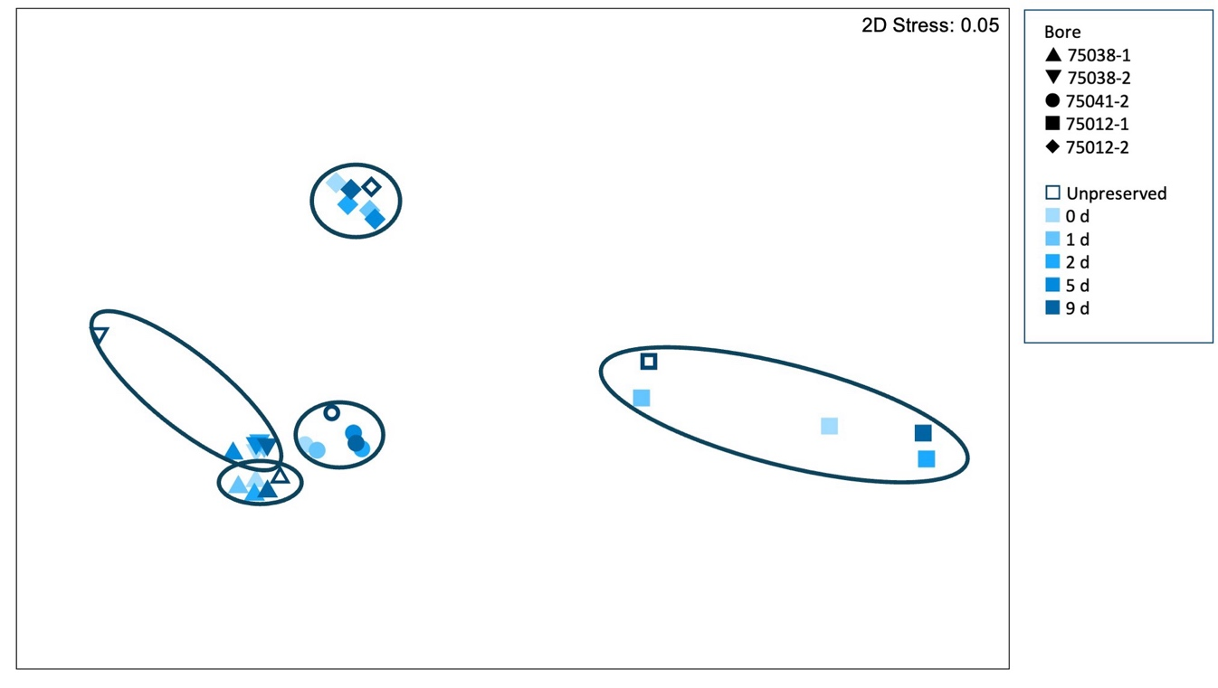
Figure 27. nMDS ordination of prokaryotic assemblages in groundwater samples, with and without preservative
Day of DNA filtering indicated by shade of blue (0–9). Ellipses group samples from the same bore.
Similarly, the eukaryote communities (Hellinger-transformed data) did not vary significantly between preservation times, including unpreserved samples (p=0.094). Importantly, as the ordination suggests, the variation among bores is generally greater than the variation among the unpreserved and preserved samples over time (Figure 28).
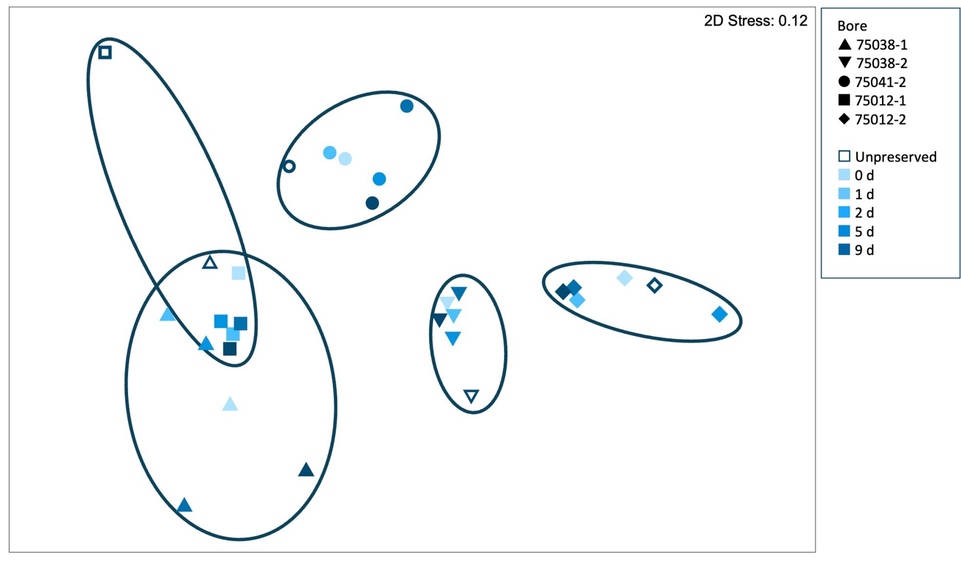
Figure 28. nMDS ordination of eukaryotic assemblages in groundwater samples, with and without preservative
Day of DNA filtering indicated by shade of blue (0–9). Ellipses group samples from the same bore. Sequence read number was Hellinger-transformed prior to analysis.
When eukaryote assemblage data were presence/absence-transformed, the communities did not vary significantly between preservation times, including unpreserved samples (p=0.357). As for the Hellinger-transformed relative abundance data, the variation among bores was significant (p=0.001) and was generally greater than the variation among the unpreserved and preserved samples over time (Figure 29).
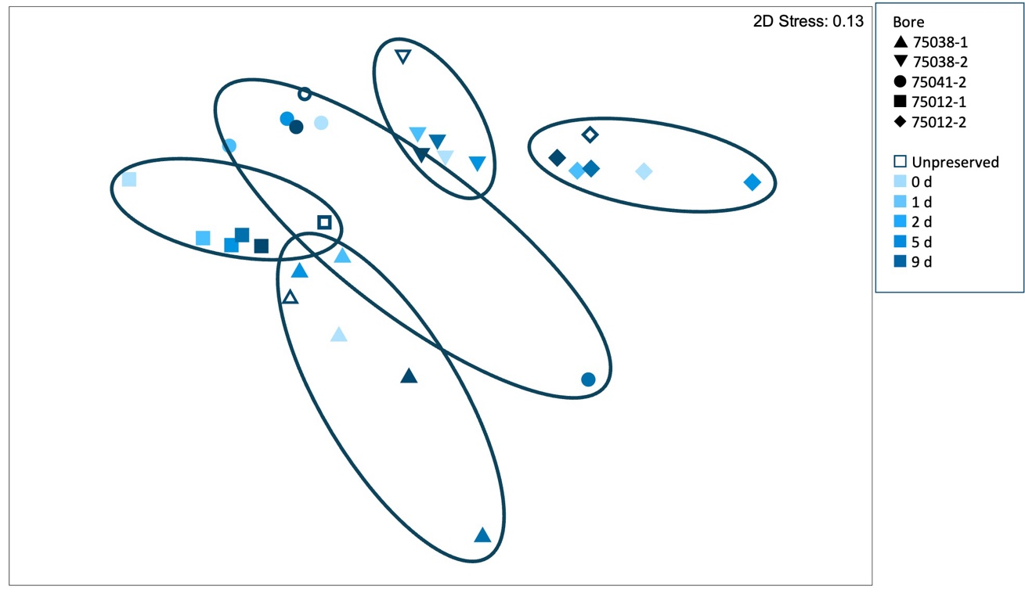
Figure 29. nMDS ordination of eukaryotic assemblages in groundwater samples, with and without preservative
Day of DNA filtering indicated by shade of blue (0–9). Ellipses group samples from the same bore. Sequence read number was presence/absence-transformed prior to analysis.
Overall, our analysis of preservative indicates that …
The addition of DESS immediately upon collection of a sample will preserve the sample and prolong the time between eDNA sampling and processing by up to nine days without impacting the prokaryote and eukaryote community structures.
This preservation of groundwater samples using DESS is a viable approach to overcome logistical challenges of eDNA sampling in remote areas or where logistics limit timely sample processing.

3.4 Comparison of metabarcoding with whole-organism methods for stygofauna
Traditionally, methods of identifying stygofauna within samples included staining, sorting and identification of individual specimens based on morphological keys. The taxonomic keys for stygofauna are deficient as many new species have yet to be fully identified by qualified taxonomists. As a result, many scientists are turning to eDNA to uncover the true diversity of stygofauna.
As indicated in the Stage 1 report, there are issues in solely relying on eDNA for the identification of stygofauna (Korbel et al. 2022a). Data from this study confirm these issues: the 18S rDNA gene performed poorly in detecting Crustacea that were identified in whole-organism samples from the same bores (Table 7). The 18S rDNA gene did well in detecting some copepods and other non-crustacean stygofauna, often detecting them in bores where traditional methods did not (Table 7).
The reasons for not detecting some Crustacea using eDNA when they were found in corresponding whole-organism samples (i.e., bailer, net and pump) are unknown. Difficulties detecting Crustacea using eDNA have been noted in other environments (West et al. 2020; Forsström and Vasemägi 2016), particularly in aquatic samples (e.g., West et al. 2020; Troth et al. 2021). Numerous studies on eDNA have shown that Crustacea release the majority of their DNA through episodic moulting (i.e., in limited periods throughout their life cycle) (Deiner and Altermatt 2014) and shed relatively less eDNA than other taxa (Andruszkiewicz Allan et al. 2021), making their detection using eDNA challenging. Additional evidence indicates that shed exoskeletons sink to the bottom of the medium that they are in (Andruszkiewicz Allan et al. 2021); thus pumping may extract the animals from the aquifer but not the exoskeletons, adding another complexity to detecting these important groundwater taxa. Alternatively, due to their very low total abundances in aquifers, small size and low metabolic rates, it is possible that groundwater crustaceans do not shed enough DNA to be detected in groundwater samples using current methods. This is of particular concern for groundwater ecosystems as Crustacea are often relatively abundant in aquifers. Further research into the detection and fate of crustacean DNA within aquifers is required before eDNA should be considered as a sole method for biological surveying.
Another issue with using eDNA for biological sampling in groundwater is the bioinformatic processing. A key process in analysing sequence data is the steps undertaken to ‘clean’ the dataset to account for inconsistencies due to tag jumping and potential contamination. Where species are rare, such as in groundwater, ‘cleaning’ poses a number of problems. The Stage 1 report (Korbel et al. 2022a) included QA procedures based on the read numbers of contaminants in the negative and positive controls, adopting a threshold of 200 reads. However, there is potential that this cleaning process may have removed rare stygofauna taxa found in low counts. Sequence data presented in the current report indicated a number of stygofauna present at low counts. Thus, two different QA procedures were investigated: one based on sequence reads of the controls (again around 200 reads) and an additional analysis including all reads. This second analysis may be contaminated by tag jumping in the sequencing process, but it did identify greater numbers of stygofauna within the bores as seen in the last column of Table 7. Issues with rare taxa (indicated by low sequence counts) within eDNA need to be investigated due to the typically low abundance of stygofauna in the environment; thus it is reasonable to expect low read numbers when sequenced. A review of the threshold value or an option for inclusion of known rare taxa should be considered, and these could be explored in future bioinformatics refinements.
Finally, eDNA sequencing is currently limited by the relatively small number of sequences for stygofauna present in reference databases. Several OTUs within our dataset were unidentified past phylum. Thus, there may be sequences corresponding to stygofauna that have not yet been recorded in DNA reference databases. This is simply because the sequence reference database of Australian stygofauna (in particular) is lacking. Thus, the collection and sequencing of individual species is required to build the reference database of Australian groundwater invertebrates to allow reliable use of eDNA for the detection of species (see Saccò et al. 2022b).
Table 7. Summary of stygofauna collection using net, bailer, pump and metabarcoding methods
Taxon | Net and bailer  No. bores in which taxon was recorded | Pump  (incl. net + bailer)  No. bores in which taxon was recorded | 18S rDNA  No. bores in which taxon was recorded  (>0 reads) | Taxon  No. bores in which taxon was recorded  (>200 reads)
Cyclopoida | 2 | 3 | 8 | 4
Harpacticoida | 5 | 7 | 12 | 3
Parabathynellidae | 2 | 3 | 1 (unknown Eumalacostraca) | 0
Bathynellidae | 1 | 3 | 1 (unknown Eumalacostraca) | 0
Syncarida Family A | 1 | 1 | 1 (unknown Eumalacostraca) | 0
Ostracoda | 1 | 1 | 0 | 0
Oligochaeta | 6 | 7 | 14 | 8
Nematoda | 8 | 11 | 14 | 9
Acarina | 10 | 11 | 11 | 6
Rotifera | 8 | 9 | 12 | 6
Platyhelminthes | 0 | 4 | 14 | 4
Tardigrada | 2 | 4 | 1 | 0
Gastropoda | 1 | 2 | 18 | 5

Overall, our analysis of detection methods for stygofauna indicated that …
It is important that studies aiming to reliably characterise or detect stygofauna communities do not rely solely on metagenomic methods but use a combination of metagenomics and whole-organism analysis.
Further investigations into the use of eDNA for detecting groundwater Crustacea are required, including studies of the fate and longevity of eDNA and its reliability for detecting Crustacea, especially in low abundances.
Sequencing of individual specimens is required to further build sequence reference libraries for stygofauna and allow more robust identification using DNA methods.

3.5 Associations of groundwater biota with water chemistry and site attributes

3.5.1 Stygofauna
Individually, habitat variables best explained the variation in stygofauna assemblages (marginal test, Table 8). Sediment volume, sulfate concentrations and the presence of trees and organic sediments were the variables that together best explained the variation in stygofauna assemblages (sequential test, Table 8). Organic sediments were only present at bore 75039, and so may be a correlate for other conditions unique to that location. The importance of sediment variables and the presence of trees in influencing stygofauna assemblages is well established (e.g., Mösslacher 1998; Korbel and Hose 2015; Korbel et al. 2019; Korbel et al. 2022a). Tree roots provide an important source of carbon in otherwise carbon-limited groundwater environments, and the presence of trees has been correlated with greater stygofauna richness and abundance (Korbel and Hose 2015).
Nitrate and ammonia concentrations were, by themselves, also significantly correlated with stygofauna assemblage composition (marginal test, Table 8), which may reflect agricultural impacts from the overlying land use. Stygofauna have been detected more frequently in mildly nitrogen-enriched sites associated with agriculture (Korbel et al. 2013a). Sodium concentrations were also correlated with stygofauna community structure, which was correlated with electrical conductivity (salinity) (r=0.88), an important determinant of groundwater assemblages (Shapouri et al. 2015; Nelson et al. in review), although EC concentrations were all relatively low (<380 µS/cm) and not in the range likely to limit the presence of stygofauna (Castaño-Sánchez et al. 2020a; Castaño-Sánchez et al. 2020b).
Table 8. Proportion of variation (r²) in stygofauna community structure explained by individual environmental variables
Variable | Marginal test  r2 | Marginal test  p | Sequential test  r² | Sequential test  Cumulative r² | Sequential test  p
Sediment volume | 0.157 | 0.001 | 0.157 | 0.157 | 0.003
Trees within 250 m | 0.062 | 0.105 | 0.120 | 0.277 | 0.003
Organic sediments | 0.105 | 0.004 | 0.105 | 0.382 | 0.002
Sulfate (SO₄) (mg/L) | 0.104 | 0.020 | 0.079 | 0.461 | 0.009
Nitrate (mg/L) | 0.152 | 0.001
Ammonia (mg/L) | 0.110 | 0.005
Na⁺ (µg/L) | 0.099 | 0.015
Total Kjeldahl nitrogen (mg/L) | 0.075 | 0.069
Electrical conductivity (µS/cm) | 0.071 | 0.069
Nitrite (mg/L) | 0.071 | 0.079
Dissolved organic carbon (mg/L) | 0.067 | 0.098
Dissolved oxygen (mg/L) | 0.061 | 0.118
pH | 0.057 | 0.163
Ferrous iron (mg/L) | 0.047 | 0.205
Total nitrogen (mg/L) | 0.047 | 0.221
Reactive phosphorus (mg/L) | 0.044 | 0.238
Ca²⁺ (µg/L) | 0.041 | 0.299
Total phosphorus (mg/L) | 0.039 | 0.307
Water level (m) | 0.036 | 0.325
K⁺ (µg/L) | 0.036 | 0.360
Mg²⁺ (µg/L) | 0.035 | 0.379
Medium sands | 0.018 | 0.752
Mean slot depth (m) | 0.018 | 0.759
Oxidation-reduction potential | 0.016 | 0.809
Fine sands | 0.015 | 0.847
Values in bold were significant (p<0.05).

3.5.2 Molecular methods

16S rDNA
Of the environmental variables tested, it was nutrient concentrations (nitrate, ammonia and sulfate) that were significantly correlated with microbial community structure (Table 9). In the stepwise model, only nitrate concentrations were significant; the addition of pH and further variables did not significantly increase the variation explained by the model. These findings are consistent with those from Stage 1 of this project, in which microbial assemblages in alluvial aquifers were most strongly correlated with nitrogen concentrations (TKN) and pH (Korbel et al. 2022c). These findings are also consistent with the findings of previous studies in which microbial assemblages responded more strongly to water quality than to physical habitat characteristics such as sediment type (Korbel and Hose 2015).
Nitrogen concentrations in groundwater are a key determinant of the groundwater microbial assemblages (Korbel et al. 2022c), and sulfate concentrations are also critical for some microbial taxa (Flynn et al. 2013; Abo and Abo-Alkasem 2022). Phosphorus concentrations were also weakly, but not significantly (p=0.059), correlated with microbial assemblage structure (Table 9). Overall, all variables were only weakly correlated with the 16S rDNA assemblages (r²=0.00–0.11), and the rank order of variables in terms of the correlations with biota could change with only small changes in the assemblages.
Table 9. Proportion of variation (r²) in prokaryote community structure based on 16S rDNA explained by individual environmental variables
Variable | Marginal test  r² | Marginal test  p | Sequential test  r² | Sequential test  Cumulative r² | Sequential test  p
Nitrate (mg/L) | 0.119 | 0.015 | 0.1186 | 0.119 | 0.011
Ammonia (mg/L) | 0.110 | 0.036
Total phosphorus (mg/L) | 0.099 | 0.059
Sulfate (SO₄) (mg/L) | 0.088 | 0.047
Total Kjeldahl nitrogen (mg/L) | 0.076 | 0.063
pH | 0.074 | 0.121
Dissolved organic carbon (mg/L) | 0.064 | 0.132
Medium sands | 0.064 | 0.158
Sediment volume | 0.059 | 0.149
Oxidation-reduction potential | 0.054 | 0.288
Mean slot depth (m) | 0.051 | 0.330
Fine sands | 0.049 | 0.358
Reactive phosphorus (mg/L) | 0.048 | 0.325
Trees within 250 m | 0.047 | 0.374
K⁺ (µg/L) | 0.045 | 0.421
Water level (m) | 0.045 | 0.399
Dissolved oxygen (mg/L) | 0.043 | 0.435
Ca²⁺ (µg/L) | 0.043 | 0.476
Organic sediments | 0.042 | 0.432
Nitrite (mg/L) | 0.038 | 0.426
Na⁺ (µg/L) | 0.036 | 0.487
Ferrous iron (mg/L) | 0.035 | 0.433
Electrical conductivity (µS/cm) | 0.032 | 0.650
Total nitrogen (mg/L) | 0.031 | 0.714
Mg²⁺ (µg/L) | 0.025 | 0.864
Values in bold were significant (p<0.05).

16S rDNA functional (FAPROTAX)
Nitrogen concentrations (NH3-N and TKN), and measures of water level/depth below ground each explained a significant proportion of the variation in functional assemblage structure based on FAPROTAX analysis of 16S rDNA (Table 10). In the stepwise DistLM model, only mean slot depth and ammonia concentrations explained a significant proportion of the variation in the microbial function assemblage data, and no further variables were included.
The significance of depth variables to microbial function is unclear. It is expected that microbial activity may vary with depth because carbon and nutrient concentrations typically decrease with groundwater depth. However, dissolved organic carbon concentrations alone were not significantly related to functional composition. Indeed, it may be that the quality or ‘form’ of dissolved carbon is most important (Hofmann et al. 2020), particularly since a large proportion of carbon in groundwater ecosystems is non-labile and cannot be assimilated by bacteria (Shen et al. 2015; Hofmann and Griebler 2018).
Given that ammonia and nitrate concentrations were correlated with microbial community structure (Table 9), it is not a surprise that ammonia was also correlated with the functional assemblage structure. Further, this implies that functions associated with nitrogen cycling also vary between samples. However, equally important here is that there was only a relatively small range of N concentrations between bores (TN range 0.5 mg/L to 16.8 mg/L).
Table 10. Summary of DistLManalysis showing the proportion of variation (r²) in the functional profile (FAPROTAX) of prokaryote assemblages based on 16S rDNA explained by environmental variables
Variable | Marginal test  r² | Marginal test  p | Sequential test  r² | Sequential test  Cumulative r² | Sequential test  p
Mean slot depth (m) | 0.112 | 0.010 | 0.112 | 0.112 | 0.010
Ammonia (mg/L) | 0.097 | 0.048 | 0.111 | 0.223 | 0.020
Water level (m) | 0.110 | 0.013
Total Kjeldahl nitrogen (mg/L) | 0.101 | 0.026
Ferrous iron (mg/L) | 0.094 | 0.109
Sediment volume | 0.087 | 0.073
Dissolved organic carbon (mg/L) | 0.084 | 0.086
Na⁺ (µg/L) | 0.082 | 0.136
Electrical conductivity (µS/cm) | 0.082 | 0.111
Nitrate (mg/L) | 0.081 | 0.079
Medium sands | 0.066 | 0.153
Sulfate (SO₄) (mg/L) | 0.059 | 0.255
Total phosphorus (mg/L) | 0.053 | 0.282
Reactive phosphorus (mg/L) | 0.053 | 0.276
Oxidation-reduction potential | 0.052 | 0.333
Ca²⁺ (µg/L) | 0.050 | 0.369
Dissolved oxygen (mg/L) | 0.048 | 0.422
Organic sediments | 0.048 | 0.420
Mg²⁺ (µg/L) | 0.047 | 0.473
pH | 0.044 | 0.510
Nitrite (mg/L) | 0.042 | 0.428
Total nitrogen (mg/L) | 0.040 | 0.580
Fine sands | 0.039 | 0.626
K⁺ (µg/L) | 0.034 | 0.697
Trees within 250 m | 0.025 | 0.890
P values in bold were significant (p<0.05).

18S rDNA (All18SF/R primers)
Seven environmental variables were each significantly correlated with eukaryote community structure. These included a suite of water quality and physical habitat attributes (Table 11). Sample depth, indicated by water level and mean slot depth, and three measures of nitrogen (ammonia, TKN and nitrate) were each correlated with 18S community structure (Table 11), as were ORP and sediment volume. Ammonia, TKN and sediment size variables were significantly correlated with 18S community structure in alluvial aquifers in Stage 1 of this project (Korbel et al. 2022a). In the stepwise model, it was ORP, mean slot depth, ammonia and sediment volume that together explained a significant component of the variation in the 18S community structure.
The importance of habitat variables such as depth and sediment volume to stygofauna (which are a part of the eukaryotes) has been demonstrated previously (Korbel et al. 2013a; Korbel and Hose 2015). In particular, the presence of large amounts of fine sediment limits the pore spaces available for macrofauna and meiofauna to inhabit (Korbel et al. 2019). Concentrations of nitrogen species in groundwater are often correlated with land use, and influence both the microbial and metazoan communities (Di Lorenzo et al. 2019; Di Lorenzo et al. 2020; Di Lorenzo et al. 2021; Korbel et al. 2022c). Oxidation-reduction conditions reflect oxygen availability and the presence of oxidising and reducing conditions. ORP is an important determinant of the geochemical conditions and processes in aquifers and is likely to influence the presence of groundwater microbes and stygofauna (Andersen et al. 2016).
Table 11. Proportion of variation (r2) in eukaryote community structure characterised using 18S rDNA (All18SF/R primer) explained by individual environmental variables
Variable | Marginal test  r² | Marginal test  p | Sequential test  r² | Sequential test  Cumulative r² | Sequential test  p
Oxidation-reduction potential | 0.085 | 0.005 | 0.085 | 0.085 | 0.005
Mean slot depth (m) | 0.081 | 0.012 | 0.080 | 0.165 | 0.009
Ammonia (mg/L) | 0.071 | 0.055 | 0.079 | 0.244 | 0.022
Sediment volume | 0.068 | 0.060 | 0.060 | 0.304 | 0.047
Total Kjeldahl nitrogen (mg/L) | 0.071 | 0.033
Nitrate (mg/L) | 0.070 | 0.036
Water level (m) | 0.067 | 0.048
pH | 0.065 | 0.065
K⁺ (µg/L) | 0.064 | 0.065
Total phosphorus (mg/L) | 0.060 | 0.117
Dissolved organic carbon (mg/L) | 0.059 | 0.148
Sulfate (SO₄) (mg/L) | 0.053 | 0.221
Medium sands | 0.051 | 0.247
Trees within 250 m | 0.047 | 0.332
Nitrite (mg/L) | 0.047 | 0.340
Reactive phosphorus (mg/L) | 0.046 | 0.360
Organic sediments | 0.046 | 0.369
Dissolved oxygen (mg/L) | 0.046 | 0.374
Total nitrogen (mg/L) | 0.042 | 0.457
Fine sands | 0.036 | 0.709
Ca²⁺ (µg/L) | 0.026 | 0.917
Ferrous iron (mg/L) | 0.026 | 0.88
Mg²⁺ (µg/L) | 0.025 | 0.96
Electrical conductivity (µS/cm) | 0.019 | 0.995
Na⁺ (µg/L) | 0.015 | 0.999
Values in bold were significant (p<0.05).

3.5.3 General discussion of environmental influences on biota
Sampling sites within this study were chosen based on their similarity of depth, aquifer geology and absence of major anthropogenic disturbance. Accordingly there were no strong environmental gradients among the sites, and no single variable or group of variables that varied strongly among sites (Table 3, Appendix 7), as indicated by the PCA (Figure 8 to Figure 10). Differences in invertebrate and microbial assemblages are often difficult to detect over small environmental gradients (e.g., Mösslacher et al. 2001; Goldscheider et al. 2006; Masciopinto et al. 2006). As a result, there were only weak relationships between environmental variables and biota in any of the DistLM analyses (Section 3.5).
The suite of environmental variables that best correlated with stygofauna assemblage structure included habitat variables such as sediment volume and type and the presence of trees, and water quality, namely sulfate concentrations (Table 8 and Table 12). The relative importance of habitat variables is consistent with previous studies that highlighted habitat variables as being most critical to stygofauna assemblages (Korbel and Hose 2015). Trees form an important source of carbon for subterranean communities (Jasinska et al. 1996, Saccò et al. 2022a) and have been correlated previously with stygofauna richness and abundance (Korbel and Hose 2015). Overall, the proportion of variation in stygofauna assemblages that could be explained by environmental variables in Stage 1 (alluvial aquifers) was very similar to that in this study (fractured sandstone aquifers).
Table 12. Summary of significant variables in DistLM analysis
- | - | Sediment volume | Organics | Trees | Nitrogen species | ORP/pH | SO₄ | Depth | Total P | Major ions/  EC
Composition | Stygofauna | ü | ü | ü | ü | - | ü | - | - | ü
- | 16S rDNA | - | - | - | ü | - | ü | - | - | -
- | 18S rDNA | ü | - | - | ü | ü | - | - | - | ü
Function | 16S rDNA- FAPROTAX | - | - | - | ü | - | - | ü | - | -

Nitrogen species were significantly correlated with all measures of biota. The expected background concentration of total N in ‘pristine’ groundwaters is 3 mg N/L or less (Edmunds and Shand 2009; Korbel and Hose 2011). The range of total N concentrations in this study was below detection limit up to 22.1 mg N/L (median 3.35 mg/L). The bore with the highest N concentrations was 271009, which is located in a mixed-agricultural area, surrounded by orchards and low-density cattle grazing. Concentrations in this bore were more than twice the concentrations in other bores in this study. Interestingly, these concentrations were well above those reported in alluvial aquifers in Stage 1 (up to 8.3 mg N/L).
The prokaryote assemblages (characterised using 16S rDNA) were only correlated with water quality variables, particularly those associated with nitrogen species and sulfate (Table 15). This is consistent with previous studies in western NSW that suggested that groundwater microbial communities were more strongly influenced by water quality than physical (habitat) variables (Korbel et al. 2013a; Korbel and Hose 2015). Korbel et al. (2022a, 2022c) showed that microbial communities may be strongly influenced by N concentrations in groundwater across a wide range (0.03 mg N/L to 70 mg N/L). In this study, environmental variables were able to account for up to 11.9% of the variation in the microbial assemblage data, and only a single variable was significant. However, only a similarly small proportion of variation in microbial assemblages could be explained by environmental variables in alluvial aquifers in Stage 1 (18.7%), which reflects the challenges in explaining, and predicting, the distribution of microbial communities in groundwaters (Griebler and Lueders 2009).
Functional profiles based on DNA (using FAPROTAX) were correlated with variables reflecting depth and N concentrations (Table 10). The significance of depth as a variable is unclear but may relate to overall nutrient availability, which is expected to decrease with depth (Pabich et al. 2001), even over the relatively small depth gradient tested here (mid screen depth 8 m bgl to 42.5 m bgl). The importance of ammonia concentrations likely reflects the relatively large proportion of microbes (up to 37% of assigned OTUs) that are associated with ammonia oxidation. Unfortunately only 23% of the microbial OTUs could be assigned a function; thus, conclusions regarding microbial function should be made with caution given the relatively small proportion of taxa being used in those analyses.
The breadth of variables explaining the variation in eukaryote assemblages (Table 12) may be expected since eukaryotes include unicellular microbes and large metazoans. The sediment volume, redox conditions, nitrogen species and EC were among the variables most strongly correlated to 18S rDNA community structures. Nitrogen species may be a surrogate for agricultural inputs to the aquifer, where mild nutrient enrichment may stimulate microbial and metazoan activity and abundance (Korbel et al. 2013a). Sediment variables are likely to reflect the distribution of the metazoan assemblages, whereas the redox-related variables may reflect the distribution of the microbial elements of the assemblages.
Although we have shown in this study that components of groundwater biota respond to a suite of environmental variables, it is likely that biota in other areas may respond differently and/or to different variables. Consequently, we recommend that detailed descriptions of sites (including land use, vegetation type and density), bores (including construction, lithology and depth) and samples (e.g., sediment volume and type) are recorded. We also recommend comprehensive analysis of water quality that should include, as a minimum, physico-chemical parameters (including ORP), nutrients and major ions. Analysis of metals, organics and other water quality variables should be considered and can provide useful background data, and characterisation of potential impacts at already disturbed sites.

3.6 Feasibility of sampling methods

3.6.1 Expert working groups
To assess the feasibility of sampling methods for routine use by environmental consultants, invitations were widely distributed to potential participants via a working group, which culminated in a field day held in April 2022. A wide range of experiences were sought for the working group, with consultants, ecologists and members of the IESC forming the group (Table 13). The aim was to consult the working group on a range of issues surrounding groundwater ecosystem sampling, including site selection, methods, and the potential feasibility of proposed sampling regimes for assessing both stygofaunal and microbial communities within aquifers. The importance of this cannot be understated, because although scientific methods may be available for analysis, the on-ground practicality of sampling must be considered when devising any sampling regime.
Organisations that contributed to the consultation working group are listed in Table 13. Prior to the workshop, material was distributed to all working group members; this included surveys aimed to investigate the main concerns with sampling groundwater ecosystems. The major areas of concern identified from the surveys were summarised as costs, time (field and processing), equipment requirements, required expertise, delays for eDNA results, and certainty using eDNA results.
Table 13. Organisations contributing to the working group
- | Company/organisation
1. | Hydrogeologist.com.au*
2. | CSIRO
3. | SLR
4. | GHD
5. | Umwelt
6. | Eco Logical Australia
7. | Office of Water Science
8. | Macquarie University
9. | IESC
*Not all attendees were able to participate in the workshop.
The workshop was held on 29 April at Macquarie University. During the workshop, a brief presentation on the requirements and the need for sampling water and biota within groundwaters was given. The results of Stage 1 and preliminary results of Stage 2 sampling were presented, with a detailed discussion on sampling methodologies and potential technical and logistical difficulties. Following the discussion, a field sampling event was simulated on site using groundwater bores owned by the university (Figure 30), with a demonstration of filtering water for the collection of eDNA onto membranes in the laboratory. An open workshop discussion provided an opportunity for participants to share and discuss concerns and potential issues facing consultants in sampling, processing and analysis.
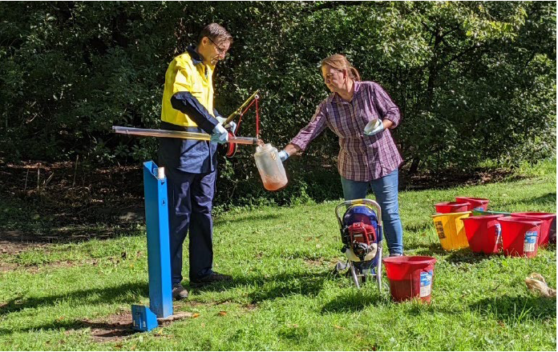
Figure 30. Field sampling demonstration at Macquarie University, where bailer (shown here), net and pumping methods for collecting water, stygofauna and eDNA were explained to workshop participants
Potential issues and concerns with sampling methodologies and the skills required to process samples were raised at the workshop. These are summarised in Table 14.
Table 14. Potential issues with the recommended sampling regime, and responses
Issue | Concerns | Reason required / response
Use of pump, not nets | Expense | The major expense here is a high-flow pump, tubing and motor. These can be purchased for around $5,000 or can be hired from various companies.
- | Net should be adequate for richness | As shown in methods (Section 2), nets can be used to indicate presence/absence of stygofauna. However, they cannot be used for community structure, richness or abundances, as pump is more accurate.
- | Time required to purge | Purging should be undertaken for any assessment of water quality or for eDNA analysis.  Purge water (i.e., pre-purge volume) can be used to indicate stygofauna richness (80% confidence).
- | Pumping 90–150 L is time-consuming | Agree it can be time-consuming. In our experience, for most bores it will not take more than around 60 minutes. If it is taking too long, the sample volume can be reduced but this also reduces confidence in the results.
Stygofauna expertise | Stygofauna identification | Agree a level of expertise is required. However, there are consultants who will identify to a coarse taxonomic level as required (some keys do not allow more fine-scale resolution) and this is currently undertaken with net sampling.  Alternatively, individuals can be sequenced for identification (100% ethanol storage in freezer), which will ultimately add to the DNA reference database libraries (consultants should be encouraged to complete this as it adds to knowledge of stygofauna within Australia).
Sterilisation in field on mining sites | Chemicals on site | This would need to be negotiated with the landowner/manager. Assume that exemptions can be granted for short-term sampling projects.
- | Petrol on site (pump) | As above.
- | Sterile sampling in field | Equipment can be sterilised in the field using bleach and ethanol. Care must be taken, and gloves worn when collecting eDNA samples, but this is part of any DNA sampling procedure and is not too onerous for the consultants.
Sample storage | Practicality of filtering eDNA once sample is collected | As microbial communities can change within hours, filtering quickly has been required in the past, with samples stored on ice and in dark and filtered within 7 hours.  Stage 2 report indicates preservative (DESS) can be added and samples filtered up to a week later. This makes eDNA sampling more practical in real-life situations.
Expertise required for eDNA | Filtering | eDNA methods will require filtering on specialised but readily available equipment. A range of disposable and sterilisable filtration options are available. Aseptic filtering requires limited experience.
- | PCR and eDNA processing | Required eDNA extraction kits, then completion of PCRs and pooling samples.  Can be done by companies using generic primers (e.g., 16S and 18S primers as used in this study).
- | Cost of sequencing | Estimated costs for sequencing are provided in Section 3.6.2.
- | Expertise for bioinformatic analysis | Bioinformatic analysis does require specialist input from bioinformaticians. This service may be available from companies that also provide sequencing services; estimated costs are provided in Section 3.6.2.
eDNA general questions | Is eDNA reliable? | eDNA has been proven to be reliable in detecting biota ranging from microbes through to large mammals. eDNA is used routinely in surface waters for microbial analysis, and also for detecting rare species (e.g., platypus).  Here, we acknowledge the limitations of eDNA where reference libraries are limited (e.g., for stygofauna) but we also recognise the power of eDNA for microbial analysis in groundwaters.
- | Do microbes really need to be assessed? | Microbes can prove a baseline for groundwater ecosystems and can be used to indicate functions. Microbial communities are known to quickly adapt and change to environmental conditions and to contamination events; thus, they are extremely powerful for monitoring impacts on groundwaters.
- | Why are there issues with taxonomy? | Issues with taxonomy arise because the sequencing reference databases are not adequate to allow identification of all stygofauna. Each primer requires a different reference database, and there has not been enough sampling and sequencing of stygofauna in Australia to adequately identify all taxa.  Therefore, we recommend both morphological and eDNA sampling at this stage, as well as sequencing of stygofauna specimens to build the reference databases.

3.6.2 Potential costs for processing eDNA
Cost of sampling, processing and sequencing was raised as a major concern for implementing eDNA sampling into routine monitoring programs. There are several steps involved with processing eDNA membranes; these are shown in Figure 31 and explained Table 15. Each of these steps has a number of consumables, requiring different levels of expertise and a different range of equipment, of which some items are standard in scientific laboratories and others are costly and require various levels of technical expertise to use.
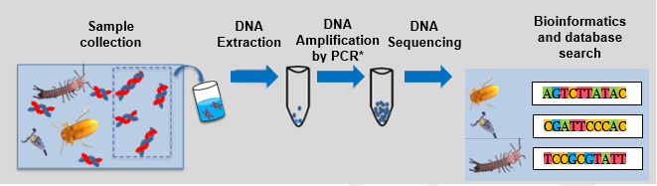
Figure 31. Schematic diagram of the eDNA analysis pipeline from sample collection to sequence analysis
*PCR = polymerase chain reaction. Numbers relate to steps in Table 15. From Korbel et al. (2022a), adapted from Boulton et al. (2023).
Table 15. Steps for laboratory processing of samples for eDNA analysis
Steps in DNA analysis | - | Consumables required | Equipment required
Sample preparation | DNA extraction (1) | DNA extraction kits, pipette tips, centrifuge tubes | Standard laboratory (e.g., centrifuge, bead beaters, sterilisation equipment)  Cool, clean workspace required to limit contamination  Freezer space (at least -20°C) for storing samples and extracted/processed DNA
- | PCR* processing (2) | Tips, tubes, mastermix, primers, tags, plates | By hand (standard lab) or by robot (specialised)  Specialist PCR machines required
- | Sample pooling (3) | Assays, gels, plates, tips, purification kits | Specialised laboratory  Clean workspace required to limit contamination
Sequencing | (4) | Sequencing kits specific to sequencing platform  Numerous other steps | Highly specialised commercial laboratory
Analysis | Bioinformatics (5) | None required | Computer and specialised technical expertise
* PCR = polymerase chain reaction.
Commercial laboratories are available to complete both the sample preparation and the sequencing of samples. Indicative costs for these steps are (in early 2023) $35 per primer for sample preparation and around $2,000 per sequence run, depending on primer used. Sequencing is typically a fixed price per analysis irrespective of the number of samples analysed. Sequencing machines vary in their capacity, but many are able to sequence around 300 samples per run. Bioinformatics specialists are available to interpret and compare sequences to standard sequence libraries, which will produce lists of taxa from the sequence runs.
Alternatively, there are a number of companies that offer a full analysis of ‘raw’ samples (e.g., water/sediment), including extraction, PCR, pooling, purification, sequencing, bioinformatics and reporting. Full analysis costs are in the order of $350 to $500 per individual sample, depending on number and types of primers used.

3.6.3 Summary: feasibility of sampling methods for routine biomonitoring
The general consensus among workshop participants was that the field methods demonstrated at the workshop are not too onerous for consultants. The verification that preservatives can be added to eDNA samples without consequences for the microbial communities is a major step forward for the practicality of sampling, particularly in remote situations.
The conclusion from workshop discussion and post-workshop surveys was that the methods provided are feasible for consultants to use to collect stygofauna and eDNA samples and to identify individual stygofauna samples (to order level). However, the expertise and laboratory equipment required to complete eDNA extraction, PCRs and bioinformatics may need to be subcontracted, at least until companies begin to develop these areas of expertise.

- Summary and recommendations

4.1 Summary of main findings
This study has demonstrated the feasibility of using metabarcoding approaches for routine monitoring and assessment of groundwater ecosystems in shallow fractured rock aquifers. It has also provided an indication of the effort and resources required for biological sampling in shallow groundwaters. When used in the context of a risk assessment approach that evaluates the likelihood and consequences of potential impacts, sampling of water quality, stygofauna and eDNA can be used to inform environmental impact assessments for coal and unconventional gas activities, as well as associated monitoring and management of water resources.
The results and recommendations from this study relate to shallow sandstone aquifers with relatively high groundwater transmissivity. The results are largely consistent with those derived from shallow alluvial aquifers (Korbel et al. 2022a), although they may not translate to other aquifer types, greater depths or sites of low transmissivity in which the recommended purging and post-purge sampling may be challenging. Further work is needed on other such bores and aquifer types.
The key outcomes of this study with respect to sample types are outlined below.

4.1.1 Water quality
Water quality in bores is significantly different to that in the surrounding aquifer. Accordingly, bores should be purged, or otherwise sampled in such a way as to ensure that water samples represent the aquifer conditions.
A comprehensive analysis of water quality should include, as a minimum, physico-chemical parameters (including ORP), nutrients and major ions.

4.1.2 Stygofauna
- Sampling for stygofauna should use multiple sampling approaches. eDNA alone is insufficient for detecting Crustacea but is effective for detecting cryptic taxa often missed by traditional identification.
- Bailers alone are insufficient for detecting the presence of stygofauna within sites.
- Bailers are insufficient for characterising the diversity of stygofauna and are likely of little value when net or pump sampling is also undertaken.
- Net samples collected following an approach similar to the WA EPA (2016) protocol using a coarse (150 µm) and a fine (63 µm) mesh net may, but do not consistently, capture a large proportion of the stygofauna taxa at a site.
- A combination of netting and pumping or pumping only is recommended to maximise the stygofauna richness collected at a site.
- Pumping 150 L or more of groundwater is recommended to maximise the richness of stygofauna collected.
- Further pumping after a bore has been purged is required in cases where the relative abundance of taxa is an important consideration, with relative abundance based on traditional identification methods and not eDNA.
- Analyses of eDNA did not always detect stygofauna that were collected in whole-organism samples. We recommend that eDNA and whole-organism sampling are both used to characterise stygofauna communities.
- In this study, at least 15 independent samples were required to adequately characterise stygofauna diversity across the study region, depending on the sampling method used. The sampling effort required is likely to vary in space and time, and sampling adequacy should be considered in any study.
- To make conclusions regarding natural distribution of stygofauna, environmental parameters – including water quality, site attributes, and sediment type and volume in samples – should be recorded at each sampling site.

4.1.3 Metabarcoding (eDNA)
- Purging a bore by pumping and removing at least three bore volumes is critical to collecting a representative sample of prokaryotes for use in metabarcoding.
- Metabarcoding effectively characterises microbial assemblages, and taxa can be related to important ecological and biogeochemical functions.
- Analyses of multiple genes such as those targeting different biological groups (e.g., prokaryotes, eukaryotes, specific taxa) are recommended to characterise the biodiversity of groundwaters.
- Further work is needed for metabarcoding to be able to reliably detect stygofauna. This includes development and optimisation of alternative primers, development of sequence reference libraries by sequencing identified stygofauna specimens, and investigations into the density of stygofauna within aquifers and how that relates to their detection in eDNA.
- Analysis of material from nets or sieves after pumping as a bulk DNA sample should be trialled as a possible alternative method to filtered water eDNA samples.
- We recommend that while metabarcoding can be reliably used for prokaryotes, it cannot at this stage replace whole-organism collections for characterising stygofauna communities.

4.2 Recommended sampling approaches
Protocols for sampling groundwater biota should be tailored to the overall aims of the study being conducted. Broadly speaking, we expect there are three scenarios which might require sampling and analysis of groundwater. In order of increasing complexity and sampling effort required, these are:
- a pilot study to determine the presence of stygofauna
- a baseline study of stygofauna and microbes
- a robust and detailed biomonitoring program.
We provide recommendations on the sampling required to characterise groundwater biota for each of these scenarios.
Table 16 provides details on the sampling processes applicable to the three sampling scenarios, their efficacy for characterising elements of the groundwater biota, and the estimated time taken to complete sampling in the field.

4.2.1 Site characterisation and water quality
Detailed descriptions of each site (including land use, vegetation type and density), bore (including construction, lithology and depth) and sample (e.g., sediment volume and type) should be recorded irrespective of sampling process. We also recommend comprehensive analysis of water quality that should include, as a minimum, physico-chemical parameters (including ORP), nutrients and major ions. See WA EPA (2016) for further details.
Table 16. Suitability of sampling methods for assessment of groundwater biota in shallow (<45 m) aquifers
Study type | Approx time* | Sampling method | Water chemistry | Stygofauna presence/  absence | Stygofauna richness | Stygofauna relative abundance | eDNA – microbial | eDNA – eukaryote#
I. Pilot study  (net or pump) | 60 mins | Net: 5 hauls of 63-µm & 150-µm mesh nets (unpurged)  Additional: bailer (eDNA) | ü  (Unlikely to represent aquifer water) | ü | - | - | - | ü
- | - | OR  Pump bore volume only | - | ü | - | - | - | ü
II. Baseline study (pump used) | 30 mins | a. Purge & sieve 2–3 x bore volume† | - | ü | ü  (~80%) | - | - | -
- | - | b. Sample water (post-purge) | ü | - | - | - | ü | ü
III. Biomonitoring (pump used) | 70 mins | a. Purge & sieve 2–3 x bore volume† | - | ü | ü  (~80%) | - | - | -
- | - | b. Sample water (post-purge) | ü | - | - | - | ü | ü
- | - | c. Pump & sieve 150 L^ | - | ü | ü  (~100% combined with purge sample) | ü  (when not combined with purge sample) | - | -
Percentages indicate the proportion of the total taxa richness occurring at a site that is typically recovered using that sampling approach. #eDNA should not be used as a standalone method for stygofauna identification. *Indicative time for sampling method, dependent on substrate, flow and depth. ^Where this volume is greater than three times the bore volume. +Purge volume recommended by Sundaram et al. (2009).

4.2.2 Scenario 1: Pilot study to detect aquatic community present
- Initial bailer sampling is recommended to collect water samples for chemical analysis. The water quality of these samples is not likely to reflect that of the surrounding aquifer but may provide a preliminary assessment of some groundwater conditions.
- Net sampling is likely to be sufficient if the focus of sampling is to determine the presence of stygofauna in a pilot study; however, pumping can also be used.
- Net sampling should include multiple net hauls using both coarse and fine mesh nets, as outlined in Table 16 and WA EPA (2016).
- The presence of microbial communities can be assumed in any aquifer. Purging, pumping and analysis of microbial communities (using eDNA) is only required where there is a desire to identify specific microbial taxa or processes.
- The sampling effort required for a pilot study will vary with location and time.
  - In this study, at least 15 samples were required to indicate richness of a region when using netting. However, netting alone did not capture the full richness across the study areas.
  - In this study, at least four net samples were required to detect crustacean stygofauna.
  - We defer to the WA EPA (2016) guidelines and recommend that six to 10 samples are collected as the basis of a pilot study.
- If stygofauna are found in the pilot study, the results can be used to design a comprehensive survey that will be required to document all species and assess their conservation status (see WA EPA 2016).
- Analysis of eDNA from a bailer sample may detect some stygofauna but may be less reliable in doing so than netting or pumping and morphological identification. Traditional methods of collection are recommended at this stage.

4.2.3 Scenario 2: Baseline study to scope biota prior to works
Sampling for a baseline study should include pumping and purging a bore to characterise stygofauna, water quality, and microbial and invertebrate assemblages (using eDNA) that are representative of the surrounding aquifer. Failure to purge the bore may result in an incomplete assessment of stygofauna at a site, and water quality data and microbial community analyses that are not representative of those in the surrounding aquifer.

Water quality
- Purging the bore is required to characterise water quality. This may be achieved using a low- or high-flow pump.

Stygofauna
- Collection and filtering of purge water only using a high-flow pump (Table 16) may capture up to 80% of the known stygofauna richness at a site.
  - If the relative abundance of stygofauna in the aquifer is important, further pumping is recommended, with abundance data to exclude pre-purge samples.
  - Using this method, at least 15 samples were required to characterise the known stygofauna richness within a study area.
  - If specific crustaceans are targeted, additional pumping may be required.
- Pumping 120 L of groundwater captures around 97% of the known stygofauna richness in a study area.
  - If the relative abundance of stygofauna in the aquifer is important, further pumping is recommended.
- Pumping 150 L of groundwater and including the pre-purge sample (Table 16) captures around 100% of the known stygofauna richness in a study area.
  - This method provides a reliable estimate of the relative abundance of stygofauna taxa in the aquifer if pre- and post-purge samples are separated.
  - Using this method, at least 15 samples are required to characterise the known stygofauna richness within an aquifer.
- WA EPA (2016) recommends that at least 12 samples are required order to characterise the stygofauna community within a single bore.
- We support the DSITI (2015) and WA EPA (2016) recommendation that a baseline assessment of stygofauna should include at least 40 samples collected from at least 10 bores within an impacted area. Sampling should occur in at least two seasons and at least three months apart.

eDNA
- Purging the bore is required to obtain samples of eDNA that reflect the microbial communities of the surrounding aquifer. Additional pumping after purging is not required to obtain a representative sample for eDNA analysis.
- eDNA analysis of 16S gene is suitable to indicate microbial richness and functional processes occurring.
- We recommend analysis of multiple genes to target specific elements of the groundwater biota.
- eDNA analysis alone is not sufficient to characterise the stygofauna at a site; we recommend that whole-organism collections also be used where characterisation of stygofauna is a goal of the study. The addition of eDNA will likely detect small cryptic biota that may not be detected by traditional methods.
If a high-flow pump is not available, netting should be used for collecting stygofauna, with the caveat that net sampling may not capture the full stygofauna richness at a site and would require more extensive sampling effort to characterise the richness of an aquifer.
It is currently unclear whether sampling using a low-flow pump will provide a representative sample for eDNA analysis, even if the water quality of the sample has stabilised and reflects that of the surrounding aquifer. Further research is needed to verify the suitability of low-flow pumps for sampling groundwater biota.

4.2.4 Scenario 3: Pre- and post-development biomonitoring
Sampling for ongoing biomonitoring should include pumping and purging a bore to characterise stygofauna, water quality, and microbial and invertebrate assemblages (using eDNA) that are representative of the surrounding aquifer. Pumping should extend beyond purging so that the relative abundance of stygofauna in the aquifer can be determined.
Analyses may target changes in water quality, stygofauna abundance, community composition and/or microbial indicators. Several existing protocols for groundwater bioassessment have been developed (e.g., Korbel and Hose 2011; Korbel and Hose 2017; Fillinger et al. 2019) which can incorporate stygofauna and microbial indicators, including those based on eDNA analysis (see Korbel et al. 2022c).

Water quality
- Purging the bore is required to characterise water quality. This may be achieved by a low- or high-flow pump.

Stygofauna
- Pumping 150 L of groundwater, including the pre-purge sample (Table 16), captures around 100% of the known stygofauna richness at a site.
  - This method provides a reliable estimate of the relative abundance of stygofauna taxa in the aquifer if pre- and post-purge samples are separated.
- WA EPA (2016) highlights the very large sample size required to detect change in stygofauna abundance.
- We recommend that metrics based on stygofauna are not the only metrics used in a monitoring and assessment program (see Korbel and Hose 2011; Korbel and Hose 2017).

eDNA
- Purging the bore is required to obtain samples of eDNA that reflect the microbial communities of the surrounding aquifer. Additional pumping after purging is not required to obtain a representative sample for eDNA analysis.
- eDNA analysis of 16S gene is suitable to characterise microbial richness and functional processes in a groundwater sample.
- We recommend analysis of multiple genes to target specific elements of the groundwater biota.
- eDNA analysis alone is currently not sufficient to characterise the stygofauna at a site; we recommend that whole-organism collections also be used where characterisation of stygofauna is a goal of the study. The addition of eDNA will likely detect small cryptic biota that may not be detected by traditional methods.
- Korbel and Hose (2017) and Korbel et al. (2022c) provide eDNA-based metrics for inclusion in groundwater biomonitoring.

4.3 Future work
This study has been undertaken in shallow, unconfined sandstone aquifers. Results from this study were similar to those achieved using similar methods in shallow alluvial aquifers, but further sampling should be undertaken in other aquifer types to determine whether patterns observed are transferrable to other aquifer types and depths and to sites of lower groundwater transmissivity.
The absence of stygofauna in eDNA samples may reflect the likely low abundance of stygofauna (particularly Crustacea) in aquifers. Further understanding of the relative densities of fauna and the frequency of their detection in metabarcoding samples would enhance the reliability of this method for stygofauna surveys. Additional investigations into sampling methodologies for collecting pre-purge eDNA to identify stygofauna are warranted. This may include methods that target eDNA within unpurged bores, which may have a higher likelihood of detecting stygofauna due to the often higher density of biota living and breeding within these artificial environments.
Analyses of functional traits of biota may be particularly useful for stygofauna to avoid the challenges of taxonomy (Hose et al. 2022). Early applications of this approach to groundwaters (see Di Lorenzo et al. 2019) suggest that it could be developed as a routine approach for groundwater monitoring in the future.
As a priority, research is needed to determine if low-flow sampling can provide samples of eDNA for analysis that are representative of the biota in the surrounding aquifer. Testing of low-flow pumps for DNA sampling has been highlighted as a key knowledge need in multiple stakeholder discussions.
Given the challenges with some DNA primers used in this study, further refinement and development of those primers, particularly those specifically targeting stygofauna, is needed. Additionally, the reference database for stygofauna in Australia is lacking and effort to sequence individual specimens to add to this database is required.
Further analysis of the optimal sampling volume (i.e., the volume of groundwater filtered and/or mass of sediment collected) is desirable to improve the sensitivity of the method and likelihood of detection of rare taxa such as stygofauna.
QA/QC processes as part of bioinformatic pipelines remove rare but potentially important taxa. Consideration of more nuanced data screening procedures is needed to maximise the information gained from metabarcoding approaches.

Acknowledgments
Fieldwork was undertaken by Grant Hose (Macquarie University (MU)), Kathryn Korbel (MU), Kitty McKnight (MU) and Zac Whetters. Laboratory analyses were undertaken by Kathryn Korbel, Kitty McKnight, Tess Nelson (MU), Loren Pollitt (MU) and Harry Anderson (MU). This report was prepared by Grant Hose, Kathryn Korbel and Kitty McKnight. Paul Greenfield (CSIRO) did all bioinformatics analyses. Anthony Chariton provided guidance on molecular methods. Brad Angel (CSIRO) and Merrin Adams (CSIRO) undertook water quality analyses.
We acknowledge the people of Darkinjung, Darug and Dharawal Nations as the traditional owners and custodians of the lands on which this work was undertaken. We pay respects to all Elders past and present as well as to the Indigenous leaders of tomorrow.

Reference list
Abo Elsoud MM and Abo-Alkasem MI 2022. Environmental sulfate-reducing microorganisms. In Inamuddin, Ahamed MI and Prasad R (eds), Application of microbes in environmental and microbial biotechnology. Springer Nature, Singapore, 625–654.
Allford A, Cooper SJB, Humphreys WF and Austin AD 2008. Diversity and distribution of groundwater fauna in a calcrete aquifer: does sampling method influence the story? Invertebrate Systematics, 22, 127–138.
Andersen M, Barron O, Bond N, Burrows R, Eberhard S, Emelyanova I, Fensham R, Froend R, Kennard M, Marsh N, Pettit N, Rossini R, Rutlidge R, Valdez D and Ward D 2016. Research to inform the assessment of ecohydrological responses to coal seam gas extraction and coal mining. Department of the Environment and Energy, Commonwealth of Australia. Available [online]: https://www.awe.gov.au/water/coal-and-coal-seam-gas/resources/assessment-ecohydrological-responses
Anderson MJ 2001. A new method for non-parametric multivariate analysis of variance. Austral Ecology, 26, 32–46.
Anderson MJ, Gorley RN and Clarke KR 2008. PERMANOVA+ for PRIMER: guide to Software and Statistical Methods. PRIMER-E, Plymouth.
Andruszkiewicz Allan E, Zhang WG, Lavery AC and Govindarajan AF 2021. Environmental DNA shedding and decay rates from diverse animal forms and thermal regimes. Environmental DNA, 3, 492–514.
Apprill A, McNally S, Parsons R and Weber L 2015. Minor revision to V4 region SSU rRNA 806R gene primer greatly increases detection of SAR11 bacterioplankton. Aquatic Microbial Ecology, 75, 129–137.
Asmyhr MG 2013. Biodiversity assessment and conservation of groundwater ecosystems. Unpublished PhD thesis. Macquarie University.
Asmyhr MG and Cooper SJB 2012. Difficulties barcoding in the dark: the case of crustacean stygofauna from eastern Australia. Invertebrate Systematics, 26, 583–591.
Barbieri M, Barberio MD, Banzato F, Billi A, Boschetti T, Franchini S, Gori F and Petitta M 2021. Climate change and its effect on groundwater quality. Environmental Geochemistry and Health, 45(1). Available [online]: https://doi.org/10.1007/s10653-021-01140-5
Berry TE, Osterrieder SK, Murray DC, Coghlan ML, Richardson AJ, Grealy AK, Stat M, Bejder L and Bunce M 2017. DNA metabarcoding for diet analysis and biodiversity: a case study using the endangered Australian sea lion (Neophoca cinerea). Ecology and Evolution, 7, 5435–5453.
BOM (Bureau of Meteorology) 2022. Climate data online. Bureau of Meteorology. Available [online]: http://www.bom.gov.au/climate/data/index.shtml accessed 23 January 2023.
Boulton AJ, Bichuette ME, Korbel K, Stoch F, Niemiller ML, Hose GC and Linke S 2023. Recent concepts and approaches for conserving groundwater biodiversity. In Malard F, Griebler C and Retaux S (eds), Groundwater Ecology and Evolution. Elsevier.
Cardno 2014a. Springvale Mine Extension Project – Aquatic Ecology and Stygofauna Assessment. Report NA49913131 prepared for Springvale Coal Pty Limited. Cardno. Available [online]: https://majorprojects.planningportal.nsw.gov.au accessed 23 January 2023.
Cardno 2014b. Angus Place Mine Extension Project – Aquatic Ecology and Stygofauna Assessment. Report NA49913131 prepared for Centennial Angus Place. Available [online]: https://majorprojects.planningportal.nsw.gov.au accessed 23 January 2023.
Castaño-Sánchez A, Hose GC and Reboleira ASPS 2020. Salinity and temperature increases impact groundwater crustaceans. Scientific Reports, 10, 12328. Available [online]: https://doi.org/10.1038/s41598-020-69050-7
Castaño-Sánchez A, Hose GC and Reboleira ASPS 2020. The ecotoxicological effects of anthropogenic stressors in subterranean organisms. Chemosphere, 244, 125422. Available [online]: https://doi.org/10.1016/j.chemosphere.2019.125422
Clarke KR and Ainsworth M 1993. A method of linking multivariate community structure to environmental variables. Marine Ecology Progress Series, 92, 205–219.
Clarke KR and Green RH 1988. Statistical design and analysis for a ‘biological effects’ study. Marine Ecology Progress Series, 46, 213–226.
Deiner K and Altermatt F 2014. Transport distance of invertebrate environmental DNA in a natural river. PLoS ONE, 9, e88786.
Di Lorenzo T, Fiasca B, Di Cicco M and Galassi DMP 2021. The impact of nitrate on the groundwater assemblages of European unconsolidated aquifers is likely less severe than expected. Environmental Science and Pollution Research, 28, 11518–11527.
Di Lorenzo T, Fiasca B, Tabilio Di Camillo A, Murolo A, Di Cicco M and Galassi DMP 2020. The weighted Groundwater Health Index (wGHI) by Korbel and Hose (2017) in European groundwater bodies in nitrate vulnerable zones. Ecological Indicators, 116, 106525.
Di Lorenzo T, Murolo A, Fiasca, B, Tabilio Di Camillo A, Di Cicco M and Galassi DMP 2019. Potential of a trait-based approach in the characterization of an N-contaminated alluvial aquifer. Water, 11, 2553.
DSITI (Department of Science, Information Technology and Innovation) 2015. Guideline for the environmental assessment of subterranean aquatic fauna: sampling methods and survey considerations. Queensland Government, Brisbane.
Eberhard SM, Halse SA, Williams MR, Scanlon MD, Cocking J and Barron HJ 2009. Exploring the relationship between sampling efficiency and short-range endemism for groundwater fauna in the Pilbara region, Western Australia. Freshwater Biology, 54, 885–901.
Edmunds WM and Shand P 2009. Groundwater baseline quality. In Edmunds WM and Shand P (eds), Natural groundwater quality. Blackwell Publishing, Oxford, 1–21.
Fillinger L, Hug K, Trimbach AM, Wang H, Kellermann C, Meyer A, Bendinger B and Griebler C. 2019. The D-A-(C) index: a practical approach towards the microbiological-ecological monitoring of groundwater ecosystems. Water Research, 163, 114902.
Flynn TM, Sanford RA, Ryu H, Bethke CM, Levine AD, Ashbolt NJ and Santo Domingo JW 2013. Functional microbial diversity explains groundwater chemistry in a pristine aquifer. BMC Microbiology, 13, 146.
Forsström T and Vasemägi A 2016. Can environmental DNA (eDNA) be used for detection and monitoring of introduced crab species in the Baltic Sea? Marine Pollution Bulletin, 109, 350–355.
Gibert J 2001. Basic attributes of groundwater ecosystems. In Griebler C, Danielopol D, Gibert J, Natchtnebel HP and Notenboom J (eds), Groundwater ecology: a tool for management of water resources. Office for Official Publications of the European Community, Luxembourg, 39–52.
Goldscheider N, Hunkeler D and Rossi P 2006. Review: Microbial biocenoses in pristine aquifers and an assessment of investigative methods. Hydrogeology Journal, 14, 926–941.
Gray MA, Pratte ZA and Kellogg CA 2013. Comparison of DNA preservation methods for environmental bacterial community samples. FEMS Microbiology Ecology, 83, 468–477. Available [online]: https://doi.org/10.1111/1574-6941.12008
Griebler C, Avramov M and Hose G 2019. Groundwater ecosystems and their services – current status and potential risks. In Schröter M, Bonn A, Klotz S, Seppelt R and Baessler C (eds), Atlas of ecosystem services – drivers, risks, and societal responses. Springer, Cham, 197–203.
Griebler C and Lueders T 2009. Microbial biodiversity in groundwater ecosystems. Freshwater Biology, 54, 649–677.
Hahn HJ and Fuchs A 2009. Distribution patterns of groundwater communities across aquifer types in south-western Germany. Freshwater Biology, 54, 848–860.
Hahn HJ and Matzke D 2005. A comparison of stygofauna communities inside and outside groundwater bores. Limnologica, 35, 31–44.
Halse SA, Scanlon MD, Cocking JS, Barron HJ, Richardson JB and Eberhard SM 2014. A biodiversity survey of the Pilbara region of Western Australia 2002–2007. Records of the Western Australian Museum. Supplement 78 (Part 2), 443–483.
Hancock PJ and Boulton AJ 2008. Stygofauna biodiversity and endemism in four alluvial aquifers in eastern Australia. Invertebrate Systematics, 22, 117–126.
Hancock PJ and Boulton AJ 2009. Sampling groundwater fauna: efficiency of rapid assessment methods tested in bores in eastern Australia. Freshwater Biology, 54, 902–917.
Hardy CM, Krul, ES, Hartley DM and Oliver RL 2010. Carbon source accounting for fish using combined DNA and stable isotope analyses in a regulated lowland river weir pool. Molecular Ecology, 19, 197–212.
Harvey MS 2002. Short-range endemism among the Australian fauna: some examples from non-marine environments. Invertebrate Systematics, 16, 555–570.
Hofmann R, Uhl J, Hertkorn N and Griebler C 2020. Linkage between dissolved organic matter transformation, bacterial carbon production, and diversity in a shallow oligotrophic aquifer: results from flow-through sediment microcosm experiments. Frontiers in Microbiology, 11, 543567.
Hofmann R and Griebler C 2018. DOM and bacterial growth efficiency in oligotrophic groundwater: absence of priming and co-limitation by organic carbon and phosphorus. Aquatic Microbial Ecology, 81, 55–71.
Hose GC 2008. Stygofauna baseline assessment for Kangaloon Borefield Investigations – Southern Highlands, NSW. Report to Sydney Catchment Authority, Access Macquarie Ltd, North Ryde.
Hose GC 2009. Stygofauna baseline assessment for Kangaloon Borefield Investigations – Southern Highlands, NSW. Supplementary report – stygofauna molecular studies. Report to Sydney Catchment Authority, Access Macquarie Ltd, North Ryde.
Hose GC, Chariton A, Daam M, Di Lorenzo T, Galassi DMP, Halse SA, Reboleira ASPS, Robertson AL, Schmidt SI and Korbel K 2022. Invertebrate traits, diversity and the vulnerability of groundwater ecosystems. Functional Ecology, 36, 2200–2214. Available [online]: https://doi.org/10.1111/1365-2435.14125
Hose GC, Fryirs K, Bailey J, Ashby N, White T and Stumpp C 2017. Different depths, different fauna: habitat influences on the distribution of groundwater invertebrates. Hydrobiologia, 797, 145–157.
Hose GC and Lategan MJ 2012. Sampling strategies for biological assessment of groundwater ecosystems. CRC CARE Technical Report no. 21. CRC for Contamination Assessment and Remediation of the Environment, Adelaide.
Hose GC, Sreekanth J, Barron O and Pollino C 2015. Stygofauna in Australian groundwater systems: extent of knowledge. Report to Australian Coal Association Research Program. Macquarie University and CSIRO.
Hose GC, Symington K, Lategan MJ and Siegele R 2019. The toxicity and uptake of As, Cr and Zn in a stygobitic syncarid (Syncarida: Bathynellidae). Water, 11, w11122508.
Hose GC, Symington K, Lott M, Lategan MJ. 2016. The toxicity of arsenic (III), chromium (VI) and zinc to groundwater copepods. Environmental Science and Pollution Research, 23:18704–18713
Jasinska EJ, Knott B and McComb AJ 1996. Root mats in ground water: a fauna-rich cave habitat. Journal of the North American Benthological Society, 15, 50–519.
Johns T, Jones JI, Knight L, Maurice L, Wood P, and Robertson A 2015. Regional-scale drivers of groundwater faunal distributions. Freshwater Science, 34, 316–328.
Korbel K, Chariton A, Stephenson S, Greenfield P and Hose GC 2017. Wells provide a distorted view of life in the aquifer: implications for sampling, monitoring and assessment of groundwater ecosystems. Scientific Reports, 7, 40702.
Korbel K, McKnight K, Greenfield P, Angel B, Adams M, Chariton A and Hose G 2022a. Bioassessment of groundwater ecosystems. I. Sampling methods and analysis of eDNA for microbes and stygofauna in shallow alluvial aquifers. Report prepared for the Independent Expert Scientific Committee on Coal Seam Gas and Large Coal Mining Development through the Department of Climate Change, Energy, the Environment and Water, Commonwealth of Australia.
Korbel K, Stephenson S and Hose GC 2019. Sediment size influences habitat selection and use by groundwater macrofauna and meiofauna. Aquatic Sciences, 81, 39
Korbel KL and Hose GC 2011. A tiered framework for assessing groundwater ecosystem health. Hydrobiologia, 661, 329–349.
Korbel KL and Hose GC 2015. Habitat, water quality, seasonality, or site? Identifying environmental correlates of the distribution of groundwater biota. Freshwater Science, 34, 329–342.
Korbel KL and Hose GC 2017. The Weighted Groundwater Health Index: improving the monitoring and management of groundwater resources. Ecological Indicators, 75, 64–181.
Korbel KL, Greenfield P and Hose GC 2022c. Agricultural practices linked to shifts in groundwater microbial structure and denitrifying bacteria. Science of the Total Environment, 807, 150870.
Korbel KL, Hancock PJ, Serov P, Lim RP and Hose GC 2013b. Groundwater ecosystems vary with land use across a mixed agricultural landscape. Journal of Environmental Quality, 42, 380–390.
Korbel KL, Lim RP and Hose GC 2013a. An inter-catchment comparison of groundwater biota in the cotton-growing region of north-western New South Wales. Crop and Pasture Science, 64, 1195–1208.
Korbel KL, Rutlidge H, Hose GC, Eberhard SM and Andersen MS 2022b. Dynamics of microbiotic patterns reveal surface water groundwater interactions in intermittent and perennial streams. Science of the Total Environment, 811, 152380.
Kwon MJ, Sanford RA, Park J, Kirk M and Bethke CM 2008. Microbiological response to well pumping. Ground Water, 46, 286–294.
Lafont M, Camus J and Rosso A 1996. Superficial and hyporheic oligochaete communities as indicators of pollution and water exchange in the River Moselle, France. Hydrobiologia, 334, 147–155.
Lee KM, Adams M and Klassen JL 2019. Evaluation of DESS as a storage medium for microbial community analysis. PeerJ, 7, e6414.
Louca S, Parfrey LW and Doebeli M 2016. Decoupling function and taxonomy in the global ocean microbiome. Science 353, 1272–1277.
Malard F, Plenet S and Gibert J 1996. The use of invertebrates in ground water monitoring: a rising research field. Groundwater Monitoring and Remediation, Spring, 103–113.
Masciopinto C, Semeraro F, La Mantia R, Inguscio S and Rossi E 2006. Stygofauna abundance and distribution in the fissures and caves of the Nardo (southern Italy) fractured aquifer subject to reclaimed water injections. Geomicrobiology Journal, 23, 267–278.
McMurdie PJ and Holmes S 2014. Waste not, want not: why rarefying microbiome data is inadmissible. PLoS Computational Biology, 10, e1003531.
Moldovan O, Iepure S and Fekete A 2001. Recent ecological research on groundwater in Transylvania (Romania). In Griebler C, Danielopol D, Gibert J, Nachtnebel HP and Notenboom J (eds), Groundwater ecology: a tool for management of water resources. Office for Official Publications of the European Community, Luxembourg, 335–343.
Mösslacher F 1998. Subsurface dwelling crustaceans as indicators of hydrological conditions, oxygen concentrations, and sediment structure in an alluvial aquifer. International Review of Hydrobiology, 83, 349–364.
Mösslacher F, Griebler C and Notenboom J 2001. Biomonitoring of groundwater systems: methods, applications and possible indicators among the groundwater biota. In Griebler C, Danielopol D, Gibert J, Nachtnebel HP and Notenboom J (eds), Groundwater ecology: a tool for management of water resources. Office for Official Publications of the European Community, Luxembourg, 173–182.
Nelson T, Hose GC, Dabovic J and Korbel K in review. Salinity as a major influence on groundwater microbial communities in agricultural landscapes. Marine and Freshwater Research.
Oberprieler S, Rees G, Nielsen D, Shackleton M, Watson G, Chandler L and Davis J 2021. Connectivity, not short-range endemism, characterises the groundwater biota of a northern Australian karst system. Science of the Total Environment, 796, 148955.
Pabich W, Valiela I and Hemond H 2001. Relationship between DOC concentration and vadose zone thickness and depth below water table in groundwater of Cape Cod, U.S.A. Biogeochemistry, 55, 247–268.
Parada AE, Needham DM and Fuhrman JA 2016. Every base matters: assessing small subunit rRNA primers for marine microbiomes with mock communities, time series and global field samples. Environmental Microbiology, 18, 1403–1414.
Pavlovska M, Prekrasna I, Parnikoza I and Dykyi E 2021. Soil sample preservation strategy affects the microbial community structure. Microbes and Environments, 36, ME20134.
Reiss J, Perkins DM, Fussmann KE, Krause S, Canhoto C, Romeijn P and Robertson AL 2019. Groundwater flooding: ecosystem structure following an extreme recharge event. Science of the Total Environment, 652, 1252–1260.
Roudnew B, Lavery TJ, Seymour JR, Jeffries TC and Mitchell JG 2014. Variability in bacteria and virus-like particle abundances during purging of unconfined aquifers. Groundwater, 52, 118–124.
Roudnew B, Seymour JR, Jeffries TC, Lavery TJ, Smith RJ and Mitchell JG 2012. Bacterial and virus-like particle abundances in purged and unpurged groundwater depth profiles. Ground Water Monitoring and Remediation, 32, 72–77.
Saccò M, Blyth AJ, Humphreys WF, Cooper SJB, White NE, Campbell M, Mousavi-Derazmahalleh M, Hua Q, Mazumder D, Smith C, Griebler C and Grice K 2021. Rainfall as a trigger of ecological cascade effects in an Australian groundwater ecosystem. Scientific Reports, 11, 3694.
Saccò M, Campbell MA, Nevill P, Humphreys WF, Blyth AJ, Grierson PF and White NE 2022a. Getting to the root of organic inputs in groundwaters: stygofaunal plant consumption in a calcrete aquifer. Frontiers in Ecology and Evolution, 10, 854591.
Saccò M, Guzik MT, van der Heyde M, Nevill P, Cooper SJB, Austin AD, Coates PJ, Allentoft ME and White NE 2022b. eDNA in subterranean ecosystems: applications, technical aspects, and future prospects. Science of the Total Environment, 820, 153223.
Shapouri M, Cancela da Fonseca L, Iepure S, Stigter T, Ribeiro L and Silva A 2015. The variation of stygofauna along a gradient of salinization in a coastal aquifer. Hydrology Research, 47, 89–103.
Shen Y, Chapelle FH, Strom EW and Benner R 2015. Origins and bioavailability of dissolved organic matter in groundwater. Biogeochemistry, 122, 61–78.
Sket B 1999. The nature of biodiversity in hypogean waters and how it is endangered. Biodiversity and Conservation, 8, 1319–1338.
Sorensen JPR, Maurice L, Edwards FK, Lapworth DJ, Read DS, Allen D, Butcher AS, Newbold LK, Townsend BR and Williams PJ 2013. Using boreholes as windows into groundwater ecosystems. PLoS ONE, 8, e70264.
Stein H, Griebler C, Berkhoff S, Matzke D, Fuchs A and Hahn HJ 2012. Stygoregions – a promising approach to a bioregional classification of groundwater systems. Scientific Reports, 2, 673.
Sundaram B, Feitz AJ, de Caritat P, Plazinska A, Brodie RS, Coram J and Ransley T 2009. Groundwater sampling and analysis: a field guide. Geoscience Australia. Available [online]: https://data.gov.au/dataset/ds-ga-a05f7892-ee1f-7506-e044-00144fdd4fa6
Sutcliffe B, Chariton AA, Harford AJ, Hose GC, Stephenson S, Greenfield P, Midgley DJ and Paulsen IT 2017. Insights from the genomes of microbes thriving in uranium-enriched sediments. Microbial Ecology, 75, 970–984.
Troth CR, Sweet MJ, Nightingale J and Burian A 2021. Seasonality, DNA degradation and spatial heterogeneity as drivers of eDNA detection dynamics. Science of the Total Environment, 768, 144466.
WA EPA (Western Australian Environmental Protection Authority) 2016. Technical guidance. Sampling methods for subterranean fauna. Western Australian Environmental Protection Authority. Available [online]: https://www.epa.wa.gov.au/sites/default/files/Policies_and_Guidance/Tech%20guidance-%20Sampling-Subt-fauna-Dec-2016.pdf
Wakelin SA, Nelson PN, Armour JD, Rasiah V and Colloff MJ 2011. Bacterial community structure and denitrifier (nir-gene) abundance in soil water and groundwater beneath agricultural land in tropical North Queensland, Australia. Soil Research, 49, 65–76.
Wentworth CK 1922. A scale of grade and class terms for clastic sediments. The Journal of Geology, 30, 377–392.
West KM, Richards ZT, Harvey ES, Susac R, Grealy A and Bunce M 2020. Under the karst: detecting hidden subterranean assemblages using eDNA metabarcoding in the caves of Christmas Island, Australia. Scientific Reports, 10, 21479.

Appendices

Appendix 1. Primers and PCR conditions for eDNA
Table A1.1. Primer sequences used in PCR
Gene | Size (bp) | Primer ID | Sequence | Reference
16S rDNA | 350 | 515FB | GTGYCAGCMGCCGCGGTAA | Parada et al. 2016
- | - | 806FB | GGACTACNVGGGTWTCTAAT | Apprill et al. 2015
18S rDNA | 200–500 | All18SF | 5'-TGGTGCATGGCCGTTCTTAGT-3' | Hardy et al. 2010
- | - | All18SR | 5'-CATCTAAGGGCATCACAGACC-3' | -
16S mtDNA | 200–500 | Crust16S_F | 5ʹ GGGACGATAAGACCCTATA 3 | Berry et al. 2017
- | - | Crust16S_R | 5ʹ ATTACGCTGTTATCCCTAAAG 3ʹ | -

Table A1.2. PCR cycle details for each primer set used for eDNA analysis
Primer | - | Temperature (°C) | Time
16S | - | - | -
Initial denaturation | - | 95 | 10 min
35 x PCR cycles | Denaturation | 94 | 45 sec
- | Hybridisation | 50 | 60 sec
- | Elongation | 72 | 90 sec
Final elongation | - | 72 | 10 min
18S | - | - | -
Initial denaturation | - | 95 | 10 min
35 x PCR cycles | Denaturation | 94 | 60 sec
- | Hybridisation | 50 | 60 sec
- | Elongation | 72 | 90 sec
Final elongation | - | 72 | 10 min
16S Crustacea | - | - | -
Initial denaturation | - | 95 | 10 min
55 x PCR cycles | Denaturation | 95 | 30 sec
- | Hybridisation | 53 | 30 sec
- | Elongation | 72 | 45 sec
Final elongation | - | 72 | 10 min
Hold after final elongation (All PCR) | - | 4 | As needed

Appendix 2. 16S/18S bioinformatic methods
The Illumina MiSeq 16S amplicon data were processed using an in-house custom pipeline based on USearch tools and Ribosomal Database Project (RDP). This hybrid pipeline takes files of reads and generates a single operational taxonomic unit (OTU) table covering all of the samples in the study. Each OTU is classified both by using RDP and by matching the sequence to a curated set of 16S reference sequences. The use of two independent classification techniques is done to provide some insight into the reliability of the taxonomic assignments.
The pipeline first demultiplexed the data to produce a pair of read files for each sample. These paired reads were then merged, trimmed and dereplicated, and then clustered at 97% similarity to generate a set of representative OTU sequences. The merging, dereplicating and clustering steps were done using USearch v8.1.1812 tools (fastq_mergepairs, derep_fulllength and cluster_otus). The merging step excluded any merged reads with greater than 1 expected error ( fastq_merge_maxee 1.0). The clustering step also checked for chimeras, running each sequence through UParse-ref using the current set of OTUs as a reference database. If the optimal model is chimeric, the sequence is discarded. Each of these OTU sequences was then classified in two different ways: by using the RDP Classifier (v2.10.2) to determine a taxonomic classification for each sequence, down to best level of genus; and by using usearch_global to find the best match for each sequence within a curated set of 16S reference sequences, giving a species-level classification for each OTU sequence. The 16S reference set used for the species-level classification was built from the RDP Classifier’s training set (v14), augmented with additional sequences from the Genomes OnLine Database (GOLD). The pipeline then used usearch_global to map the merged reads from each sample back onto the OTU sequences to get accurate read counts for each OTU/sample pairing. The classified OTUs and the counts for each sample were then used to generate OTU tables in both text and .biom (v1) formats, complete with taxonomic classifications, species assignments and counts for each sample. Summaries of the OTU classifications were also produced at taxonomic levels from phylum to genus and species.
The Illumina MiSeq 18S data were processed using a variant of the 16S pipeline described above. The 18S pipeline is identical to the 16S pipeline except that the classification is done by using ublast to match a representative sequence from each OTU against a curated set of 18S reference sequences derived from the SILVA v123 SSU reference set. This 18S reference set was built by taking all the eukaryote sequences from the SILVA v123 SSU dataset, and removing those sequences found to contain bacterial or chloroplast regions. For both the 16S rDNA and 18 rDNA datasets, all singleton reads were removed prior to the OTU formation step. The datasets were then filtered by removing OTUs with <10 counts across samples. Counts within individual samples were then adjusted based on the number of counts of positive controls that had jumped between samples. Rare species were removed for 16S datasets but not for 18S, as some stygofauna species only occurred at one site and it was considered important to retain these taxa within our dataset.
While we recognise that there are issues with using the number of amplicon sequence reads as a surrogate for taxon abundance, there is currently no consensus on the most appropriate strategy for the analysis of such data. Although commonly practised, we have chosen not to rarefy these data (i.e., randomly resample to standardise all samples to a minimum read number) prior to analysis because of the loss of important biological information that this process mandates (e.g., McMurdie and Holmes 2014), and because we have already removed rare taxa that are potential erroneous sequences in our earlier data screening processes (see previous paragraph). Instead we have normalised read numbers for each taxon by dividing by the total read number for the sample, thereby expressing each taxon in terms of its relative read abundance.

Appendix 3. Summary of 16S mtDNA (Crustacea) optimisation
Results from IESC Stage 1 indicated that 16S mtDNA primers performed poorly in detecting groundwater crustaceans. For Stage 2, we investigated whether optimisation of the PCR reaction and conditions improved the performance of these primers in detecting groundwater crustaceans. A series of qPCRs were performed using eDNA samples from Stage 1, where groundwater crustaceans were observed using microscopy (MC7.2, BV01, 30305 and 30447). Sample volumes (either 2 L, 30 L or 150 L) with the highest number of groundwater crustaceans were preferentially chosen for use in the qPCRs. The DNA used in the qPCRs was co-extracted with RNA in Stage 1 as there was available volume to use for primer optimisation. Additionally, whole-organism extractions of amphipods and syncarids were used to further assess the performance of the primers. These samples contained DNA from whole-organism extractions of groundwater crustaceans and were less complex than the eDNA for interpretation of the results. Additionally, amphipods and syncarids were two taxa that were targets within our environmental samples. Crab tissue DNA was used as the positive control throughout the qPCR optimisation process. Primer efficiency and DNA optimisation was performed by testing a range of reactions. All qPCR reactions were prepared with the reagents in Table A3.1. A summary of the qPCR conditions and results is outlined in Table A3.2.
Table A3.1. qPCR reaction reagents
Reagent | qPCR reaction (μL)
SYBR green | 0.5
Primer forward | Variable
Primer reverse | Variable
AmpliTaq | 10
H2O | Variable
DNA | Variable
Total | 20

Initial results indicated potential issues with the reagents, so the primers were re-diluted from stocks and a fresh vial of SYBR green was used. There were also issues with jagged qPCR curves throughout the series of qPCRs, with potential that the repetitive freeze/thaw process of samples was impacting the samples or there were issues with the mixing of the qPCR reaction during set-up. From the results for qPCR 6 and gel electrophoresis, it was identified that the PCRs are best performed using 2 μL of DNA with 0.5 μM primer and an annealing temperature of 53°C. However, the syncarid DNA did not amplify well using the conditions that were best for the eDNA and amphipod samples. A separate strip PCR was performed using higher DNA (3.6 μL) and primer concentration (0.8 μM) and an increased number of cycles to compare the results (Table A3.2). Limitations to the optimisation method included time constraints within the project and limited volume of extracted DNA to replicate results.

Table A3.2. Summary of 16S (mt)DNA primer optimisation steps using qPCR
qPCR no. | Aim | Primer concentration and DNA volume in qPCR reaction | qPCR conditions  Initial denaturation | qPCR conditions  Quantification  Denaturation | qPCR conditions  Quantification  Hybridisation/annealing | qPCR conditions  Quantification  Elongation | qPCR conditions  Melting curves | Results
1–3 | Run qPCR to determine primer efficiency and DNA optimisation | Primer concentrations were 0.2, 0.3, 0.4, 0.5, 0.6, 0.8 and 1.0 μM.  DNA volumes were 2 and 3, 5 μL. | 95°C for 10 mins | 95°C for 30 secs | 51°C for 30 secs | 72°C for 45 secs | 95°C continuous | Variable initial results indicating no clear optimal reaction mixture using a range of primer and DNA concentrations.  Due to lack of amplification in initial qPCRs, it was decided to prepare new reagents.
4 | Prepare and test new reagents | Primer concentration 0.8 μM and DNA volume 2 μL were used to compare previous results with qPCR #4 results. | As above | As above | As above | As above | As above | New primers amplified DNA in test samples, with variable cycle numbers needed to achieve curve plateau.  Crab positive control, MC7.2-2L, amphipod-2 plateaued within approximately 55 cycles.  Sample 30447-150L did not start amplifying until a minimum of 44 cycles were performed and amplification did not plateau.  New SYBR green reagent performed well.
5 | Re-run qPCR to determine primer efficiency and DNA optimisation using new reagents | Primer concentrations were 0.5 and 0.8 μM.  DNA volumes were 2, 3 and 5 μL. | As above | As above | As above | As above | As above | Variable results with 2 and 3 μL of DNA with 0.8 μM of primer performing the best for eDNA, syncarid and amphipod samples.  The reaction mix with 5 μL of DNA resulted in poor amplification.  qPCR products were determined by gel electrophoresis and there were multiple bands of amplified DNA in the samples.  Results indicated annealing temperature potentially too low, causing primer to bind non-specifically to the template DNA. Try an increase of 2°C for the annealing temperature.
6 | Annealing temperature optimisation | Primer concentrations were 0.5 and 0.8 μM.  DNA volumes were 2 and 3 μL | As above | As above | 53°C for 30 secs | As above | As above | Annealing temperature increased to 53°C and results were less variable across reaction mixtures.  Gel electrophoresis was used to determine qPCR results. Comparing the results to the previous qPCR, a more distinct dominant band of DNA was observed in the samples.  2 μL of DNA with 0.5 μM primer concentration appeared to perform the best for eDNA and amphipod samples based on the qPCR curves.  Syncarid DNA did not amplify in 2 μL of DNA and low amplification of DNA within 55 cycles with 3 μL template DNA.

Table A3.3. PCR cycle details for 16S (mt)DNA primer used for eDNA analysis for IESC Stage 2
Primer | - | Temperature (°C) | Time
mt16S Crustacea | - | - | -
Initial denaturation | - | 95 | 10 min
55 x PCR cycles | Denaturation | 95 | 30 sec
- | Hybridisation (annealing) | 53 | 30 sec
- | Elongation | 72 | 45 sec
Final elongation | - | 72 | 10 min
mt16S Crustacea (PCR strip test) | - | - | -
Initial denaturation | - | 95 | 10 min
60 x PCR cycles | Denaturation | 95 | 30 sec
- | Hybridisation (annealing) | 53 | 30 sec
- | Elongation | 72 | 45 sec
Final elongation | - | 72 | 10 min
Hold after final elongation (All PCR) | - | 4 | As needed

Appendix 4. Stygofauna raw counts – whole-organism collection and morphological taxonomy
Table A4.1. Stygofauna collected at each site
Site | Sample method | Cyclopoida | Harpacticoida | Nauplii | Parabathynellidae | Bathynellidae | Family A | Ostracoda | Oligochaeta | Nematoda | Acarina | Rotifera | Platyhelminthes | Tardigrada | Gastropoda | Cumulative total abundance | Cumulative richness
75006 | 2 L bailer | 0 | 0 | 0 | 0 | 0 | 0 | 0 | 1 | 0 | 0 | 0 | 0 | 0 | 0 | 1 | 1
 | 63 µm net | 0 | 0 | 0 | 0 | 0 | 0 | 0 | 0 | 0 | 5 | 0 | 0 | 0 | 0 | 6 | 2
 | 150 µm net | 0 | 1 | 0 | 0 | 0 | 0 | 0 | 4 | 0 | 3 | 0 | 0 | 0 | 0 | 14 | 3
 | 30 L pump | 0 | 1 | 0 | 0 | 0 | 0 | 0 | 0 | 0 | 0 | 0 | 0 | 0 | 0 | 15 | 3
 | 60 L pump | 0 | 1 | 0 | 0 | 0 | 0 | 0 | 2 | 0 | 0 | 0 | 0 | 0 | 0 | 18 | 3
 | 90 L pump | 0 | 1 | 0 | 0 | 0 | 0 | 0 | 0 | 0 | 0 | 0 | 1 | 0 | 0 | 20 | 4
 | 120 L pump | 0 | 0 | 0 | 0 | 0 | 0 | 0 | 0 | 0 | 0 | 0 | 0 | 0 | 0 | 20 | 4
 | 150 L pump | 0 | 2 | 0 | 0 | 0 | 0 | 0 | 0 | 0 | 1 | 0 | 1 | 0 | 0 | 24 | 4
 | 180 L pump | 0 | 0 | 0 | 0 | 0 | 0 | 0 | 2 | 0 | 0 | 0 | 0 | 0 | 0 | 26 | 4
75005 | 2 L bailer | 0 | 0 | 0 | 0 | 0 | 0 | 0 | 0 | 0 | 0 | 0 | 0 | 0 | 0 | 0 | 0
 | 63 µm net | 0 | 0 | 0 | 0 | 0 | 0 | 0 | 0 | 0 | 0 | 0 | 0 | 0 | 0 | 0 | 0
 | 150 µm net | 0 | 0 | 0 | 0 | 0 | 0 | 0 | 0 | 0 | 0 | 0 | 0 | 0 | 0 | 0 | 0
 | 30 L pump | 0 | 0 | 0 | 0 | 0 | 0 | 0 | 0 | 0 | 0 | 0 | 0 | 0 | 0 | 0 | 0
 | 60 L pump | 0 | 0 | 0 | 0 | 0 | 0 | 0 | 0 | 0 | 0 | 0 | 0 | 0 | 0 | 0 | 0
 | 90 L pump | 0 | 0 | 0 | 0 | 0 | 0 | 0 | 0 | 0 | 0 | 0 | 0 | 0 | 0 | 0 | 0
 | 120 L pump | 0 | 0 | 0 | 0 | 0 | 0 | 0 | 0 | 0 | 0 | 0 | 0 | 0 | 0 | 0 | 0
 | 150 L pump | 0 | 0 | 0 | 0 | 0 | 0 | 0 | 0 | 0 | 0 | 0 | 0 | 0 | 0 | 0 | 0
 | 180 L pump | 0 | 0 | 0 | 0 | 0 | 0 | 0 | 0 | 0 | 0 | 0 | 0 | 0 | 0 | 0 | 0
75092 | 2 L bailer | 0 | 0 | 0 | 0 | 0 | 0 | 0 | 0 | 0 | 0 | 0 | 0 | 0 | 0 | 0 | 0
 | 63 µm net | 0 | 0 | 0 | 0 | 0 | 0 | 0 | 0 | 0 | 0 | 0 | 0 | 0 | 0 | 0 | 0
 | 150 µm net | 0 | 0 | 0 | 0 | 0 | 0 | 0 | 1 | 0 | 0 | 0 | 0 | 0 | 0 | 1 | 1
 | 30 L pump | 0 | 0 | 0 | 0 | 0 | 0 | 0 | 0 | 0 | 0 | 0 | 0 | 0 | 0 | 1 | 1
 | 60 L pump | 0 | 0 | 0 | 0 | 0 | 0 | 0 | 0 | 0 | 0 | 0 | 0 | 0 | 0 | 1 | 1
 | 90 L pump | 0 | 0 | 0 | 0 | 0 | 0 | 0 | 3 | 0 | 0 | 0 | 0 | 0 | 0 | 4 | 1
 | 120 L pump | 0 | 0 | 0 | 0 | 0 | 0 | 0 | 0 | 0 | 0 | 0 | 0 | 0 | 0 | 4 | 1
 | 150 L pump | 0 | 0 | 0 | 0 | 0 | 0 | 0 | 0 | 0 | 0 | 0 | 0 | 0 | 0 | 4 | 1
 | 180 L pump | 0 | 0 | 0 | 0 | 0 | 0 | 0 | 0 | 0 | 0 | 0 | 0 | 0 | 0 | 4 | 1
75093 | 2 L bailer | 0 | 0 | 0 | 0 | 0 | 0 | 0 | 0 | 0 | 0 | 0 | 0 | 0 | 0 | 0 | 0
 | 63 µm net | 0 | 0 | 0 | 0 | 0 | 0 | 0 | 0 | 0 | 0 | 0 | 0 | 0 | 0 | 0 | 0
 | 150 µm net | 0 | 0 | 0 | 0 | 0 | 0 | 0 | 0 | 0 | 0 | 0 | 0 | 0 | 0 | 0 | 0
 | 30 L pump | 0 | 0 | 0 | 0 | 0 | 0 | 0 | 0 | 0 | 0 | 0 | 0 | 0 | 0 | 0 | 0
 | 60 L pump | 0 | 0 | 0 | 0 | 0 | 0 | 0 | 0 | 0 | 0 | 0 | 0 | 0 | 0 | 0 | 0
 | 90 L pump | 0 | 0 | 0 | 0 | 0 | 0 | 0 | 0 | 0 | 0 | 0 | 0 | 0 | 0 | 0 | 0
 | 120 L pump | 0 | 0 | 0 | 0 | 0 | 0 | 0 | 0 | 0 | 0 | 0 | 0 | 0 | 0 | 0 | 0
 | 150 L pump | 0 | 0 | 0 | 0 | 0 | 0 | 0 | 0 | 0 | 0 | 0 | 0 | 0 | 0 | 0 | 0
 | 180 L pump | 0 | 0 | 0 | 0 | 0 | 0 | 0 | 0 | 0 | 0 | 0 | 0 | 0 | 0 | 0 | 0
271009 | 2 L bailer | 0 | 0 | 0 | 0 | 0 | 0 | 0 | 0 | 1 | 0 | 1 | 0 | 0 | 0 | 2 | 2
 | 63 µm net | 0 | 0 | 0 | 0 | 0 | 0 | 0 | 0 | 1 | 0 | 0 | 0 | 0 | 0 | 3 | 2
 | 150 µm net | 0 | 0 | 0 | 0 | 0 | 0 | 0 | 0 | 0 | 0 | 0 | 0 | 0 | 0 | 3 | 2
 | 30 L pump | 0 | 0 | 0 | 0 | 0 | 0 | 0 | 0 | 0 | 0 | 0 | 0 | 0 | 0 | 3 | 2
 | 60 L pump | 0 | 0 | 0 | 0 | 0 | 0 | 0 | 0 | 0 | 0 | 0 | 0 | 0 | 0 | 3 | 2
 | 90 L pump | 0 | 0 | 0 | 0 | 0 | 0 | 0 | 0 | 0 | 0 | 0 | 0 | 0 | 0 | 3 | 2
 | 120 L pump | 0 | 0 | 0 | 0 | 0 | 0 | 0 | 0 | 0 | 0 | 0 | 0 | 0 | 0 | 3 | 2
 | 150 L pump | 0 | 0 | 0 | 0 | 0 | 0 | 0 | 0 | 0 | 0 | 0 | 0 | 0 | 0 | 3 | 2
 | 180 L pump | 0 | 0 | 0 | 0 | 0 | 0 | 0 | 0 | 0 | 0 | 0 | 0 | 0 | 0 | 3 | 2
271007 | 2 L bailer | 0 | 0 | 0 | 0 | 0 | 0 | 0 | 0 | 1 | 1 | 0 | 0 | 0 | 0 | 2 | 2
 | 63 µm net | 0 | 0 | 0 | 0 | 0 | 0 | 0 | 0 | 2 | 0 | 0 | 0 | 0 | 0 | 4 | 2
 | 150 µm net | 0 | 0 | 0 | 0 | 0 | 0 | 0 | 0 | 0 | 0 | 0 | 0 | 0 | 0 | 4 | 2
 | 30 L pump | 0 | 0 | 0 | 0 | 0 | 0 | 0 | 0 | 0 | 0 | 0 | 0 | 0 | 0 | 4 | 2
 | 60 L pump | 0 | 0 | 0 | 0 | 0 | 0 | 0 | 0 | 0 | 0 | 0 | 0 | 0 | 0 | 4 | 2
 | 90 L pump | 0 | 0 | 0 | 0 | 0 | 0 | 0 | 0 | 0 | 0 | 0 | 0 | 0 | 0 | 4 | 2
 | 120 L pump | 0 | 0 | 0 | 0 | 0 | 0 | 0 | 0 | 0 | 0 | 0 | 0 | 0 | 0 | 4 | 2
 | 150 L pump | 0 | 0 | 0 | 0 | 0 | 0 | 0 | 0 | 0 | 0 | 0 | 0 | 0 | 0 | 4 | 2
 | 180 L pump | 0 | 0 | 0 | 0 | 0 | 0 | 0 | 0 | 0 | 0 | 0 | 0 | 0 | 0 | 4 | 2
75013 | 2 L bailer | 0 | 0 | 0 | 0 | 0 | 0 | 0 | 0 | 0 | 0 | 0 | 0 | 0 | 0 | 0 | 0
 | 63 µm net | 0 | 0 | 0 | 0 | 0 | 0 | 0 | 0 | 0 | 0 | 0 | 0 | 0 | 0 | 0 | 0
 | 150 µm net | 0 | 0 | 0 | 0 | 0 | 0 | 0 | 0 | 0 | 1 | 0 | 0 | 0 | 0 | 1 | 1
 | 30 L pump | 0 | 0 | 0 | 0 | 0 | 0 | 0 | 0 | 0 | 0 | 0 | 0 | 0 | 0 | 1 | 1
 | 60 L pump | 0 | 0 | 0 | 0 | 0 | 0 | 0 | 0 | 1 | 0 | 0 | 0 | 0 | 0 | 2 | 2
 | 90 L pump | 0 | 0 | 0 | 0 | 0 | 0 | 0 | 0 | 0 | 0 | 0 | 0 | 0 | 0 | 2 | 2
 | 120 L pump | 0 | 0 | 0 | 0 | 0 | 0 | 0 | 0 | 0 | 0 | 0 | 0 | 0 | 0 | 2 | 2
 | 150 L pump | 0 | 0 | 0 | 0 | 0 | 0 | 0 | 0 | 0 | 0 | 0 | 0 | 0 | 0 | 2 | 2
 | 180 L pump | 0 | 0 | 0 | 0 | 0 | 0 | 0 | 0 | 0 | 0 | 0 | 0 | 0 | 0 | 2 | 2
75012 | 2 L bailer | 0 | 3 | 0 | 0 | 0 | 0 | 0 | 0 | 0 | 0 | 2 | 0 | 0 | 0 | 5 | 2
 | 63 µm net | 0 | 248 | 0 | 0 | 0 | 0 | 0 | 0 | 0 | 14 | 0 | 0 | 0 | 0 | 267 | 3
 | 150 µm net | 0 | 44 | 0 | 0 | 0 | 0 | 0 | 0 | 0 | 2 | 0 | 0 | 0 | 0 | 313 | 3
 | 30 L pump | 0 | 15 | 1 | 0 | 0 | 0 | 0 | 0 | 2 | 1 | 1 | 0 | 0 | 0 | 333 | 5
 | 60 L pump | 0 | 10 | 0 | 0 | 0 | 0 | 0 | 0 | 5 | 2 | 3 | 0 | 0 | 0 | 353 | 5
 | 90 L pump | 0 | 4 | 1 | 0 | 0 | 0 | 0 | 0 | 0 | 1 | 0 | 0 | 0 | 0 | 359 | 5
 | 120 L pump | 0 | 16 | 1 | 0 | 0 | 0 | 0 | 0 | 2 | 3 | 0 | 0 | 0 | 0 | 381 | 5
 | 150 L pump | 0 | 14 | 4 | 0 | 0 | 0 | 0 | 0 | 5 | 0 | 4 | 0 | 0 | 0 | 408 | 5
 | 180 L pump | 0 | 4 | 1 | 0 | 0 | 0 | 0 | 0 | 1 | 0 | 0 | 0 | 0 | 0 | 414 | 5
75039 | 2 L bailer | 0 | 0 | 0 | 0 | 0 | 0 | 0 | 3 | 11 | 29 | 1 | 0 | 0 | 0 | 44 | 4
 | 63 µm net | 0 | 0 | 0 | 0 | 0 | 0 | 0 | 10 | 220 | 66 | 690 | 0 | 4 | 0 | 1034 | 5
 | 150 µm net | 0 | 0 | 0 | 0 | 0 | 0 | 0 | 36 | 210 | 147 | 9 | 0 | 9 | 0 | 1445 | 5
 | 30 L pump | 0 | 0 | 0 | 0 | 0 | 0 | 0 | 6 | 120 | 60 | 376 | 0 | 0 | 0 | 2007 | 5
 | 60 L pump | 0 | 372 | 36 | 0 | 0 | 0 | 0 | 364 | 442 | 27 | 472 | 0 | 6 | 0 | 3726 | 7
 | 90 L pump | 0 | 162 | 110 | 0 | 0 | 0 | 0 | 34 | 847 | 98 | 204 | 0 | 4 | 0 | 5185 | 7
 | 120 L pump | 0 | 64 | 0 | 0 | 0 | 0 | 0 | 8 | 116 | 68 | 72 | 0 | 0 | 0 | 5513 | 7
 | 150 L pump | 28 | 388 | 64 | 0 | 0 | 0 | 0 | 296 | 756 | 44 | 116 | 0 | 8 | 0 | 7213 | 8
 | 180 L pump | 8 | 560 | 144 | 0 | 0 | 0 | 0 | 136 | 992 | 72 | 312 | 0 | 8 | 0 | 9445 | 8
75040 | 2 L bailer | 0 | 0 | 0 | 0 | 0 | 0 | 0 | 0 | 1 | 6 | 1 | 0 | 0 | 0 | 8 | 3
 | 63 µm net | 8 | 62 | 28 | 0 | 0 | 3 | 0 | 17 | 22 | 45 | 37 | 0 | 0 | 0 | 230 | 8
 | 150 µm net | 9 | 3 | 1 | 0 | 0 | 1 | 1 | 3 | 19 | 9 | 13 | 0 | 0 | 0 | 289 | 9
 | 30 L pump | 0 | 9 | 0 | 0 | 1 | 0 | 0 | 0 | 0 | 9 | 0 | 0 | 0 | 0 | 308 | 10
 | 60 L pump | 1 | 11 | 1 | 0 | 0 | 0 | 0 | 1 | 1 | 7 | 0 | 0 | 0 | 0 | 330 | 10
 | 90 L pump | 29 | 64 | 5 | 0 | 1 | 0 | 0 | 1 | 3 | 8 | 1 | 2 | 0 | 0 | 444 | 12
 | 120 L pump | 18 | 164 | 111 | 0 | 0 | 0 | 0 | 4 | 28 | 6 | 11 | 1 | 0 | 0 | 787 | 12
 | 150 L pump | 0 | 106 | 107 | 0 | 0 | 0 | 0 | 3 | 48 | 8 | 13 | 17 | 0 | 0 | 1089 | 12
 | 180 L pump | 3 | 47 | 32 | 0 | 1 | 0 | 0 | 2 | 3 | 0 | 0 | 1 | 0 | 0 | 1178 | 12
75041 | 2 L bailer | 0 | 7 | 0 | 1 | 0 | 0 | 0 | 0 | 1 | 2 | 0 | 0 | 0 | 0 | 11 | 4
 | 63 µm net | 0 | 0 | 0 | 0 | 0 | 0 | 0 | 0 | 0 | 0 | 0 | 0 | 0 | 0 | 11 | 4
 | 150 µm net | 0 | 5 | 0 | 0 | 0 | 0 | 0 | 0 | 1 | 5 | 3 | 0 | 0 | 0 | 25 | 5
 | 30 L pump | 0 | 0 | 0 | 0 | 0 | 0 | 0 | 0 | 0 | 2 | 0 | 0 | 0 | 2 | 29 | 6
 | 60 L pump | 0 | 0 | 0 | 0 | 0 | 0 | 0 | 0 | 0 | 3 | 0 | 0 | 1 | 0 | 33 | 7
 | 90 L pump | 0 | 0 | 0 | 0 | 0 | 0 | 0 | 0 | 0 | 0 | 0 | 0 | 0 | 0 | 33 | 7
 | 120 L pump | 0 | 0 | 0 | 0 | 0 | 0 | 0 | 0 | 3 | 0 | 0 | 0 | 0 | 0 | 36 | 7
 | 150 L pump | 0 | 0 | 0 | 0 | 0 | 0 | 0 | 0 | 1 | 4 | 0 | 0 | 0 | 0 | 41 | 7
 | 180 L pump | 0 | 0 | 0 | 0 | 0 | 0 | 0 | 0 | 1 | 0 | 0 | 0 | 0 | 0 | 42 | 7
271012-2 | 2 L bailer | 0 | 0 | 31 | 0 | 0 | 0 | 0 | 0 | 1 | 89 | 7 | 0 | 0 | 0 | 128 | 4
 | 63 µm net | 0 | 0 | 0 | 0 | 0 | 0 | 0 | 0 | 0 | 191 | 8 | 0 | 0 | 0 | 327 | 4
 | 150 µm net | 0 | 0 | 0 | 0 | 0 | 0 | 0 | 0 | 0 | 121 | 0 | 0 | 0 | 0 | 448 | 4
 | 30 L pump | 0 | 0 | 0 | 0 | 0 | 0 | 0 | 0 | 1 | 13 | 1 | 0 | 0 | 0 | 463 | 4
 | 60 L pump | 0 | 0 | 0 | 0 | 0 | 0 | 0 | 0 | 0 | 2 | 0 | 0 | 0 | 0 | 465 | 4
 | 90 L pump | 0 | 0 | 0 | 0 | 0 | 0 | 0 | 0 | 0 | 6 | 2 | 0 | 0 | 0 | 473 | 4
 | 120 L pump | 0 | 0 | 0 | 0 | 0 | 0 | 0 | 0 | 2 | 1 | 1 | 0 | 0 | 0 | 477 | 4
 | 150 L pump | 0 | 0 | 0 | 0 | 0 | 0 | 0 | 0 | 3 | 0 | 0 | 0 | 0 | 0 | 480 | 4
 | 180 L pump | 0 | 0 | 0 | 0 | 0 | 0 | 0 | 0 | 0 | 3 | 1 | 0 | 0 | 0 | 484 | 4
80166 | 2 L bailer | 0 | 0 | 0 | 0 | 0 | 0 | 0 | 0 | 0 | 0 | 0 | 0 | 0 | 0 | 0 | 0
 | 63 µm net | 0 | 0 | 0 | 0 | 0 | 0 | 0 | 0 | 0 | 0 | 0 | 0 | 0 | 0 | 0 | 0
 | 150 µm net | 0 | 0 | 0 | 0 | 0 | 0 | 0 | 0 | 0 | 0 | 0 | 0 | 0 | 0 | 0 | 0
 | 30 L pump | 0 | 0 | 0 | 0 | 0 | 0 | 0 | 5 | 3 | 2 | 0 | 0 | 0 | 0 | 10 | 3
 | 60 L pump | 0 | 0 | 0 | 0 | 0 | 0 | 0 | 3 | 5 | 3 | 0 | 0 | 0 | 0 | 21 | 3
 | 90 L pump | 0 | 0 | 0 | 0 | 0 | 0 | 0 | 1 | 0 | 2 | 1 | 0 | 0 | 0 | 25 | 4
 | 120 L pump | 0 | 0 | 0 | 0 | 0 | 0 | 0 | 0 | 0 | 1 | 1 | 0 | 0 | 0 | 27 | 4
 | 150 L pump | 0 | 0 | 0 | 0 | 0 | 0 | 0 | 1 | 1 | 0 | 0 | 0 | 0 | 0 | 29 | 4
 | 180 L pump | 0 | 0 | 0 | 0 | 0 | 0 | 0 | 0 | 0 | 0 | 0 | 0 | 0 | 0 | 29 | 4
75041-2 | 2 L bailer | 1 | 41 | 4 | 0 | 1 | 0 | 0 | 4 | 4 | 9 | 6 | 0 | 0 | 0 | 70 | 8
 | 63 µm net | 12 | 127 | 23 | 10 | 3 | 0 | 0 | 9 | 21 | 12 | 21 | 0 | 2 | 0 | 310 | 10
 | 150 µm net | 2 | 10 | 0 | 1 | 0 | 0 | 0 | 1 | 4 | 2 | 2 | 0 | 0 | 0 | 332 | 10
 | 30 L pump | 0 | 2 | 0 | 0 | 3 | 0 | 0 | 1 | 1 | 2 | 0 | 0 | 0 | 0 | 341 | 10
 | 60 L pump | 1 | 7 | 0 | 4 | 6 | 0 | 0 | 1 | 2 | 3 | 3 | 0 | 0 | 0 | 368 | 10
 | 90 L pump | 4 | 10 | 9 | 0 | 2 | 0 | 0 | 3 | 1 | 2 | 4 | 1 | 0 | 0 | 404 | 11
 | 120 L pump | 0 | 1 | 0 | 0 | 3 | 0 | 0 | 1 | 1 | 2 | 2 | 0 | 0 | 0 | 414 | 11
 | 150 L pump | 2 | 2 | 0 | 0 | 2 | 0 | 0 | 1 | 0 | 0 | 0 | 0 | 0 | 0 | 421 | 11
 | 180 L pump | 0 | 0 | 0 | 0 | 0 | 0 | 0 | 0 | 0 | 0 | 0 | 0 | 0 | 0 | 421 | 11
75038 | 2 L bailer | 0 | 0 | 0 | 0 | 0 | 0 | 0 | 101 | 11 | 13 | 2 | 0 | 0 | 1 | 128 | 5
 | 63 µm net | 0 | 0 | 0 | 0 | 0 | 0 | 0 | 373 | 23 | 56 | 13 | 0 | 0 | 0 | 593 | 5
 | 150 µm net | 0 | 0 | 0 | 0 | 0 | 0 | 0 | 94 | 6 | 12 | 2 | 0 | 0 | 0 | 707 | 5
 | 30 L pump | 0 | 0 | 0 | 0 | 0 | 0 | 0 | 44 | 6 | 12 | 0 | 0 | 1 | 0 | 770 | 6
 | 60 L pump | 0 | 0 | 0 | 0 | 6 | 0 | 0 | 42 | 15 | 15 | 3 | 3 | 6 | 0 | 860 | 8
 | 90 L pump | 0 | 3 | 0 | 0 | 0 | 0 | 0 | 21 | 18 | 18 | 0 | 0 | 0 | 0 | 920 | 9
 | 120 L pump | 0 | 3 | 0 | 0 | 18 | 0 | 0 | 42 | 36 | 27 | 3 | 0 | 3 | 0 | 1052 | 9
 | 150 L pump | 0 | 0 | 0 | 0 | 27 | 0 | 0 | 24 | 6 | 3 | 3 | 0 | 0 | 0 | 1115 | 9
 | 180 L pump | 0 | 0 | 0 | 0 | 18 | 0 | 0 | 12 | 21 | 18 | 9 | 0 | 0 | 0 | 1193 | 9
 | Total | 126 | 2594 | 714 | 11 | 90 | 4 | 1 | 1721 | 4059 | 1399 | 2437 | 27 | 52 | 3 | 13246

Appendix 5. Cumulative abundance of stygofauna per site
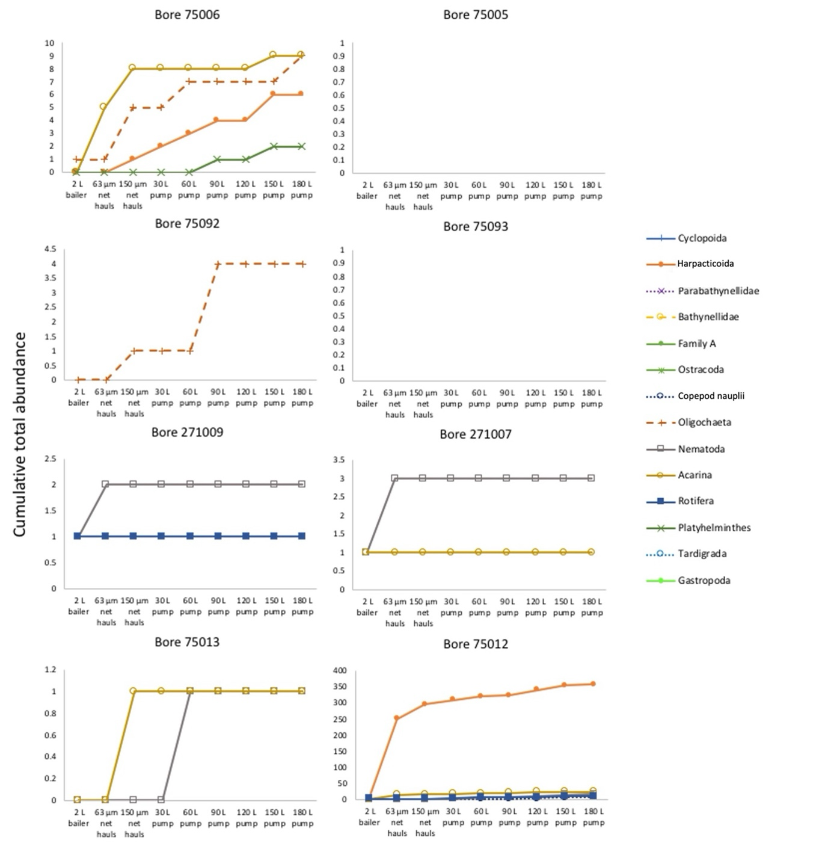
Figure A5.1. Cumulative abundance of individual taxa using different sampling methods in each bore
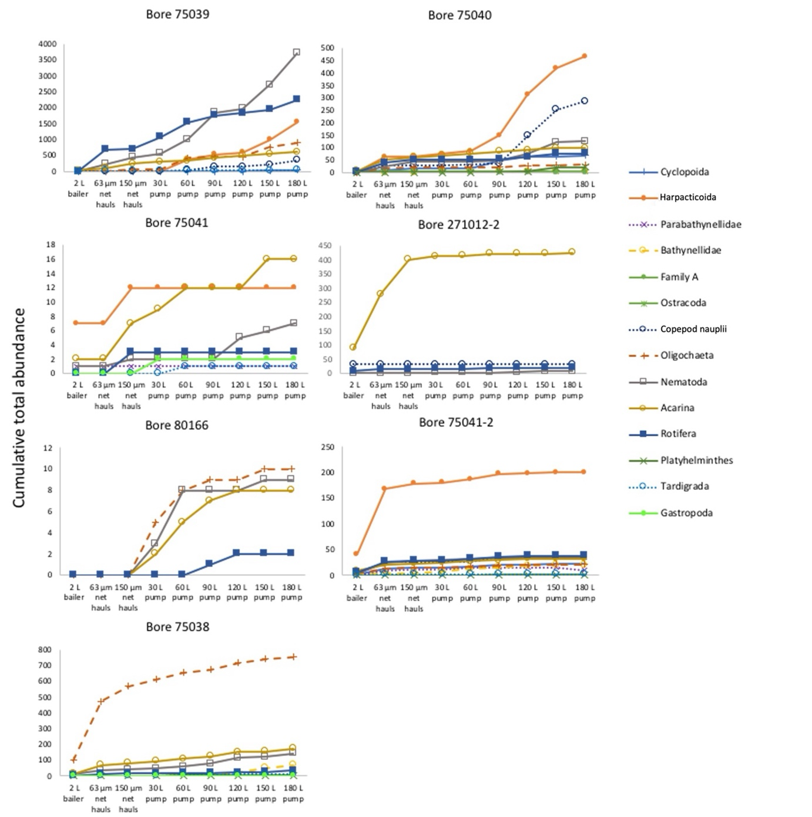
Figure A5.1 cont. Cumulative abundance of individual taxa using different sampling methods in each bore

Appendix 6. Stygofauna abundance by sampling method
Table A6.1. Abundance of individual taxa using different sampling methods (data combined for the 15 bores within the study area)
- | Cyclopoida | Harpacticoida | Copepod nauplii | Parabathynellidae | Bathynellidae | Family A | Ostracoda | Oligochaeta | Nematoda | Acarina | Rotifera | Platyhelminthes | Tardigrada | Gastropoda
2 L bailer | 1 | 51 | 35 | 1 | 1 | 0 | 0 | 109 | 31 | 149 | 20 | 0 | 0 | 1
63 µm + 150 µm nets | 31 | 500 | 52 | 11 | 3 | 4 | 1 | 548 | 529 | 691 | 798 | 0 | 15 | 0
Pump | 94 | 2043 | 627 | 6 | 86 | 0 | 0 | 1064 | 3499 | 559 | 1619 | 27 | 37 | 2

Appendix 7. Water quality data
Table A7.1. Physico-chemical parameters in 2 L and 180 L samples from the 15 study bores
Bore ID | Unit | 75006 | 75006 | 75005 | 75005 | 75092 | 75092 | 75093 | 75093 | 271009 | 271009 | 271007 | 271007 | 75013 | 75013 | 75012 | 75012
Date (2022) | - | 4/2 | 4/2 | 4/2 | 4/2 | 4/2 | 4/2 | 4/2 | 4/2 | 7/2 | 7/2 | 7/2 | 7/2 | 7/2 | 7/2 | 7/2 | 7/2
Volume removed | L | 2 | 180 | 2 | 180 | 2 | 90ª | 2 | 180 | 2 | 180 | 2 | 180 | 2 | 180 | 2 | 180
Dissolved oxygen | mg/L | 6.77 | 7.22 | 7.07 | 5.79 | 7.59 | 6.59 | 2.21 | 4.96 | 7.71 | 6.97 | 2.32 | 4.37 | 6.81 | 5.73 | 4.96 | 3.38
Electrical conductivity | µS/cm | 40.7 | 29.6 | 40.6 | 37.6 | 75.5 | 116.8 | 340.7 | 378.1 | 141.5 | 264.3 | 128.8 | 154.8 | 114.0 | 128.9 | 128.9 | 133.0
Oxidation-reduction potential | mV | 234.4 | 278.8 | 238.4 | 443.1 | 88.0 | 199.2 | 185.1 | 163.8 | 203.0 | 255.0 | 47.5 | 388.3 | 282.9 | 690.5 | 347.3 | 342.2
pH | - | 6.81 | 4.98 | 5.20 | 4.55 | 6.26 | 6.06 | 4.88 | 4.94 | 5.23 | 5.16 | 6.26 | 3.96 | 6.81 | 4.14 | 4.29 | 3.94
Temperature | °C | 13.5 | 14.0 | 14.3 | 15.0 | 18.7 | 20* | 18.0 | 17.2 | 17.8 | 18.0 | 19.7 | 22.2 | 18.4 | 17.8 | 16.8 | 17.2
Alkalinity | (meq/L) |  | 0.264 | - | -0.114 | - | 0.423 | - | 0.230 | - | -0.102 | - | 0.191 | - | -0.013 | - | 0.185
Dissolved organic carbon | mg/L | 1.60 | <0.61 | <0.61 | <0.61 | <0.61 | 3.50 | 1.90 | 2.00 | 0.43 | 0.71 | 1.90 | 5.40 | 0.34 | 0.25 | 0.92 | 5.10
Total organic carbonª | mg/L | 3.90 | 0.66 | <0.61 | 3.00 | <0.61 | 8.30 | 3.10 | 4.60 | 1.40 | nd | 4.10 | nd | 0.66 | 0.88 | 0.80 | nd
Sulfate | mg/L | 2 | 2 | <1 | <1 | 2 | 2 | 11 | 9 | <1 | 6 | 13 | 4 | 2 | 3 | 13 | <1
Ferrous iron | mg/L | <0.05 | <0.05 | <0.05 | <0.05 | 0.05 | <0.05 | 4.57 | 11.1 | <0.05 | <0.05 | 0.45 | <0.05 | <0.05 | <0.05 | <0.05 | 0.16
Ammonia as N | mg/L | 0.07 | <0.01 | 0.02 | 0.04 | <0.01 | 0.01 | 0.11 | 0.07 | 0.02 | <0.01 | 0.71 | 0.1 | <0.01 | <0.01 | 0.01 | <0.01
Nitrite as N | mg/L | <0.01 | <0.01 | <0.01 | <0.01 | <0.01 | <0.01 | <0.01 | <0.01 | <0.01 | <0.01 | <0.01 | <0.01 | <0.01 | <0.01 | <0.01 | <0.01
Nitrate as N | mg/L | 0.65 | 0.08 | 0.5 | 0.31 | 1.69 | 0.82 | 0.01 | <0.01 | 15.2 | 17.9 | 1.84 | 4 | 4.15 | 5.7 | 1.14 | 0.95
Nitrite plus nitrate as N (NOx) | mg/L | 0.65 | 0.08 | 0.5 | 0.31 | 1.69 | 0.82 | 0.01 | <0.01 | 15.2 | 17.9 | 1.84 | 4 | 4.15 | 5.7 | 1.14 | 0.95
Total Kjeldahl nitrogen | mg/L | 0.4 | 0.1 | 0.2 | 3.3 | 0.4 | 0.3 | 0.3 | 4.6 | 1.6 | 4.2 | 2.1 | 4.4 | 0.8 | 1.1 | 0.3 | 0.2
Total nitrogen as N (TKN + NOx) | mg/L | 1 | 0.2 | 0.7 | 3.6 | 2.1 | 1.1 | 0.3 | 4.6 | 16.8 | 22.1 | 3.9 | 8.4 | 5 | 6.8 | 1.4 | 1.2
Total phosphorus as P | mg/L | 0.09 | 0.1 | 0.04 | 6.39 | 0.02 | 0.05 | 0.08 | 2.42 | 0.23 | 1.26 | 0.4 | 2.4 | 0.02 | 0.02 | 0.02 | 0.04
Reactive phosphorus as P | mg/L | 0.03 | <0.01 | <0.01 | <0.01 | <0.01 | <0.01 | <0.01 | <0.01 | <0.01 | <0.01 | 0.02 | <0.01 | <0.01 | <0.01 | <0.01 | 0.28
ªTotal volume pumped was 90 L
nd = concentrations not determined as excessive turbidity resulted in instrumental artefacts
Table A7.1 cont. Physico-chemical parameters in 2 L and 180 L samples from the 15 study bores
Bore ID | Unit | 75039 | 75039 | 75040 | 75040 | 75041 | 75041 | 271012-2 | 271012-2 | 80166 | 80166 | 75041/2 | 75041/2 | 75038 | 75038
Date (2022) | - | 7/2 | 7/2 | 8/2 | 8/2 | 8/2 | 8/2 | 8/2 | 8/2 | 8/2 | 8/2 | 23/2 | 23/2 | 23/2 | 23/2
Volume removed | L | 2 | 180 | 2 | 180 | 2 | 180 | 2 | 180 | 2 | 180 | 2 | 180 | 2 | 180
Dissolved oxygen | mg/L | 2.54 | 4.81 | 4.15 | 2.27 | 5.06 | 4.72 | 5.48 | 6.44 | 7.34 | 2.80 | 6.49 | 6.12 | 7.29 | 2.70
Electrical conductivity | µS/cm | 220.7 | 98.5 | 120.6 | 112.4 | 118.1 | 126.5 | 94.0 | 91.5 | 120.6 | 113.0 | 87.9 | 69.9 | 36.3 | 75.5
Oxidation-reduction potential | mV | NR | 196.9 | 175.6 | 231.1 | 219.1 | 335.8 | 211.2 | 272.4 | 279.5 | 278.5 | 290.4 | 414.0 | 154.8 | 258.6
pH | - | 5.92 | 4.81 | 4.83 | 4.63 | 4.54 | 4.02 | 4.76 | 4.18 | 5.44 | 4.38 | 4.89 | 3.72 | 6.29 | 5.21
Temperature | °C | 18.2 | 19.3 | 24.9 | 20.4 | 18.1 | 18.3 | 18.1 | 17.7 | 18.3 | 18.7 | 22.5 | 21.3 | 18.7 | 19.3
Alkalinity | (meq/L) | - | -0.292 | - | -0.308 | - | 0.057 | - | 0.421 | - | 0.144 | - | 0.305 | - | 0.243
Dissolved organic carbon | mg/L | 12 | 2.20 | 1.80 | 1.30 | 1.10 | 0.40 | 0.92 | 0.27 | 1.60 | 0.10 | 1.10 | 0.72 | 12 | 1.0
Total organic carbon | mg/L | nd | nd | 2.70 | nd | 2.70 | 0.18 | nd | 0.50 | 2.90 | 0.25 | 1.70 | 0.87 | nd | nd
Sulfate | mg/L | <1 | 2.0 | 25 | 30 | <1 | 1.0 | <1 | <1 | 4.0 | 3.0 | 22 | 25 | 1.0 | 9.0
Ferrous iron | mg/L | 0.28 | <0.05 | 0.64 | <0.05 | 0.28 | <0.05 | 0.3 | <0.05 | <0.05 | <0.05 | 0.11 | 0.05 | 0.09 | 0.07
Ammonia as N | mg/L | 0.74 | 0.3 | 0.44 | 0.02 | 0.25 | 0.01 | 0.02 | <0.01 | 0.01 | <0.01 | 0.04 | 0.01 | 1.55 | 2.13
Nitrite as N | mg/L | <0.01 | 0.01 | <0.01 | <0.01 | <0.01 | <0.01 | <0.01 | <0.01 | <0.01 | <0.01 | 0.01 | 0.01 | 0.01 | 0.01
Nitrate as N | mg/L | 0.06 | 1.11 | 0.24 | 0.02 | 5.43 | 5.09 | 3.35 | 3.24 | 0.9 | 0.04 | 0.22 | 0.23 | 0.03 | 0.06
Nitrite plus nitrate as N (NOx) | mg/L | 0.06 | 1.12 | 0.24 | 0.02 | 5.43 | 5.09 | 3.35 | 3.24 | 0.9 | 0.04 | 0.22 | 0.23 | 0.03 | 0.06
Total Kjeldahl nitrogen | mg/L | 7 | 2 | 1.8 | 1.5 | 1.7 | 0.6 | 1.8 | 0.5 | 0.4 | <0.1 | 0.2 | 0.1 | 9 | 8.2
Total nitrogen as N (TKN + NOx) | mg/L | 7.1 | 3.1 | 2 | 1.5 | 7.1 | 5.7 | 5.2 | 3.7 | 1.3 | <0.1 | 0.4 | 0.2 | 9 | 8.3
Total phosphorus as P | mg/L | 1.08 | 0.8 | 0.22 | 0.86 | 0.31 | 0.07 | 0.24 | 0.16 | 0.14 | 0.02 | 0.06 | 0.02 | 1.03 | 4.25
Reactive phosphorus as P | mg/L | 0.3 | <0.01 | <0.01 | <0.01 | <0.01 | <0.01 | <0.01 | <0.01 | 0.11 | <0.01 | 0.01 | 0.01 | 0.1 | 0.01
nd = concentrations not determined as excessive turbidity resulted in instrumental artefacts
NR = not recorded

Table A7.2. Water quality data – dissolved major cations in 2 L and 180 L samples from the 15 study sites
Bore ID | Date (2022) | Ca (µg/L)  2 L | Ca (µg/L)  180 L | K (µg/L)  2 L | K (µg/L)  180 L | Mg (µg/L)  2 L | Mg (µg/L)  180 L | Na (µg/L)  2 L | Na (µg/L)  180 L
75006 | 4/2 | 1070 | 315 | 632 | 397 | 519 | 495 | 5340 | 3840
75005 | 4/2 | 106 | 188 | 249 | 143 | 739 | 686 | 4290 | 4670
75092 | 4/2 | 8470 | 4340 | 4050 | 2290 | 328 | 1220 | 3270 | 13500
75093 | 4/2 | 5810 | 3860 | 753 | 762 | 3240 | 3160 | 60600 | 63900
271009 | 7/2 | 4100 | 15100 | 558 | 655 | 5690 | 8890 | 17900 | 22900
271007 | 7/2 | 4440 | 3160 | 3350 | 938 | 2400 | 2640 | 7510 | 13400
75013 | 7/2 | 278 | 33.7 | 187 | 102 | 1910 | 2680 | 14100 | 16800
75012 | 7/2 | 1240 | 1490 | 345 | 269 | 3280 | 4040 | 14300 | 13100
75039 | 7/2 | 3300 | 1370 | 3380 | 1620 | 1330 | 3070 | 5170 | 9420
75040 | 8/2 | 3870 | 5350 | 945 | 1220 | 3610 | 3720 | 8390 | 7310
75041 | 8/2 | 1150 | 219 | 820 | 289 | 5230 | 4230 | 10400 | 12500
271012-2 | 8/2 | 639 | 125 | 1500 | 1430 | 1450 | 1640 | 12700 | 11800
80166 | 8/2 | 1310 | 129 | 1140 | 748 | 1810 | 1680 | 15900 | 14400
75041-2 | 23/2 | 4560 | 5030 | 1690 | 1620 | 1490 | 1810 | 4410 | 4650
75038 | 23/2 | 2410 | 481 | 1710 | 1350 | 747 | 713 | 2400 | 8320
Average | - | 2850 | 2746 | 1421 | 922 | 2252 | 2712 | 12445 | 14701

Table A7.3. Dissolved metal concentrations in 2 L and 180 L samples from the 15 study bores
Bore ID | Unit | 75006 | 75006 | 75005 | 75005 | 75092 | 75092 | 75093 | 75093 | 271009 | 271009 | 271007 | 271007 | 75013 | 75013 | 75012 | 75012
Date (2022) |  | 4/2 | 4/2 | 4/2 | 4/2 | 4/2 | 4/2 | 4/2 | 4/2 | 7/2 | 7/2 | 7/2 | 7/2 | 7/2 | 7/2 | 7/2 | 7/2
Sample volume | L | 2 | 180 | 2 | 180 | 2 | 180 | 2 | 180 | 2 | 180 | 2 | 180 | 2 | 180 | 2 | 180
Ag | µg/L | <0.033 | <0.033 | <0.033 | <0.033 | <0.033 | <0.033 | <0.033 | <0.033 | <0.033 | <0.033 | <0.033 | <0.033 | <0.033 | <0.033 | <0.033 | <0.033
Al | µg/L | 64 | 85 | 149 | 98 | 20 | 5.7 | 52 | 27 | 1100 | 28 | 14 | 36 | 68 | 124 | 388 | 530
As | µg/L | <0.058 | <0.058 | <0.058 | <0.058 | <0.058 | <0.058 | <0.058 | 0.2 | <0.058 | <0.058 | <0.058 | <0.058 | <0.058 | <0.058 | <0.058 | <0.058
B | µg/L | 2.4 | <1.2 | <1.2 | <1.2 | <1.2 | <1.2 | 2 | 1.3 | <1.2 | 1.5 | 4.6 | 3.1 | <1.2 | <1.2 | <1.2 | <1.2
Ba | µg/L | 0.54 | 0.48 | 0.48 | 0.48 | 3.1 | 1.9 | 4 | 3.9 | 2.4 | 3.2 | 0.83 | 15 | 0.49 | 0.59 | 1.4 | 0.95
Be | µg/L | 0.0049 | <0.0021 | <0.0021 | <0.0021 | <0.0021 | 0.0092 | 0.0325 | 0.0329 | 0.0284 | <0.0021 | <0.0021 | 0.0668 | <0.0021 | 0.0044 | <0.0021 | 0.0044
Bi | µg/L | <0.012 | <0.012 | <0.012 | <0.012 | <0.012 | <0.012 | <0.012 | <0.012 | <0.012 | <0.012 | <0.012 | <0.012 | <0.012 | <0.012 | <0.012 | <0.012
Cd | µg/L | 0.031 | <0.013 | <0.013 | <0.013 | <0.013 | <0.013 | <0.013 | <0.013 | 0.028 | <0.013 | <0.013 | <0.013 | <0.013 | <0.013 | <0.013 | <0.013
Ce | µg/L | 0.038 | 0.081 | 0.055 | 0.039 | <0.0029 | 0.018 | 0.019 | 0.021 | 2.11 | 0.216 | 0.027 | 0.021 | 0.04 | 0.084 | 0.174 | 0.265
Co | µg/L | 0.049 | 0.024 | 0.036 | 0.03 | <0.017 | 0.078 | 0.235 | 0.27 | 0.063 | 0.093 | <0.017 | <0.017 | 0.022 | 0.028 | 0.048 | 0.05
Cr | µg/L | <0.058 | <0.058 | <0.058 | <0.058 | <0.058 | <0.058 | <0.058 | <0.058 | <0.058 | <0.058 | <0.058 | <0.058 | <0.058 | <0.058 | <0.058 | <0.058
Cs | µg/L | <0.0062 | <0.0062 | <0.0062 | <0.0062 | <0.0062 | <0.0062 | <0.0062 | <0.0062 | <0.0062 | 0.01 | <0.0062 | <0.0062 | <0.0062 | <0.0062 | 0.01 | 0.01
Cu | µg/L | 1.74 | 0.066 | 0.108 | <0.055 | 2.4 | 0.627 | 1 | 0.19 | 0.19 | <0.055 | 0.326 | 0.06 | 0.29 | <0.055 | 0.27 | 0.058
Dy | µg/L | <0.0031 | 0.007 | 0.009 | <0.0031 | <0.0031 | <0.0031 | <0.0031 | 0.004 | 0.351 | 0.04 | <0.0031 | 0.007 | 0.003 | 0.008 | 0.057 | 0.099
Er | µg/L | <0.0016 | <0.0016 | 0.004 | 0.004 | <0.0016 | <0.0016 | 0.002 | 0.002 | 0.207 | 0.027 | <0.0016 | 0.005 | 0.004 | 0.008 | 0.037 | 0.045
Eu | µg/L | <0.0017 | <0.0017 | 0.002 | <0.0017 | <0.0017 | <0.0017 | <0.0017 | <0.0017 | 0.05 | 0.006 | <0.0017 | <0.0017 | <0.0017 | <0.0017 | 0.005 | 0.011
Fe | µg/L | 12 | 3.2 | 1.8 | 3.3 | 1 | 3.9 | 4210 | 7440 | 6.4 | 3.6 | 415 | 25 | 4.7 | 1.4 | 8 | 2.5
Ga | µg/L | <0.0088 | <0.0088 | <0.0088 | <0.0088 | <0.0088 | <0.0088 | <0.0088 | <0.0088 | <0.0088 | <0.0088 | <0.0088 | <0.0088 | <0.0088 | <0.0088 | <0.0088 | <0.0088
Gd | µg/L | 0.003 | 0.006 | 0.01 | 0.002 | <0.0012 | <0.0012 | <0.0012 | 0.002 | 0.346 | 0.042 | 0.002 | 0.003 | 0.004 | 0.011 | 0.045 | 0.073
Hf | µg/L | <0.0058 | <0.0058 | <0.0058 | <0.0058 | <0.0058 | <0.0058 | <0.0058 | <0.0058 | <0.0058 | <0.0058 | <0.0058 | <0.0058 | <0.0058 | <0.0058 | <0.0058 | <0.0058
Ho | µg/L | <0.0008 | <0.0008 | <0.0008 | <0.0008 | <0.0008 | <0.0008 | <0.0008 | <0.0008 | 0.071 | 0.007 | <0.0008 | 0.001 | <0.0008 | 0.001 | 0.013 | 0.018
In | µg/L | <0.015 | <0.015 | <0.015 | <0.015 | <0.015 | <0.015 | <0.015 | <0.015 | <0.015 | <0.015 | <0.015 | <0.015 | <0.015 | <0.015 | <0.015 | <0.015
Ir | µg/L | <0.0055 | <0.0055 | <0.0055 | <0.0055 | <0.0055 | <0.0055 | <0.0055 | <0.0055 | <0.0055 | <0.0055 | <0.0055 | <0.0055 | <0.0055 | <0.0055 | <0.0055 | <0.0055
La | µg/L | 0.012 | 0.015 | 0.035 | 0.022 | <0.0017 | 0.007 | 0.009 | 0.011 | 0.868 | 0.113 | 0.01 | 0.007 | 0.02 | 0.037 | 0.051 | 0.098
Li | µg/L | <0.06 | <0.06 | <0.06 | <0.06 | 2.45 | 1.1 | 0.223 | 0.255 | <0.06 | <0.06 | <0.06 | <0.06 | <0.06 | <0.06 | <0.06 | <0.06
Lu | µg/L | <0.0012 | <0.0012 | <0.0012 | <0.0012 | <0.0012 | <0.0012 | <0.0012 | <0.0012 | 0.028 | 0.002 | <0.0012 | 0.002 | <0.0012 | <0.0012 | 0.002 | 0.003
Mn | µg/L | 3 | 1.4 | 1.2 | 1.3 | 0.31 | 5.7 | 9.1 | 9 | 3.7 | 6.8 | 1.87 | 1.38 | 0.763 | 0.18 | 1.7 | 1.4
Mo | µg/L | <0.007 | <0.007 | <0.007 | <0.007 | <0.007 | <0.007 | <0.007 | <0.007 | <0.007 | <0.007 | <0.007 | <0.007 | <0.007 | <0.007 | <0.007 | <0.007
Nb | µg/L | <0.026 | <0.026 | <0.026 | <0.026 | <0.026 | <0.026 | <0.026 | <0.026 | <0.026 | <0.026 | <0.026 | <0.026 | <0.026 | <0.026 | <0.026 | <0.026
Nd | µg/L | 0.006 | 0.017 | 0.032 | 0.037 | <0.0025 | 0.003 | 0.021 | 0.011 | 1.54 | 0.166 | 0.006 | 0.021 | 0.029 | 0.051 | 0.132 | 0.242
Ni | µg/L | 0.35 | <0.043 | 0.36 | 0.13 | 0.05 | 0.17 | 0.38 | 0.53 | 0.14 | 0.12 | 0.06 | 0.1 | 0.13 | <0.043 | 0.14 | <0.043
Os | µg/L | <0.046 | <0.046 | <0.046 | <0.046 | <0.046 | <0.046 | <0.046 | <0.046 | <0.046 | <0.046 | <0.046 | <0.046 | <0.046 | <0.046 | <0.046 | <0.046
P | µg/L | 74 | <1.5 | <1.5 | <1.5 | <1.5 | <1.5 | <1.5 | <1.5 | <1.5 | <1.5 | 110 | <1.5 | 10 | <1.5 | 6.5 | <1.5
Pb | µg/L | 0.286 | <0.038 | 0.056 | <0.038 | <0.038 | <0.038 | <0.038 | 0.1 | 0.513 | <0.038 | 0.05 | 0.148 | 0.083 | <0.038 | 0.13 | <0.038
Pr | µg/L | <0.0008 | 0.005 | 0.009 | 0.007 | <0.0008 | 0.001 | 0.001 | 0.001 | 0.342 | 0.032 | 0.005 | 0.003 | 0.003 | 0.009 | 0.033 | 0.044
Rb | µg/L | 0.09 | 0.09 | 0.03 | 0.06 | 1.5 | 0.78 | 0.18 | 0.22 | 0.251 | 0.236 | 0.33 | 0.38 | 0.06 | 0.03 | 0.16 | 0.16
Re | µg/L | <0.0014 | <0.0014 | <0.0014 | <0.0014 | <0.0014 | <0.0014 | <0.0014 | <0.0014 | <0.0014 | <0.0014 | <0.0014 | <0.0014 | <0.0014 | <0.0014 | <0.0014 | <0.0014
Rh | µg/L | <0.021 | <0.021 | <0.021 | <0.021 | <0.021 | <0.021 | <0.021 | <0.021 | <0.021 | <0.021 | <0.021 | <0.021 | <0.021 | <0.021 | <0.021 | <0.021
Ru | µg/L | <0.0042 | <0.0042 | <0.0042 | <0.0042 | <0.0042 | <0.0042 | <0.0042 | <0.0042 | <0.0042 | <0.0042 | <0.0042 | <0.0042 | <0.0042 | <0.0042 | <0.0042 | <0.0042
S | µg/L | 1060 | 932 | 154 | 173 | 858 | 679 | 4080 | 3300 | 518 | 1710 | 4830 | 3970 | 842 | 613 | 4980 | 6430
Sb | µg/L | 0.06 | <0.041 | <0.041 | <0.041 | <0.041 | <0.041 | <0.041 | <0.041 | 0.07 | <0.041 | <0.041 | <0.041 | 0.28 | <0.041 | 0.12 | <0.041
Sc | µg/L | <0.047 | <0.047 | <0.047 | <0.047 | <0.047 | <0.047 | <0.047 | <0.047 | <0.047 | <0.047 | <0.047 | <0.047 | <0.047 | <0.047 | <0.047 | <0.047
Se | µg/L | <0.025 | <0.025 | <0.025 | <0.025 | <0.025 | <0.025 | <0.025 | <0.025 | <0.025 | <0.025 | <0.025 | <0.025 | <0.025 | <0.025 | <0.025 | <0.025
Si | µg/L | 1240 | 1220 | 1880 | 1960 | 914 | 2640 | 15000 | 14000 | 3690 | 3740 | 1910 | 2590 | 2900 | 2950 | 3080 | 2880
Sm | µg/L | 0.009 | 0.008 | 0.025 | 0.004 | <0.0025 | 0.008 | <0.0025 | <0.0025 | 0.337 | 0.027 | <0.0025 | <0.0025 | 0.004 | 0.004 | 0.022 | 0.068
Sn | µg/L | <0.15 | <0.15 | <0.15 | <0.15 | <0.15 | <0.15 | <0.15 | <0.15 | <0.15 | <0.15 | <0.15 | <0.15 | <0.15 | <0.15 | <0.15 | <0.15
Sr | µg/L | 0.66 | 0.51 | 0.17 | 0.23 | 12 | 6.3 | 4.8 | 3.5 | 1.4 | 2.8 | 1.8 | 3.7 | 0.23 | 0.11 | 1.5 | 1.7
Ta | µg/L | <0.017 | <0.017 | <0.017 | <0.017 | <0.017 | <0.017 | <0.017 | <0.017 | <0.017 | <0.017 | <0.017 | <0.017 | <0.017 | <0.017 | <0.017 | <0.017
Tb | µg/L | <0.0016 | <0.0016 | <0.0016 | <0.0016 | <0.0016 | <0.0016 | <0.0016 | <0.0016 | 0.055 | 0.005 | <0.0016 | <0.0016 | <0.0016 | <0.0016 | 0.008 | 0.011
Te | µg/L | <0.0008 | <0.0008 | 0.114 | <0.0008 | <0.0008 | <0.0008 | <0.0008 | <0.0008 | <0.0008 | <0.0008 | <0.0008 | <0.0008 | <0.0008 | <0.0008 | <0.0008 | <0.0008
Th | µg/L | <0.025 | <0.025 | <0.025 | <0.025 | <0.025 | <0.025 | <0.025 | <0.025 | <0.025 | <0.025 | <0.025 | <0.025 | <0.025 | <0.025 | <0.025 | <0.025
Tl | µg/L | <0.018 | <0.018 | <0.018 | <0.018 | <0.018 | <0.018 | <0.018 | <0.018 | <0.018 | <0.018 | <0.018 | <0.018 | <0.018 | <0.018 | <0.018 | <0.018
Tm | µg/L | <0.0011 | <0.0011 | <0.0011 | <0.0011 | <0.0011 | <0.0011 | <0.0011 | <0.0011 | 0.0273 | 0.0021 | <0.0011 | <0.0011 | <0.0011 | <0.0011 | 0.0043 | 0.0062
U | µg/L | <0.0027 | <0.0027 | <0.0027 | <0.0027 | <0.0027 | 0.006 | <0.0027 | <0.0027 | 0.006 | <0.0027 | <0.0027 | <0.0027 | <0.0027 | <0.0027 | 0.014 | 0.015
V | µg/L | <0.26 | <0.26 | <0.26 | <0.26 | <0.26 | <0.26 | <0.26 | <0.26 | <0.26 | <0.26 | <0.26 | <0.26 | <0.26 | <0.26 | <0.26 | <0.26
W | µg/L | <0.014 | <0.014 | <0.014 | <0.014 | <0.014 | <0.014 | <0.014 | <0.014 | <0.014 | <0.014 | <0.014 | <0.014 | <0.014 | <0.014 | <0.014 | <0.014
Y | µg/L | 0.008 | 0.015 | 0.032 | 0.019 | <0.0002 | 0.012 | 0.028 | 0.01 | 2.04 | 0.3 | 0.012 | 0.023 | 0.016 | 0.055 | 0.35 | 0.496
Yb | µg/L | 0.002 | 0.003 | 0.003 | 0.003 | <0.0013 | <0.0013 | <0.0013 | <0.0013 | 0.177 | 0.016 | <0.0013 | 0.01 | <0.0013 | <0.0013 | 0.02 | 0.038
Zn | µg/L | 8 | 0.26 | 0.89 | 0.92 | 0.7 | 1.9 | 3.9 | 4.3 | 12 | 0.78 | 1.1 | 0.55 | 16 | 0.33 | 12 | 0.41
Zr | µg/L | <0.022 | <0.022 | <0.022 | <0.022 | <0.022 | <0.022 | <0.022 | <0.022 | <0.022 | <0.022 | <0.022 | <0.022 | <0.022 | <0.022 | <0.022 | <0.022
Table A7.3 cont. Dissolved metal concentrations in 2 L and 180 L samples from the 15 study bores
Bore ID | Unit | 75039 | 75039 | 75040 | 75040 | 75041 | 75041 | 271012-2 | 271012-2 | 80166 | 80166 | 75041/2 | 75041/2 | 75038 | 75038
Date (2022) |  | 7/2 | 7/2 | 8/2 | 8/2 | 8/2 | 8/2 | 8/2 | 8/2 | 8/2 | 8/2 | 23/2 | 23/2 | 23/2 | 23/2
Sample volume | L | 2 | 180 | 2 | 180 | 2 | 180 | 2 | 180 | 2 | 180 | 2 | 180 | 2 | 180
Ag | µg/L | <0.033 | <0.033 | <0.033 | <0.033 | <0.033 | <0.033 | <0.033 | <0.033 | <0.033 | <0.033 | <0.033 | <0.033 | <0.033 | <0.033
Al | µg/L | 535 | 78 | 57 | 35 | 119 | 321 | 7.3 | 51 | 200 | 261 | 170 | 257 | 499 | 11
As | µg/L | <0.058 | <0.058 | <0.058 | <0.058 | <0.058 | <0.058 | <0.058 | <0.058 | <0.058 | <0.058 | <0.058 | <0.058 | <0.058 | <0.058
B | µg/L | 1.6 | 1.3 | <1.2 | <1.2 | <1.2 | <1.2 | <1.2 | <1.2 | <1.2 | <1.2 | <1.2 | <1.2 | <1.2 | <1.2
Ba | µg/L | 0.4 | 0.6 | 0.54 | 0.48 | 0.52 | 1.1 | 2.2 | 4 | 1.6 | 2 | 0.51 | 0.53 | 0.16 | 0.39
Be | µg/L | <0.0021 | <0.0021 | <0.0021 | <0.0021 | <0.0021 | <0.0021 | 0.0092 | <0.0021 | 0.0761 | 0.0476 | 0.0044 | <0.0021 | <0.0021 | 0.0044
Bi | µg/L | <0.012 | <0.012 | <0.012 | <0.012 | <0.012 | <0.012 | <0.012 | <0.012 | <0.012 | <0.012 | <0.012 | <0.012 | <0.012 | <0.012
Cd | µg/L | <0.013 | <0.013 | <0.013 | <0.013 | <0.013 | <0.013 | <0.013 | <0.013 | <0.013 | <0.013 | <0.013 | <0.013 | <0.013 | <0.013
Ce | µg/L | 0.055 | 0.043 | 0.041 | 0.054 | 0.034 | 0.108 | <0.0029 | 0.025 | 0.067 | 0.137 | 0.071 | 0.14 | 0.02 | 0.003
Co | µg/L | <0.017 | 0.06 | <0.017 | <0.017 | 0.03 | 0.04 | 0.07 | 0.07 | 0.384 | 0.41 | <0.017 | <0.017 | <0.017 | <0.017
Cr | µg/L | 0.062 | <0.058 | <0.058 | <0.058 | <0.058 | <0.058 | <0.058 | <0.058 | 0.074 | <0.058 | <0.058 | <0.058 | <0.058 | <0.058
Cs | µg/L | <0.0062 | 0.01 | <0.0062 | <0.0062 | <0.0062 | <0.0062 | <0.0062 | <0.0062 | <0.0062 | <0.0062 | <0.0062 | <0.0062 | <0.0062 | 0.02
Cu | µg/L | 0.28 | 0.083 | <0.055 | 0.08 | 0.2 | <0.055 | 0.09 | <0.055 | 1.2 | 0.23 | 0.27 | 0.11 | 0.71 | <0.055
Dy | µg/L | <0.0031 | 0.005 | <0.0031 | <0.0031 | 0.009 | 0.015 | <0.0031 | 0.003 | 0.014 | 0.028 | 0.007 | 0.008 | <0.0031 | <0.0031
Er | µg/L | <0.0016 | 0.003 | <0.0016 | <0.0016 | 0.004 | 0.01 | <0.0016 | <0.0016 | 0.012 | 0.014 | <0.0016 | 0.003 | <0.0016 | <0.0016
Eu | µg/L | <0.0017 | <0.0017 | <0.0017 | <0.0017 | <0.0017 | 0.003 | <0.0017 | <0.0017 | <0.0017 | 0.004 | <0.0017 | <0.0017 | <0.0017 | <0.0017
Fe | µg/L | 409 | 32 | 557 | 13 | 248 | 5.4 | 286 | 37 | 18 | 3.9 | 56 | 7.3 | 273 | 16
Ga | µg/L | <0.0088 | <0.0088 | <0.0088 | <0.0088 | <0.0088 | <0.0088 | <0.0088 | <0.0088 | <0.0088 | <0.0088 | <0.0088 | <0.0088 | <0.0088 | <0.0088
Gd | µg/L | <0.0012 | <0.0012 | <0.0012 | 0.012 | 0.01 | 0.014 | <0.0012 | 0.007 | 0.013 | 0.016 | 0.008 | 0.006 | 0.003 | <0.0012
Hf | µg/L | <0.0058 | <0.0058 | <0.0058 | <0.0058 | <0.0058 | <0.0058 | <0.0058 | <0.0058 | <0.0058 | <0.0058 | <0.0058 | <0.0058 | <0.0058 | <0.0058
Ho | µg/L | 0.002 | <0.0008 | <0.0008 | 0.001 | 0.001 | 0.002 | <0.0008 | <0.0008 | 0.002 | 0.005 | 0.001 | <0.0008 | <0.0008 | <0.0008
In | µg/L | <0.015 | <0.015 | <0.015 | <0.015 | <0.015 | <0.015 | <0.015 | <0.015 | <0.015 | <0.015 | <0.015 | <0.015 | <0.015 | <0.015
Ir | µg/L | <0.0055 | <0.0055 | <0.0055 | <0.0055 | <0.0055 | <0.0055 | <0.0055 | <0.0055 | <0.0055 | <0.0055 | <0.0055 | <0.0055 | <0.0055 | <0.0055
La | µg/L | 0.015 | 0.015 | 0.02 | 0.016 | 0.018 | 0.045 | <0.0017 | 0.012 | 0.033 | 0.053 | 0.05 | 0.064 | 0.008 | <0.0017
Li | µg/L | <0.06 | <0.06 | <0.06 | <0.06 | <0.06 | <0.06 | <0.06 | 0.085 | 0.267 | 0.287 | <0.06 | <0.06 | <0.06 | <0.06
Lu | µg/L | <0.0012 | <0.0012 | <0.0012 | <0.0012 | <0.0012 | <0.0012 | <0.0012 | <0.0012 | <0.0012 | 0.002 | <0.0012 | <0.0012 | <0.0012 | <0.0012
Mn | µg/L | 5.3 | 1.6 | 2 | 0.21 | 3 | 1.6 | 3.7 | 1 | 6.5 | 5.3 | 1.1 | 1.2 | 4.5 | 1.9
Mo | µg/L | <0.007 | <0.007 | <0.007 | <0.007 | 0.01 | <0.007 | <0.007 | <0.007 | <0.007 | <0.007 | <0.007 | <0.007 | <0.007 | <0.007
Nb | µg/L | <0.026 | <0.026 | <0.026 | <0.026 | <0.026 | <0.026 | <0.026 | <0.026 | <0.026 | <0.026 | <0.026 | <0.026 | <0.026 | <0.026
Nd | µg/L | 0.023 | 0.021 | 0.019 | 0.026 | 0.035 | 0.064 | <0.0025 | 0.018 | 0.066 | 0.059 | 0.025 | 0.073 | 0.017 | <0.0025
Ni | µg/L | 0.07 | 0.06 | 0.05 | <0.043 | 0.26 | <0.043 | 0.1 | 0.09 | 0.64 | 0.3 | <0.043 | 0.05 | 0.15 | <0.043
Os | µg/L | <0.046 | <0.046 | <0.046 | <0.046 | <0.046 | <0.046 | <0.046 | <0.046 | <0.046 | <0.046 | <0.046 | <0.046 | <0.046 | <0.046
P | µg/L | 410 | 18 | <1.5 | <1.5 | 34 | <1.5 | 10 | <1.5 | 120 | <1.5 | <1.5 | <1.5 | 240 | 1.6
Pb | µg/L | 0.04 | <0.038 | 0.04 | <0.038 | 0.05 | 0.054 | <0.038 | <0.038 | 0.088 | 0.051 | 0.91 | 0.09 | <0.038 | <0.038
Pr | µg/L | 0.002 | 0.004 | 0.006 | 0.002 | 0.011 | 0.014 | <0.0008 | 0.001 | 0.012 | 0.022 | 0.01 | 0.016 | 0.004 | 0.001
Rb | µg/L | 0.22 | 0.17 | 0.15 | 0.109 | 0.07 | 0.16 | 0.6 | 0.45 | 0.41 | 0.52 | 0.21 | 0.23 | 0.16 | 0.27
Re | µg/L | <0.0014 | <0.0014 | <0.0014 | <0.0014 | <0.0014 | <0.0014 | <0.0014 | <0.0014 | <0.0014 | <0.0014 | <0.0014 | <0.0014 | <0.0014 | <0.0014
Rh | µg/L | <0.021 | <0.021 | <0.021 | <0.021 | <0.021 | <0.021 | <0.021 | <0.021 | <0.021 | <0.021 | <0.021 | <0.021 | <0.021 | <0.021
Ru | µg/L | <0.0042 | <0.0042 | <0.0042 | <0.0042 | <0.0042 | <0.0042 | <0.0042 | <0.0042 | <0.0042 | <0.0042 | <0.0042 | <0.0042 | <0.0042 | <0.0042
S | µg/L | 920 | 899 | 9450 | 11300 | 433 | 510 | 428 | 407 | 1670 | 1350 | 8450 | 9360 | 578 | 3360
Sb | µg/L | <0.041 | <0.041 | <0.041 | <0.041 | <0.041 | <0.041 | <0.041 | <0.041 | 0.22 | <0.041 | <0.041 | <0.041 | <0.041 | <0.041
Sc | µg/L | <0.047 | <0.047 | <0.047 | <0.047 | <0.047 | <0.047 | <0.047 | <0.047 | <0.047 | <0.047 | <0.047 | <0.047 | <0.047 | <0.047
Se | µg/L | <0.025 | <0.025 | <0.025 | <0.025 | <0.025 | <0.025 | <0.025 | <0.025 | <0.025 | <0.025 | <0.025 | <0.025 | <0.025 | <0.025
Si | µg/L | 1100 | 2610 | 1580 | 1290 | 2860 | 3290 | 4810 | 4690 | 3970 | 3910 | 1640 | 1740 | 890 | 1960
Sm | µg/L | <0.0025 | 0.01 | <0.0025 | 0.008 | 0.012 | 0.016 | <0.0025 | 0.004 | 0.014 | 0.014 | 0.008 | 0.008 | 0.006 | <0.0025
Sn | µg/L | <0.15 | <0.15 | <0.15 | <0.15 | <0.15 | <0.15 | <0.15 | <0.15 | <0.15 | <0.15 | <0.15 | <0.15 | <0.15 | <0.15
Sr | µg/L | 1 | 0.92 | 2.3 | 2.9 | 1.5 | 1.1 | 0.86 | 0.64 | 0.91 | 0.55 | 0.71 | 1.1 | 0.76 | 0.73
Ta | µg/L | <0.017 | <0.017 | <0.017 | <0.017 | <0.017 | <0.017 | <0.017 | <0.017 | <0.017 | <0.017 | <0.017 | <0.017 | <0.017 | <0.017
Tb | µg/L | <0.0016 | <0.0016 | <0.0016 | <0.0016 | <0.0016 | 0.003 | <0.0016 | <0.0016 | 0.002 | 0.004 | <0.0016 | <0.0016 | <0.0016 | <0.0016
Te | µg/L | <0.0008 | <0.0008 | 0.06 | <0.0008 | <0.0008 | <0.0008 | <0.0008 | <0.0008 | <0.0008 | <0.0008 | <0.0008 | <0.0008 | <0.0008 | 0.142
Th | µg/L | <0.025 | <0.025 | <0.025 | <0.025 | <0.025 | <0.025 | <0.025 | <0.025 | <0.025 | <0.025 | <0.025 | <0.025 | <0.025 | <0.025
Tl | µg/L | <0.018 | <0.018 | <0.018 | <0.018 | <0.018 | <0.018 | <0.018 | <0.018 | <0.018 | <0.018 | <0.018 | <0.018 | <0.018 | <0.018
Tm | µg/L | <0.0011 | <0.0011 | <0.0011 | <0.0011 | <0.0011 | <0.0011 | <0.0011 | <0.0011 | <0.0011 | 0.0023 | <0.0011 | <0.0011 | <0.0011 | <0.0011
U | µg/L | <0.0027 | <0.0027 | <0.0027 | <0.0027 | <0.0027 | 0.004 | <0.0027 | 0.006 | 0.005 | 0.028 | 0.004 | <0.0027 | <0.0027 | <0.0027
V | µg/L | <0.26 | <0.26 | <0.26 | <0.26 | <0.26 | <0.26 | <0.26 | <0.26 | <0.26 | <0.26 | <0.26 | <0.26 | <0.26 | <0.26
W | µg/L | <0.014 | <0.014 | <0.014 | <0.014 | <0.014 | <0.014 | <0.014 | <0.014 | <0.014 | <0.014 | <0.014 | <0.014 | <0.014 | <0.014
Y | µg/L | 0.005 | 0.007 | 0.013 | 0.016 | 0.02 | 0.084 | <0.0002 | 0.032 | 0.127 | 0.23 | 0.009 | 0.028 | 0.02 | <0.0002
Yb | µg/L | <0.0013 | 0.002 | <0.0013 | <0.0013 | 0.008 | 0.006 | <0.0013 | <0.0013 | 0.008 | 0.02 | 0.002 | 0.004 | <0.0013 | 0.002
Zn | µg/L | 1 | 0.9 | 0.96 | 1.5 | 1.7 | 0.98 | 1.2 | 0.36 | 35 | 3.1 | 0.7 | 0.27 | 1.4 | 0.53
Zr | µg/L | 0.051 | <0.022 | <0.022 | <0.022 | <0.022 | <0.022 | <0.022 | <0.022 | <0.022 | <0.022 | <0.022 | <0.022 | 0.03 | <0.022



