Using impact pathway diagrams based on ecohydrological conceptualisation in environmental impact assessment

# Background

Environmental impact assessment seeks to predict potential impacts of a proposed project on valued assets such as groundwaters, surface waters and their associated biota and ecological processes. Typically the assessment involves a multidisciplinary team of consultant experts with skills in, for example, earth sciences, hydrogeology, hydrology, ecotoxicology and ecology. These experts work together to predict what, how, when and where impacts from the project might affect valued assets. The result is one or more reports that usually include multiple appendices, large datasets and numerical and analytical models.

However, very few of these reports use pictorial conceptual models to bring this information together. A powerful approach for assessing potential impacts of a project is to draw up an ecohydrological conceptual model (ECM) of how hydrological (surface water and groundwater) components relate to ecological ones (e.g., animal and plant species, communities and ecosystems) in a project area.

This ECM can then be used to generate one or more impact pathway diagrams (IPDs) to show how a proposed project might affect water-dependent assets. When superimposed on maps of the project area, IPDs indicate where such impacts might occur and which assets might be affected. IPDs should be supported by narratives describing the key points of concern, knowledge gaps and associated confidence levels.

The approach has many benefits. It is a valuable tool to develop and illustrate the lines of sight from stressors to receptors in environmental impact assessment. Applying it enhances interactions among the proponent’s consultant team when they collaborate early to prepare IPDs of what, where and how key impacts might occur and what mitigation options are feasible. This early collaboration improves efficiency and reduces the cost of initial baseline data collection because surveying can target key pathways and receptors identified in preliminary IPDs. The final diagrams presented in the assessment document integrate evidence from its different sections to provide visual summaries that help readers quickly grasp the main concerns.

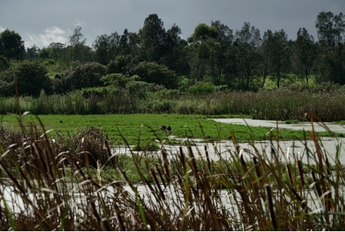

Hunter wetland © Department of Climate Change, Energy, the Environment and Water

# Context

Given the approach’s many benefits in environmental impact assessment, the IESC commissioned an Explanatory Note to describe why and how to draw up an ECM to generate IPDs and accompanying maps and narratives. This evidence-based ECM is crucial because most impacts on water-dependent assets are likely to be conveyed by ecohydrological pathways.

The Explanatory Note starts by describing ecohydrological IPDs, their ‘building blocks’ and the benefits of this approach to environmental impact assessment, supported by three examples from the mining and gas extraction literature. The next section describes an approach to generating IPDs based on an ecohydrological conceptualisation, illustrating it with a worked example of a hypothetical open-cut coal mine in the Bowen Basin, Queensland.

The Explanatory Note concludes with brief sections on how to use IPDs to portray the impact pathways from activities of a given development to vulnerable receptors, identify relevant knowledge gaps, guide the design of monitoring programs, and identify and justify potential strategies to avoid or mitigate environmental impacts.

# The ‘building blocks’ of IPDs

Pathways in IPDs are typically represented as linking consecutive types of components (Figure 1), starting with a driver and ending in receptors, which in this context are water-dependent assets. **Drivers**, defined as major external forces that have large-scale influences, can be natural, such as climate and geology; or anthropogenic (human induced), such as climate change and resource development.

In IPDs, a **source** is any entity or action that generates or increases stressors in the environment. In environmental impact assessment, we are mainly interested in sources associated with anthropogenic drivers associated with a proposed development. These can be entities (e.g., mine pits, wastewater dams, roads) or activities (e.g., vegetation clearance, civil construction, exploratory drilling).

**Stressors** are physical, chemical or biological entities that can cause an adverse response. It is useful to also specify the change in the entity that causes stress. For example, the stressor salinity may not cause an adverse response in a particular species of freshwater fish until it exceeds some threshold level. An IPD can also illustrate how multiple stressors combine to affect a process, potentially causing adverse responses sooner.

The term **process** describes the way(s) in which a stressor is conveyed from one or more sources to one or more receptors. Therefore, processes can precede and follow stressors in the pathway (Figure 1). These processes are usually ecological and/or hydrological ones, which is why we strongly advocate that the consultant team initially develop an ecohydrological conceptualisation from which to derive IPDs.

Impact pathways end in **receptors** (Figure 1). In the context of this Explanatory Note, receptors are primarily water-dependent assets such as wetlands, rivers, streams and groundwater-dependent ecosystems (GDEs), and their hydrology, water quality, microbes, plants, animals and ecological processes.

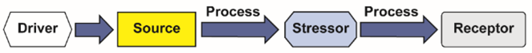

Figure 1. The consecutive categories of components along an impact pathway in a typical IPD

# How to generate IPDs

When starting a new research project, members of multidisciplinary teams routinely generate preliminary conceptual models to help them discuss their shared understanding, develop hypotheses and identify knowledge gaps. Information and data are then collected to address these gaps so that the conceptual models can be progressively refined.

The same approach is ideal for environmental impact assessment of a proposed development. The Explanatory Note presents an eight-step workflow (Figure 2) to generate an initial ECM and preliminary and final IPDs, sub-models, maps and associated narratives for environmental impact assessment, and illustrates its use with a worked example of a hypothetical proposal for an open-cut coal mine.

The collaborative process should start as soon as possible. The first four steps of the workflow involve mapping impact sources, stressors, ecohydrological pathways and receptors onto diagrams of the **potential impact area** (PIA), defined as the maximum areal extent of potential impacts of the development. This is done as early as possible, and allows the proponent and consultant experts to identify information gaps and discuss how best to address them.

These first four steps generate the initial ECM upon which the IPDs will be based. They also help the team of consultant experts become familiar with the project area and where relevant baseline data will be needed to improve understanding of the current state of the receptors in the PIA.

Once these steps have been completed, the team is ready to discuss and tabulate potential impact pathways between sources and receptors (Step 5) and construct a preliminary IPD and any sub-models that may be needed (Step 6). The seventh step involves mapping these impact pathways onto the PIA to identify the locations of particularly vulnerable receptors and areas where baseline data are needed to establish initial pre-development conditions. The last step, done after baseline data and other information have been collected, is to revise the IPDs, maps and narratives into final versions for the environmental impact assessment report.

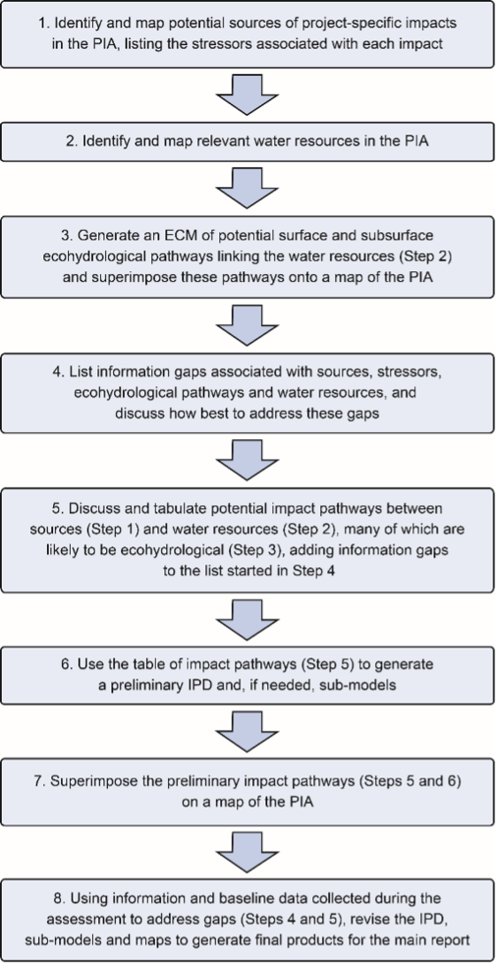

Figure 2. An eight-step workflow to generate an initial ECM and preliminary and final IPDs, sub-models, maps and associated narratives for environmental impact assessment.

Note: Although presented as a linear workflow, these steps can be iterative loops (e.g., data collected during Step 8 can inform further meetings at Step 5).

**A worked example**

The worked example described in the Explanatory Note is a hypothetical open-cut coal mine in the Isaac River catchment of Queensland’s Bowen Basin, targeting the Leichhardt and Vermont coal seams. Predicted average extraction rate is 2 million tonnes per annum of run-of-mine coal over nine years. The final pit is to be approximately 1.5 km by 2 km with a maximum depth of 170 m, and will be backfilled to leave no void in the final landform.

Approximately 1.5 km of an ephemeral stream (North Creek) will be diverted around the pit (Figure 3). An ephemeral tributary of North Creek will also be diverted several hundred metres into the northern sediment dam. Riparian vegetation along the Isaac River and North Creek is classified as a ‘high potential GDE’ and is likely to be used by wildlife such as Koala (*Phascolarctos cinereus*) and Greater Glider (*Petauroides volans*). Another ‘high potential GDE’ is Wetland W, designated as a wetland of high ecological significance (HES) by the Queensland Government.

Alluvial sediments have been mapped along the Isaac River and lower North Creek in the PIA. In addition to being accessible to groundwater-dependent vegetation, this alluvial groundwater is likely to support stygofauna. Predicted contours (>2 m) of maximum project-specific drawdown in the alluvial sediments typically extend less than 1 km from the pit except along the intercepted channel of North Creek and the confluence with the Isaac River.

The limited space in this summary guide precludes presenting all the details of the hypothetical worked example and the outputs given in the Explanatory Note. Instead, just two outputs are shown, to give an idea of what IPDs look like and how they help summarise potential impact pathways for a proposed development like an open-cut coal mine.

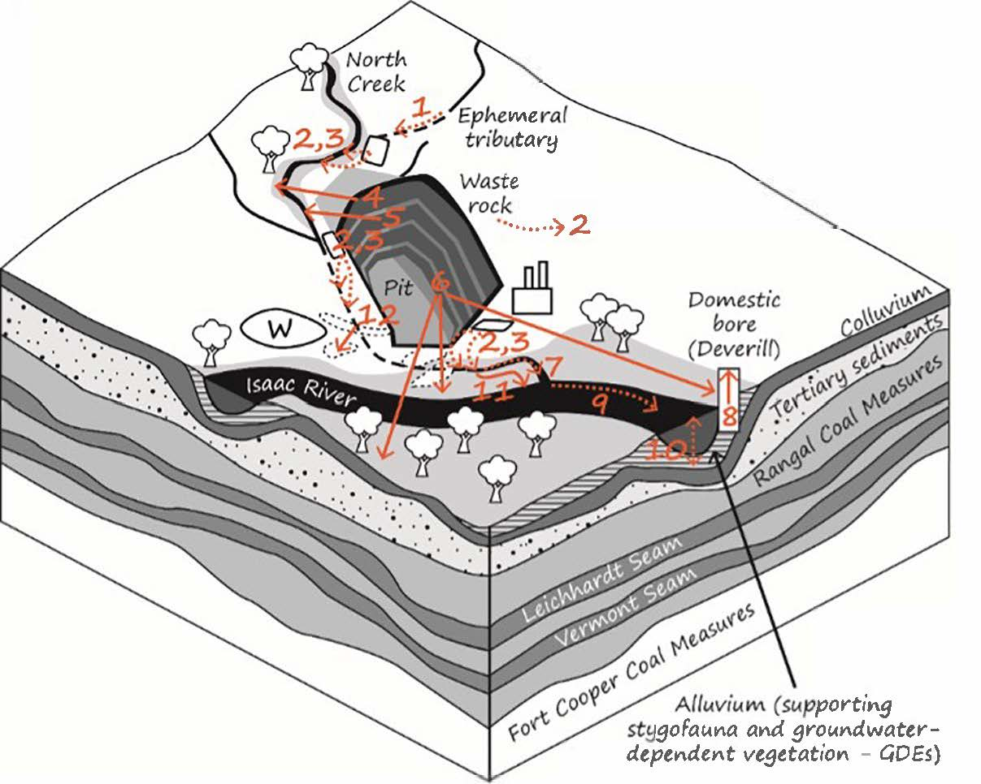

Figure 3. Twelve potential impact pathways suggested during the initial meeting of the expert consultants and superimposed on an oblique-view diagram of the PIA of the hypothetical example.

Dashed lines indicate uncertain pathways; numbered boxes represent the 12 pathways described in Table 1. Representation of geological layers is simplified for this example and does not reflect the actual geology of this area. Full details of this example are given in the Explanatory Note.

Table 1. Twelve potential impact pathways (Figure 3) suggested during the initial meeting of the expert consultants

| **Pathway number in Figure 3** | **Description of hypothesised pathway** |
| --- | --- |
| 1 | Changes in flow regime due to ephemeral channel diversion |
| 2 | Potentially contaminated seepage, either from dams or through the waste-rock pile |
| 3 | Controlled and uncontrolled releases from sediment and mine-affected water dams that may alter water quality and flow regime in North Creek |
| 4 | **Drawdown that dewaters alluvial sediments and groundwater-dependent riparian vegetation along North Creek** |
| 5 | **Reduced runoff to North Creek caused by the pit** |
| 6 | **Drawdown that dewaters alluvial sediments and groundwater-dependent remnant vegetation near the North Creek–Isaac River confluence** |
| 7 | Altered flow regime and water quality along North Creek downstream of release points from the three dams and the new diversion channel |
| 8 | **Drawdown that dewaters the Deverill bore** |
| 9 | Altered flow regime and water quality along Isaac River downstream of North Creek |
| 10 | Altered surface water–groundwater exchange in North Creek and Isaac River caused by drawdown that dewaters alluvial sediments |
| 11 | **Disruption by the diverted channel of alluvial and riparian connectivity along North Creek** |
| 12 | **Altered/reduced runoff to ephemeral wetlands caused by the new diversion channel (and parts of some wetlands will be removed during construction of the channel)** |

Pathways in bold type (4, 5, 6, 8, 11, 12) are those about which the team of experts felt confident. More information is required to confirm the likelihood and/or consequence of the others.

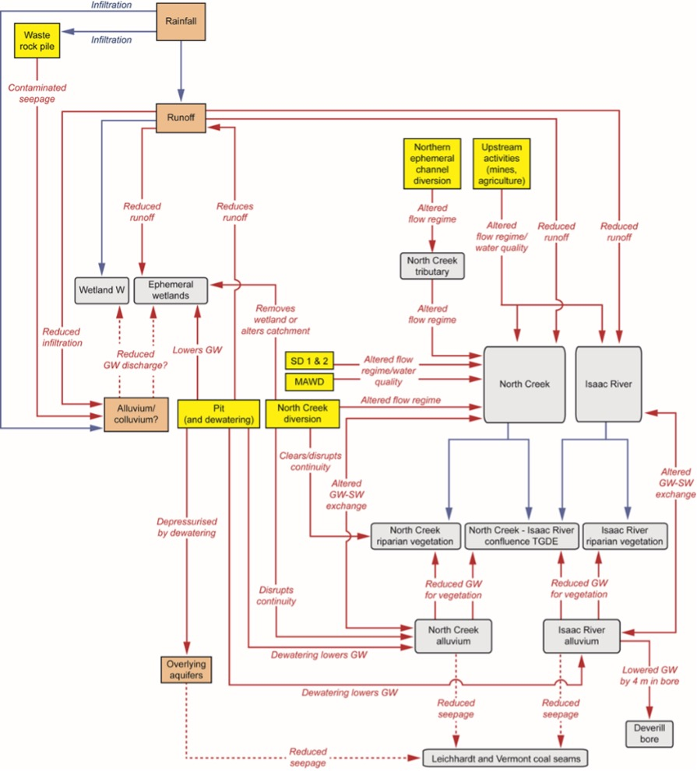

Figure 4. Final IPD, refined after several meetings of the team of expert consultants

Red arrows show impacts; blue arrows represent unimpacted hydrological pathways. Impact sources are shaded in yellow, receptors (water resources) are shaded in grey, and processes are superimposed on or near the arrows. Dashed lines indicate pathways that remain uncertain. MAWD = mine-affected water dam, SD = sediment dam, TGDE = terrestrial GDE. This IPD would be supplemented with evidence-based narratives and, where needed, superimposed on a map of the project area.

The first output is a rough oblique-view diagram (Figure 3) of the PIA drawn up during the initial meeting of the expert consultants to show 12 potential impact pathways (Table 1). This figure, with its accompanying table, is a helpful visual summary of the locations of ecohydrological linkages in the PIA that may be potential pathways linking impact sources with water-dependent receptors. Line style (Figure 3) and bold type (Table 1) are used to indicate initial levels of confidence and understanding of the hypothesised pathways.

The second output is a final IPD (Figure 4) of the form that might be presented in the assessment documentation. This IPD would be supplemented with evidence-based narratives and, where needed, superimposed on a map of the project area.The Explanatory Note gives more details on the derivation and interpretation of this IPD, along with a sub-model IPD of the North Creek diversion to better portray relevant stressors and receptors associated with this activity.

# Final comments

Generating IPDs derived from an evidence-based ecohydrological conceptualisation results in a smoother and more thorough assessment process for little extra work. No extra information is required beyond what already should be provided. For proponents and their consultants, the approach is likely to reduce work and save time (money) because the more systematic integration illustrated through the diagrams helps focus effort on the most important pathways. For regulators, the approach generates clearer assessments of potential impact pathways and their likely interactions.

Evidence-based IPDs superimposed on maps of the project area should be used to illustrate where water resources in the project area may be adversely affected and what mitigation options are available. Furthermore, as they are based on a site-specific ECM, they acknowledge the fundamental role played by ecohydrological linkages between sources of impacts in the project area and the water resources that may be impacted by the development.