Subsidence associated with coal seam gas production

# Background

The production of coal seam gas (CSG) requires the extraction of associated water from the target formation to liberate methane that is adsorbed (i.e., bonded) to the coal. Depressurisation of the subsurface leads to the compaction of geological units, a proportion of which can propagate to the surface, resulting in downwards surface movement known as subsidence.

In Australian geological conditions, the magnitude of CSG-induced subsidence is largely expected to be less than 100 mm (up to 150 mm in small areas), with an associated change in surface gradient of less than 0.01%. These are of similar orders of magnitude to natural fluctuations such as the shrinking and swelling of expansive clays. It is, therefore, important to be able to disentangle the different components of net surface movement. This helps stakeholders, including landholders, operators, local communities, and government, understand the magnitude and risk of impacts associated with CSG-induced subsidence.

To understand the magnitude of induced subsidence that might manifest in a CSG field, it is necessary to appreciate the configuration and operation of wells and the coupled physical processes which govern subsurface fluid flow and geomechanics. In comparison to conventional oil and gas operations, CSG wells are densely spaced (e.g. the average well spacing in Queensland is 800 m). This is because of the comparatively low permeability and connectivity of the target formations. The route to effective depressurisation is complex and dependent on several interlinked physical processes. These relationships are represented diagrammatically in Figure 1, which shows that coal permeability plays a fundamental role in gas and water flow. The extraction of these fluids from the subsurface results in formation depressurisation, which facilitates methane desorption and subsequent coal shrinkage. The methane liberated by desorption feeds back to the two-phase flow system, while formation depressurisation and coal shrinkage feed back to the coal permeability. The combination of depressurisation and shrinkage results in formation compaction which, after some attenuation by the overburden, manifests as surface subsidence.

# Context

To supplement the [IESC Information Guidelines](https://www.iesc.gov.au/publications/information-guidelines-independent-expert-scientific-committee-advice-coal-seam-gas) (2024), the IESC has developed an Explanatory Note (EN) on subsidence associated with CSG production. The intent of this EN is to present tailored guidance and a summary of robust, contemporary scientific methodologies and tools available for assessing the potential for and subsequent monitoring of subsidence associated with CSG production.

The specific scope provided by the IESC for the CSG subsidence EN was:

* subsurface depressurisation due to CSG production, including the propagation of signal from active wells and tenement blocks
* the physical mechanisms that link CSG production to surface movement, including the role of poroelastic compaction, desorption-induced shrinkage, and natural fractures
* prediction of CSG-induced subsidence using analytical, empirical and numerical methods, including the parameters needed for analysis
* potential impacts of CSG-induced subsidence, including elevation change, gradient change and surface disturbance, and how to assess them
* monitoring of surface movement over large length and time scales using interferometric synthetic aperture radar (InSAR), global navigation satellite systems (GNSS), light detection and ranging (LiDAR), and survey, including discussion of their precision and comparative strengths and weaknesses
* past and ongoing estimates of CSG-induced subsidence undertaken by industry, the Office of Groundwater Impact Assessment, Geoscience Australia and others
* shale gas production and underground coal gasification, including how they compare to CSG production and underground coal mining.

When considering the potential impacts of subsidence associated with CSG production, it is important to consider their magnitude in the context of other drivers, both natural and anthropogenic, particularly those likely in Australia. Figure 2 helps with this comparison by highlighting the characteristic subsidence profile and typical magnitudes associated with CSG production, bord and pillar coal mining, longwall coal mining, and multi-seam coal mining. In terms of absolute magnitude (and also gradient), it is clear that underground coal mining is the most significant source of historical and potential future subsidence. However, comparatively small elevation changes do not necessarily imply low impact. For example, some Australian CSG operations are co-located with intensive agriculture, where small terraformed gradients are used to control flood irrigation of crops. Changes to these gradients have the potential to adversely affect surface drainage and crop yield. This represents an important environmental, social, and governance challenge for the CSG industry.

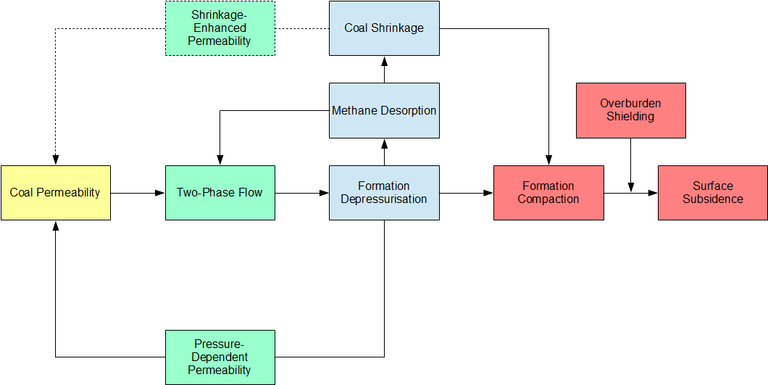

Figure 1. Schematic representation of the relationship between permeability, fluid flow, coal shrinkage, rock/coal compaction, and subsidence

Note: Both formation depressurisation and coal shrinkage provide feedback in the system via permeability change.

# Key topics

The EN provides an overview of the origins of CSG in the Australian context and explains the reservoir engineering and well completion techniques, including hydraulic fracturing, used to extract methane and associated water from coal seams. This includes a discussion of the fundamental principles of two-phase flow in cleated and fractured coals, dynamic reservoir permeability, reservoir geomechanics, and desorption- or adsorption-induced shrinking or swelling of coals.

This is followed by a discussion of international and domestic (e.g., the Gippsland Basin) examples of anthropogenic subsidence, with a focus on groundwater abstraction and oil and gas production. This is then extended to explore other natural and anthropogenic sources of surface movement, such as the compaction and swelling of shallow soils. The potential subsidence impacts are presented, with a focus on those most relevant to areas of CSG production in Australia.

Subsidence monitoring techniques such as InSAR, DGNSS and LiDAR are presented with examples of their use in CSG operations. Approaches to subsidence assessment are then outlined, including simple consolidation modelling, poromechanical analysis, and advanced aspects of numerical modelling. Their use in past and ongoing predictions of CSG-induced subsidence in Australia is summarised.

The EN concludes with a summary of relevant modelling parameters and how they can be quantified or estimated, and a subsidence case study. This compares two distinct numerical approaches to subsidence assessment. It shows that if key stratigraphic features are captured, material properties are well characterised, and appropriate assumptions are made, then the predicted subsidence magnitudes are similar.

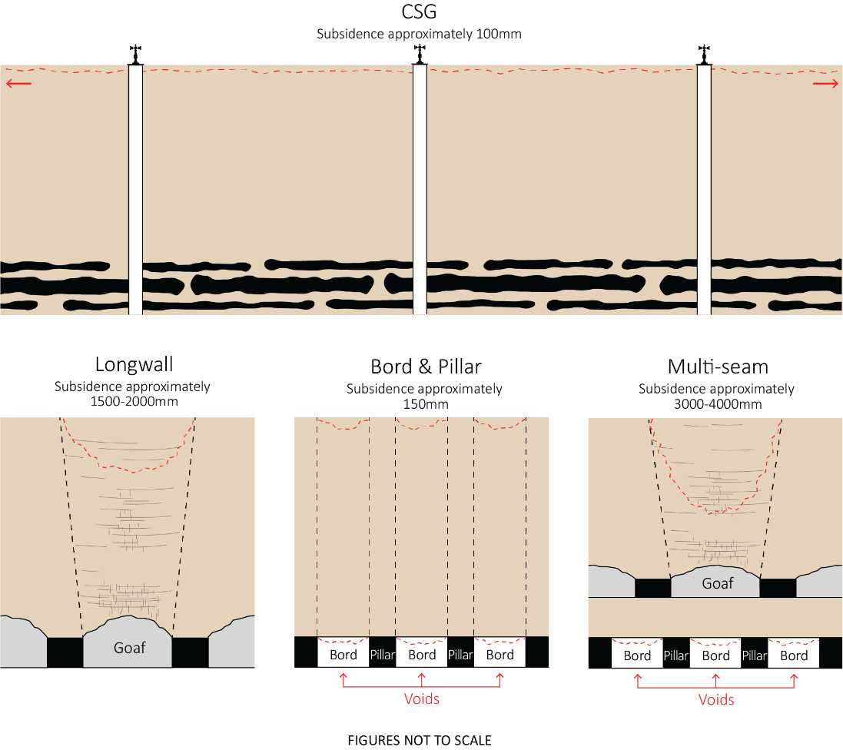

Figure 2. Comparison of the subsidence profile and magnitude associated with CSG production, longwall coal mining, bord and pillar coal mining, and multi-seam longwall mining in Australia

# Assessment considerations

Predictions of subsidence are complicated by the fact that the region of interest is usually large (i.e., in the order of hundreds of metres to kilometres in each direction) but contains much smaller features which influence behaviour (e.g., thin geological units with low hydraulic conductivity). There is also significant stratigraphic variability throughout the Surat Basin, in particular, and interpolation of geological units between well locations is subject to a high degree of uncertainty. A further complication is that most of the processes that drive depressurisation and subsidence vary with depth and coal type. When attempting to predict CSG-induced subsidence it is, therefore, pertinent to consider how much of this detail is necessary and at what level of precision it should be included in the analysis. This can then guide the use of either an analytical or a numerical approach to predicting CSG-induced subsidence.

Subsidence monitoring can be used to meet a number of objectives. These include quantification of the baseline trend of surface movement in areas where CSG is not (and will not be) produced, as well as in petroleum leases prior to CSG development; estimation of the surface movement that is attributable to CSG-induced subsidence after production commences; and validation of predictive tools for calculating CSG-induced subsidence. Further, surface movement data can be used to calibrate predictive models in a process called history matching. However, this must be approached with caution because the surface movement signal from InSAR, for example, will aggregate the contribution from a number of additional processes (e.g., shrinking and swelling of soils) which might not be captured in the model being calibrated.

For the assessment of new developments, it is recommended that InSAR be used for field-scale monitoring of elevation change; LiDAR be deployed only in locations that might be sensitive to small changes in slope or where InSAR coherence is poor or anticipated to degrade; and fixed monitoring stations be used as control on the two remote sensing techniques. To assist the determination of the surface movement baseline, both inside and outside a proposed CSG development, it is recommended that InSAR and LiDAR (where deemed necessary) data acquisition commence prior to production to establish temporal trends. The interpretation and analysis of surface movement data should be supported by the ongoing monitoring of groundwater pressures.

# Future research priorities

Predictions of subsurface phenomena continue to be challenged by uncertainty surrounding the stratigraphy (What is down there and where is it?), the properties of each geological unit (How do they behave from the perspectives of mechanics and fluid transport?), and the variability of these properties (What is an appropriate distribution?). Recommended research priority areas to help address these challenges include:

* continued study of background (or baseline) trends of surface movement in non-production areas to assist with separating multiple contributions to net surface movement in areas of CSG production
* further investigation of remote sensing tools and how they can be combined to result in a comprehensive monitoring strategy
* continued improvement in the description of the subsurface, including a better description of sequence stratigraphy and statistics on the correlation of strata between wells
* investigation of the influence of faults on subsidence and differential surface movement via the inclusion of discontinuities in geomechanical analysis
* investigation of how permeability, and particularly relative permeability, is upscaled from a single cleat to a coal block, a coal seam and then a coal-bearing unit
* investigation of the transient nature of subsidence, recognising the cumulative impacts of poroelastic compaction (which should be greatest in the early stages of a well’s life) and desorption-induced shrinkage (which might persist throughout a well’s life)
* understanding of how anisotropy and the stress dependence and pressure dependence of properties influence forward estimates of subsidence.