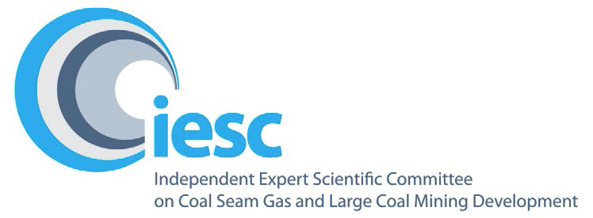

# 2022-2023

# Annual Review of Activities

**An overview of the activities of the Independent Expert Scientific Committee on Coal Seam Gas and Large Coal Mining Development from July 2022 to June 2023**

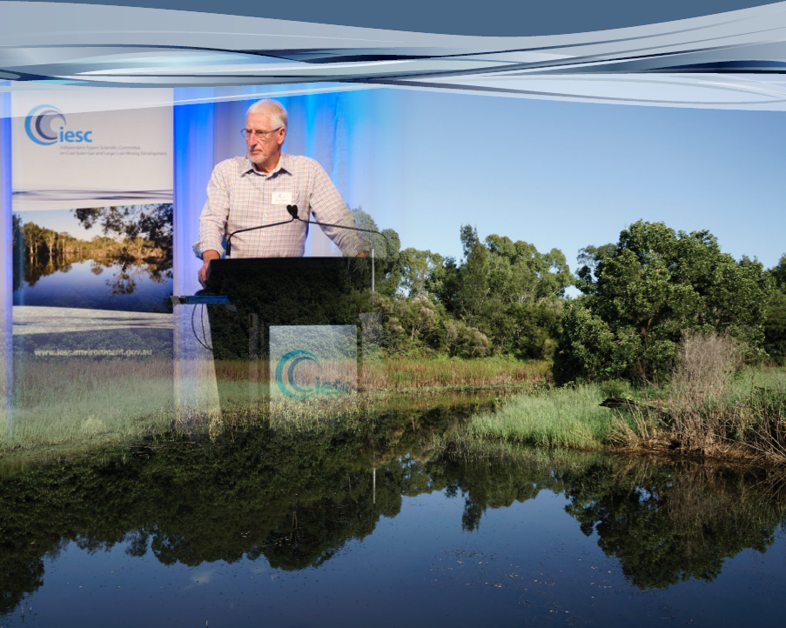

**© Commonwealth of Australia 2023**



*Annual Review of Activities - July 2022 to June 2023* is licensed by the Commonwealth of Australia for use under a Creative Commons Attribution 4.0 International licence with the exception of the Coat of Arms of the Commonwealth of Australia, the logo of the agency responsible for publishing the report, content supplied by third parties, and any images depicting people. For licence conditions see: <https://creativecommons.Org/licenses/by/4.0/>

This report should be attributed as 'Independent Expert Scientific Committee on Coal Seam Gas and Large Coal Mining Development: Annual Review of Activities - July 2022 to June 2023, Commonwealth of Australia'.

This publication is funded by the Australian Government Department of Climate Change, Energy, the Environment and Water. The views and opinions expressed in this publication are those of the authors and do not necessarily reflect those of the Australian Government or the Minister for the Environment.

**Contact details**

For information about this report or about the work of the IESC, please contact:

IESC Secretariat  
Office of Water Science  
Department of Climate Change, Energy, the Environment and Water  
GPO Box 3090  
CANBERRA ACT 2601

Email: [IESCSecretariat@dcceew.gov.au](mailto:IESCSecretariat@dcceew.gov.au)

The report can be accessed at <http://www.iesc.gov.au/>

**Images**

Front cover: Hunter Valley Wetlands and IESC Chair, Dr Chris Pigram at the IESC Stakeholder Forum in Brisbane | © Copyright Department of Climate Change, Energy, the Environment and Water

Back cover: Hunter Valley Wetlands | © Copyright Department of Climate Change, Energy, the Environment and Water

All other images © Department of Climate Change, Energy, the Environment and Water

**Table of Contents**

1. Message from the Chair 4

2. Highlights 5

3. Members 6

4. Meetings 10

5. Scientific advice 12

6. Information Guidelines and Explanatory Notes 15

7. Research 19

8. Engagement 20

## Message from the Chair

Dr Chris Pigram AM, FTSE
IESC Chair

I am pleased to present the Independent Expert Scientific Committee on Coal Seam Gas and Large Coal Mining Development (IESC) 2022-2023 Annual Review of Activities.

Providing independent scientific advice to Commonwealth and state government regulators continues to be the primary role of the committee. Since the establishment of the interim IESC in 2012, the IESC has now provided 157 pieces of advice. In 2022-23, we provided 10 pieces of scientific advice to government. To formulate our advice, we met nine times in 2022-23, including six virtual meetings and three in-person meetings, held in Canberra, Adelaide and Brisbane.

In January 2023, we welcomed Dr Juliette Woods to the committee. Dr Woods has worked in hydrogeology for 26 years, specialising in groundwater modelling. I would also like to take the opportunity to thank departing member Professor Craig Simmons, for over 10 years of dedication and commitment to the work of the IESC.

In March 2023, we hosted a stakeholder forum in Brisbane. The committee valued the opportunity to engage with such a broad range of stakeholders and were pleased to hear that the forum was also well received by the participants who attended.

We appreciated the opportunity to meet with the Taskforce for Environmental Legislative Reform and Establishment of an EPA in April 2023 to discuss the *Environment Protection and Biodiversity Conservation Act 1999* reform work being undertaken. The IESC has also provided further input into this reform work through various forums and working groups.

We continue to develop and expand our range of published resource material. A review of our first Explanatory Note on uncertainty analysis was completed in 2023 and the review of our Information Guidelines is currently ongoing. We are continuing development of further Explanatory Notes on ecohydrological conceptual models and subsidence. Throughout the development of all our resource material we welcome stakeholder feedback through targeted and public consultations.

The Office of Water Science (OWS), within the Australian Government Department of Climate Change, Energy, the Environment and Water, assists the IESC through the provision of secretariat support and scientific expertise. The IESC thanks former OWS Director, Mr Peter Baker for providing over 10 years of expert support to the IESC and looks forward to working with new Director, Dr Des Owen in 2023-24. On behalf of the IESC, I thank the OWS for its continued dedication to supporting the activities of the committee.

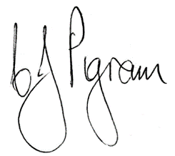

**Dr Chris Pigram AM, FTSE**

IESC Chair

## Highlights

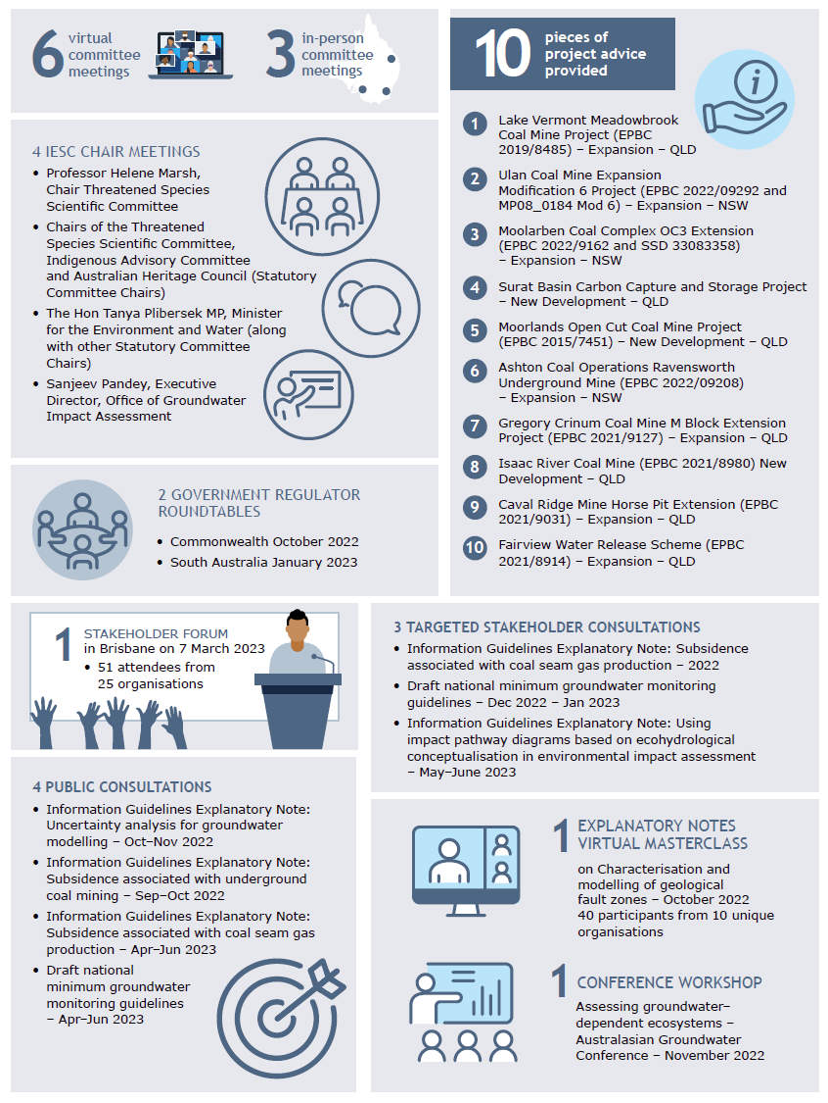

## Members

The IESC consists of a maximum eight members. Members are leading scientists in their fields and have extensive scientific qualifications and expertise in geology, hydrogeology, hydrology, ecology and ecotoxicology.

### New members in 2022-23

#### Dr Juliette Woods



Dr Woods has worked in hydrogeology for 26 years, specialising in groundwater modelling, often investigating the interconnections between groundwater, hydrology and ecology. She currently leads a groundwater modelling team within the South Australian Government and has previously worked in academia and industry, fostering knowledge transfer across these sectors. Dr Woods's recent research explores interactions between surface water, groundwater, and vegetation in saline floodplains.

### Ongoing members in 2022-23

#### Dr Chris Pigram AM FTSE – Chair

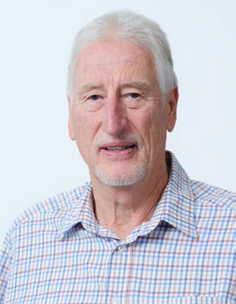

Dr Pigram is a geologist with over 40 years' experience and is a leader in research and management of minerals, marine and petroleum geoscience programs, and geospatial and earth monitoring. Dr Pigram was formerly the CEO of Geoscience Australia, where he held the role for seven years. Consequently, he has extensive experience in managing the interface between science and government and in stakeholder engagement.

#### Dr Jenny Stauber

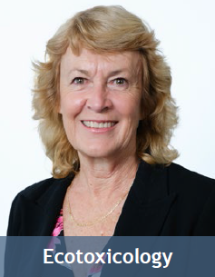

Dr Stauber has 40 years of research experience in the fields of ecotoxicology, water quality, contaminant environmental risk assessment and human toxicology. She serves as an expert ecotoxicologist on a wide range of advisory panels for national and international agencies. Dr Stauber is currently a Chief Research Scientist in CSIRO Environment. She is a Fellow of the Australian Academy of Technology and Engineering and a Fellow of the Australian Academy of Science.

#### Professor Wendy Timms



Professor Timms has extensive geology, hydrogeology and engineering expertise with over 25 years of professional experience. In 2020 she was the Distinguished Lecturer for the National Centre for Groundwater Research and Training, on 'Digg'n deeper - the state of mining hydrogeology'. She has engineering project and research experience at coal, gas, uranium, metals and potash sites in Australia, Asia and Canada. Wendy is Professor of Environmental Engineering at Deakin University, teaching geology for geotechnical engineering and leading research in geological carbon sequestration, water tracer technology, and groundwater hydrology. She has published over 200 technical reports and more than 50 peer-reviewed journal papers and served as Vice-President of the International Association of Hydrogeologists.

#### Professor Jenny Davis



Professor Davis has expertise in freshwater biodiversity and wetland conservation, with more than 200 published papers and reports. She was awarded the Limnology Medal for excellence in freshwater research in 2006. Professor Davis co-chairs the Wetlands Working Group of the International Association for Ecology (INTECOL). She is a member of the Research Institute for Environment and Livelihoods at Charles Darwin University.

#### Professor Rory Nathan

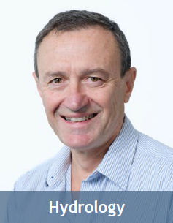

Professor Nathan has over 35 years' experience in engineering and environmental hydrology and is currently Professor of Hydrology and Water Resources at the University of Melbourne. He has made a substantial contribution to industry best practice in a range of engineering and environmental fields, particularly in the characterisation of hydrologic risk, the assessment of hydrologic impacts, and hydrologic model development and application.

#### Associate Professor Phil Hayes

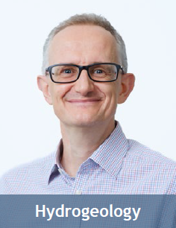

Associate Professor Hayes is a geoscientist, hydrogeologist and groundwater modeller with over 25 years' experience in Australia, the United Kingdom and South America. He has worked across sectors from water resource management and groundwater protection to impact prediction and mitigation for mining, oil and gas, contaminated land, infrastructure, and nuclear waste. He is Associate Professor of Water Resources at the University of Queensland, leading research at the interface between reservoir engineering and hydrogeology, and in groundwater modelling uncertainty analysis.

#### Dr Andrew Boulton

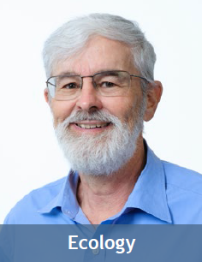

Dr Boulton's research spans river and groundwater ecology, especially in semi-arid areas, with four books and over 130 peer-reviewed articles. He has been on international and national panels to assess riparian zone policies, environmental flows, groundwater-dependent ecosystems and biodiversity of intermittent rivers. Dr Boulton is Adjunct Professor in Ecosystem Management at the University of New England and has held academic positions at other national and international universities.

## Meetings

In 2022–23, the IESC continued to return to in-person meetings, meeting three times in person and six times virtually to prepare its scientific advice. [Minutes](http://iesc.environment.gov.au/about-us/meeting-minutes) of each IESC meeting are published on the IESC website.

### IESC meeting dates and subject matter, 2022-23

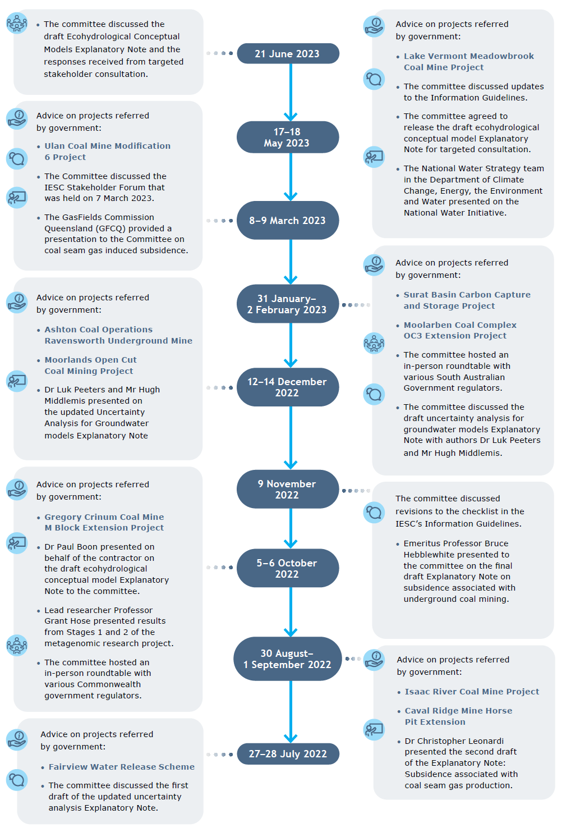

### Guest presentations

Guests from a range of organisations and disciplines are invited to IESC meetings to present on topics of interest to the IESC. These presentations increase the IESC's collective scientific understanding of the potential impacts of coal and coal seam gas development proposals on water resources.

#### Guest presentations in 2022-23

* Water Policy Division, Department of Climate Change, Energy, the Environment and Water
* The National Water Strategy team at the Department of Climate Change, Energy, the Environment and Water presented on the National Water Initiative.
* GasFields Commission Queensland
* GasFields Commission Queensland presented on a current project which is seeking to understand the potential consequence of coal seam gas induced subsidence on agricultural land, and a proposed management framework.

### Member presentations

IESC members regularly present at committee meetings to update colleagues on the latest developments in their particular scientific disciplines.

#### Member presentations in 2022-23

* Professor Jenny Davis - The conservation challenge of protecting recently discovered subterranean wetlands and stygofauna in northern Australia
* Professor Jenny Davis presented on recent research involving stygofauna and groundwater- dependent ecosystems supported by the Tindall Limestone Aquifer in the Northern Territory.
* Associate Professor Phil Hayes and Professor Wendy Timms - Carbon capture and storage: deep-well sequestration
* Professor Wendy Timms and Associate Professor Phil Hayes presented on carbon capture and storage (CCS) and, specifically, deep-well sequestration, with an overview of CCS injection targets, CO2 trapping, leakage, storage accreditation, risks and monitoring.
* Associate Professor Phil Hayes - Remote sensing for impact monitoring
* Associate Professor Phil Hayes presented on remote sensing for impact monitoring.
* Dr Juliette Woods - Groundwater Modelling: A Whirlwind Tour
* Dr Juliette Woods presented on groundwater modelling, outlining its mathematical underpinnings, interdisciplinary nature, representation of hydrogeological features, ongoing challenges, and areas of current research.

## Scientific advice

In 2022-23, the IESC provided 10 pieces of scientific advice on development proposals. Since the establishment of the interim IESC in 2012, the IESC has provided 157 pieces of advice to government regulators.

The IESC is not responsible for regulatory decisions; this remains the role of the Commonwealth and state government regulators. IESC advice enables the regulators to make decisions based on the best available science.

Under the *Environment Protection and Biodiversity Conservation Act 1999* (Cth) (EPBC Act), the Australian Government and relevant state government regulators request the advice of the IESC on the potential impacts of coal seam gas and large coal mining developments on water resources. The IESC can also provide advice on proposals for resource developments other than large coal mining and coal seam gas developments, at the request of relevant state government ministers with the written agreement of the Australian Government Environment Minister.

To ensure transparency, the IESC’s [scientific advice](https://iesc.environment.gov.au/advice/scientific-advice) is published on the IESC website within 10 days after being provided to the relevant regulator.

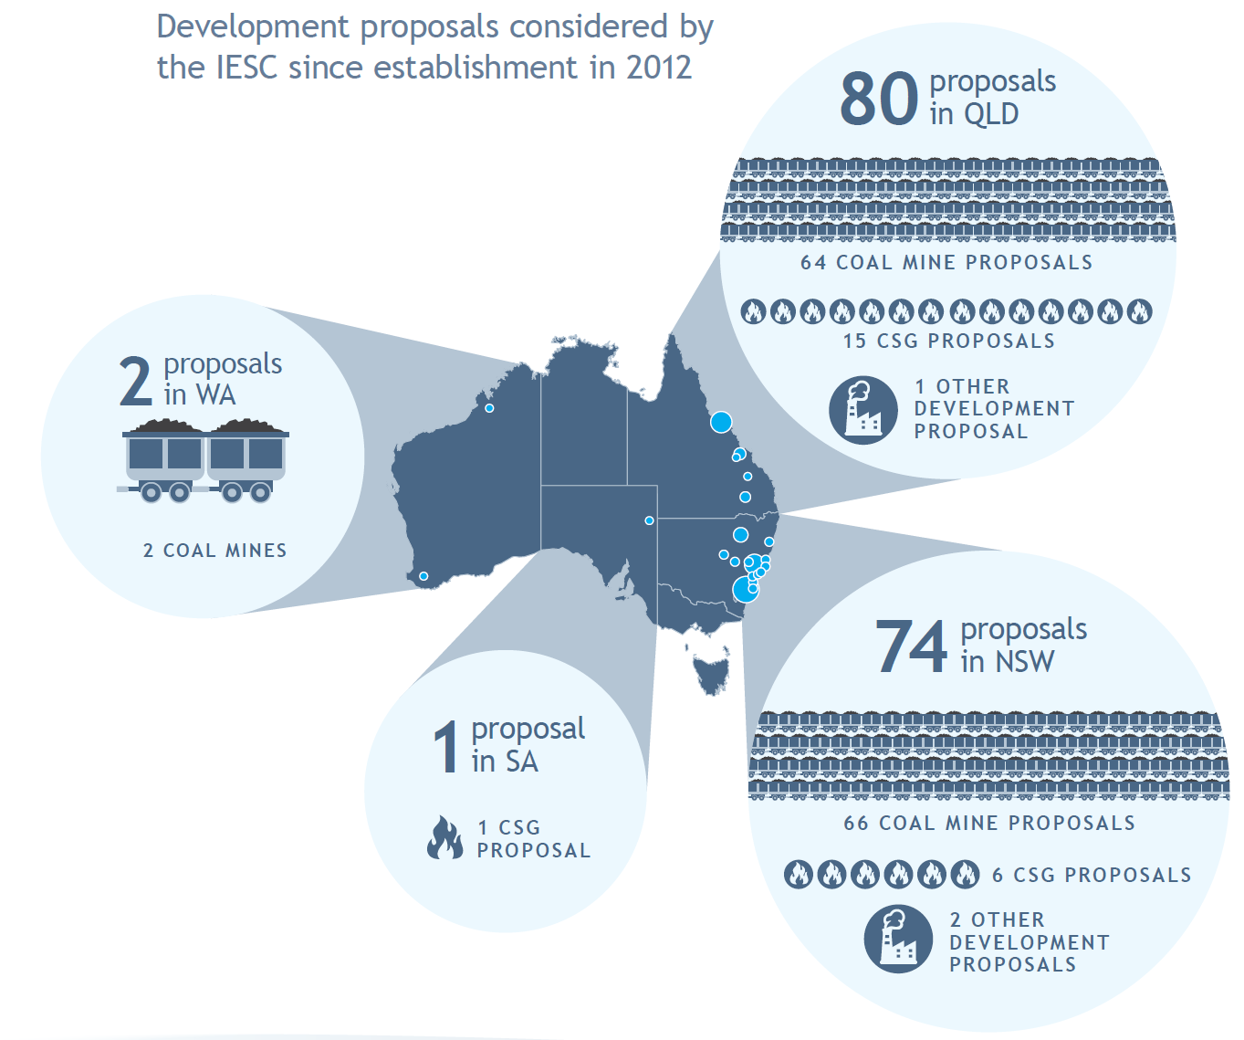

Development proposals on which the IESC provided scientific advice, 2022-23

|  |  |  |  |  |
| --- | --- | --- | --- | --- |
| **IESC reference** | **Referring government** | **Project location** | **Project name** | **Date of IESC advice** |
| 2023-142 | Australian Government and QLD | QLD | [Lake Vermont Meadowbrook Coal Mine Project - Expansion](https://www.iesc.gov.au/sites/default/files/2023-06/iesc-advice-lake-vermont-meadowbrook-project-2023-142.pdf) | 23 May 2023 |
| 2023-141 | Australian Government and NSW | NSW | [Ulan Coal Mine Expansion Modification 6 Project - Expansion](https://www.iesc.gov.au/sites/default/files/2023-03/iesc-advice-ulan-coal-mine-expansion-2023-141.pdf) | 15 Mar 2023 |
| 2022-140 | Australian Government and NSW | NSW | [Moolarben Coal Complex OC3 Extension - Expansion](https://www.iesc.gov.au/sites/default/files/2023-02/iesc-advice-moolarben-coal-complex-oc3-extension-2023-140.pdf) | 7 Feb 2023 |
| 2022-139 | QLD | QLD | [Surat Basin Carbon Capture and Storage Project - New Development](https://www.iesc.gov.au/sites/default/files/2023-02/iesc-advice-surat-basin-carbon-capture-storage-project-2022-139.pdf) | 5 Feb 2023 |
| 2022-138 | Australian Government | QLD | [Moorlands Open Cut Coal Mine Project - New Development](https://www.iesc.gov.au/sites/default/files/2022-12/iesc-advice-moorlands-open-cut-coal-mine-project-2022-138.pdf) | 16 Dec 2022 |
| 2022-137 | Australian Government | NSW | [Ashton Coal Operations Ravensworth Underground Mine - Expansion](https://www.iesc.gov.au/sites/default/files/2022-12/iesc-advice-ashton-coal-operations-ravensworth-underground-mine-2022-137.pdf) | 14 Dec 2022 |
| 2022-136 | Australian Government | QLD | [Gregory Crinum Coal Mine M Block Extension Project - Expansion](https://www.iesc.gov.au/sites/default/files/2022-10/iesc-advice-gregory-crinum-coal-mine-2022-136.pdf) | 9 Oct 2022 |
| 2022-135 | Australian Government | QLD | [Isaac River Coal Mine - New Development](https://www.iesc.gov.au/sites/default/files/2022-10/iesc-advice-isaac-river-coal-mine-2022-135.pdf) | 3 Sep 2022 |
| 2022-134 | Australian Government | QLD | [Caval Ridge Mine Horse Pit Extension - Expansion](https://www.iesc.gov.au/sites/default/files/2022-10/iesc-advice-caval-ridge-mine-horse-pit-extension-2022-134.pdf) | 3 Sep 2022 |
| 2022-133 | Australian Government | QLD | [Fairview Water Release Scheme - Expansion](https://www.iesc.gov.au/sites/default/files/2022-10/iesc-advice-fairview-water-release-2022-133_0.pdf) | 30 July 2022 |

Locations of proposed developments considered by the IESC in 2022-23

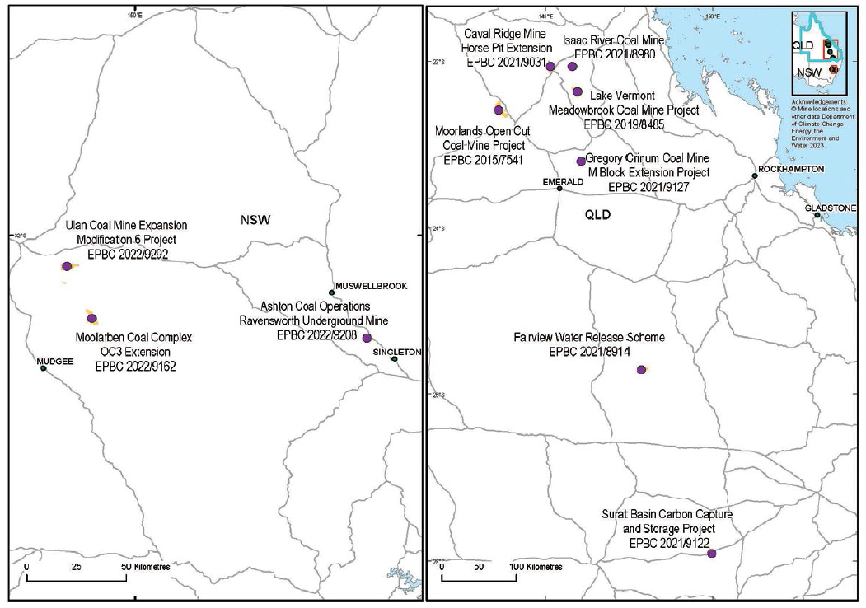

*Approximate EPBC Act project referral areas indicated by shading*

## Information Guidelines and Explanatory Notes

The IESC has developed a suite of resources to assist industry and regulators with environmental assessments. These resources provide guidance on the suggested information and data to be included in an environmental impact assessment.

To ensure that the suite of resources remains current, the IESC regularly reviews and updates its existing resource documents. New resource material is also developed in areas where the IESC considers there to be a need.

### Information Guidelines review

In 2021, the IESC commenced a review of the [Information guidelines for proponents preparing coal seam gas and large coal mining development proposals](https://www.iesc.gov.au/publications/information-guidelines-independent-expert-scientific-committee-advice-coal-seam-gas) and proposed updates to provide additional and clearer guidance to project proponents on the IESC’s information requirements.

As part of the review, public consultation on the proposed updates was undertaken in late 2021.

Feedback from the public consultation period has been addressed and incorporated, and the updated Information Guidelines are expected to be released for further public consultation in June 2023.

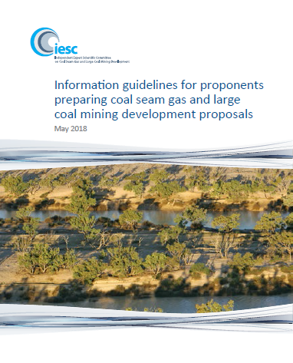

*Information guidelines for proponents preparing coal seam gas and large coal mining development proposals*

### Information Guidelines Explanatory Notes

Explanatory Notes have been written to supplement the IESC Information Guidelines, providing tailored guidance and up-to-date robust scientific methodologies and tools for specific components of environmental impact assessments of coal seam gas and large coal mining developments. Explanatory Notes are intended to supplement the IESC Information Guidelines.

Explanatory Notes have also been applied across a range of other resource industries, including the iron ore sector.

To date, the IESC has published four Explanatory Notes on its website:

[Uncertainty analysis for groundwater modelling](https://www.iesc.gov.au/publications/information-guidelines-explanatory-note-uncertainty-analysis) provides a range of approaches available to proponents and regulators in understanding and interpreting uncertainty analysis for groundwater modelling to assist in decision making.

[Assessing groundwater-dependent ecosystems](https://iesc.environment.gov.au/publications/information-guidelines-explanatory-note-assessing-groundwater-dependent-ecosystems) reviews tools and methods for groundwater dependent ecosystem assessment to help proponents choose the most effective approach.

[Deriving site-specific guideline values for physico-chemical parameters and toxicants](https://iesc.environment.gov.au/publications/information-guidelines-explanatory-note-deriving-site-specific-guidelines-values) introduces the use of a water and sediment quality management framework to assist with the design of appropriate monitoring programs for measuring physico-chemical parameters and toxicants from which site-specific guideline values can be developed.

[Characterisation and modelling of geological fault zones](https://iesc.environment.gov.au/publications/information-guidelines-explanatory-note-characterisation-modelling-geological-fault-zones) provides a range of approaches available to proponents to determine the role faults may play in impeding or propagating pressure and groundwater flow impacts from proposed development projects.

#### Updates to existing Explanatory Notes

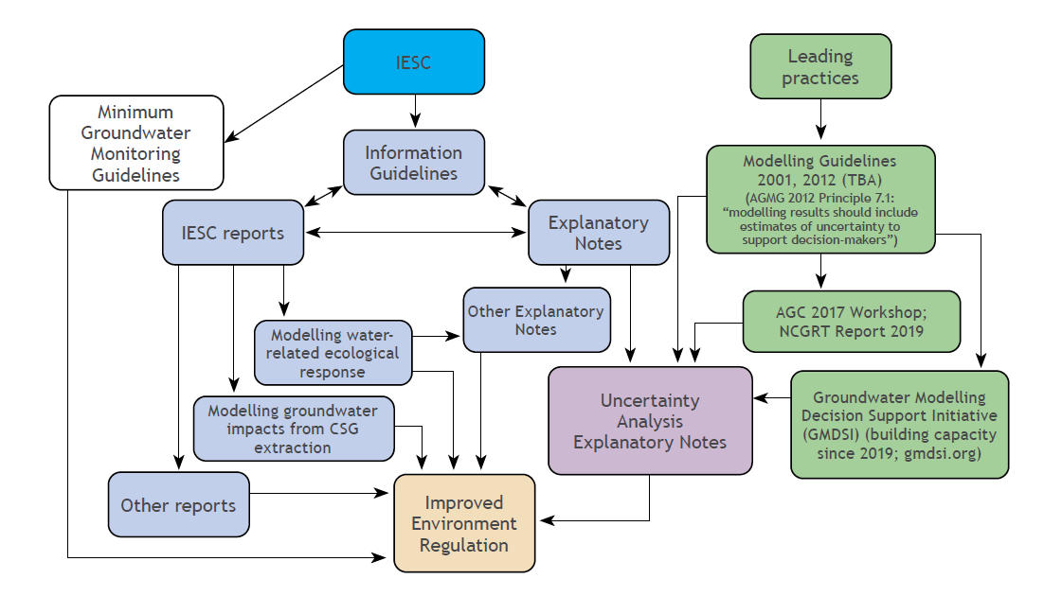

*Flow chart showing the linkages between resources described in the Explanatory  
Note: Uncertainty analysis for groundwater modelling*

Updates to the IESC Information Guidelines and Explanatory Notes are undertaken as new methodologies and tools become available.

Throughout 2022-23, the IESC reviewed and updated its first Explanatory Note: *Uncertainty analysis - Guidance for groundwater modelling within a risk management framework.*

The 2023 edition of the Explanatory Note, titled *Uncertainty analysis for groundwater modelling,* is still underpinned by the same principles that underpinned the 2018 edition. Whereas the emphasis in the 2018 version was on encouraging uptake of uncertainty analysis as an essential part of groundwater modelling practice, the recent update aims to make groundwater model outcomes more relevant to decision-makers.

Public consultation on the updates was undertaken in late 2022, with four submissions received. The IESC thanks all those who provided comments during this period.

The Explanatory Note. [Uncertainty analysis for groundwater modelling](https://www.iesc.gov.au/publications/information-guidelines-explanatory-note-uncertainty-analysis) was published on the IESC website on 29 June 2023.

### Explanatory Notes in preparation

#### Subsidence associated with underground coal mining

The IESC has developed a new Explanatory Note to provide tailored guidance and up-to-date robust scientific methodologies and tools for consultants and assessors dealing with project proposals for assessing the risk and magnitudes of subsidence (surface deformation) and its environmental impact due to large coal mining developments.

The [Explanatory Note: Subsidence associated with underground coal mining](https://www.iesc.gov.au/node/479) was published after incorporating feedback from four submissions received during an eight-week public consultation period in late 2022.

#### Subsidence associated with coal seam gas production

The IESC is currently preparing a new Explanatory Note on subsidence associated with coal seam gas production. The Explanatory Note provides tailored guidance and up-to-date robust scientific methodologies and tools for assessing the risk and magnitudes of subsidence (one source of surface movement) and its environmental impact due to coal seam gas development. It has been targeted at prospective consultants and assessors dealing with coal seam gas project proposals.

Targeted consultation on the draft Explanatory Note was undertaken in late 2022 and was followed by an eight-week open public consultation period between April and June 2023, in which six submissions were received.

Feedback from the consultation periods is now being incorporated and the Explanatory Note is expected to be published in late 2023.

#### Explanatory Note on using impact pathway diagrams based on ecohydrological conceptualisation in environmental impact assessment

The IESC has commenced work on the development of a new Explanatory Note on using impact pathway diagrams based on ecohydrological conceptualisation in environmental impact assessment.

This Explanatory Note promotes the use of impact pathway diagrams based on ecohydrological conceptualisation in environmental impact assessment to map sources, pathways and receptors of impacts arising from, for example, large coal mines and coal seam gas developments. Because of the IESC's legislated role, this Explanatory Note focuses on potential water-related impacts, but the benefits and approaches of such conceptual modelling apply equally to assessment of environmental impacts of other activities.

The Explanatory Note was released for targeted stakeholder consultation in May 2023, and is expected to be released for public consultation in late 2023

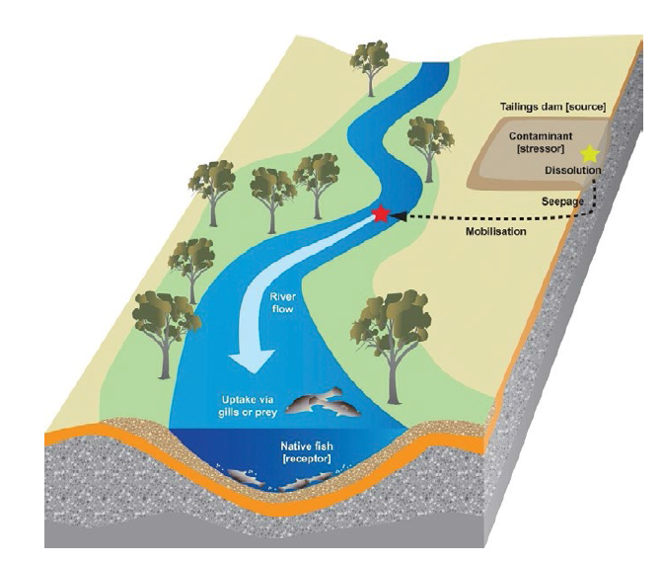

*Example of physical, chemical and biological processes along a hypothetical impact pathway*

### Additional resources

#### Draft national minimum groundwater monitoring guidelines

The IESC is currently working with the National Groundwater Committee to standardise groundwater monitoring requirements across Australia through national minimum groundwater monitoring guidelines.

The purpose of these guidelines is to recommend minimum requirements for groundwater level/pressure and quality monitoring for the various stages of impact assessment. Biological monitoring is not within scope of the guidelines.

The guidelines focus on impact assessment of projects affecting groundwater. This includes a broad range of activities involving penetration of an aquifer, interference with water in an aquifer, obstruction of flow, taking of water (outside of a water allocation planning context) or disposal of water. At the discretion of the respective regulator, all state/territory and Commonwealth impact assessment processes related to groundwater are considered to be within scope. To keep the scope broad, the guidelines avoid referring to specific project approval processes.

Targeted consultation on the draft guidelines was undertaken in late 2022 and was followed by an open public consultation period between April and June 2023, in which eight submissions were received.

Feedback from the consultation periods is now being incorporated and the guidelines are expected to be published in late 2023.

The IESC thanks those organisations and individuals who provided comments on the range of draft documents through several different consultation processes.

## Research

In 2017, the IESC recommended [research priorities](https://iesc.environment.gov.au/research) to the Australian Government. Under these priorities, the IESC has since commissioned a number of projects to strengthen the science underpinning regulatory decisions on coal seam gas and large coal mining developments.

### Ongoing research projects

In 2022–23, the IESC progressed a number of ongoing projects under its [research priorities](https://iesc.environment.gov.au/research).

This research program includes the IESC's multistage metagenomic research project, which continued to progress in 2022-23. The three stages of the project are now nearing completion. The three stage reports, an overview video and a fact sheet are expected to be published on the IESC website in late 2023.

This research project evaluated the effectiveness of different sampling methods and the feasibility for proponents to use environmental DNA (eDNA) to assess groundwater invertebrates and microbes in aquifers that may be impacted by coal mining and CSG development. Conventional methods for collecting and processing samples from alluvial and fractured-rock aquifers in NSW were compared with metagenomic approaches.

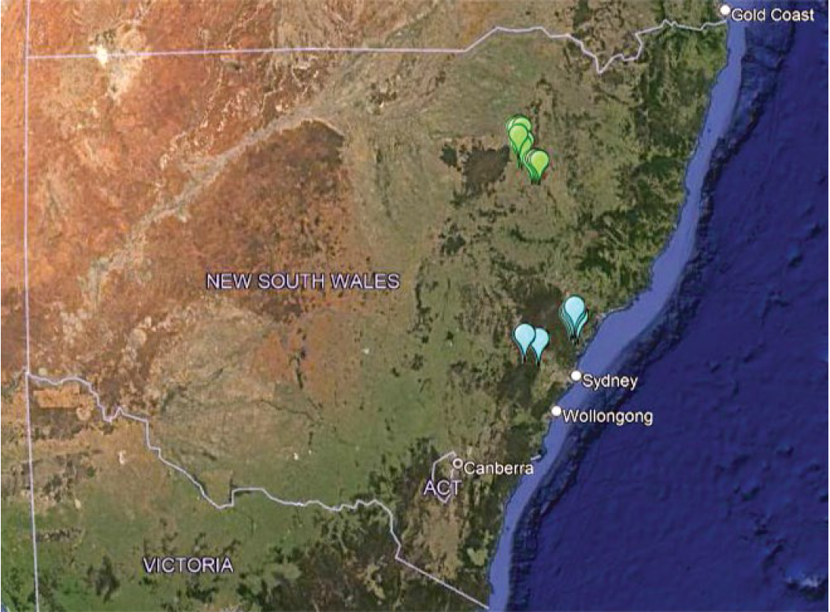

*Map showing metagenomic research project sampling locations of fractured rock aquifer samples (blue symbols) in the Hawkesbury Nepean catchment and central coast region, and alluvial aquifer samples (green symbols) in the Namoi River catchment*

## Engagement

The IESC continues to promote its work and published resource material by meeting with interested parties through various stakeholder activities.

### Chair meetings

The IESC Chair continues to meet with interested parties to promote the role of the IESC, to learn more about how the IESC's advice is used, and to seek stakeholder views on the IESC Information Guidelines and Explanatory Notes. In 2022-23, the IESC Chair met with:

* Professor Helene Marsh, Chair, Threatened Species Scientific Committee - October 2022
* the Chairs of the Threatened Species Scientific Committee, Indigenous Advisory Committee and Australian Heritage Council (Statutory Committee Chairs) - November 2022
* the Hon Tanya Plibersek MP, Minister for the Environment and Water (along with Statutory Committee Chairs) - November 2022
* Sanjeev Pandey, Executive Director, Office of Groundwater Impact Assessment - March 2023.

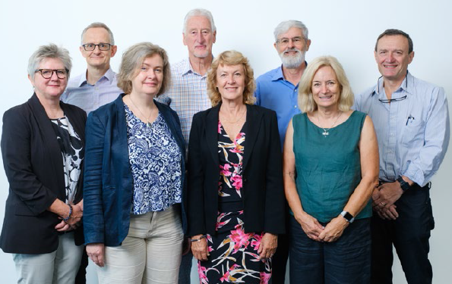

*IESC members at the IESC Stakeholder Forum in Brisbane*

### Government regulator roundtables

The IESC regularly meets with government regulators to seek feedback on and discuss the IESC's scientific advice, to update regulators on IESC activities and to discuss items of mutual interest.

The IESC hosted two in-person regulator roundtables in 2022-23:

* In October 2022, the IESC hosted a roundtable discussion in Canberra with Commonwealth regulators from the Department of Climate Change, Energy, the Environment and Water.
* In January 2023, the IESC hosted a roundtable discussion in Adelaide with regulators from various South Australian Government agencies.

### 2022 Australasian Groundwater Conference

In November 2022, the IESC hosted an interactive 'Assessing groundwater-dependent ecosystems (GDE) workshop' as part of the 2022 Australasian Groundwater Conference (AGC) in Perth.

The workshop briefly reviewed the main points of the *Information Guidelines Explanatory Note: Assessing groundwater-dependent ecosystems* and demonstrated the various tools and methods identified in the Explanatory Note. It was presented by Explanatory Note authors Dr Tanya Doody and Dr Jodie Pritchard (CSIRO) and Dr Peter Hancock (Eco Logical Australia) and was facilitated by IESC member Dr Andrew Boulton. The workshop also included a session on the IESC's metagenomic research project, presented by the lead researchers, Professor Grant Hose and Dr Kathryn Korbel (Macquarie University).

*'The GDE workshop at the 2022 AGC was especially interesting to me because the five presenters (all ecologists) were addressing an audience composed mostly of hydrogeologists, which led to several lively discussions from the different perspectives on how best to assess these diverse types of ecosystems.'*

— Dr Andrew Boulton, IESC member

### EPBC Act reform

The IESC has provided input into the EPBC reform work being undertaken by the Department of Climate Change, Energy, the Environment and Water. This includes:

* IESC members meeting with the Taskforce for Environmental Legislative Reform and Establishment of an EPA team in April 2023
* Professor Rory Nathan representing the IESC on the Matters of National Environmental Significance advisory member working group.

### IESC Explanatory Note masterclass

Following the positive feedback from a series of online Explanatory Notes masterclasses in 2021, the IESC hosted a fourth masterclass on 12 October 2022, on the *Characterisation and modelling of geological fault zones* Explanatory Note.

Forty people participated in the masterclass from various locations across Australia and, in one case, New Zealand. They represented 10 unique organisations.

A short snap poll was undertaken at the end of the masterclass to provide some measure of success. Of those who completed the poll, 100% advised that the masterclass met (30%) or exceeded (70%) their expectations.

*'This workshop was useful to hear several perspectives on geological fault zones, and bring together practical know-how.'*

— Professor Wendy Timms, IESC member

*'Really useful to have the opportunity to spend time with hydrogeological professionals, to discuss faults and how they can impact groundwater movement'*

— Associate Professor Phil Hayes, IESC member

### 2023 Stakeholder Forum

The IESC hosted a stakeholder forum on 7 March 2023 at the Brisbane Convention and Exhibition Centre.

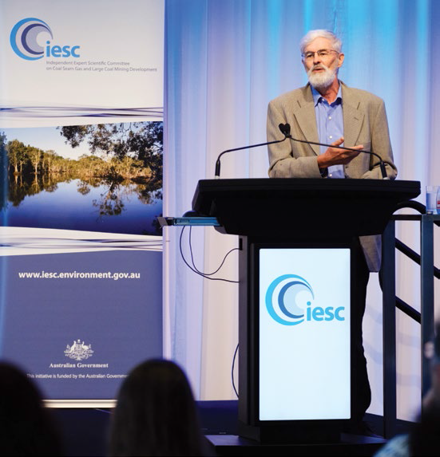

*IESC member, Dr Andrew Boulton at the IESC Stakeholder Forum in Brisbane*

The purpose of the Stakeholder Forum was to:

* increase industry and stakeholder understanding of the role of the IESC
* increase awareness of and seek feedback on the Information Guidelines and other resources developed by the IESC
* provide an open and engaging environment for IESC members to interact with and better understand the challenges currently faced by the industry with regard to the development of environmental assessments
* provide an open and engaging environment for stakeholders to raise issues and ask questions of the IESC.

The full-day event was attended by 51 people from 25 different organisations from across a range of sectors (excluding IESC members, Office of Water Science staff and the facilitator).

*'The IESC Stakeholder Forum was a rare opportunity to have stakeholders from around the country to discuss the latest projects and advice from the IESC. There was plenty of energy from presenters and participants, happy to be face to face again talking science after a long hiatus. The conversation and questioning was lively and the online questions stimulated great discussion. This event was an excellent means to disseminate new IESC outcomes.'*

— Grant Hose, Macquarie University

**The range of organisations represented at the forum is outlined in the chart below.**

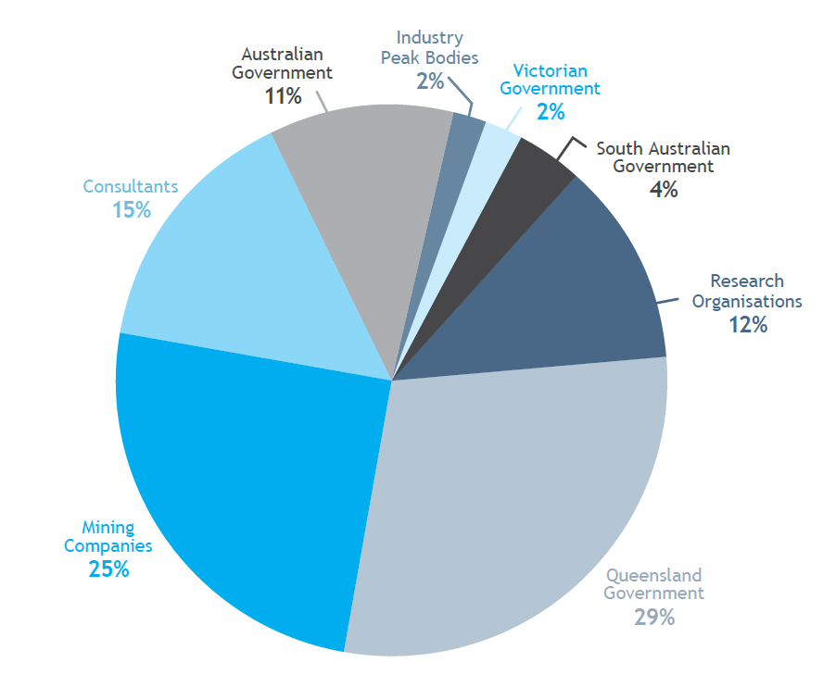

### Three poll-based evaluation questions were asked during the final sessions of the forum

**In response:**

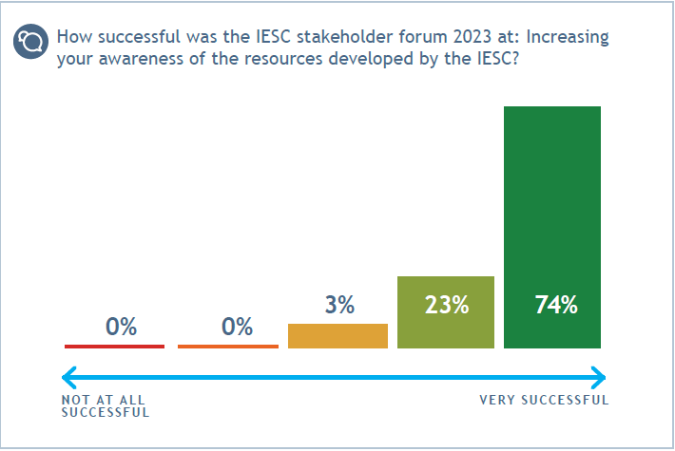

*Increasing awareness of IESC resources*

* 97% of poll participants reported that the forum was 'very successful' (74%) or 'successful' (23%) at increasing awareness of the resources developed by the IESC

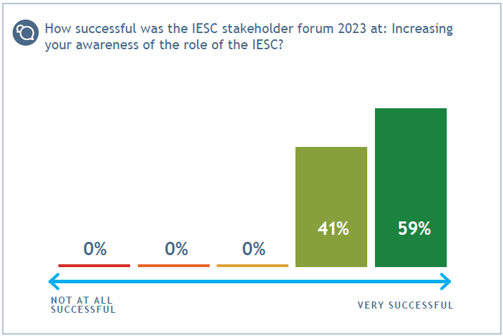

Increasing awareness of the IESC’s role

* 100% percent of poll participants reported that the forum was 'very successful' (59%) or 'successful' (41%) at increasing awareness of the role of the IESC

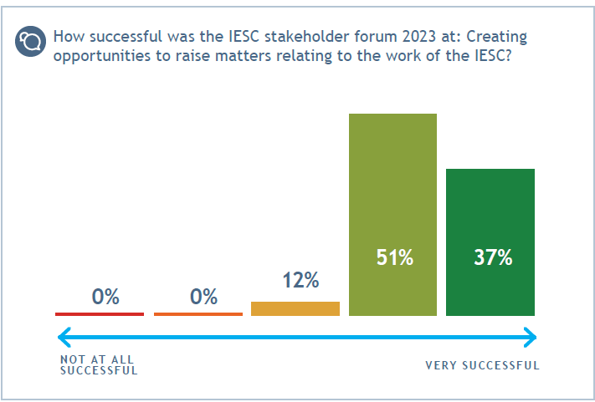

*Opportunities to raise matters relating to the IESC’s work*

* 88% of poll participants reported that the forum was 'very successful' (37%) or 'successful' (51%) at creating opportunities to raise matters relating to the work of the IESC

*'The IESC forum provided an excellent opportunity to present scientific developments in groundwater monitoring to a group of end users and industry participants. Not only could we provide information on new technologies but we were able to listen to, and converse with, other presenters, to learn how we, as scientists, can aid the management of our natural resources.'*

— Kathryn Korbel, Macquarie University