Subsidence associated with underground coal mining

Background
Any form of underground coal extraction will result in some degree of deformation of the overlying overburden strata. This is described as mining-induced subsidence. The amount of subsidence can vary from just a few millimetres over what is referred to as first workings extraction, to several metres of vertical subsidence above the centre of wide extraction panels where a thick coal seam has been extracted. In Australian geological conditions, the maximum surface subsidence is generally no greater than about 65% of the thickness of coal extracted underground (for single-seam extraction), subject to depth and extraction width parameters. Also associated with vertical subsidence deformation are components of horizontal deformation from above the edges of coal extraction (and beyond), together with associated curvature, tilt and strain on the surface.
In order to understand the type and magnitude of subsidence that may be expected, it is necessary to appreciate the different systems of underground mining used in Australia.
Longwall mining is the dominant means of underground coal extraction in Australia. It is a total extraction mining system that requires caving of the immediate roof strata behind the coal extraction face for operational and safety reasons, causing vertical deformation of the overlying strata making up the overburden. Longwall mining therefore causes surface subsidence by design. The parameters of panel width, mining or extraction height and depth are the primary factors determining the amount of surface subsidence.
There are also various forms of total pillar extraction that involve caving and can result in maximum subsidence developing on the surface. Where there is a need to reduce the magnitude of surface subsidence, the mining extraction widths can be reduced – either by using narrower longwall panels or, for further reduction, the miniwall technique; or by using a form of partial pillar extraction.

Context
To supplement the IESC Information Guidelines (2018), the IESC has developed an Explanatory Note (EN) on subsidence associated with underground coal mining. The intent of this EN is to provide guidance and a summary of up-to-date robust scientific methodologies and tools available for assessing the risks and magnitudes of subsidence and its environmental impact due to large underground coal mining developments.
The specific scope provided by the IESC for the underground coal mining subsidence EN was:
- Mechanisms
- Principles of ground behaviour in response to underground excavation
- Mechanisms of subsidence due to underground coal mining, and related terminology
- Differences in subsidence due to different types of underground mining systems
- Mining
- Summary overview of different systems of underground coal mining
- Subsidence prediction methodologies and mine design approaches to manage subsidence effects
- Subsidence impacts and impact assessment
- Subsidence monitoring technologies and management.
In reviewing the different forms of subsidence behaviour, a distinction is drawn between subsidence effects – the direct ground deformation associated with surface subsidence – and subsidence impacts, such as the resultant strains, tilts and cracking.
The subsidence behaviour observed above underground coal extraction varies between conventional subsidence, which occurs with generally flat surface terrain and is confined to a region defined by a modest angle of draw beyond the extremities of the mining extraction limits; and non-conventional subsidence, which occurs in areas of irregular surface terrain such as steep slopes and valleys.
In areas of irregular terrain, subsidence behaviour varies considerably and can extend well beyond the extraction limits in the form of far-field effects. Other features of this behaviour can include significant horizontal valley closure above and adjacent to the excavation area, coupled with a degree of relative valley floor uplift, or upsidence. The recommended terminology for the different forms of subsidence behaviour is illustrated in Figure 1.

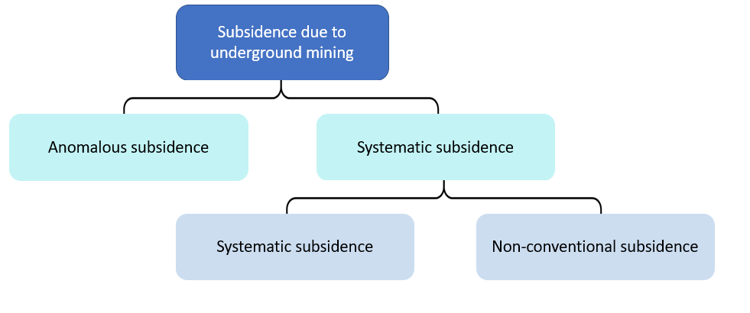
Figure 1: Hierarchy of subsidence terminology

The categories of systematic and anomalous subsidence are defined as:
- Systematic subsidence – A generic, high-level term to describe subsidence behaviour that can be defined by reasonably consistent and predictable models
- Anomalous subsidence – Subsidence behaviour that does not follow any of the accepted normal systematic behavioural models; it is often associated with localised anomalous geological structural features such as faults, dykes or joint swarms. Anomalous subsidence is usually quite a discrete behavioural event, in localised areas only, and is extremely difficult to predict.

Key topics
The EN provides an overview of the major underground mining methods and the different types of subsidence behaviour to be expected from each.
This is followed by a discussion of the fundamental geotechnical principles associated with underground excavations in rock, and how these apply to overburden deformation and failure above underground coal extraction excavations leading to the different forms of surface subsidence. This section of the EN includes illustrations of non-conventional subsidence case studies from the NSW Southern Coalfields and Pennsylvania, USA.
The EN then discusses the current state of knowledge and capabilities for prediction of subsidence effects and impacts. This includes a brief review of empirical, analytical and numerical prediction techniques. The applications and limitations of each technique or generic methodology are considered.
Important considerations before selecting and applying a prediction technique include:
- Mining geometry
- Pillar and panel widths
- Mining or extraction height
- Depth
- Surface topography
- Site geological characterisation
- Strata unit rock types and thicknesses
- Discontinuities
- Soft floor strata
- Previous subsidence history/data.
The next section of the EN discusses sub-surface subsidence behaviour above longwall panels and the critically important development of understanding of the fracturing and deformational networks that develop above a caving extraction system of mining. This is relevant to an understanding of the effects of sub-surface subsidence on potential groundwater horizons, and the impacts that such effects can have on both vertical and horizontal permeability and groundwater characteristics.
While the EN focuses on the geotechnical aspects of subsidence, it also discusses these issues in the context of hydrogeological conditions. This includes potential fracturing and water flow paths through the overburden above the mining horizon, and the domain of near-surface strata cracking that can impact surface water flow.
The EN then discusses the importance of a sound subsidence management plan and reviews its essential elements. It explains the need for this plan to be informed by extensive monitoring of subsidence effects and impacts – not only during the mining operation but also prior to mining in order to establish reliable baseline data.
Finally, the EN lists some of the current priority areas where further research would benefit the mining industry and all stakeholders.

Key planning considerations
The EN recommends consideration of each of the following factors as part of the planning process, before finalising a subsidence management plan or an overall project Environmental Impact Statement:
- Conduct overall site characterisation with respect to geology, surface conditions, features, topography, infrastructure etc.
- Clearly identify sensitive features to be protected and establish an agreed level of acceptable impacts for each feature.
- Select the proposed underground mining method and the methodology for prediction of surface (and, where required, sub-surface) subsidence effects and impacts. This should include validated calibration of prediction methodology to suit the site conditions.
- Conduct reconciliation between (2) and (3).
- Review the selection of mining method and/or mine layout parameters in order to address any deficiencies in the reconciliation (4). This may include:
- Is the longwall method suitable?
- Consider narrower panel widths or even miniwall.
- Reduce mining height.
- Increase chain pillar/barrier pillar widths.
- Consider partial extraction panels.
- Reorient or relocate extraction panels to provide protection (e.g., above pillars) for specific sensitive features.
- Consider placement of backfill in extraction panels behind the face to limit maximum subsidence. (Note: This is practised in some other countries but not routinely in Australia – primarily due to cost.)
- Establish all relevant baseline surveys, prior to mining commencement, including – i.e., subsidence, groundwater, surface water, ecology, heritage sites etc.
- Design and install any specified monitoring instrumentation as part of (6).
- Develop appropriate Trigger Action Response Plans (TARPs) to manage the monitoring program and the requirements/criteria identified in (2).
- Plan for regular review/audit of the program, in the context of an overall Subsidence Management Plan.

Future research priorities
Recommended research priority areas are:
- Fundamental consideration of geotechnical mechanisms of non-conventional subsidence.
- Improvement of non-conventional subsidence prediction techniques.
- Improvement of the capabilities and level of detail available in numerical modelling of all forms of subsidence in three dimensions.
- Fundamental understanding of the impact of mining geotechnical interactions on subsidence in multi-seam mining, leading to higher confidence level prediction techniques.
- Improved characterisation of the surface fracturing zone above underground extraction.
- Improved baseline and investigation of changes associated with subsidence interaction with swamps, rock bars in surface waters, and the environmental consequences.
- Fundamental understanding and development of an improved modelling/prediction capability to better characterise the development of overburden deformation and fracturing above underground mining and the resultant impact on groundwater.
- Ongoing development of subsidence monitoring techniques to improve resolution and expand application – in particular, remote and airborne sensing technologies.

