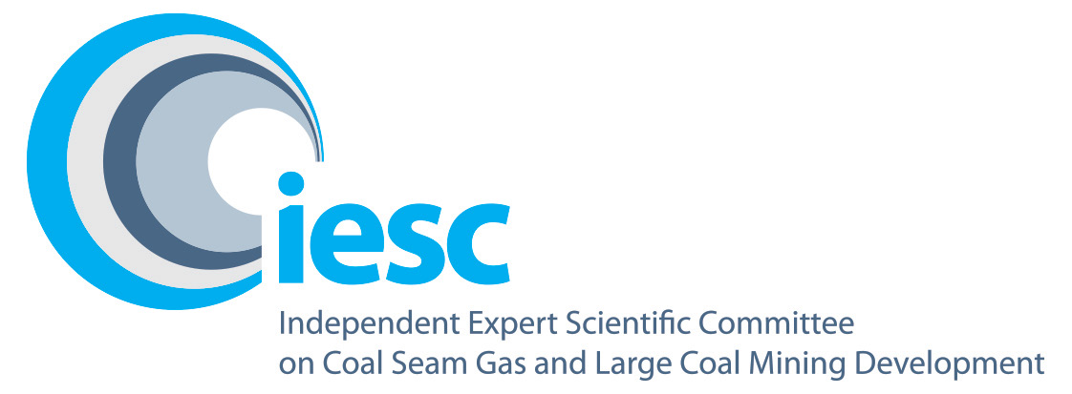

2021–2022

Annual Review of Activities
An overview of the activities of the Independent Expert Scientific Committee on Coal Seam Gas and Large Coal Mining Development from July 2021 to June 2022


© Commonwealth of Australia, 2022.

Annual Review of Activities – July 2021 to June 2022 is licensed by the Commonwealth of Australia for use under a Creative Commons Attribution 4.0 International licence with the exception of the Coat of Arms of the Commonwealth of Australia, the logo of the agency responsible for publishing the report, content supplied by third parties, and any images depicting people. For licence conditions see: https://creativecommons.Org/licenses/by/4.0/
This report should be attributed as 'Independent Expert Scientific Committee on Coal Seam Gas and Large Coal Mining Development: Annual Review of Activities – July 2021 to June 2022, Commonwealth of Australia'.
This publication is funded by the Australian Government Department of Climate Change, Energy, the Environment and Water. The views and opinions expressed in this publication are those of the authors and do not necessarily reflect those of the Australian Government or the Minister for the Environment.
Contact details
For information about this report or about the work of the IESC, please contact:
IESC Secretariat
Office of Water Science
Department of Climate Change, Energy, the Environment and Water
GPO Box 3090
CANBERRA ACT 2601
Email: IESCSecretariat@awe.gov.au
The report can be accessed at http://www.iesc.environment.gov.au/
Images
Front cover:
Hunter Valley Wetlands | © Copyright Department of Climate Change, Energy, the Environment and Water
Back cover:
Hunter Valley Wetlands | © Copyright Department of Climate Change, Energy, the Environment and Water
All other images © Department of Climate Change, Energy, the Environment and Water
Table of Contents
1. Message from the Chair 4
2. Highlights 5
3. Members 6
4. Meetings 8
5. Scientific advice 10
6. Information Guidelines and Explanatory Notes 12
7. Research 16
8. Engagement 20

Message from the Chair
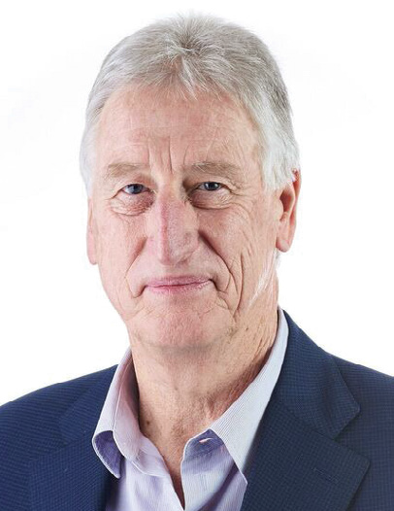
I am pleased to present the Independent Expert Scientific Committee on Coal Seam Gas and Large Coal Mining Development (IESC) 2021-2022 Annual Review of Activities.
Since the establishment of the interim IESC in 2012, the IESC has provided 147 pieces of independent scientific advice to Commonwealth and state government regulators.
In 2021-22, the committee met 10 times and provided eight pieces of scientific advice to government. The IESC welcomed the opportunity to recommence in-person meetings in 2022, hosting our 86th meeting in Brisbane in May 2022.
The IESC continues to expand its range of published resources to assist proponents preparing environmental impact assessments.
In March 2022, we published our fourth Explanatory Note: Characterisation and modelling of geological fault zones. We are currently developing Explanatory Notes on ecohydrological conceptual models and on subsidence due to longwall coal mining and coal seam gas production. We continue to engage with stakeholders throughout the development of our Explanatory Notes and look forward to inviting stakeholder feedback as our future Explanatory Notes progress.
Under our research priorities, we have undertaken several research projects to continue to build the broader scientific understanding of the potential impacts of coal seam gas and coal mining on water resources.
Our scoping study on coal mine voids in Queensland was published in November 2021 and is available on the IESC website. In 2021-22, we progressed our multistage metagenomic research project. Stage one is nearing completion and stages two and three continue to progress. We look forward to sharing the outcomes of our research projects as they are finalised.
In October 2021, the Hon Sussan Ley MP reappointed committee members Dr Andrew Boulton, Professor Jenny Davis and Professor Rory Nathan.
On behalf of the IESC, I thank the Office of Water Science (OWS) for its continued support and dedication through
2021-22. The OWS, within the Australian Government Department of Climate Change, Energy, the Environment and Water, provides excellent support to the IESC through the provision of secretariat assistance and scientific expertise.
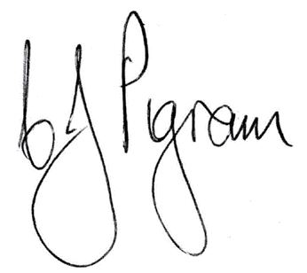
Dr Chris Pigram AM, FTSE
IESC Chair

Highlights
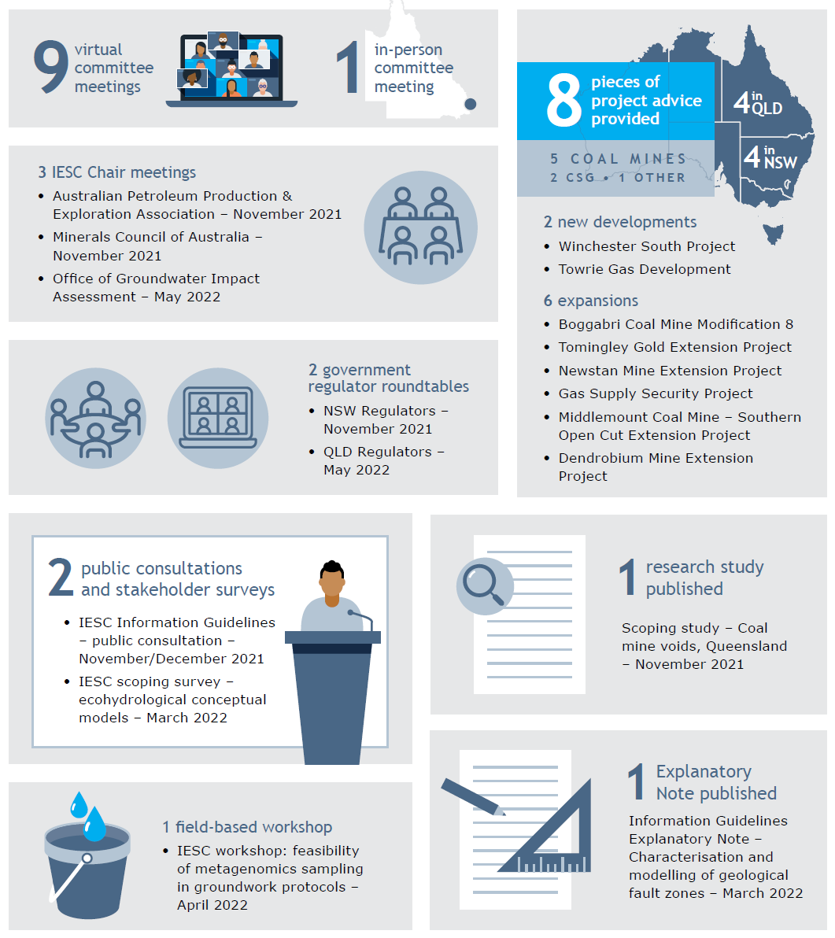

Members
The IESC consists of a maximum eight members. Members are leading scientists in their fields and have extensive scientific qualifications and expertise in geology, hydrogeology, hydrology, ecology and ecotoxicology.

Ongoing members in 2021-22
 | Dr Chris Pigram AM FTSE – Chair  Dr Pigram is a geologist with over 40 years' experience and is a leader in research and management of minerals, marine and petroleum geoscience programs, and geospatial and earth monitoring. Dr Pigram was formerly the CEO of Geoscience Australia, where he held the role for seven years. Consequently, he has extensive experience in managing the interface between science and government and in stakeholder engagement.
 | Dr Jenny Stauber – Ecotoxicology  Dr Stauber has 40 years of research experience in the fields of ecotoxicology, water quality, contaminant environmental risk assessment and human toxicology. She serves as an expert ecotoxicologist on a wide range of advisory panels for national and international agencies. Dr Stauber is currently a Chief Research Scientist in CSIRO Land and Water. She is a Fellow of the Australian Academy of Technology and Engineering and a Fellow of the Australian Academy of Science.
 | Professor Craig Simmons – Hydrogeology  Professor Simmons is a leading international authority on hydrogeology and groundwater modelling. He is currently on secondment to the Australian Research Council as Executive Director from Flinders University, where he is the Matthew Flinders Distinguished Professor of Hydrogeology and the Schultz Chair in Environment. Professor Simmons was the 2015 South Australian Scientist of the Year and the 2017 Australian Water Professional of the Year. He is a Fellow of the Australian Academy of Technology and Engineering, a Fellow of the Australian Academy of Science and a Fellow of the American Geophysical Union.
 | Professor Wendy Timms – Geology and Hydrogeology  Professor Timms has extensive geology, hydrogeology and engineering expertise with over 25 years of professional experience. In 2020 she was the Distinguished Lecturer for the National Centre for Groundwater Research and Training, on 'Digg'n deeper – the state of mining hydrogeology'. She has engineering project and research experience at coal, gas, uranium, metals and potash sites in Australia, Asia and Canada. Wendy is Professor of Environmental Engineering at Deakin University, teaching geology for geotechnical engineering and leading research in geological carbon sequestration, water tracer technology, and groundwater hydrology. She has published over 200 technical reports and more than 50 peer-reviewed journal papers and served as Vice-President of the International Association of Hydrogeologists.
 | Professor Jenny Davis – Ecology  Professor Davis has expertise in freshwater biodiversity and wetland conservation, with more than 200 published papers and reports. She was awarded the Limnology Medal for excellence in freshwater research in 2006. Professor Davis co-chairs the Wetlands Working Group of the International Association for Ecology (INTECOL). She is a member of the Research Institute for Environment and Livelihoods at Charles Darwin University.
 | Professor Rory Nathan – Hydrology  Professor Nathan has over 35 years' experience in engineering and environmental hydrology and is currently Professor of Hydrology and Water Resources at the University of Melbourne. He has made a substantial contribution to industry best practice in a range of engineering and environmental fields, particularly in the characterisation of hydrologic risk, the assessment of hydrologic impacts, and hydrologic model development and application.
 | Associate Professor Phil Hayes – Hydrogeology  Associate Professor Hayes is a geoscientist, hydrogeologist and groundwater modeller with over 25 years' experience in Australia, the United Kingdom and South America. He has worked across sectors from water resource management and groundwater protection to impact prediction and mitigation for mining, oil and gas, contaminated land, infrastructure, and nuclear waste. He is Associate Professor of Water Resources at the University of Queensland, leading research at the interface between reservoir engineering and hydrogeology, and in groundwater modelling uncertainty analysis.
 | Dr Andrew Boulton – Ecology  Dr Boulton's research spans river and groundwater ecology, especially in semi-arid areas, with 4 books and over 130 peer-reviewed articles.  He has been on international and national panels to assess riparian zone policies, environmental flows, groundwater-dependent ecosystems and biodiversity of intermittent rivers. Dr Boulton is Adjunct Professor in Ecosystem Management at the University of New England and has held academic positions at other national and international universities.

Meetings
In 2021-22, the IESC met once in person and nine times virtually to prepare its scientific advice. Minutes of each IESC meeting are published on the IESC website.

IESC meeting dates and subject matter, 2021-22
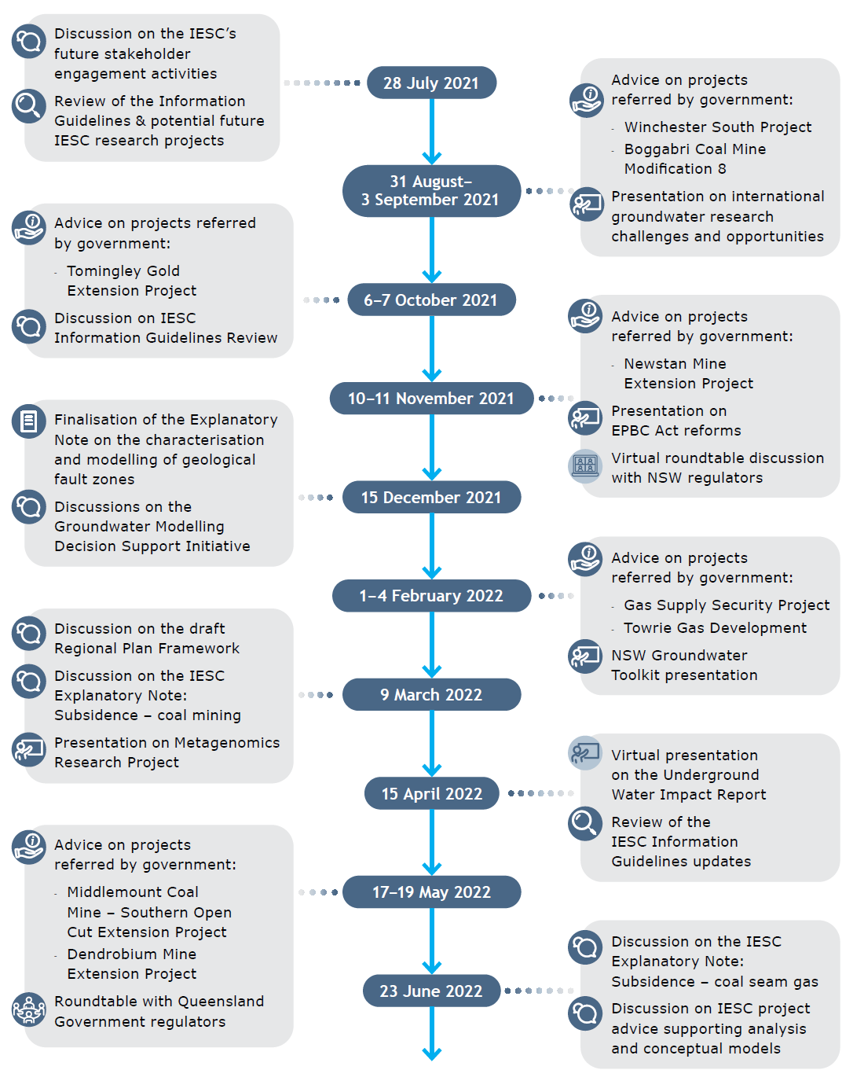

Guest presentations
Guests from a range of organisations and disciplines are invited to committee meetings to present on topics of interest to the IESC. These presentations increase the IESC's collective scientific understanding of the potential impacts of coal and coal seam gas development proposals on water resources.

Guest presentations in 2021-22
- Commonwealth Department of Agriculture, Water and the Environment – Environment Protection and Biodiversity Conservation Act 1999 reforms and regional planning framework
- Groundwater Modelling Decision Support Initiative Representatives – Discussion on the usefulness of groundwater modelling in the environmental assessment regulatory framework
- New South Wales Department of Planning and Environment – Water Division presentation on groundwater technical guidelines
- Queensland Office of Groundwater Impact Assessment – Update of the Underground Water Impact Report for the Surat Basin Cumulative Management Area and discussion on predicted subsidence
- Office of the Queensland Mine Rehabilitation Commissioner – Rehabilitation Workshop

Member presentations
IESC members present regularly at committee meetings to update the committee on the latest developments in members' various disciplines.

Member presentations in 2021-22
- Dr Andrew Boulton – Stygofauna ecology and ecohydrological conceptual models in environmental impact assessment
- Professor Craig Simmons – International groundwater research challenges and opportunities
- Dr Jenny Stauber – Assessing the risk of metal contaminants in aquatic systems

Scientific advice
Under the Environment Protection and Biodiversity Conservation Act 1999 (Cth) (EPBC Act), the Australian Government and relevant state government regulators request the advice of the IESC on the potential impacts of coal seam gas and large coal mining developments on water resources. The IESC can also provide advice on proposals for resource developments other than large coal mining and coal seam gas developments, at the request of relevant state government ministers with the written agreement of the Australian Government Environment Minister.
When reviewing development proposals, the IESC considers impacts on groundwater, surface water, water quantity and quality, ecosystems and ecological processes as defined under the Commonwealth Water Act 2007.
In 2021-22, the IESC provided eight pieces of scientific advice on development proposals. Since the establishment of the interim IESC in 2012, the IESC has provided 147 pieces of advice to government regulators.
The IESC is not responsible for regulatory decisions; this remains the role of the Commonwealth and state government regulators. Its advice enables the regulators to make their decisions based on the best available science.
To ensure transparency, the IESC's scientific advice is published on the IESC website within 10 days after being provided to the relevant regulator.
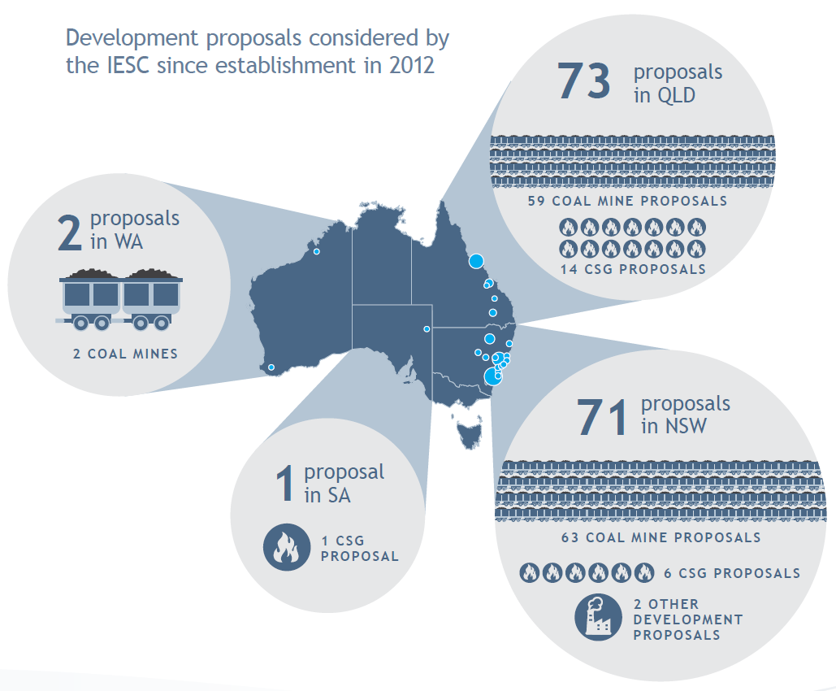
Table 1 Development proposals on which the IESC provided scientific advice, 2021-22
IESC Reference | Referring government | Project Location | Project name | Date of IESC advice
2021-124 | Australian Government and QLD | QLD | Winchester South Project – New Development | 5 Sep 2021
2021-125 | Australian Government and NSW | NSW | Boggabri Coal Mine Modification 8 – Expansion | 5 Sep 2021
2021-127 | NSW | NSW | Tomingley Gold Extension Project – Expansion | 9 Oct 2021
2021-128 | Australian Government and NSW | NSW | Newstan Mine Extension Project – Expansion | 15 Nov 2021
2022-129 | Australian Government | QLD | Gas Supply Security Project – Expansion | 6 Feb 2022
2022-130 | Australian Government | QLD | Towrie Gas Development – New Development | 7 Feb 2022
2022-131 | Australian Government | QLD | Middlemount Coal Mine – Southern Open Cut Extension Project – Expansion | 7 June 2022
2022-132 | Australian Government and NSW | NSW | Dendrobium Mine Extension Project – Expansion | 9 June 2022

Locations of proposed developments considered by the IESC in 2021-22
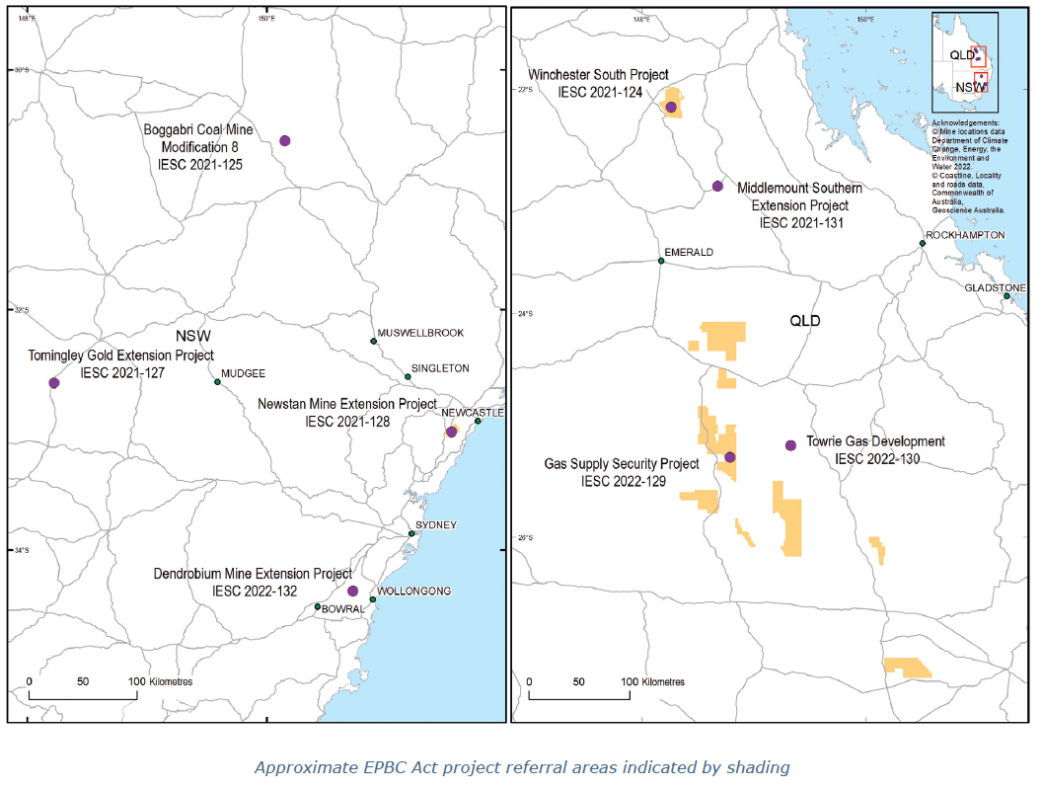

Information Guidelines and Explanatory Notes
The IESC has developed a suite of resources to assist industry and regulators with environmental assessments. The resources provide guidance on the suggested information and data to be included in an environmental impact assessment.
Provision of appropriate information by proponents enables the IESC to provide robust scientific advice to government regulators on the potential water-related impacts of proposed coal seam gas and large coal mining developments.

Information Guidelines review
The outline the information project proponents should provide to enable the IESC to provide robust scientific advice on the potential water-related impacts of proposed coal seam gas and large coal mining developments.
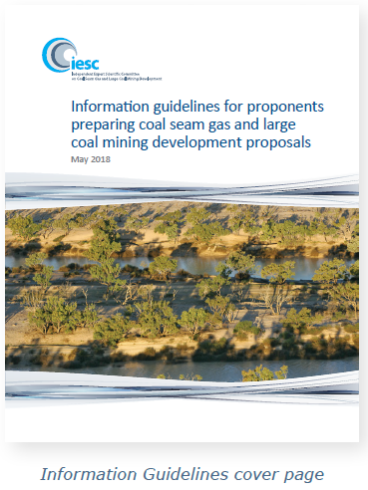
The IESC Information Guidelines were first published in February 2013. They were reviewed and amended in April 2014, June 2015 and May 2018.
In 2021, the IESC agreed to undertake a review of the Information Guidelines and proposed updates which provide additional and clearer guidance to project proponents on the IESC's information requirements.
Public consultation on the proposed updates was undertaken between October and December 2021. Submissions were welcomed from interested organisations and individuals on the content, usability and applicability of the updates.
The IESC thanks those organisations and individuals who provided comment on the updates to the Information Guidelines.
The updated Information Guidelines are expected to be published in late 2022.

Information Guidelines Explanatory Notes
For some topics, Explanatory Notes have been written to supplement the IESC Information Guidelines, providing tailored guidance and up-to-date robust scientific methodologies and tools for specific components of environmental impact assessments of coal seam gas and large coal mining developments.
Explanatory Notes have also been applied across a range of other resource industries, including the iron ore sector. To date, the IESC has published four Explanatory Notes on its website.
Uncertainty analysis – Guidance for groundwater modelling within a risk management framework identifies tools and methods to help proponents understand the range of available approaches to uncertainty analysis in groundwater modelling. It is designed to be used across a range of regulatory regimes.
Assessing groundwater-dependent ecosystems reviews tools and methods for groundwater- dependent ecosystem assessment to help proponents choose the most effective approach.
Deriving site-specific guideline values for physico-chemical parameters and toxicants introduces the use of a water and sediment quality management framework to assist with the design of appropriate monitoring programs for measuring physico-chemical parameters and toxicants from which site-specific guideline values can be developed.
On 28 March 2022, the IESC published its fourth Explanatory Note: Characterisation and modelling of geological fault zones.
This Explanatory Note provides a range of approaches available to proponents to determine the role faults may play in impeding or propagating pressure and groundwater flow impacts from proposed development projects.
The Explanatory Note was finalised after incorporating comments from a public consultation period undertaken in 2021.

Explanatory Notes in preparation

Explanatory Note on ecohydrological conceptual models
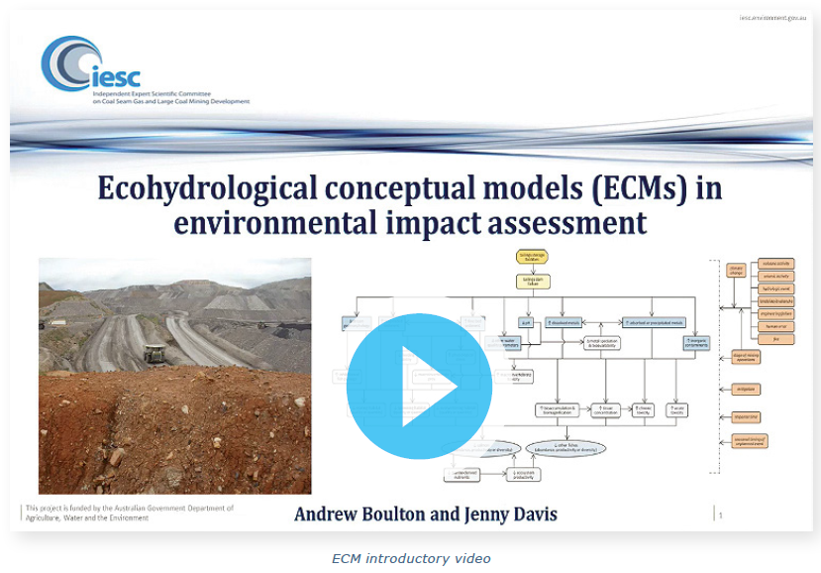
The IESC has commenced work on the development of a new Explanatory Note to provide tailored guidance and up-to-date robust scientific methodologies and tools for developing ecohydrological conceptual models (ECMs) for assessing impacts on ecological systems due to changes to water resources caused by coal seam gas and large coal mining developments.
In March 2022, a scoping stakeholder survey was undertaken to help shape the development of the Explanatory Note.
To provide context for the survey and to provide a background to the development and use of ECMs, an introductory video was prepared by IESC member Dr Andrew Boulton.
The IESC would like to thank those who completed the survey and provided valuable feedback to help shape the development of the Explanatory Note.
It is projected that the Explanatory Note will be released for public consultation in late 2022.

Explanatory Notes on subsidence associated with underground coal mining and subsidence associated with coal seam gas
The IESC intends to develop two Explanatory Notes to provide tailored guidance and up-to-date robust scientific methodologies and tools for assessing the risk and magnitudes of subsidence (surface deformation) and its environmental impact due to coal seam gas and large coal mining developments. The proposed Explanatory Notes will provide updated guidance and build on the current IESC subsidence-related documents.
Public consultation on the subsidence Explanatory Notes will be undertaken in the second half of 2022.

Updates to existing Explanatory Notes
Updates to the IESC Information Guidelines and Explanatory Notes are undertaken as new methodologies and tools become available.
In early 2022, the IESC began a review of its first Explanatory Note: Uncertainty analysis – Guidance for groundwater modelling within a risk management framework. Updates are being made to incorporate developments in this area since the Explanatory Note was first published in 2018.
Public consultation on the updates is expected to be undertaken in late 2022.

Research
The IESC sets research priorities and funds research under these priorities to improve understanding of the potential water-related impacts of coal seam gas and large coal mining developments.

Completed research projects in 2021-22

Scoping study – Coal mine voids, Queensland
In November 2021, the IESC published its Scoping study – Coal mine voids, Queensland.
As part of its hydrology research priority, the IESC aimed to increase understanding of residual (final) coal mine voids in Queensland through the scoping study to identify the location and potential impacts of these features within the landscape.
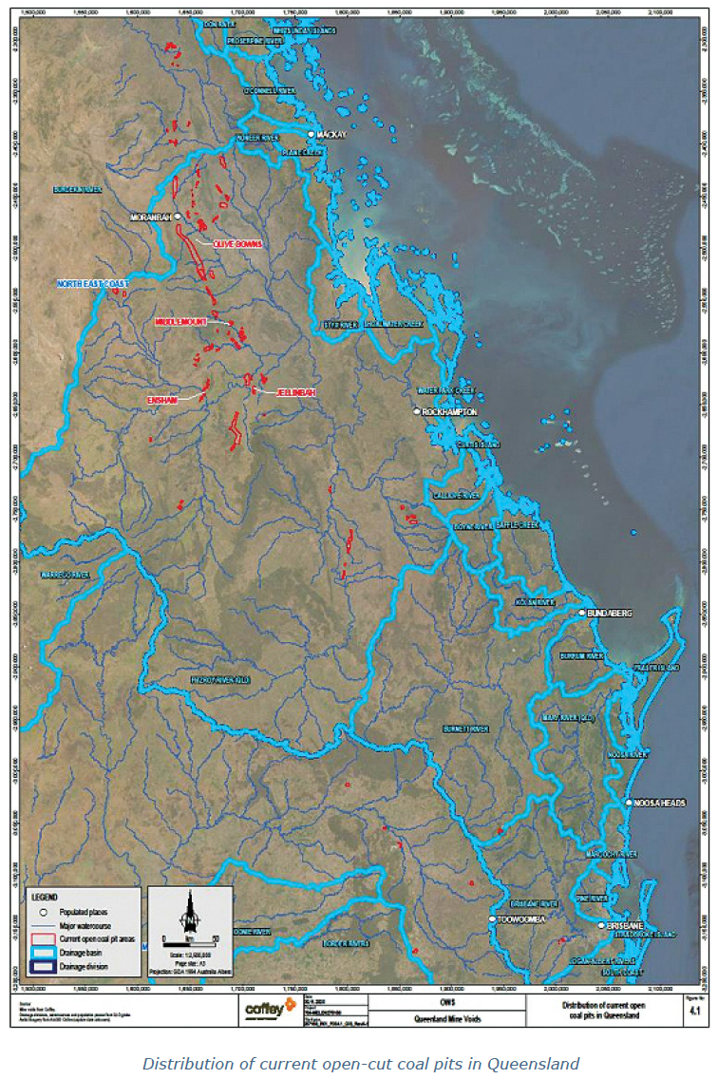
The scoping study consisted of:
- a database of current open coal pits in Queensland and characterisation of their vulnerability to potential impacts
- case study analysis of residual coal mine voids for four selected mine sites
- development of a risk assessment approach to assess the risks of residual coal mine voids to water resources and the receiving environment.
Four coal mine sites were selected as case studies to examine a range of characteristics of residual voids, including strategies for rehabilitation, and to assist in developing a risk assessment approach for consideration by the IESC.
For the four selected case studies, publicly available information (e.g. environmental impact statements, impact assessment reports, environmental assessments records and IESC advice) and information made available by the Queensland Government was collated and interrogated for the purposes of characterising proposed or existing residual voids according to specified attributes.
Esri shape files and KMZ files of the digitised coal mine pits, including key attributes that can be uploaded by the user to Queensland Globe, are also provided as part of the scoping study outputs.
The scoping study and associated shape files can be accessed on the IESC's website.

Ongoing research projects
In 2021-22, the IESC commenced several new research projects as well as progressing a number of ongoing projects under its research priorities.

Metagenomic research project
Since late 2020 and continuing into 2021-22, the IESC has been funding a research project under its Chemical and Ecology research priority themes.
The project aims to use metagenomic approaches to improve understanding of how changes to groundwater quality arising from coal seam gas and large coal mining developments might affect the biodiversity and function of phreatic fauna and microbes and their associated ecosystem services.
The project has been split into the following three stages.

Metagenomic project – stage one
To undertake the first part of this priority research, a year-long project has been undertaken to:
- assess associations between groundwater quality and the composition of stygofaunal and phreatic microbial assemblages in alluvial aquifers
- compare the effectiveness of various sampling protocols (e.g. sampling unpurged versus purged bores, different sample volumes) to find an optimum for estimating stygofaunal assemblage composition
- evaluate the feasibility of metagenomic approaches for routine groundwater biomonitoring.
The outcomes of stage one are expected to be published on the IESC website in mid-2022.
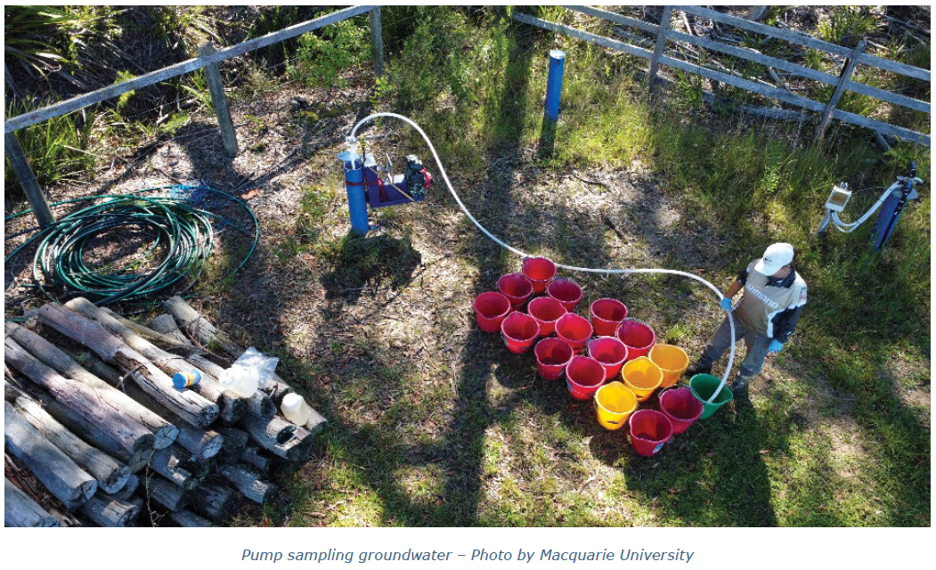

Metagenomic project – stage two
Stage two of this research project commenced in early 2022.
The scope of stage two will be to extend the findings from stage one to assess:
- associations between groundwater quality and the taxonomic and inferred functional composition of phreatic assemblages (including microbes) in a sandstone aquifer
- if possible, the effectiveness of various sampling protocols (e.g. sampling unpurged versus purged bores, optimal sample volumes) in this aquifer type
- the feasibility for field practitioners to collect and process samples for the use of metagenomic approaches in routine groundwater biomonitoring for potential impacts of coal and coal seam gas activities.
Stage two of the project included a field-based workshop for consultants, held on 29 April 2022.
It is expected that field sampling and analytical methods for groundwater quality, phreatic assemblages and metagenomic approaches will be the same as those used in stage one. This will enable direct comparison of findings from stage two with those from the alluvial aquifers sampled in stage one.

Metagenomic project – stage three
Stage three commenced in 2022 and is the final stage of the project. Stage three aims to:
- compare the use of shot-gun sequencing and metabarcoding approaches to assess or infer the functional composition of microbial assemblages in alluvial and sandstone aquifers that may potentially be affected by coal mining and coal seam gas development

- investigate associations between water quality parameters and microbial function and composition in both aquifers
- evaluate the feasibility for consultants to collect and process groundwater samples for either shot-gun sequencing or metabarcoding approaches to assess potential impacts of coal mining and coal seam gas development on microbial composition and activity.
Results from each stage of the project will be published on the IESC website as they are finalised.

Minimum groundwater monitoring guidelines
In 2021-22, the IESC, working with the National Groundwater Committee (a subcommittee of the National Water Reform Committee), progressed its project to standardise groundwater monitoring requirements across Australia.
The project aims to provide a snapshot of the current state of the draft guidelines that reviews and standardises groundwater monitoring requirements across Australia.
The IESC looks forward to sharing the results of its ongoing research projects as they are finalised.

Engagement
The IESC continues to promote its work by meeting with interested parties to ensure that its role and function are well understood.

Chair meetings
The IESC Chair continues to meet with interested parties to promote the role of the IESC, to learn more about how the IESC's advice is used, and to seek stakeholder views on the IESC Information Guidelines and Explanatory Notes.
In November 2021, Dr Pigram met virtually with industry representatives from the Australian Petroleum Production & Exploration Association, the Minerals Council of Australia, and the Queensland Resources Council to discuss proposed updates to the IESC Information Guidelines.
In May 2022, Dr Pigram met with representatives from the Office of Groundwater Impact Assessment.

Government regulator roundtables
The IESC regularly meets with government regulators to seek feedback on and discuss the IESC's scientific advice, to update state government regulators on the IESC's recent activities, and to discuss items of mutual interest.
The IESC held two virtual regulator roundtables in 2021-22:
- In November 2021, the IESC hosted a virtual roundtable discussion with regulators from various New South Wales Government agencies.
- In May 2022, the IESC hosted an in-person roundtable with regulators from various Queensland Government agencies in Brisbane.

EAGE Workshop on Faults in Groundwater, CO₂ and Hydrocarbons in Asia Pacific
In August 2021, IESC member Professor Wendy Timms provided a virtual keynote presentation at the First European Association of Geoscientists and Engineers Workshop on Faults in Groundwater, CO₂ and Hydrocarbons in the Asia Pacific. The virtual workshop explored the impact of structural features on fluid flow working with case studies from a wide range of extractive industries.
Professor Timms's keynote presentation provided an overview of the IESC and highlighted the recently published IESC Information Guidelines Explanatory Note: Characterisation and modelling of geological fault zones.

Feasibility of metagenomics sampling protocols workshop
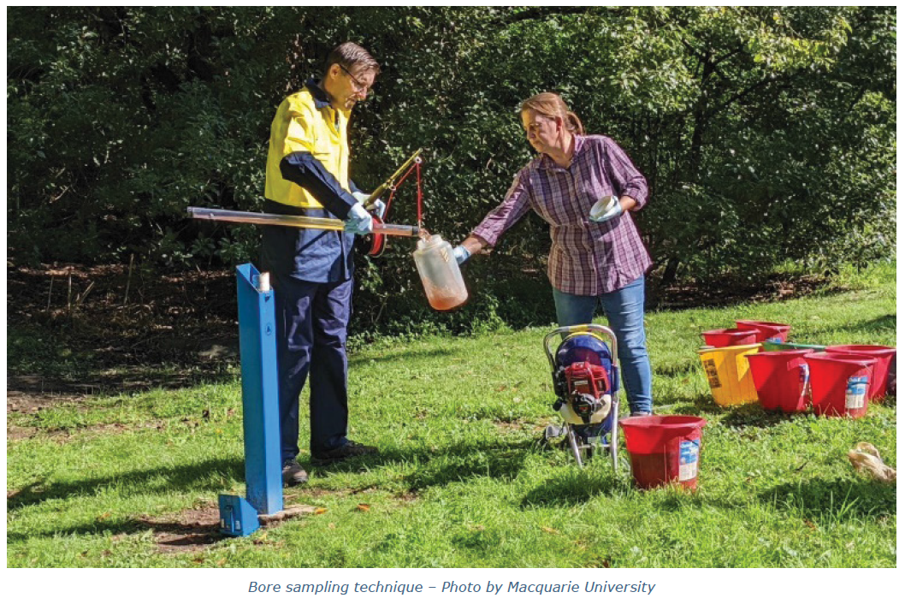
On 29 April 2022, the IESC supported a workshop at Macquarie University to demonstrate a range of sampling approaches to understand the impacts of coal seam gas and large coal mining developments on stygofaunal and microbial assemblages in groundwater.
The workshop, hosted by Professor Grant Hose, Associate Dean Innovation, Macquarie University, included:
- an update on the key outcomes of the IESC's metagenomic research project
- demonstration of preferred sampling techniques
- a sample-filtering demonstration
- discussions on the feasibility of incorporating metagenomic approaches into monitoring programs.
The IESC would like to thank workshop participants for their enthusiasm and knowledge-sharing.

SETAC Pellston Workshop: Integrating Global Climate Change in Ecological Risk Assessment
From 20 to 24 June 2022, IESC members Dr Jenny Stauber and Professor Rory Nathan attended the Society of Environmental Toxicology and Chemistry (SETAC) Pellston Workshop in Oslo, Norway.

The workshop, organised by leaders in the field, aimed to:
- explore and adapt existing downscaling methods from climate models and link their predictions (of temperature and rainfall, among others) to changes in chemical-emission and fate data and models
- develop new or adapt existing methods for incorporating the range of outputs from the first objective into ecological risk assessments (ERAs) for chemical, physical and biological stressors of interest
- use the output from the first two objectives to illustrate how incorporating global climate change predictions into ERAs can help inform adaptation and mitigation strategies to address global climate change impacts.



www.iesc.environment.gov.au

