

Information Guidelines Explanatory Note   
Deriving site-specific guideline values for physico-chemical parameters and toxicants

© Commonwealth of Australia, 2019

*Deriving site-specific guideline values for physico-chemical parameters and toxicants* is licensed by the Commonwealth of Australia for use under a Creative Commons Attribution 4.0 International licence with the exception of the Coat of Arms of the Commonwealth of Australia, the logo of the agency responsible for publishing the report, content supplied by third parties, and any images depicting people. For licence conditions see: <https://creativecommons.org/licenses/by/4.0/>

This report should be attributed as ‘Huynh T and Hobbs D 2019. D*eriving site-specific guideline values for physico-chemical parameters and toxicants*. Report prepared for the Independent Expert Scientific Committee on Coal Seam Gas and Large Coal Mining Development through the Department of the Environment and Energy, Commonwealth of Australia 2019’. The Commonwealth of Australia has made all reasonable efforts to identify content supplied by third parties using the following format ‘© Copyright, [name of third party]’.

This publication is funded by the Australian Government Department of the Environment and Energy. The views and opinions expressed in this publication are those of the authors and do not necessarily reflect those of the Australian Government or the Minister for the Environment and Energy.

While reasonable efforts have been made to ensure that the contents of this publication are factually correct, the Commonwealth does not accept responsibility for the accuracy or completeness of the contents, and shall not be liable for any loss or damage that may be occasioned directly or indirectly through the use of, or reliance on, the contents of this publication.

Citation

Huynh T and Hobbs D 2019. *Deriving site-specific guideline values for physico-chemical parameters and toxicants*. Report prepared for the Independent Expert Scientific Committee on Coal Seam Gas and Large Coal Mining Development through the Department of the Environment and Energy.

Acknowledgements

This report was finalised by the Independent Expert Scientific Committee on Coal Seam Gas and Large Coal Mining Development (IESC) based on consideration of work commissioned by the Office of Water Science (OWS) on behalf of the IESC in March 2019 through the Department of the Environment and Energy.

The main additional contributors of scientific input to this work were Jenny Stauber (IESC), Carl Zimmermann (OWS) and Taysha Le Compte (OWS).

The Department acknowledges the traditional owners of country throughout Australia and their continuing connection to land, sea and community. We pay our respects to them and their cultures and to their elders both past and present.

Contact details

For information about this report or about the work of the IESC please contact:

IESC Secretariat

Office of Water Science

Department of the Environment and Energy

GPO Box 787

CANBERRA ACT 2601

This report can be accessed at <http://www.iesc.environment.gov.au/>

Table of Contents

Overview 4

The role of the IESC 4

The purpose of the Explanatory Notes 4

Legislative context 5

Executive summary 6

1 Introduction 7

1.1 CSG and LCM industries 7

2Understanding the Australian and New Zealand Water Quality Guidelines 11

2.1 Water quality guideline values and water quality objectives 11

2.2 Stressors 11

2.3 Levels of protection 12

2.4 Lines of evidence 12

2.5 Water quality in ecoregions 12

2.6 Management framework for applying the Guidelines for CSG and LCM industries 13

2.6.1 The management framework 13

2.6.2 Set primary management aims 14

2.7 Default water GVs for physico-chemical stressors 14

2.8 Default GVs for toxicants in water 15

2.9 Default GVs for toxicants in sediments 15

3Deriving site-specific GVs for water and sediment quality 17

3.1 Why derive site-specific guideline values? 17

3.2 How do we apply site-specific GVs? 17

3.3 Approaches to deriving site-specific GVs 19

3.3.1 Deriving site-specific water GVs using local reference data 19

3.3.2 Deriving site-specific sediment GVs using local reference data 21

3.3.3 Deriving site-specific water quality GVs for a toxicant without default GVs using the species sensitivity distribution approach 22

4Designing water and sediment quality monitoring programs for CSG and LCM industries 27

4.1 Sampling program design 27

4.2 Effective water monitoring program 28

4.3 Effective sediment monitoring program 28

4.4 Site-specific water and sediment sampling program 29

4.4.1 Quality assurance and quality control in sampling and chemical analysis 29

4.4.2 Dealing with outliers and censored data 30

5Integrating and optimising monitoring and assessment programs 31

5.1 Using multiple lines of evidence and associated indicators 31

5.2 Integrating chemical and biological approaches in the water quality management framework 31

5.3 Applying biological assessments as part of an integrated assessment 32

6Temporary water bodies 33

6.1 Characteristics of temporary water bodies 33

6.2 Effective monitoring programs for water and sediment quality indicators of temporary water bodies 33

6.2.1 Temporary water body conceptual modelling 33

6.2.2 Monitoring approach 34

6.2.3 Monitoring temporary water bodies 35

6.3 Special problems associated with monitoring sediment and water quality in highly temporary water bodies 36

7Conclusions 38

References 39

Appendix 1: Recommended reading 41

Appendix 2: Glossary of terms and abbreviations 42

Appendix 3: Sediment quality guideline values – Current guideline values and recommended revisions (Table A.1, Simpson and Batley, 2016) 44

Appendix 4: Time-period measurements and passive sampling devices 46

Overview

The role of the IESC

The Independent Expert Scientific Committee on Coal Seam Gas and Large Coal Mining Development (the IESC) is a statutory body under the Environment Protection and Biodiversity Conservation Act 1999 (Cth) (EPBC Act). The IESC’s key legislative functions are to:

• provide scientific advice to the Commonwealth Environment Minister and relevant state ministers on coal seam gas (CSG) and large coal mining development proposals that are likely to have a significant impact on water resources

• provide scientific advice to the Commonwealth Environment Minister on [bioregional assessments (CoA 2018a) of areas of CSG and large coal mining development](https://www.bioregionalassessments.gov.au/)

• provide scientific advice to the Commonwealth Environment Minister on research priorities and projects

• collect, analyse, interpret and publish scientific information about the impacts of CSG and large coal mining activities on water resources

• publish information relating to the development of standards for protecting water resources from the impacts of CSG and large coal mining development

• provide scientific advice on other matters in response to a request from the Commonwealth or relevant state ministers.

Further information on the IESC’s role is on the [IESC website](http://www.iesc.environment.gov.au/) (CoA 2018b).

The purpose of the Explanatory Notes

One of the IESC’s key legislative functions is to provide scientific advice to the Commonwealth Environment Minister and relevant state ministers in relation to coal seam gas and large coal mining development proposals that are likely to have a significant impact on water resources.

The IESC outlines its specific information requirements in the IESC *I*nformation guidelines for proponents preparing coal seam gas and large coal mining development proposals (IESC 2018) (the Information Guidelines). This information is requested to enable the IESC to formulate robust scientific advice for regulators on the potential water-related impacts from coal seam gas and large coal mining developments.

For some topics, Explanatory Notes have been written to supplement the IESC Information Guidelines, giving more detailed guidance to help the coal seam gas and large coal mining industries prepare environmental impact assessments. These topics are chosen based on the IESC’s experience of providing advice on over 100 development proposals.

Explanatory Notes are intended to assist proponents in preparing environmental impact assessments. They provide tailored guidance and describe up-to-date robust scientific methodologies and tools for specific components of environmental impact assessments on large coal mining and coal seam gas mining developments. Case studies and practical examples of how to present certain information are also discussed.

Explanatory Notes provide guidance rather than mandatory requirements. Proponents are encouraged to refer to issues of relevance to their particular project.

The tools and methods identified in this document are provided to help proponents understand the range of available approaches to deriving site-specific guideline values for physico-chemical parameters and toxicants and are designed to be utilised across a range of regulatory regimes. Proponents are encouraged to refer to specialised literature and engage with their relevant state regulators.

The IESC recognises that approaches, methods, tools and software will continue to develop. The Information Guidelines and Explanatory Notes will be reviewed and updated as necessary to reflect these advances.

Legislative context

The [*Environment Protection and Biodiversity Conservation Act 1999*](https://www.legislation.gov.au/Series/C2004A00485) (Cth) (EPBC Act) states that water resources in relation to coal seam gas and large coal mining developments are a matter of national environmental significance.

A water resource is defined by the [*Water Act 2007*](https://www.legislation.gov.au/Series/C2007A00137) (Cth) as: ‘(i) surface water or groundwater; or (ii) a water course, lake, wetland or aquifer (whether or not it currently has water in it); and includes all aspects of the water resource (including water, organisms and other components and ecosystems that contribute to the physical state and environmental value of the resource)’.

Australian and state regulators who are signatories to the National Partnership Agreement seek the IESC’s advice under the EPBC Act 1999 (Cth) at appropriate stages of the approvals process for a coal seam gas or large coal mining development that is likely to have a significant impact on water resources. The regulator determines what is considered to be a significant impact based on the [*Significant Impact Guidelines 1.3*](http://www.environment.gov.au/resource/significant-impact-guidelines-13-coal-seam-gas-and-large-coal-mining-developments-impacts)*.*

Executive summary

Coal seam gas and large coal mine development (the CSG and LCM industries) encompasses operations such as drilling, mining, extraction and transportation of products, often involving chemicals that could be harmful if released into the environment. Physical and chemical parameters can affect water and sediment quality. These effects are considered in the context of the Australian and New Zealand Guidelines for Fresh and Marine Water Quality (the Guidelines) (ANZG 2018). These provide detail on how guideline values (GVs) for water and sediment quality parameters are derived and can be applied in the environmental assessment process. In the Guidelines, default aquatic ecosystem water quality GVs were developed for a broad range of water types and indicators. However, they strongly emphasise that developing more locally relevant water quality GVs is preferred, particularly for areas associated with anthropogenic activities. The use of default GVs is discussed as part of understanding when and how site-specific GVs should be derived and used.

This Explanatory Note supplements the IESC Information Guidelines [(http://www.iesc.environment.gov.au/publications/information-guidelines-independent-expert-scientific-committee-advice-coal-seam-gas](http://www.iesc.environment.gov.au/publications/information-guidelines-independent-expert-scientific-committee-advice-coal-seam-gas)). It provides guidance tailored specifically to the CSG and LCM industries however it can be used to provide guidance across the resources sectors more generally. CSG and LCM operations are often located in arid, semi-arid or wet–dry tropical regions with temporary water bodies such as ephemeral streams and salt lakes. The Explanatory Note introduces the use of a water and sediment quality management framework (WQMF) to assist with the design of spatially and temporally appropriate monitoring programs for measuring physico-chemical parameters and toxicants from which site-specific GVs for water and sediment quality can be developed. How to design a monitoring program and then derive site-specific GVs for water and sediment is explained within the context of the CSG and LCM industries. References to documents with more specific information on concepts used are provided throughout the Explanatory Note.

1 Introduction

In coal seam gas and large coal mine developments (the CSG and LCM industries), the quality of existing water and sediment in the receiving environments varies considerably. Site-specific guideline values (GVs) are often prepared by project proponents in consultation with local environmental authorities and stakeholders. This Explanatory Note aims to better articulate how the the Guidelines (ANZG 2018) can be implemented through the design of spatially and temporally appropriate monitoring programs for physico-chemical parameters and toxicants from which site-specific GVs for water and sediment quality can be developed. These site-specific GVs can then be applied by the CSG and LCM industries to both permanent and temporary water bodies.

The Explanatory Note provides information on:

• when and how to derive site-specific GVs for different indicators and how to use them for adaptive management and for impact mitigation

• requirements for deriving site-specific GVs at different stages of assessment

• designing an effective monitoring program for water and sediment quality stressors

• dealing with the effects of temporary water when designing a monitoring program

• integrating and optimising a monitoring and assessment program.

These concepts are illustrated with worked examples as case studies. Recommended reading and supporting information is provided in the appendices.

This Explanatory Note supplements the existing IESC Information Guidelines that have been prepared to assist proponents in the CSG and LCM industries with the preparation of environmental assessment documentation. It is hoped that the Explanatory Note will be of use not only to environmental scientists working in the CSG and LCM industries but also to consultants, regulators and managers with an interest in water management issues related to the CSG and LCM industries.

Groundwater and groundwater dependent ecosystems are not covered in this document however they are presented in a separate Explanatory Note: [Assessing groundwater-dependent ecosystems](http://www.iesc.environment.gov.au/publications/information-guidelines-explanatory-note-assessing-groundwater-dependent-ecosystems). The concepts presented in this Explanatory Note may be relevant to groundwater, but it is recommended that specific advice beyond this Explanatory Note be sought regarding deriving suitable groundwater GVs. This Explanatory Note does not cover the topic of biological monitoring, although it is recognised that this is an integral part of ecosystem monitoring and assessment in a weight-of-evidence approach to environmental management.

In view of the broad readership, only basic descriptions are provided in the main body of the Explanatory Note; however, a list of publications is provided for those seeking greater technical detail. A comprehensive glossary is provided in Appendix 2 to assist the non-specialist reader with the terms used in this Explanatory Note.

1.1 CSG and LCM industries

The CSG and LCM industries is a highly diverse sector that encompasses activities such as drilling, mining, extraction and transportation of products, all of which have the potential to impact on aquatic systems. Water is an important issue in CSG production and LCM. In addition to direct discharge, there is also potential for overland transport in run-off waters of solid materials associated with the operations. Water management issues need to be considered in development application documentation at the exploration stage (greenfield) as well as in the design of extensions to an existing development (brownfield).

Activities from CSG operations might require site vegetation removal including ground-based geophysics and the construction of pipeline networks, storage ponds, site processing plants, water treatment plants and access roads. These activities might result in changes to surface water quality, for example from soil erosion following heavy rainfall.

Water management is critical during mine construction, operation and associated rehabilitation/restoration phases. An appropriate closure strategy needs to be in place to minimise post-mining impacts on water quality.

The water and sediment quality management framework in this document attempts to take these factors, such as phases of operation and closure, into consideration.

Each CSG or LCM development, whether on a greenfield or a brownfield site, will have its own specific risks and requirements. However, a general conceptual model of the stressors, exposure pathways and receptors can help identify which indicators will be useful to monitor. Such conceptual models of causal pathways for the CSG and LCM industries for surface water have recently been described (see Figure 1 and Figure 2). These summarise and synthesise the potential linkages between coal resource development and the impacts on water and water-dependent assets. Four causal pathway groups for surface water identified as part of the Bioregional Assessment (BA) Program are:

• groundwater depressurisation and dewatering

• groundwater physical flow paths

• surface water drainage

• operational water management.

More detail about these causal pathways is presented in Appendix 3 of the BAs (Henderson et al. 2016).

Stressors from the CSG and LCM industries include physico-chemical stressors (e.g. salinity, pH, nutrients) and toxicants (e.g. metals). A general list of analytes from CSG is provided in Appendix A of the Chemical Risk Assessment Guidance Manual: for chemicals associated with coal seam gas extraction (CoA 2017). The analytes listed are designed to provide an example suite of analytical parameters that could be used to inform water quality monitoring programs.

Further information on chemicals potentially released from coal that are also representative of those used for CSG activities is available in a report by Apte et al. (2017). The report describes a laboratory-based study that investigated the potential for release of geogenic (naturally occurring) contaminants from coal samples taken from eight locations across eastern Australia. The tests were designed to provide upper bound estimates of contaminant release.

The chemicals potentially released through coal mining activities are similar to those listed for CSG, as stated above. For more information on wastewater quality associated with coal mine sites in Australia, Thiruvenkatachari et al. (2011) lists a number of parameters of interest. Parameters will vary depending on the geology of the region. Further reading on potential chemicals of interest from coal mining can be found in Jankowski and Spies (2007), which investigates how subsidence from coal mining can affect the chemistry of surface water.

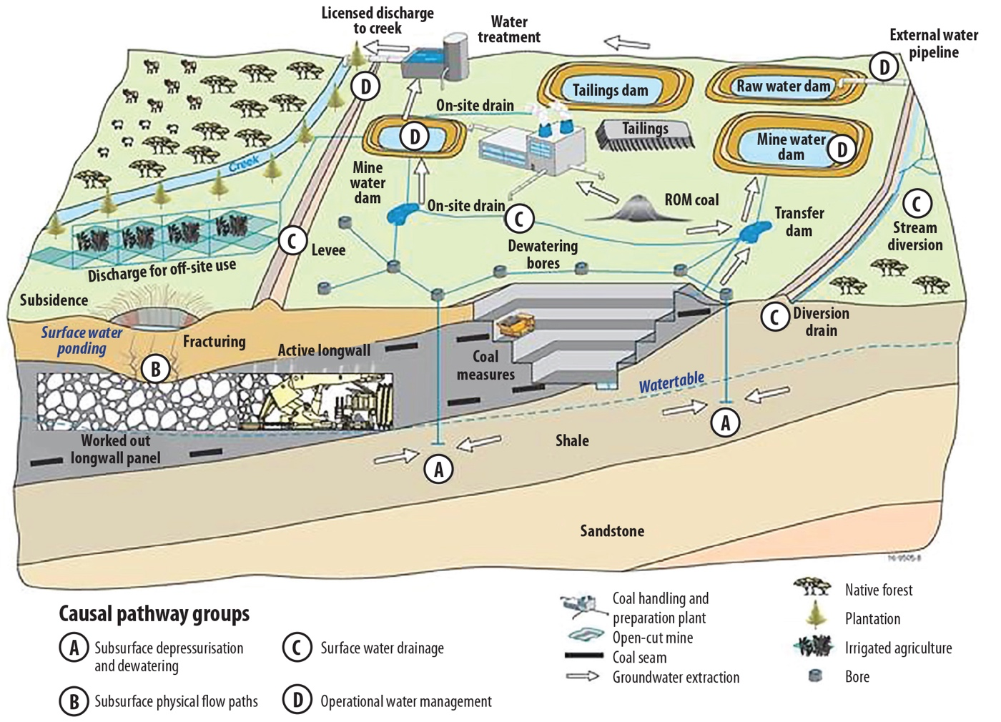

Figure 1: Conceptual diagram of causal pathway groups associated with coal mines (Henderson et al. 2016). This conceptual model is a simple diagram and does not represent all the complexities associated with large coal mining.

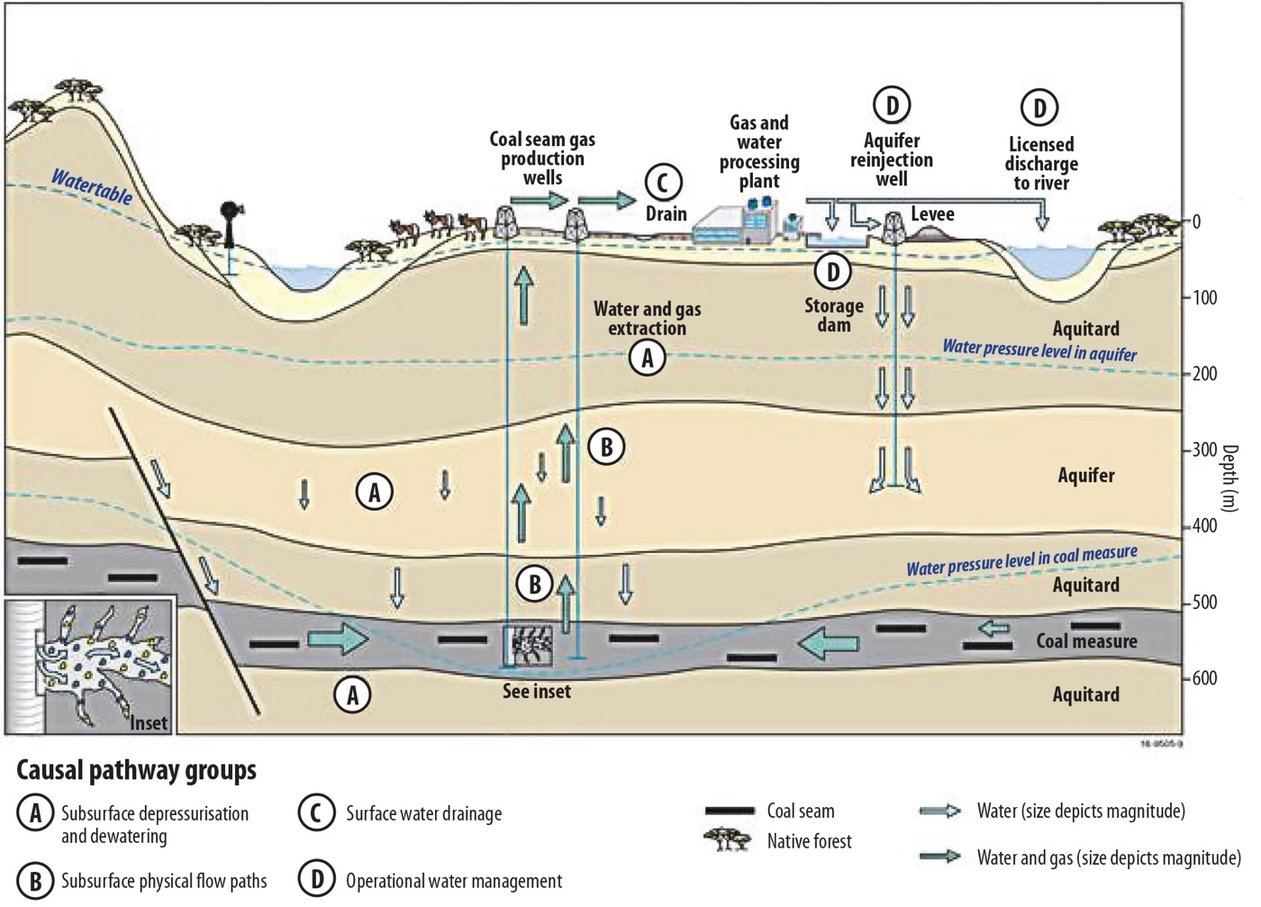

Figure 2: Conceptual diagram of causal pathway groups associated with coal seam gas operations (Henderson et al. 2016). This conceptual model is a simple diagram and does not represent all the complexities associated with CSG activities.

2 Understanding the Australian and New Zealand Water Quality Guidelines

As part of the National Water Quality Management Strategy (NWQMS), the release of the Guidelines (ANZECC & ARMCANZ 2000a; Document 4 of the NWQMS) and the supporting Australian Guidelines for Water Quality Monitoring and Reporting (ANZECC & ARMCANZ 2000b; Document 7 of the NWQMS) represented a major step forward in water quality assessment and monitoring. The Guidelines package consists of several large volumes of information and provides a complete outline of how the Guidelines should be applied, together with a lengthy discussion on the underpinning science. For members of specific industries, accessing the relevant information from this comprehensive package is a daunting yet necessary task. A complete update to the Guidelines, released in August 2018 (ANZG 2018), collated all of the information from the 2000 edition of the Guidelines, with updates to methodology used to derive guideline values and updates to a number of toxicant guidelines values, in one online location (<http://www.waterquality.gov.au/guidelines>). This chapter focuses on understanding the Guidelines.

2.1 Water quality guideline values and water quality objectives

A water quality guideline value (GV) is a concentration of the key performance indicator measured for the ecosystem, below which there exists a low risk that adverse biological (ecological) effects will occur. For some parameters, such as pH, GVs are an acceptable range rather than a maximum. A GV indicates a risk of impact if exceeded (modified from the ‘trigger value’ definition in ANZG (2018)). The GVs are used as a general tool for assessing water quality and are the key to determining water quality objectives (WQOs) that protect and support the designated community values of our water resources and provide targets against which performance can be measured. WQOs are the specific water quality targets (numerical concentration limit or narrative statement) agreed between stakeholders or set by local jurisdictions.

2.2 Stressors

Many aquatic ecosystems experience a range of stressors, both natural and anthropogenic, that affect biodiversity or ecological health. These are discussed at length in the Guidelines (ANZG 2018). Ecosystem conceptual models (ECMs) are a useful tool in identifying and understanding the importance of a range of potential stressors. Information on the development and use of ECMs can be found at <http://www.environment.gov.au/node/38339>. Examples drawn up by the Queensland Government of ECMs of various types of wetland environments are presented on the Queensland Wetland Info website at <https://wetlandinfo.ehp.qld.gov.au/wetlands/ecology/aquatic-ecosystems-natural/>.

Stressors can be classified broadly into two types, depending on whether they have direct or indirect effects on the ecosystem.

Direct effects: Two types of physico-chemical stressors that directly affect aquatic ecosystems can be distinguished: those that are directly toxic to biota; and those that, while not directly toxic, can result in adverse changes to the ecosystem (e.g. to its biological diversity or its usefulness to humans). Excessive amounts of direct-effect stressors cause problems, but some elements and compounds (e.g. nutrients such as phosphorus (P) and nitrogen (N), and metals such as copper and zinc) are essential at low concentrations for the effective functioning of biota. Contaminants that are potentially directly toxic to biota include metals, organic toxicants, ammonia, salinity and pH.

Indirect effects: Stressors that do not directly affect biota can affect other stressors, making them more or less toxic. For example, the effects of reduced dissolved oxygen can influence redox conditions, which can in turn influence the uptake or release of nutrients in sediments. Equally pH, dissolved organic carbon (DOC) and suspended particulate matter (SPM) at lower levels than would cause direct effects themselves can have a major effect on the bioavailable concentrations of some metals.

Other indirect stressors could be invasive species, irrigation extraction, disruption of riparian connectivity, altered flow periods, altered patterns of inundation, and increased variability of climate and rainfall/run-off. For example, the intentional dewatering of aquifers from mining may result in groundwater drawdown and reduce groundwater availability for a natural spring. CSG and LCM industry proposals are often for development in areas that already experience a variety of stressors; therefore it is important to identify the multiple stressors co-occurring in the vicinity and their cumulative impacts.

The Guidelines specifically deal with key water quality management stressors for which guideline packages are provided. These include:

• nuisance growth of aquatic plants due to the change in nutrient (N or P) composition (usually in the water (eutrophication))

• lack of dissolved oxygen (DO, asphyxiation of respiring organisms)

• increased suspended particulate matter because of increased erosion (smothering of benthic organisms, inhibition of primary production, inhibition of visual predation, reproductive impairment)

• unnatural changes in salinity, pH and/or temperature due to the interactions of water and exposed rock (clays and carbonate minerals). For example, acid mine drainage (decreased pH) has resulted from the weathering of sulfide minerals (e.g. pyrite) contained in tailing, waste rock, exposed open cut walls or overburden

• unnatural flow, for example due to stream diversion, mining infrastructure or water discharge (inhibition of migration; associated changes to water temperature, which may particularly affect spawning; changes in estuarine productivity).

2.3 Levels of protection

For aquatic ecosystem protection, three levels of protection are recognised in ANZG (2018).

High conservation/ecological value systems: These are unmodified or other highly valued ecosystems, typically occurring in national parks, conservation reserves or remote and/or inaccessible locations. Although they are not entirely without human influence, the ecological integrity of such systems is regarded as intact, with no detectable changes in biological diversity beyond natural variability.

Slightly to moderately disturbed systems: These are ecosystems in which aquatic biological diversity may have been adversely affected to a relatively small but measurable degree by human activity. The biological communities remain in a healthy condition and ecosystem integrity is largely retained. Some relaxation of the stringent management approach used for high conservation systems may be appropriate; however, maintenance of biological diversity relative to a suitable reference condition should be a key management goal.

Highly disturbed systems: These are measurably degraded ecosystems of lower ecological value. Although degraded they retain, or after rehabilitation may have, ecological or conservation value, but for practical reasons it may not be feasible to return them to a slightly to moderately disturbed condition in the short term.

The level of protection should be discussed and agreed with the relevant regulators. Note that even though a system is assigned a certain level of protection, it does not have to remain ‘locked’ at that level in perpetuity. The Guidelines emphasise working to reduce the level of disturbance. The concepts of adaptive management and continual improvement should always be promoted, to maximise future options for a waterway. See the adaptive management section in ANZG (2018) for more detail.

2.4 Lines of evidence

ANZG (2018) recommends measuring indicators from multiple lines of evidence across the pressure–stressor–ecosystem receptor (PSER) causal pathway. This will give greater weight (or certainty) to assessment conclusions, and to subsequent management decisions to meet the water/sediment quality objective, than basing the evaluation on a single line of evidence.

Weight of evidence describes the process to collect, analyse and evaluate a combination of different qualitative, semi-quantitative or quantitative lines of evidence to make an overall assessment of water/sediment quality and its associated management. It is the central platform for water/sediment quality assessments in the Water Quality Guidelines. Further details on how to conduct a weight-of-evidence process is presented in section 5.1, including the use of multiple lines of evidence and associated indicators in integrating and optimising monitoring and assessment programs.

2.5 Water quality in ecoregions

Water quality varies naturally across different water types, so different GVs may need to be developed for each water type. Water types are classified by ecosystem type, with up to six types of water recognised for the GVs for physico-chemical stressors. Examples of major water types are fresh waters (lakes and reservoirs, wetlands, upland rivers and streams, and lowland rivers and streams) and marine water (estuarine and coastal waters) (ANZECC & ARMCANZ 2000a, p 3.1–9). The expansion of ecoregions in ANZG (2018) is a considerable improvement on the approach in ANZECC & ARMCANZ (2000), with information and regional guideline values being developed for permanent waters in each of 12 drainage divisions.

The Interim Australian National Aquatic Ecosystem (ANAE) Classification Framework (Aquatic Ecosystems Task Group 2012) provides a nationally consistent process to classify aquatic ecosystem and habitat types within an integrated regional and landscape setting. The ANAE classification framework relates ‘water type’ to chemistry and is influenced by the surrounding landscape (geological setting, water balance, quality, types of soils, vegetation and land use), which in turn dictates the habitat of the aquatic environment. Water type information can be used to determine the ‘normal’ water chemistry of a water body, which can then be used when deriving GVs. See Aquatic Ecosystems Task Group (2012) at <http://www.environment.gov.au/resource/aquatic-ecosystems-toolkit-module-2-interim-australian-national-aquatic-ecosystem-anae> for further information on how the ANAE framework can be used for classifying the ecosystem for which a site-specific GV is to be derived, and on the importance of the type of data required to consider all possible water quality variables.

Consideration should also be given to temporary water bodies. These are discussed in Chapter 6 of this document. Water regime conditions have a major influence in determining the nature and persistence of aquatic ecosystems. For example, permanent systems are often highly important in providing refugia for plants and animals during dry/drought conditions, while the unique nature of ephemeral systems, especially those in arid areas, leads to interesting endemic and highly adapted plants and animals.

2.6 Management framework for applying the Guidelines for CSG and LCM industries

2.6.1 The management framework

The water and sediment quality management framework (WQMF) provides managers with information to decide on strategies that will ensure ecologically sustainable development in the long term for the CSG and LCM industries. Stakeholders and the community should also have a collective vision of how a water resource will be used, and there should be a good scientific understanding of the impact of CSG and LCM industry activities on that resource. The WQMF can be used across a range of water/sediment quality management issues for both greenfield and brownfield mine development. In general, a greenfield development will have less monitoring data available for deriving local GVs than a brownfield site.

The WQMF is shown in Figure 3 (ANZG 2018). This Explanatory Note focuses on explaining how to determine the water/sediment quality GVs (WQGVs) and when and how to derive site-specific GVs (Step 4 in the WQMF). In the WQMF, an assessment is made as to whether current water/sediment quality is sufficiently protective of the established community values and management goals, through a comparison of ambient water and sediment quality against the WQOs. If the WQOs are met, the management focus will be on maintaining existing water quality. If the WQOs are not met, the management focus will be on improving water quality to meet the WQO. These decisions will typically be informed by a weight-of-evidence assessment, which may in turn trigger a reassessment of the indicator set or the WQGVs/WQOs step. This step will assess whether the selected GVs for the monitoring objectives are appropriate. If they are not, consideration of the need for deriving site-specific GVs is required (see more details in Chapter 3 and Figure 5).


This image provides a visual representation of the water quality man-agement framework. To protect the community values of waterways, the Water Quality Manage-ment Framework logically encompasses key re-quirements for long-term management strategies:
•good understanding of links between human activity and wa-ter/sediment quality
•clearly defined commu-nity values or uses, in-cluding the setting of unambiguous manage-ment goals
•clearly identified and appropriate wa-ter/sediment quality ob-jectives
•adoption of cost-effective strategies to achieve water/sediment quality objectives.

Figure 3: Water Quality Management Framework (ANZG 2018)

2.6.2 Set primary management aims

In step 2 of the WQMF, the levels of protection are selected for the relevant environmental values. Some temporary waters may be assigned, a priori, high conservation value (e.g. particular mound springs, wild rivers protection, and waters that provide habitat for listed threatened species). The combination of spatial and temporal variability in inundation may impose spatial and temporal requirements on both management goals and levels of protection.

Stakeholders set the primary management goals for water quality management of the water bodies of interest. Large parts of arid and semi-arid Australia are under native title or Indigenous tenure; therefore consideration of the range of cultural and spiritual values has been included in the Guidelines. For temporary waters, managers need to allow for the effects of temporal variability within and between wetting–drying cycles when determining management goals for the protection of environmental values.

2.7 Default water GVs for physico-chemical stressors

Default GVs (DGVs) for physico-chemical stressors are provided in the Guidelines for five geographical regions across Australia and New Zealand. The five regions comprise south-east Australia, tropical Australia, south-west Australia, south central Australia and New Zealand. Where sufficient data are available, values are subdivided within each region into upland rivers, lowland rivers, freshwater lakes and reservoirs, wetlands, estuaries and marine waters. In the latest revision, more catchment-specific regions have been defined (ANZG 2018). Default GVs have been developed for the following physico-chemical stressors: chlorophyll a, total phosphorus, filterable reactive phosphate, total nitrogen, ammonia, NOx (oxides of nitrogen), dissolved oxygen and pH.

These DGVs have been derived using the 80th and/or 20th percentiles of the distributions of reference data provided by local agencies for these regions. For stressors such as nutrients, the DGV is the upper 80th percentile (i.e. a higher value than the median), while for dissolved oxygen the lower 20th percentile is used, since detrimental effects usually occur due to a lack of oxygen. Stressors such as pH, temperature and salinity have both upper and lower bounds, as impacts are seen at either extreme. These values apply to slightly to moderately disturbed ecosystems. For highly disturbed ecosystems, a less conservative target such as the 90th (or 10th) percentile might apply (Step 2 of the WQMF, ANZG 2018). The application of DGVs is presented in section 3.2.

2.8 Default GVs for toxicants in water

The DGVs for toxicants, such as metals, pesticides and other organic and inorganic chemicals, have been derived using advanced statistical analyses of database information on chronic (i.e. long-term) toxic effects on aquatic biota. They aim to protect designated percentages of aquatic life. For slightly to moderately disturbed systems, GVs are chosen that protect 95 per cent of species. For high conservation/ecological value systems, the 99 per cent species protection value is chosen until locally derived toxicity data are available. For highly disturbed systems, values are provided for 90 per cent and 80 per cent species protection. For those chemicals that have the potential to bioaccumulate, a higher level of protection is recommended (e.g. 99 per cent protection for slightly to moderately disturbed systems instead of 95 per cent).

In some cases, sufficient chronic toxicity data were unavailable to apply the preferred statistical approach to GV derivation. This is especially so for most of the organic toxicants. In these cases the GVs are derived using an assessment factor approach, where the lowest effect concentration from any one of the toxicity tests relevant to the toxicant in question is divided by a safety factor to give a conservative value that is protective of the ecosystem. Such GVs have lower levels of reliability (see Warne et al. 2018).

2.9 Default GVs for toxicants in sediments

It has been recognised that sediments are the ultimate repository for many contaminants that enter aquatic systems, and that many of these contaminants can have impacts on biota that live on or in the sediments (Simpson and Batley 2016). Benthic biota can include surface-dwelling filter feeders (mussels, oysters) and grazers (amphipods, harpacticoid copepods, snails, shrimps), burrowing organisms that may filter feed and/or deposit feed (amphipods, bivalves, crabs, polychaete worms, shrimps) and those that live in intimate contact with the sediment, such as benthic algae or rooted plants. The availability of contaminants to sediment organisms will depend on their chemical forms and the exposure route. The exposure route to sediment organisms can be via pore waters (the water surrounding sediment particles below the sediment–water interface), via ingestion of actual sediment particles, via food or via dermal exposure. For a CSG or LCM project, it will be necessary to show that contaminants in sediments are not accumulating to unacceptable concentrations or releasing soluble contaminants at unacceptable dissolved concentrations to surface water or groundwater.

The Australian and New Zealand Sediment Quality GVs are based on ranked North American data on the effects of contaminants on several benthic organisms. Two GVs are provided. The lower number is based on the lower 10th percentile of effects data. This is termed the sediment quality GV (SQGV). Sediment contaminant concentrations below this number are unlikely to result in biological impacts. The upper number is the SQGV-high and is the median of the effects data. Toxicity to benthic organisms is more likely if this number is exceeded. Because the guideline values were derived from a ranking of field samples with a mixture of contaminants, there is no explicit link between the upper guideline values and the cause of toxicity. The values are therefore likely to be conservative. The SQGVs are summarised in Appendix 3.

For organic contaminants, SQGVs are normalised to 1 per cent organic carbon content to take into account the effect of organic carbon contaminant interactions in reducing toxicity. This normalisation to 1 per cent organic carbon can be applied over the range 0.2–10 per cent organic carbon (i.e. for 10 per cent organic carbon in the sediments, the GV is multiplied by 10). It is therefore desirable to measure the organic carbon content of sediments when evaluating the impacts of organic contaminants.

Because most sediments are lacking in dissolved oxygen (anoxic or sub-oxic) except in the very surface (<2 cm) layer, metals that have the potential to be released to the pore waters will react in anoxic sediments with iron sulfide (FeS), forming insoluble metal sulfides. If there is an excess of iron sulfide (called acid-volatile sulfide (AVS)) over acid-soluble metals, then there is little likelihood of toxicity via pore water exposure.

The key component of the sediment assessment is the comparison of measured contaminant concentrations to SQGVs. Some sediment contaminants are present only in pore waters (e.g. ammonia). In these instances water quality GVs are applied. The hierarchical decision tree that applies to metals in sediments is shown in Figure 4 (Simpson and Batley 2016). For all contaminants, a consideration of background concentrations will be important. This applies to metals that have natural sources. As organic contaminants are mainly anthropogenic, their background concentrations should be negligible.

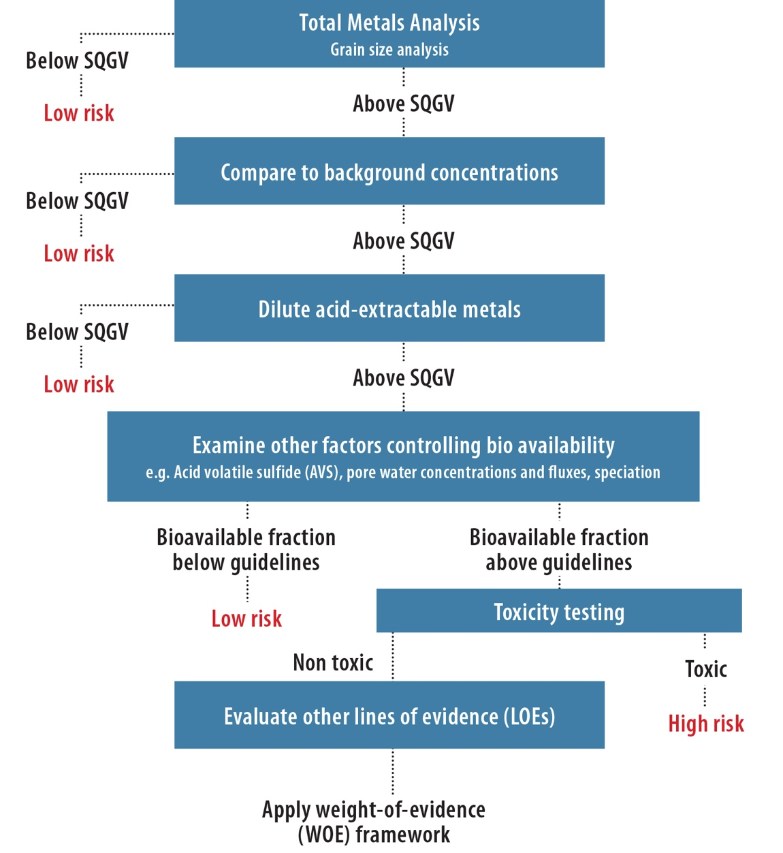

Figure 4: The decision tree for assessment of contaminated sediments for metals (Simpson and Batley 2016; © CSIRO 2016)

A more detailed consideration of metal bioavailability, as required in the lower part of the decision tree, would investigate the presence of AVS in relation to acid-extractable metals. Concentrations of metals in pore waters can be compared with the appropriate water quality GVs to assess the impact of sediments via the pore water exposure route.

The evaluation of sediment toxicity through laboratory or field bioassays is an important additional line of evidence for assessments of sediment quality. The toxicity tests are designed to determine whether the whole sediment, or sediment-associated water in the case of pore water tests, may cause toxic effects on individual species (Simpson and Batley 2016). The assessment of toxicity should include organisms with a range of behaviours, feeding strategies and exposure routes. More details on sediment toxicity testing species and methods are presented in Simpson and Batley (2016).

3 Deriving site-specific GVs for water and sediment quality

3.1 Why derive site-specific guideline values?

The Guidelines (ANZG 2018) provide default guideline values (DGVs) as a generic starting point for assessing water quality to protect aquatic ecosystems for a range of water types (ANZG 2018). They emphasise that site-specific guideline values for physico-chemical stressors should be derived and used in preference to DGVs. Core to this is the concept of ‘continual improvement’, where management of waters should aim towards better water quality and ecological health. Some states (e.g. Queensland, Victoria) also have their own water quality guidelines, based on the framework of the Guidelines but with consideration of the specific local conditions.

Adaptive management should be considered in conjunction with a decision-tree approach when developing site-specific water and sediment quality guideline values (GVs) for physico-chemical and toxicant indicators. ANZG (2018) defines adaptive management as ‘a continuous cycle of improvement based on setting goals and priorities, developing strategies, taking action and measuring results, and then feeding the results of monitoring back into new goals, priorities, strategies and actions’. It is important to have appropriately designed management interventions and related monitoring and assessment programs that support this adaptive management approach. Site-specific GVs should also be derived for chemicals where no DGV for water or sediment quality currently exists, as well as when waters and sediments contain naturally high background levels that exceed DGVs.

ANZG (2018) sets out a preferred approach for derivation of GVs. The preferred approach is generally to use local field and/or laboratory biological effects (toxicity) data. For physico-chemical stressors, in the absence of effects data, local reference-site data should be used. The significance of risk from the stressor and the level of protection assigned to the waterway should guide the approach, with more conservative or more accurate approaches used for high-risk toxicants and waterways assigned high levels of protection.

3.2 How do we apply site-specific GVs?

At different stages of the development of a coal mine or coal seam gas (CSG) field, data availability is often different. For example, at a brownfield site that may be undergoing expansion, more monitoring data are often available than for a new development project at a greenfield site. Therefore the assessment process for a development application is also different from site to site.

A generic decision framework for deciding when it is appropriate to derive site-specific GVs is presented in Figure 5.

Step 1: An initial assessment is undertaken to select the appropriate physico-chemical and toxicant indicators relevant to the activity that are needed to support the management goals. The selections are based on a conceptual model of the activity (CSG, open cut or underground coal mine development) and its potential impacts, the environmental values of the site and its spatial bounds, water type, relevant stressors and levels of protection. These may have already been formally established by the responsible agency.

Step 2: Design an appropriate monitoring program for the selected indicators from Step 1 (see Chapter 4).

Step 3: Indicators

Physico-chemical indicators: For indicators with suitable local reference data, derive site-specific GVs. For indicators with unsuitable local reference data, apply regional or national default GVs until local data become available to derive site-specific GVs.

Toxicant indicators: Apply default GVs if they are available. There is no need to derive site-specific GVs, except for sediments where background data from local reference sites exceed a default GV. In this case, derive a site-specific GV using local reference data.

If there are no default water quality GVs available for the selected toxicants, use ecotoxicity data from the literature to derive interim GVs until DGVs are developed. Interim GVs can be derived using the species sensitivity distribution (SSD) method (detailed in Warne et al. 2018). If there are insufficient ecotoxicity data available, determine whether there are sufficient local concentration data from reference sites (see section 3.3) and use these to derive a site-specific GV.

Step 4: Test data can now be compared to the appropriate GVs. For physicochemical indicators, the median of the test data for a number, n, of independent samples from the test site should be compared. Exceedance of a GV is the prompt for further investigation.

In the case of toxicants, a more conservative approach is required. It is recommended that further investigation be triggered if the 95th percentile of the distribution of test data exceeds the GV (i.e. no action is triggered if 95 per cent of the test values are below the GV). If only one sample is collected and the result is greater than the GV, this would in most cases be a trigger for further action.

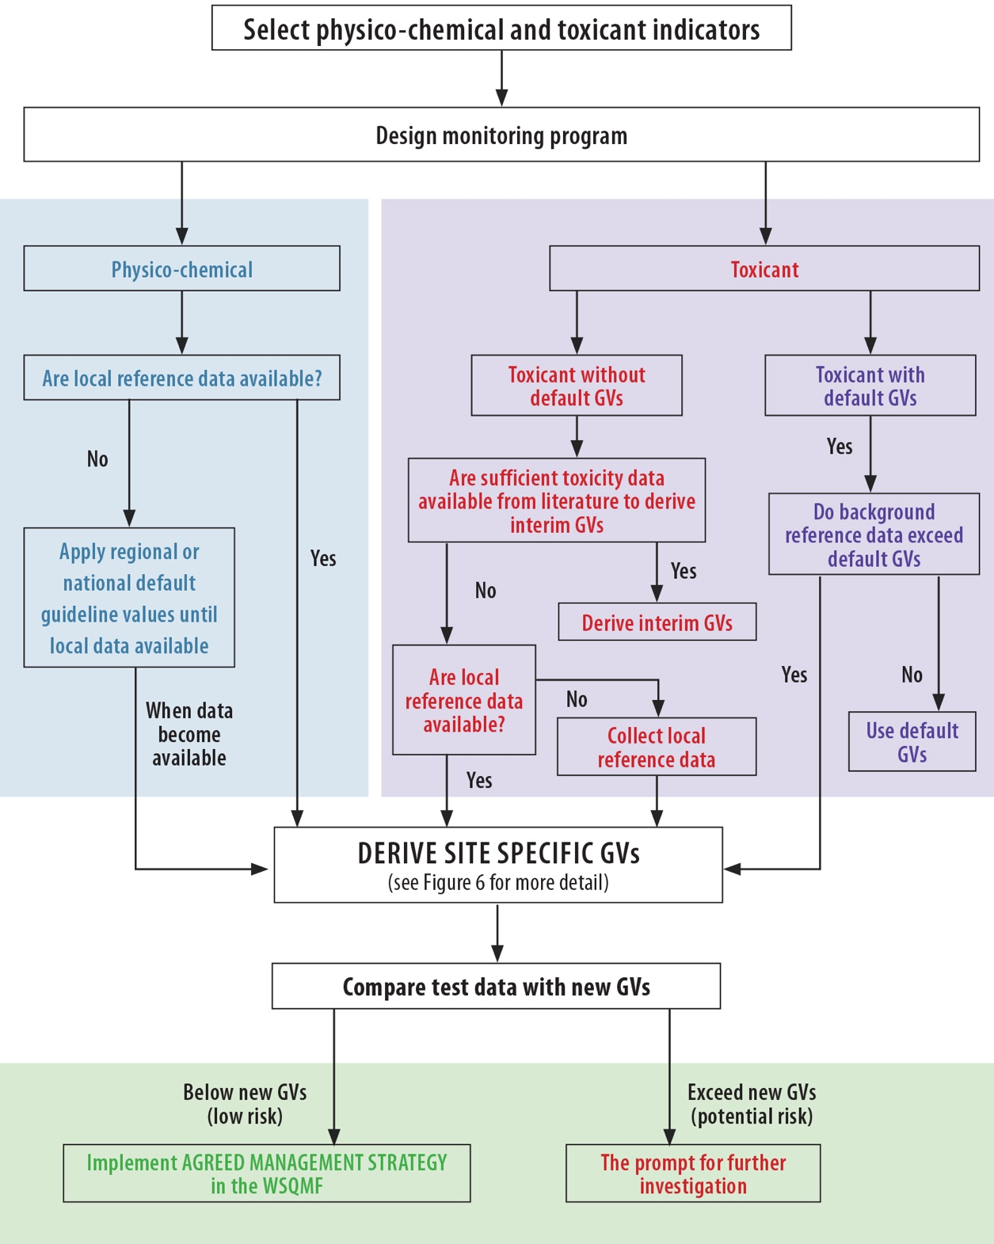

Figure 5: A decision tree to derive site-specific GVs for physico-chemical stressors and toxicants in CSG and LCM industry water and sediment

3.3 Approaches to deriving site-specific GVs

There are two approaches to deriving local water and sediment quality GVs for aquatic ecosystems:

• Acceptable departure from reference condition—GVs are based on the premise that some departure from the reference condition is acceptable. (See section 3.3.1.2 on how to derive numerical GVs from reference data for water and sediment, and associated case studies.)

• Direct measurement of biological impacts—GVs are based on the results of direct testing of the impacts of an indicator (e.g. a toxicant) on a target organism (usually by laboratory studies). This approach, using species sensitivity distribution (SSD), is used to derive site-specific GVs for toxicants (see more detail of this method in Warne et al. 2018); see also Case Study 2.)

The process to select appropriate reference sites should include input from regulators as well as members of the scientific community and other stakeholders who have knowledge about the receiving ecosystem.

3.3.1 Deriving site-specific water GVs using local reference data

Using reference site monitoring data to derive site-specific water quality GVs is especially suited to water quality parameters that indirectly affect aquatic ecosystem health rather than parameters that are directly or acutely toxic. This approach involves the following steps.

3.3.1.1 Identifying reference sites

A reference site is a site considered to be in an unimpacted or minimally impacted condition that can serve as a suitable baseline or benchmark for the assessment and management of impacted sites in similar water bodies. The condition of the reference site is the ‘reference condition’. The values of individual indicators at that site are the ‘reference values’. These values can encompass physico-chemical, biological and habitat characteristics of an unimpacted or minimally impacted ecosystem (ANZG 2018).

Reference sites should meet the following criteria:

• Minimal disturbance to local and upstream environments (e.g. from dense urban and industrial activity, extractive industry, intensive livestock or cropping areas)

• No significant point source and diffuse source discharges nearby or upstream (e.g. mine discharges, sewage treatment plant discharges, industrial discharges, major agricultural or storm water drains, agricultural discharges such as those from dairies)

• Flow or water regime not significantly altered (if the site is classified as temporary, water body types and wet and dry phase GVs should be defined)

• Sufficient water quality monitoring data available, and data from these sites collected, stored and analysed using approved protocols.

The best available sites will be used to derive local water quality GVs. Where no sites are deemed suitable, alternative approaches may be required, such as the use of default GVs or state/regional GVs, establishment of new reference sites for monitoring, or use of different percentiles of best available reference-site data. GVs derived from data at a particular reference site should only be applied to similar water types.

Large coal mines and CSG projects are often located in regions with a range of pre-existing land uses including cropping, grazing, townships and other extractive activities. Multiple lines of evidence should be used in deriving site-specific GVs (see section 5.1).

3.3.1.2 Deriving numerical GVs for water from local reference data

The Guidelines recommend derivation of GVs based on monitoring at reference sites. The preferred approach for the derivation of site-specific GVs for physico-chemical indicators is based on at least two years of monthly monitoring data from appropriate reference site(s) at a frequency sufficient to capture likely changes in the system. The sampling frequency and duration need to be tailored to the degree of variability in the relevant analytes in order to capture two complete annual cycles, particularly for temporary water (see Chapter 6 for more detail). In some regions, water quality can be influenced by strong seasonal or event-scale effects. It will be important to use monitoring data that cover these seasons or events and derive GVs appropriate to the particular season (e.g. separate wet and dry season GVs for tropical waters). Using more than one reference site will better characterise the local region than using a single site.

The decision tree that provides guidance for deriving site-specific GVs for physico-chemical stressors (Figure 5) indicates that if no local reference data are available, DGVs should be used as interim GVs while additional data from appropriate reference sites are collected. This includes the collection of information on the variation in environmental variables that may influence the bioavailability and toxicity of contaminants. This will support the assessment and primary approval time frames for projects, particularly brownfield projects. It should be noted that DGVs provide an important starting point for managing water quality but cannot account for the large spatial or temporal variation in natural water quality. For further details on accounting for local conditions when deriving guideline values using field-effects data, see ANZG (2018).

Figure 6 presents an example of the procedure for deriving numerical GVs from local reference data for each water type within each region for a slightly to moderately disturbed system. The first step is to undertake a review of the local reference data to determine whether the data meet the requirements: (i) adequate temporal and spatial sampling program; (ii) compliance with the quality assurance and quality control (QA/QC) protocol; and (iii) appropriate reference sites. If the dataset does not meet these requirements (particularly for greenfield sites), several appropriate reference sites should be established and monitoring data collected. Default national and regional GVs should be used until local reference data become available.

Note that the above approach is generally applicable to physico-chemical stressors and is less common for toxicants.

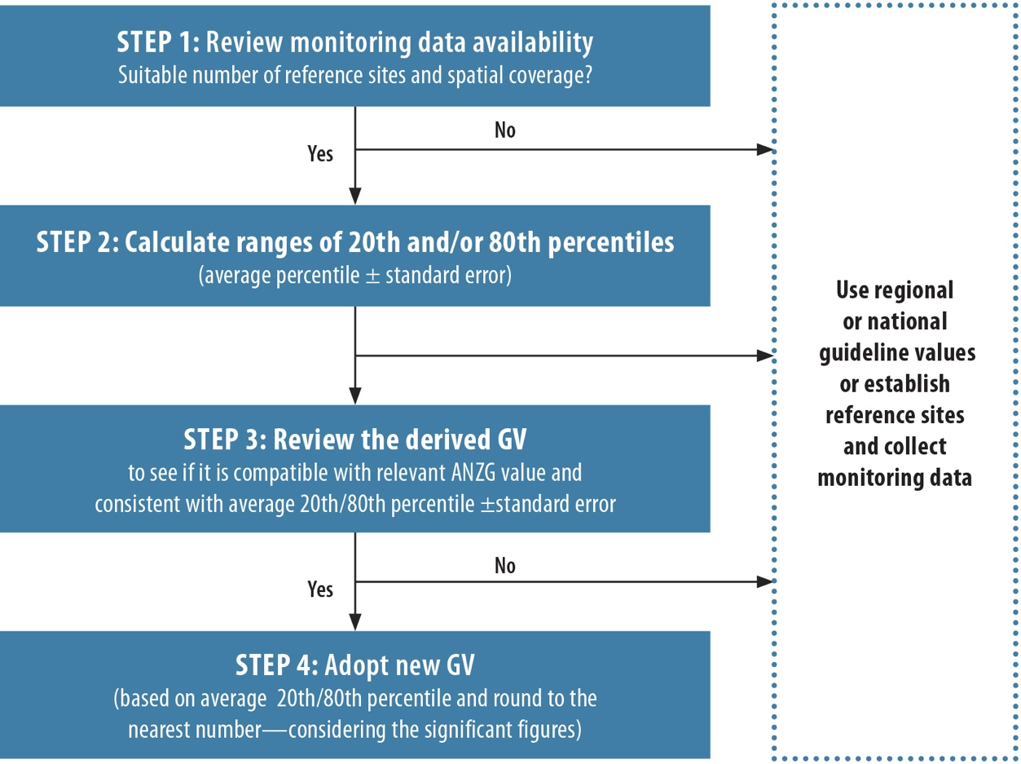

Figure 6: Procedure for deriving numerical GVs from local reference data for each water type within each region (slightly to moderately disturbed systems) (adapted from DEHP 2009)

If the data requirements are met, ranges of 20th and/or 80th percentiles using the local reference data are calculated to derive the site-specific GVs for selected indicators. The Guidelines note that the choice of percentiles is arbitrary and advocate the use of ‘an appropriate percentile of the reference data distribution to derive the GV’ (ANZG 2018).

The Guidelines state that when site-specific GVs are more lenient than the DGVs, proponents should consider the extent to which the ecosystem will be able to accommodate any further move away from existing conditions without unacceptable risk of impact. The WQMF states that if the aquatic ecosystem has a limited ability to tolerate substantial further increases in disturbance, it might be necessary to set the reference-based GV at or near the median value and ensure that biological monitoring is implemented for assurance of ecosystem protection, as part of a multiple-lines-of-evidence approach. For further detail see the section on site-specific GVs for physical and chemical stressors in ANZG (2018).

3.3.2 Deriving site-specific sediment GVs using local reference data

The Guidelines apply the DGVs for some contaminants based on the contaminant’s biological effect on biota. This was achieved by statistical data evaluation of concentrations and toxicity. However, many other contaminants that enter the environment have no ecotoxicological effects data that can be used to develop sediment quality GVs (SQGVs). In some situations, site-specific GVs for sediment quality (SS-SQGVs) can be developed for some contaminants that do not have DGVs or where natural background concentrations of the contaminant exceed the DGVs. One approach is to derive a value on the basis of median natural background (reference) concentrations multiplied by an appropriate factor. As suggested in the Guidelines (ANZG 2018), a factor of two is recommended. In some highly disturbed ecosystems a slightly larger factor may be more appropriate, but no larger than three. It is noted, however, that this approach has low reliability. A second and more usual approach is to derive numerical GVs from local reference data for a sediment indicator by calculating the minimum and maximum values as well as the 20th, 50th (median) and 80th percentiles. In most cases, the 80th percentile is used as the GV (See ANZG (2018) for more detail on deriving guideline values using reference-site data).

Both approaches require baseline data to be collected from local reference sites (see section 3.3.1.1) for at least two years, so that the data encompass natural variability. It is important, however, that the grain size and organic carbon concentration of the reference sites is comparable with that of the test site.

| case study 1:  Deriving a site-specific GV for salinity of water at a coal mine in the Hunter Valley (NSW) using baseline monitoring data |
| --- |
| An open-cut thermal coal mine in the Upper Hunter Valley region of New South Wales commenced production in 1995. Even though the mine operates as a zero off-site discharge mine, requirements for discharged water were defined in case the proponent was required to undertake controlled discharges. Site-specific GVs for physico-chemical indicators of the site needed to be derived. Monitored parameters for controlled discharges could then be compared to the site-specific GVs to determine whether an impact was likely. This case study describes how to derive site-specific GVs for water salinity.  An initial assessment identified that salinity was the main stressor of environmental concern if mine water was discharged off site. The national default GV for upland rivers in south-east Australia for water salinity (as electrical conductivity, EC) of 30–350 µS/cm was used as the water quality objective for aquatic ecosystem protection of the Hunter River. As the salinity of the water at reference sites exceeded this GV, a site-specific GV for salinity was derived using monitoring data from the reference sites.  Three locations (A, B and C) were selected as reference sites that reflected the water quality of the local waterways before mine operations commenced. The water quality of these reference sites was collected monthly over the mine operation period. Subsequent review of the data identified that only one reference site (B) met all the reference site criteria, namely sufficient water quality monitoring data that met the QA/QC protocol. There was a point source of wastewater discharge from a new mine within 20 km upstream of reference site A and evidence of water run-off from agriculture activities above reference site C. Therefore only data from reference site B were used to derive the site-specific GV for salinity.  Salinity (EC) data collected monthly over 10 years (1994 to 2005) at the selected reference site were used to derive the site-specific GV for salinity (Table 1). As the site was identified as a slightly to moderately disturbed system, the 80th percentile of the reference-site data was calculated. |
| Table 1: Recommended GV for salinity derived from local reference monitoring data   | Indicator | Aquatic ecosystem for upland river1 | Variation of local reference data | | | | Recommended site-specific GV for slightly to moderately disturbed system | | --- | --- | --- | --- | --- | --- | --- | | Min | Max | Median | 80th percentile | | EC (µS/cm) | 30-350 | 867 | 4850 | 2800 | 3,470 | 3,470 |   1. Regional GVs (Hunter River Water Quality Objectives for upland rivers)  The derived site-specific GV (3470 µS/cm) was a factor of 10 higher than the regional default of 350 µS/cm. However, a study in 1979 reported that soils within the catchment are typically sodic or saline-sodic and confirmed that the pre-mining creek water quality was saline, with water samples having an average EC of 7500 µS/cm. Therefore, the new GV of 3470 µS/cm was considered to be acceptable and was adopted.  The above approach required local reference data collected monthly for at least two years from an appropriate reference site, so that the data would accommodate natural variability. In wet–dry tropical systems where seasonal flow is dominant, it may be desirable to group data into seasonal periods and derive more than one GV (e.g. separate wet and dry season GVs). |

3.3.3 Deriving site-specific water quality GVs for a toxicant without default GVs using the species sensitivity distribution approach

| case study 2:  Deriving a site-specific GV for a toxicant (zinc) in sediment |
| --- |
| This hypothetical case study aims to provide an example of how to derive a site-specific sediment quality guideline value (SS-SQGV) where a toxicant’s natural background concentration exceeds the DGV. A new CSG development is being proposed in a New South Wales river basin that has historically received wastewater discharges from coal mine activities. The new CSG operation was required to develop sediment quality objectives and design a sediment monitoring program. The initial assessment identified that a new GV for zinc (Zn) would be needed as the median concentration of zinc in the sediment of local reference sites exceeded the DGV for Zn of 200 mg/kg.  Six upstream reference sites were selected. Sediment samples were collected in triplicate from an area within 1 m2 in clean screw-capped glass jars that contained no preservatives. A composite sample for each site was used for analysis of Zn. The standard sampling and laboratory analysis methods from the practical guide of sediment quality assessment (Simpson and Batley 2016) were used. To cover the natural variability of the sites, including in the water body, habitat and grain size of sediment, the sampling program was conducted over two years, with three samples collected per year. The laboratory analysis data were used to develop the SS-SQGV. |
| Table 2: Recommended SS-SQGV for Zn derived from local reference monitoring data   | Indicator | Default GVs | | Variation of local reference data | | | | | Recommended site-specific  GV for highly disturbed system | | --- | --- | --- | --- | --- | --- | --- | --- | --- | | GV | SQG-high | Min | 20th percentile | Median | 80th percentile | Max | | Zn (mg/kg) | 200 | 410 | 105 | 150 | 178 | 350 | 480 | 350 |   Key regional stakeholders reviewed the background information and monitoring data with consideration of local conditions, natural variation of Zn concentrations in sediment at reference sites, management goals and economic benefits of the project. The condition of the river was identified as a highly disturbed system. In this case the 80th percentile (350 mg/kg) was lower than the default SQG-high (410 mg/kg) and significantly lower than the maximum value of the reference site (480 mg/kg) (Table 2). This value of 350 mg/kg was selected as the new site-specific sediment quality GV for Zn for this site. |

The SSD method is the preferred method for deriving site-specific water quality GVs for toxicants without DGVs. The method should be used whenever sufficient toxicity data are available. Toxicity data for at least five species that belong to at least four taxonomic groups are required. For further details on minimum data requirements for using an SSD, see the Guidelines and Warne et al. (2018).

Background information and detail on the SSD method can be found in Warne (2001) and Warne et al. (2018). An overview of the revised method for calculating GVs using the SSD method is provided in Figure 7. While DGVs are derived to protect against harmful effects from long-term (i.e. chronic) exposures, the method set out in this Explanatory Note can also be used to derive GVs for short-term (i.e. acute) exposures, which may be useful at regional and/or site-specific scales or for other uses such as setting licences or in prosecutions. Short-term GVs typically aim to protect most species against lethality during intermittent and transient exposures (see Batley et al. (2014) for further guidance on the derivation of short-term GVs). Case Study 3 provides an example of how to derive a new GV for a toxicant that does not have a default GV, using the SSD method.

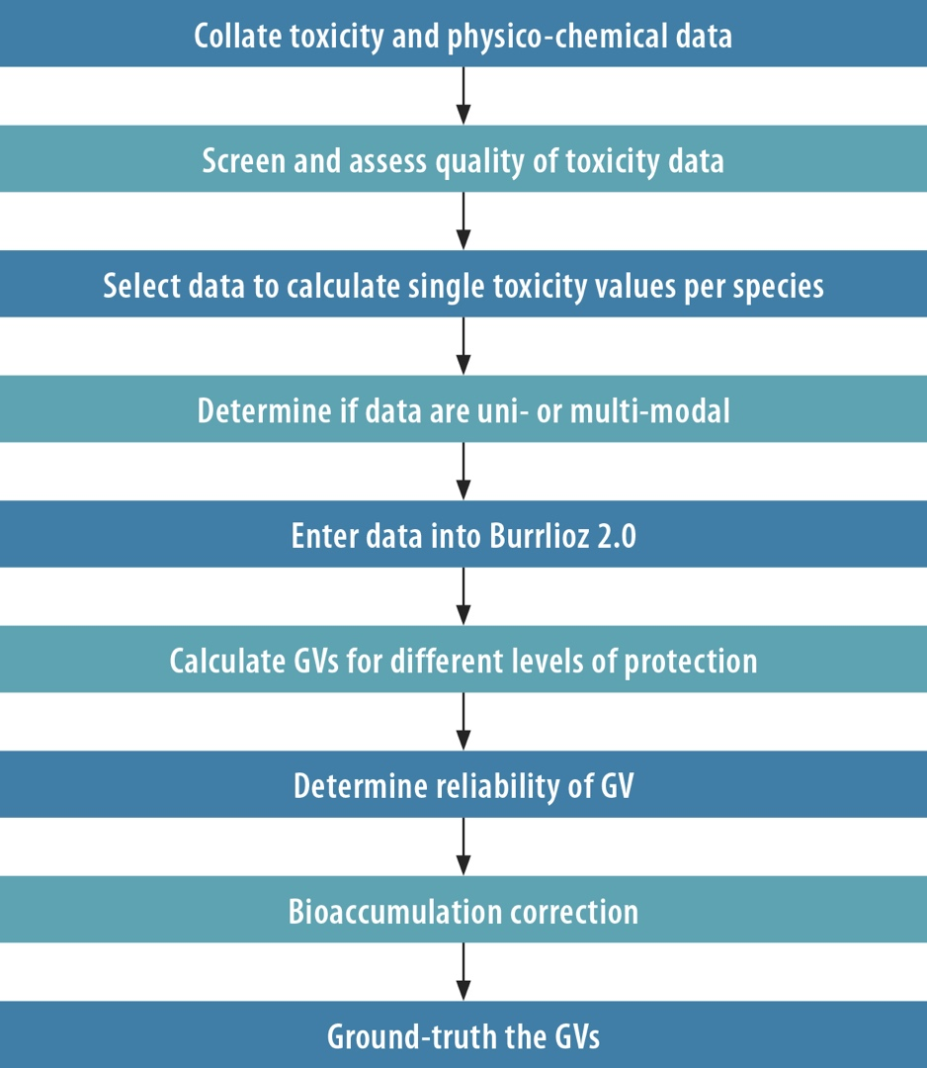

Figure 7: Schematic of the method for deriving guideline values using the species sensitivity distribution approach (Warne et al. 2018)

Warne et al. (2018) gives advice on considering the potential bioaccumulation of a toxicant when deriving a guideline value. Warne et al. (2018) and ANZG (2018) discuss the background to incorporating bioaccumulation into site-specific guidelines and how bioaccumulation was incorporated into the derivation of the current GVs, respectively.

When deriving a site-specific GV for a toxicant that has the potential to bioaccumulate, ANZG (2018) recommends, as a first step, using the next more stringent protective concentration as the GV. For example, where the receiving ecosystem is designated as slightly to moderately disturbed and the 95 per cent protective GV would normally be recommended, in the case of a toxicant that has the potential to bioaccumulate, the 99 per cent protection GV would be used instead. This GV would then be reality checked as per the last step of Figure 7. Further steps are described in ANZG (2018) and should be considered if specific data are available.

| case study 3:  Deriving site-specific guideline values for sulfate using an ecotoxicity assessment and species sensitivity distribution approach |
| --- |
| Elevated concentrations of sulfate (SO42–) can occur in river water associated with coal mine activities. In most cases, water produced through coal mine activities is stored or re-used. Although not a preferred option, in some circumstances disposal of excess water to the receiving environment is necessary, for example to prevent the failure of storage dams during extreme rainfall events. Where such scenarios could occur, there is a need to establish concentration limits for discharge water that protect aquatic ecosystems at both local and catchment scales. Sulfate was the key parameter of potential concern, but there was no DGV for sulfate to protect freshwater ecosystems.  A new GV for sulfate using an ecotoxicity assessment approach was derived. Ambient water GVs for sulfate were derived using the species sensitivity distribution (SSD) method described in the Guidelines, using the concentration that would affect 10 per cent of the test population (EC10) (Warne and van Dam 2008). In this example, new site-specific GVs were derived for sulfate at four levels of protection (80 per cent, 90 per cent, 95 per cent and 99 per cent for local freshwater species) as per ANZECC & ARMCANZ (2000a). This range of protection levels covers a wide spectrum of ecosystems found in the catchment and can be applied in different locations of the river basin. The following data (Table 3) were obtained from tests of chronic toxicity of sulfate to eight locally relevant species, using upstream water as a control and upstream water spiked with sulfate in a serial dilution as the test waters. The eight test species used for the direct toxicity assessments commonly occur over large parts of central Queensland (tropical Australia). |
| Table 3: Estimates of chronic toxicity data used to derive a sulfate GV, presented as concentrations (mg/L) of sulfate   | Species | Test end point and duration | EC10 SO42–  (mg/L) | | --- | --- | --- | | Paratya australiensis  (glass shrimp juvenile) | Juvenile growth—7 days | 3590 | | Melanotaenia splendida splendida (tropical fish juvenile) | Biomass—7 days | 6030 | | Lemna disperma (duckweed) | Population growth—7 days | 1750 | | Pseudokirchneriella subcapitata  (green alga) | Population growth—72 hours | 2350 | | Ceriodaphnia cf. dubia (water flea) | Reproduction—7 day partial life-cycle test | 926 | | Lates calcarifer (tropical fish juvenile) | Juvenile growth—7 days | 5880 | | Hydra viridissima (green hydra) | Population growth—96 hours | 985 | | Chironomus tepperi (chironomid) | Population growth—7 days | 1528 | |
| This graph shows species sensitivity distribution showing the concentration of sulfate (mg/L) that will protect 95% of species.  Figure 8: Species sensitivity distribution showing the concentration of sulfate (mg/L) that will protect 95 per cent of species  The above approach required one ‘range finder’ (to determine a range of concentrations to define the target concentration for each toxicity test) and two ‘definitive’ tests for each of the test species, with each test conducted over a set time period. ANZECC & ARMCANZ (2000a) states that, while the SSD was derived from eight species from at least four taxonomic groups, the resultant GVs should be regarded with caution since only the minimum data requirements are met. |
| Table 4: Guideline values at various levels of species protection (80–99 per cent) for sulfate   | Level of species protection (%) | Moderate reliability GVs based on chronic EC10 values for 5 species for SO42– (mg/L) | | --- | --- | | 80 | 1150 | | 90 | 916 | | 95 | 776 | | 99 | 590 | |

4 Designing water and sediment quality monitoring programs for CSG and LCM industries

4.1 Sampling program design

Monitoring programs need to be based on some conceptual model of the behaviour of the contaminants of concern in the aquatic system into which they are to be discharged. An example of a basic conceptual model is given in Figure 1 and Figure 2, which show the causal pathways to the receiving environment for contaminants from different components of a typical CSG and LCM operation. More detailed models might consider the fate and impacts of specific contaminants (e.g. see ANZG 2018).

This section summarises the key information required for designing an appropriate monitoring program, following the management framework. The monitoring program design is determined by the monitoring objectives of the CSG and LCM development. First the study type is considered, because this will define the field sampling program and subsequent data analyses. Three distinct study types can be identified: (1) descriptive studies; (2) studies that measure change; and (3) studies that improve system understanding (cause and effect). The scope of the study should then be defined. This comprises the spatial and temporal boundaries of the study. The reference sites should be identified. From this point, it is possible to consider specific aspects of the sampling design.

The sampling program should ultimately be defined by program objectives that can include the statistical power required for discriminating between hypotheses or be based on the levels of acceptable sampling variability. For example, important considerations would include the likely spatial uniformity of the parameter(s) of interest at a location (e.g. at depth, cross-sections of a river) and the extent of the potential impacts downstream. For example, where a water body is well mixed and a parameter of interest is evenly distributed in the water column, a grab sample may be appropriate. However, if water quality changes with depth, a number of samples at different depths may be required.

Essential features of a sampling strategy include ensuring that:

• samples collected are representative of the source material (i.e. waters, sediments and biota in a creek, river or lake) at the locations of interest

• variation is taken into account—both in space (spatially) and over time (temporally)—owing to the need to recognise that different physico-chemical variables often vary at different spatial and temporal scales so one size may not fit all variables

• in situ measurements are reliable (see Chapter 6 for more detail on passive sampling devices)

• the integrity of materials sent for laboratory analysis has not been compromised by contamination, degradation or transformation

• sample volume is sufficient to meet required detection limits for a particular analytical method, appropriate collection methods are used, and filed and laboratory blanks are collected

• consideration of flow conditions (whether event or ambient or knowing the time since last flood and/or when rewetting occurred) (see Chapter 6 for more details on temporary water bodies).

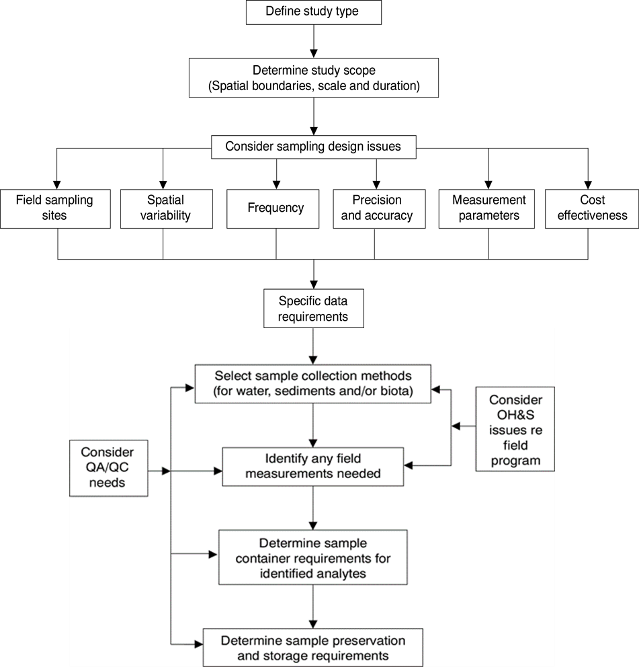

Figure 9: Framework for a water/sediment quality monitoring program with specific data requirements for a sampling program (based on ANZG 2018)

4.2 Effective water monitoring program

Deciding what to measure will follow from the conceptual understanding. All possible CSG and LCM associated water entering a water body needs to be analysed. Where it is seen that concentrations of any contaminant may not be adequately diluted, these should form part of the monitoring program. Contaminant constituents that have the potential to be mobilised in mine discharges will also be of concern. In relation to process water discharges, measurements might include the range of metals, ammonium and nitrate (open-cut blasting activities) and sulfate (and possibly sulfide), as well as chemicals used in fracturing fluids.

4.3 Effective sediment monitoring program

The design of a sampling program for sediments should consider the fact that sediments are often heterogeneous. Contaminant distribution depends heavily on grain size. In general, metals that accumulate via adsorption to particles will be associated with the finest particles with high surface area to volume ratios. Sandy and other coarse-grain sediment particles generally have a low metal content. Generally the metals on these particles have low bioavailability and so potentially pose a low threat to benthic organisms. However, bioavailability of metals is also dependent on the redox conditions. If these are altered, adsorbed contaminants may become bioavailable.

Sampling of sediments will generally use a stratified random sampling design, where sampling of sediment is undertaken from locations at increasing distances from the point source in the case of a discharge. The spatial heterogeneity (both horizontal and vertical) should also be taken into consideration. Sampling should involve replicate samples to determine localised heterogeneity. Vertical heterogeneity can be assessed from core samples and, in general, these are preferable to surface grab samples. Sediment deposition in a water body will not necessarily occur uniformly but will be dictated by flow. Scouring of bottom sediments is common in the channels of fast-flowing rivers, while deposition will occur in low flow regions, floodplains and terminal lakes and swamps. Depositional areas are therefore more relevant for the assessment of mining impacts on sediment quality.

Sedimentation rates in water bodies typically vary from millimetres to 1–2 cm per year, although in tropical areas with large seasonal variability in river flows, sediment accumulation in off-river areas can be much larger. Except in the latter cases, recent sedimentation is therefore unlikely to be seen at depths below 5 cm. The bulk of biological activity also occurs in the upper 5 cm, although some organisms can burrow to greater depths (Simpson and Batley 2016). The depths to which sediments are sampled should therefore be relevant to the monitoring objective. At some stage, it may be appropriate in any monitoring survey to establish the nature of the depth profile of contaminants at the sites under consideration. (Further details can be found in Chapter 2 of Simpson and Batley 2016).

4.4 Site-specific water and sediment sampling program

From the specific data requirements identified in the design process, sample collection methods for water and sediment should be considered, including sample container requirements for the identified analytes, together with any sample preservation and storage requirements. Any necessary field measurements should also be identified. Laboratory and field quality assurance and quality control (QA/QC) needs should be considered, together with specific occupational health and safety requirements.

The sampling design should comprise:

• selection of field sampling sites: systematic, random, stratified or clustered sampling

• spatial variability within a sample site (e.g. surface versus depth)

• frequency: daily, weekly, monthly; wet or dry season

• precision and accuracy: number of samples; replication; power to detect differences

• preservation, storage and treatment requirements for each indicator

• cost-effectiveness: as low cost as possible while still meeting the stated objectives of the monitoring study.

4.4.1 Quality assurance and quality control in sampling and chemical analysis

As part of the quality assurance procedure, data collection, storage and analysis should be consistent. The detail of sampling protocols is clearly presented in the Queensland Monitoring and Sampling Manual 2018 ([https://www.ehp.qld.gov.au/water/monitoring/sampling-manual/pdf/monitoring-sampling-manual-2018.pdf)](https://www.ehp.qld.gov.au/water/monitoring/sampling-manual/pdf/monitoring-sampling-manual-2018.pdf).

Appropriate QA/QC will be required to be demonstrated by any laboratory undertaking chemical analyses. Quality assurance includes aspects that would be covered in laboratory accreditation, such as fully documented methods, traceability of results, appropriately trained personnel and implementation of good laboratory practice.

As part of any analysis, QA/QC should include:

• recovery of known additions (spike recovery tests)

• analysis of appropriate certified reference materials (where available): this should be undertaken with each batch of samples

• adequate calibration of the analytical method

• replicate analyses: at least 5–10 per cent of samples should be analysed in duplicate

• field sampling and method blanks.

In addition, the laboratory should participate regularly and perform well in inter-laboratory collaborative testing programs. Accreditation of the laboratory is desirable, as it is a means of ensuring that appropriate standards of QA/QC are in place, although it will not necessarily guarantee accurate results.

4.4.2 Dealing with outliers and censored data

Below detection limit (BDL) data are typically reported as <x, where x is the detection limit. The data analysis section of the monitoring and reporting guidelines in ANZG (2018) recommends that, when analysing results containing BDL data, BDL values be replaced by either the detection limit or half the detection limit. It also notes that the impact of this action should be clearly understood. This practice is clearly inappropriate in assessing a single value for compliance with a GV. If a significant portion (e.g. >25 per cent) of data falls into this category, then care should be taken with drawing inferences. In this case, a more sensitive analytical method would be required.

Unusual or extreme observations are termed ‘outliers’, implying that they are aberrant and should be discarded. For typical-sized datasets, generally any data point falling outside three standard deviations of the mean will be aberrant. They should first be the subject of follow-up investigations to determine whether they are related to recording or analytical errors or associated with sampling and sample handling. Examining co-dependence with data for other components of the aberrant sample will assist here. It is recommended that only with the most extreme measurements (i.e. more than four standard deviations from the mean) should the data be automatically discarded. However, in highly variable systems (e.g. temporary waters) where pulses in contaminant concentrations can occur, applying such a recommendation may not be appropriate.

5 Integrating and optimising monitoring and assessment programs

5.1 Using multiple lines of evidence and associated indicators

While this Explanatory Note focuses on physico-chemical stressors, additional biological parameters are also an important component of environmental management. The concept of a weight-of-evidence (WoE) assessment using multiple lines of evidence (LoEs) implies that the integration of the different LoEs gives greater weight (or certainty) to the inference, and thereby to the decision regarding the water/sediment quality objective being met, than the consideration of a single LoE. WoE using multiple LoEs is now in international usage and is an accepted methodology for the assessment of water and sediment quality. The updated Guidelines (ANZG 2018) have included the WoE approach in water and sediment quality assessments (Figure 10). For each pressure on a system, a set of stressors of the system are selected to be measured. This is a particularly important approach for temporary waters where all indicators are variable (with results difficult to interpret without as complete a dataset as possible) and data collection opportunities for water quality are inherently limited and opportunistic. It is also a common step at the commencement of monitoring to acquire data to derive water quality GVs and assemble suitable chemical and biological baselines. A series of ecosystem receptor LoEs is also selected for measurement.

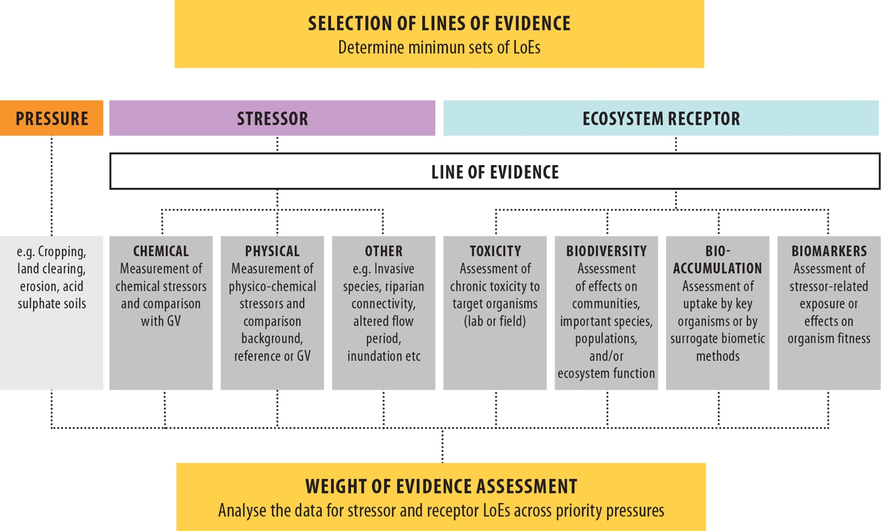

Figure 10: Weight-of-evidence assessment (ANZG 2018)

5.2 Integrating chemical and biological approaches in the water quality management framework

It is important to consider integrated monitoring and assessment at all phases of the water and sediment quality management framework. Key features to consider concerning the early management steps include ensuring that:

• technical expertise for both chemical and biological aspects is available at all relevant steps, including negotiations on the primary management aims

• chemical and biological indicators are selected and balanced to meet the primary management aims, especially the level of protection and the availability of controls

• sampling of common sites is conducted jointly, as far as possible, recognising that biological assessment places greater demands on the availability of spatial controls

• the level of acceptable change and statistical sensitivity to detect the change is consistent with the level of protection that is designated, for both indicator types

• optimisation of the program is applied equally and fairly across both types of assessment in a manner that does not compromise environmental protection.

5.3 Applying biological assessments as part of an integrated assessment

A combination of physical, chemical and biological assessments enhances the confidence in correctly attributing causes to any observed change in water quality. Biological variables integrate effects of past and present exposure and directly assess progress in achieving the management goals, while physical and chemical variables provide information about causality. Such an integrated approach is also promoted for sediment assessment, where a combination of toxicity tests, chemical contaminant measurements and benthic macroinvertebrate analyses provide weight of evidence of adverse impacts.

Biological (and chemical) assessment could be reduced wherever wastewaters at a mine site are fully contained and where the risk of reaching surface or groundwaters is negligible. Biological assessment might also be reduced where, after extensive investigations, a very good understanding of wastewater/ecological effects relationships has been developed, so that chemical measures could be used to predict effects in receiving waters. However, wastewaters are inevitably complex and typically change in composition over time, so it would be unusual to find examples where water chemistry alone would suffice for environmental assessment.

As a rule, while some biological assessment will be expected wherever a corresponding chemical assessment program is in place, the extent and intensity of this assessment will increase the higher the level of protection assigned to an ecosystem. The level of protection, the assessment objectives and the balance of indicators to apply in a monitoring program are intimately linked, and the process of determining these should be carried out simultaneously. Where mine effluent is discharged to a receiving water body, prediction and early detection may be important considerations. Ecotoxicological studies, apart from determining a safe dilution for wastewater discharge, also provide a definitive assessment of possible high risk to ecosystems where the GV is exceeded in the event of discharge.

Ecological studies, particularly by way of biodiversity assessment, provide the ultimate evaluation of whether ecosystems have been protected. Some level of biodiversity monitoring will be expected to provide such assurance to key stakeholders and the community generally. However, it is important to remember that biodiversity responses integrate past and present contaminant exposures. As a rule, the frequency with which biological sampling occurs is substantially less than that which may be required for chemical water sampling. For example, annual monitoring might be appropriate (especially when complemented by early detection methods). In tropical areas, this could be at the end of a wet season, to integrate the effects of any wastewater discharges over that season.

Biodiversity assessment in the broader sense provides information on all types of threats to aquatic ecosystems, not just chemical. Thus, ecological studies are also particularly useful with respect to issues such as those that do not necessarily involve toxic effects but have whole-of-ecosystem effects that can be demonstrated by comparison with reference sites. In combination with the chemical measurements, these will aid in the development of site-specific GVs.

Where few ecological data currently exist, it is recommended that seasonal sampling be conducted for two or three years to develop a suitable monitoring program. At this point, the program would be revised and rationalised where necessary. In general, applying biodiversity assessments as one-off surveys at mining operations is not a sufficient approach to water quality evaluations.

6 Temporary water bodies

CSG and LCM industry operations in Australia frequently deal with temporary water bodies. The GVs for toxicants in the Guidelines (ANZG 2018) were based on chronic responses to steady-state conditions, which by definition do not occur in temporary waters. Nonetheless, the flexibility of the ANZG (2018) approach does provide for consideration of these issues from a risk-based perspective. Recent updates in the methods for GV derivation (Warne et al. 2018) also offer useful advice on setting appropriate protective concentrations for temporary water bodies.

6.1 Characteristics of temporary water bodies

Most of Australia’s inland waters are temporary and include ephemeral, intermittent and seasonal streams and rivers, temporary ponds, lakes and wetlands (including playas and many salt lakes) and intermittent seeps and springs. Like permanent waters, these temporary waters support vital ecological processes (e.g. nutrient cycling, biogeochemical breakdown of organic matter) and provide crucial habitats for diverse native plants, animals and microbes adapted to wetting and drying. The duration, timing and frequency of inundation in many of these temporary waters vary widely from year to year which, in turn, has major consequences for their sediment and water quality.

Variability in water quantity and quality means that factors such as long-term fate, persistence, load and concentration, and contextual issues such as sensitivity and connectivity, need to be taken into account by management agencies. The lack of explicit guidance in the Guidelines and the dominance of temporary waters in many areas where CSG and LCM operations are undertaken led to concerns as to how to deal with the following issues:

• Temporary systems tend to be highly variable in nature, with flows or inundation periods that are unpredictable and often short but intense. Toxicant concentrations may subsequently be highly variable over the wetting–drying cycle, and fixed frequency sampling may miss events.

• The toxicant GVs from the Guidelines are derived from chronic exposure responses to single toxicants. How to deal with pulsed exposures is not well defined, but Batley et al. (2014) offer advice on deriving short-term GVs using acute toxicity data that may be applied to temporary waters.

• There are logistical difficulties associated with sampling in systems that can flood unpredictably and over enormous scales. The remoteness of arid and semi-arid zone systems from major centres has hampered an understanding of these systems, including life cycles, biodiversity, and life histories of resident biota and general ecological processes.

These features potentially impede successful implementation of the Guidelines. Some advice is offered below on how to tackle most of the uncertainties and problems associated with temporary systems.

6.2 Effective monitoring programs for water and sediment quality indicators of temporary water bodies

To design an effective monitoring program for temporary water bodies, the following sections outline steps that should be considered.

6.2.1 Temporary water body conceptual modelling

As mentioned previously, the use of ecological conceptual models (section 2.2) allows the development and understanding of the interactions between natural ecosystem variability and responses to pressures unrelated to water quality on ecosystem health. Specific considerations required for sampling and ongoing monitoring of temporary waters include:

• understanding the variation in turbidity, salinity and colour (dissolved organic carbon concentrations), all of which are biologically important stressors that have high levels of natural variability in temporary waters

• developing a link between the duration and the nature of connectivity between temporary waters, which will assist in predictive modelling of the extent and duration of water quality stressors

• improving the understanding of the relationship between antecedent hydrologic conditions, the length of time since the last inundation, the volume of inundation at the start of the wetting phase, and initial water quality conditions.

6.2.2 Monitoring approach

Water quality monitoring should be undertaken in much the same way as it is for permanent water bodies, with monitoring of key parameters over the wetting–drying cycle. The effect of the wetting–drying cycle on key physical and chemical parameters (e.g. temperature, dissolved oxygen, salinity, turbidity, pH) in intermittent rivers and ephemeral streams (IRES) will depend on a number of key local (IRES-specific) and often interacting variables (Figure 11) including:

• channel substrate type (bedrock, sand or silt, organic-rich or organic-poor material)

• groundwater interactions, including hyporheic flows

• whether pools form after flow cessation and, if so, pool morphology (e.g. length, width, depth, orientation to prevailing winds).

Event-driven sampling is desirable to capture waters during key events, including the first flush where the higher concentrations of contaminants enter the river system. Water quality will usually change from having higher pH and clarity and low conductivity and dissolved organic carbon after rainfall and significant flow, to having lower pH, being turbid and being rich in organic matter and sometimes salt during and after recessional flow, as evaporation concentrates the diminishing water. Exceedance of GVs should be assessed as prescribed in the Guidelines, partitioning and comparing the data for physico-chemical stressors into respective wet and dry seasons.

This variability should also be established for nearby reference systems (possibly sites on the same water body upstream of the mine site). The wet and near-dry phases should be characterised separately, as per section 2.6. In general, the default GVs are adopted for toxicants and sediments (see sections 2.8 and 2.9). While the relevance of these GVs to particular temporary systems may not have been assessed, other broad-ranging comparisons, including between temperate and tropical species sensitivity, have not revealed significant differences. However, it may be necessary to adjust values for background variation, particularly in the case of the first flush.

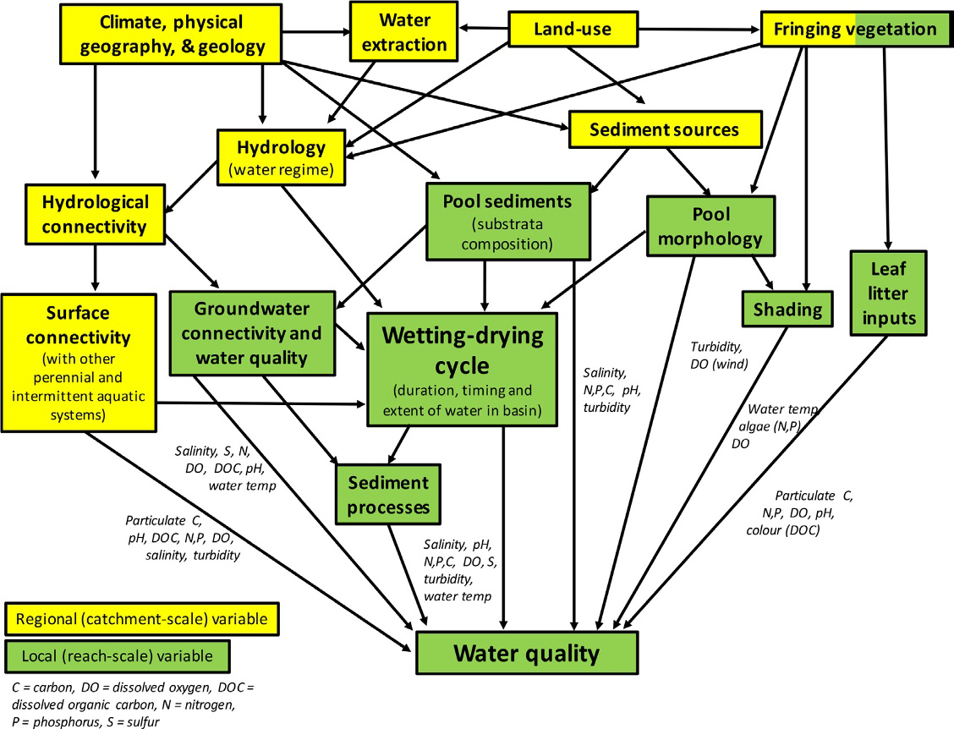

Figure 11: Physical and chemical parameters of water in IRES are influenced by a number of regional- and local-scale variables (from Gómez et al. 2017)

6.2.3 Monitoring temporary water bodies

Accessibility problems (especially during the wet phase) and very significant spatial and temporal variation in water quality over the wetting–drying cycle require tailored approaches to reliable collection and measurement of indicators. Established and newer approaches to addressing these issues include:

• automatic samplers (refrigerated if necessary) triggered by events (or via telemetry)

• continuous or integrated monitoring of stressors (loggers and telemetry), with potential in the near future to extend to direct measurement of some toxicants; and passive samplers that integrate chemical concentrations over time (e.g. diffusive gradients in thin films DGT, ‘peepers’, Chelex-resin columns, polar and non-polar organic molecule samplers) (see more detail in Appendix 4)

• remote sensing and hyperspectral and other imagery (e.g. salts, turbidity, chlorophyll)

• sediment chemistry as an archive of past water quality.

Where access during the wet phase is particularly challenging, and also for the less predictably inundated water bodies, the use of surrogate/proxy datasets that can be obtained during the dry phase is also likely to be beneficial. Examples are:

• direct toxicity assessment of potential discharges coupled with hydrological and/or geochemical modelling to predict acceptable whole-effluent dilutions and the probability of their exceedance in the receiving environment

• assessment of sediment chemistry as a direct measure of sediment quality, as an archive of past water quality and as a proxy of potential water quality during the wet phase and potential water quality detriment footprint

• use of terrestrial phase assessments as surrogates for aquatic phase water/sediment, such as terrestrial invertebrate health indices (see Steward et al. 2018); riparian vegetation condition indices; and, in pastoral areas, measures of stock access/trampling and defecation rates

• assessment of propagule (eggs, spores, resting stages) bank status as a proxy for in situ recruitment potential

• assessment of permanent refuge water, sediment and ecological status as an indicator of probable wet-phase ecosystem health

• remote sensing and hyperspectral and other imagery to detect deposited salts.

Given the generally high variability of physico-chemical stressors in temporary waters, and the effects of first flushes and evapo-concentration on them, ecological LoEs that integrate this variability in abiotic conditions through time will be particularly useful inclusions for water quality assessment. However, the following factors can strongly influence the variability in organism assemblage development between wetting–drying cycles and, geographically, within temporary water networks:

• stochastic recruitment effects on assemblage development

• in-built genetic variability in timing and triggers for ending aestivation within populations (‘spreading the risk’) and among different species

• physical and chemical constraints on assemblage succession trajectories and variability between years will require different benchmarking between inundation events. For example, the initial conditions (and hence the process of ecosystem successional development) in temporary salt lakes are dependent on the amount of inflow in the initial re-wetting of the ecosystem, with different taxa favoured by different salinities

• changes in the relative input of surface, hyporheic and groundwater flows (particularly to pools/refugia) over the wetting–drying cycles, with differing implications for water and sediment quality.

All of these factors will affect the selection of ecological lines of evidence and the achievable sensitivity to water quality changes.

Other considerations when selecting ecological lines of evidence include:

• Developing ‘omic’ technologies shows promise for collecting extensive datasets quickly (ANZG 2018), which is valuable where sampling opportunities are limited and/or to provide additional lines of evidence within limited time frames and budgets

• Anthropogenic changes in water quality will commonly be associated with some change in water quantity, such as via a discharge or spill.

Temporary waters may be very sensitive to alterations in the wetting–drying cycle, so assessment of water quality impacts will usually need to be done in light of ecosystem responses to the associated changes to water availability. An understanding of the extent of the sensitivity of the ecosystem to the change in water availability would need to be developed along with an appropriate measurement for use as an LoE for monitoring purposes.

6.3 Special problems associated with monitoring sediment and water quality in highly temporary water bodies

Although biological monitoring is not part of this Explanatory Note, given all the unique problems with temporary waters, biological monitoring is needed as an additional LoE. The (mostly invertebrate) biota of temporary systems demonstrate a succession associated with the wetting and drying cycle. Water quality during the first flush, and later when pools have nearly dried out, may be extreme, and the biota may be particularly stressed at these times. In temporary systems, biological monitoring offers the same virtues as elsewhere. Particularly where water chemistry is highly variable, biological responses may better integrate and ‘smooth’ past and present exposures to varying concentrations of contaminants. In the likely absence of relevant ecological information, efforts should be made to characterise the dynamics of biological communities in these systems at ‘impact’ and adjacent reference sites for each phase of the wetting–drying cycle—for example, sampling twice during stream flow and well after a first flush, during recessional flow and in the pool phase. First-flush studies are relevant where there is potential for dissolution of deposited mine contaminants and especially where there is potential for fish kills.

If seepage of mine waters is likely to reach the sediments of stream beds during the dry phase, sampling of the hyporheic fauna might also be required if such a fauna is naturally present. This general sampling program should proceed regardless of how advanced a mine is into its operational life. Wherever possible, such baseline data should be gathered in a site configuration that meets a quality-control design of multiple before–after, control–impact, preferably paired sites (BACIPS) (Smith 2002; Downes et al. 2002). Modifications can then be made as information accrues. After such information has been gathered intensively for two years (or two wetting–drying cycles), the program can be optimised for future monitoring.

Key sampling times for routine monitoring are likely to focus on the recessional flow period and, in the case of temporary water bodies, during the dry phase. Large inland rivers may be particularly difficult to sample during floods as waters spread over vast areas and when, in any case, dilution rates of any dispersed mine wastes would be expected to be very high. In anticipation of high variability in temporary systems, it would be prudent for managers to also include in their monitoring programs early detection indicators such as pH, electrical conductivity or dissolved oxygen whose responses provide reasonable evidence of contaminant exposure and, therefore, early warning of possible adverse effects. These indicators, however, should not be employed as a substitute for biodiversity measurement.

7 Conclusions

This Explanatory Note provides guidance on the desired information for the IESC to undertake an assessment of development applications from coal seam gas (CSG) and large coal mining (LCM) proponents. It aims to achieve this by assisting in designing an effective monitoring program for water and sediment quality indicators that can be applied for adaptive management and impact mitigation. Importantly, the Explanatory Note guides the CSG and LCM industries on how to use monitoring data from appropriate reference and control condition sites to develop site-specific guideline values for water and sediment quality and discusses when it may be appropriate to derive toxicant guideline values (GVs) for water and sediment where the default GVs are either missing or not appropriate.

Case studies are used to further illustrate the process to derive site-specific GVs for physico-chemical stressors and toxicants in water and sediments. Further advice is also given on how to design effective monitoring programs for the collection of water and sediment samples for selected indicators that will be used to derive site-specific GVs. This considers both spatial and temporal aspects and various other factors such as seasonality, water body types, flow regimes and reference sites, which can have a major effect on how appropriate the site-specific GVs are for the activity being proposed.

References

ANZECC & ARMCANZ 2000a. Australian and New Zealand Guidelines for Fresh and Marine Water Quality. National Water Quality Management Strategy. Paper No 4. Volume 1, The Guidelines. Australian and New Zealand Environment and Conservation Council, Agriculture and Resource Management Council of Australia and New Zealand, Canberra.

ANZECC & ARMCANZ 2000b. Australian Guidelines for Water Quality Monitoring and Reporting. National Water Quality Management Strategy. Paper No. 7. Australian and New Zealand Environment and Conservation Council, Agriculture and Resource Management Council of Australia and New Zealand, Canberra.

ANZG 2018. Australian and New Zealand Guidelines for Fresh and Marine Water Quality. Australian and New Zealand governments and Australian state and territory governments, Canberra. Available at [www.waterquality.gov.au/anz-guidelines](http://www.waterquality.gov.au/anz-guidelines)

Apte SC, Williams M, Kookana RS, Batley GE, King JJ, Jarolimek CV, Jung RF 2017. Release of Geogenic Contaminants from Australian Coal Seams: Experimental Studies. Project report. Report prepared by CSIRO Land & Water as part of the National Assessment of Chemicals Associated with Coal Seam Gas Extraction in Australia. Commonwealth of Australia, Canberra.

Aquatic Ecosystems Task Group 2012. Aquatic Ecosystems Toolkit. Module 2. Interim Australian National Aquatic Ecosystem Classification Framework. Department of Sustainability, Environment, Water, Population and Communities, Commonwealth of Australia, Canberra. Available at [www.environment.gov.au/resource/aquatic-ecosystems-toolkit-module-2-interim-australian-national-aquatic-ecosystem-anae](http://www.environment.gov.au/resource/aquatic-ecosystems-toolkit-module-2-interim-australian-national-aquatic-ecosystem-anae)

Batley GE, van Dam RA, Warne MStJ, Chapman JC, Fox DR, Hickey, CW, Stauber JL 2014. Technical rationale for changes to the method for deriving Australian and New Zealand water quality guideline values for toxicants. CSIRO Land and Water Report, Lucas Heights, NSW. Available at <https://publications.csiro.au/rpr/pub?pid=csiro:EP137854>

Commonwealth of Australia (CoA) 2017. Chemical Risk Assessment Guidance Manual: for Chemicals Associated with Coal Seam Gas Extraction. Guidance manual prepared by Hydrobiology and ToxConsult Pty Ltd for the Department of the Environment and Energy, Commonwealth of Australia, Canberra.

Commonwealth of Australia (CoA) 2018a. Bioregional Assessment Program - website. Available at [http://www.bioregionalassessments.gov.au](http://www.bioregionalassessments.gov.au/)

Commonwealth of Australia (CoA) 2018b. Independent Expert Scientific Committee on Coal Seam Gas and Large Coal Mining Development - website. Available at: <http://iesc.environment.gov.au/>

CCME 2002. Canadian sediment quality guidelines for the protection of aquatic life – Summary table update 2002. Canadian Council of Ministers of the Environment, Hull, QC, Canada. Available at <https://www.elaw.org/system/files/sediment_summary_table.pdf>

Department of Environment and Heritage Protection (DEHP) 2009. Queensland Water Quality Guidelines. Version 3. ISBN 978-0- 9806986-0-2.

Downes J, Barmuta L, Fairweather P, Faith D, Keough M, Lake P, Mapstone P, and Quinn G 2002. Monitoring Ecological Impacts: Concepts and Practice in Flowing Water. Cambridge University Press, New York, New York.

Gómez R, Arce M, Baldwin D and Dahm C 2017. Water physicochemistry in intermittent rivers and ephemeral streams. Intermittent Rivers and Ephemeral Streams Ecology and Management. Datry T, Bonada N and Andrew Boulton (eds). Academic Press, Elsevier, UK, 109–127.

Henderson BL, Hayes KR, Mount R, Schmidt RK, O’Grady A, Lewis S, Holland K, Dambacher J, Barry S, Raiber M 2016. Developing the Conceptual Model of Causal Pathways. Submethodology M05 from the Bioregional Assessment Technical Programme. Department of the Environment and Energy, Bureau of Meteorology, CSIRO and Geoscience Australia. Available at <http://www.bioregionalassessments.gov.au/sites/default/files/ba-m05-conceptualmodels-20170501.pdf>

Huynh T, Vink S 2016. Reducing Analytical and Water Quality Monitoring Costs using Diffusive Gradients in Thin Films (DGT) Technique. Technical report. ACARP project C23027. Australian Coal Association Research Program, Brisbane, Qld.

IESC 2018. Information Guidelines for proponents preparing coal seam gas and large coal mining development proposals. Available at: <http://iesc.environment.gov.au/publications/information-guidelines-independent-expert-scientific-committee-advice-coal-seam-gas>

Jankowski J, Spies B 2007. Impact of longwall mining on surface water-groundwater interaction and changes in chemical composition of creek water. Proceedings of the XXXV IAH Congress: Groundwater and Ecosystems. Lisbon, Portugal, 17–21 September 2007. Ribiero, Chambel, Condesso de Melo (eds). International Association of Hydrogeologists, ISBN 978-989-95297-3-1.

Long ER, MacDonald DD, Smith SL, Calder FD 1995. Incidence of adverse biological effects within ranges of chemical concentrations in marine and estuarine sediments. Environmental Management 19, 81-97. DOI: 10.1007/BF02472006.

MacDonald DD, Ingersoll CG, Berger TA 2000. Development and evaluation of consensusbased sediment quality guidelines for freshwater ecosystems. Archives of Environmental Contamination and Toxicology 39, 20-31. DOI:10.1007/s002440010075.

Simpson SL, Batley GE, Chariton AA 2013. Revision of the ANZECC/ARMCANZ sediment quality guidelines. CSIRO Land and Water Report 8/07, Lucas Heights, NSW.

Simpson SL, Batley GE 2016. Sediment Quality Assessment: A Practical Guide (2nd Edition). CSIRO Publishing, Clayton, Vic.

Smith E 2002. BACI design. Encyclopedia of Environmetrics. El-Shaarawi A and Piegorsch W (eds), 141–148. John Wiley & Sons Ltd, Chichester.

Steward A, Negus P, Marshall J, Clifford S, Dent C. 2018. Assessing the ecological health of rivers when they are dry. Ecological Indicators, 85: 537–547.

Thiruvenkatachari R, Younes M, Su S 2011. Coal mine site investigation of wastewater quality in Australia. Desalination and Water Treatment, 32: 357–364.

Warne MStJ 2001. Derivation of the ANZECC and ARMCANZ Water Quality Guidelines for Toxicants. Australasian Journal of Ecotoxicology, 7: 123–136.

Warne MStJ, van Dam R 2008. NOEC and LOEC data should no longer be generated or used. Australasian Journal of Ecotoxicology, 14: 1–5.

Warne MStJ, Batley GE, van Dam RA, Chapman JC, Fox DR, Hickey CW, Stauber JL 2018. Revised Method for Deriving Australian and New Zealand Water Quality Guideline Values for Toxicants. Update of 2015 version. Prepared for the revision of the Australian and New Zealand Guidelines for Fresh and Marine Water Quality. Australian and New Zealand governments and Australian state and territory governments, Canberra. Available at <http://www.waterquality.gov.au/anz-guidelines/Documents/warne-wqg-derivation2018.pdf>

Appendix 1: Recommended reading

Batley GE 2003. Regulation of toxicants in the Australian environment. Australian Journal of Chemistry, 56: 141–147.

BSI 2011. Water Quality—Sampling. Part 23: Guidance on passive sampling in surface waters (ISO 5667-23:2011), British Standards Institution.

Department of Environment and Heritage Protection 2011. Dawson River Sub-Basin Environmental Values and Water Quality Objectives Basin No. 130 (part), including all waters of the Dawson River Sub-Basin except the Callide Creek Catchment. Available at <https://www.ehp.qld.gov.au/water/policy/pdf/plans/fitzroy_dawson_river_wqo_290911.pdf>

This fact sheet explains the framework under which water quality guidelines and objectives are derived under the Environmental Protection (Water) Policy 2009. Water types for which guidelines can be derived include fresh (surface and ground water), estuarine and coastal/marine.

Environment Protection Authority Victoria 2018. Development of environmental quality indicators and objectives for the draft SEPP (Waters). Available at <http://www.epa.vic.gov.au/~/media/Publications/1688.pdf>

National partnership agreement on coal seam gas and large coal mining development. Available at <http://www.federalfinancialrelations.gov.au/content/npa/environment/national-partnership/past/coal_mining_development_NP.pdf>

New South Wales Department of Planning and Environment 2014. State Environmental Planning Policy for mining, petroleum production and extractive industries amendment planning rules for coal mining and coal seam gas activity. Available at <http://www.epa.vic.gov.au/~/media/Publications/1688.pdf>

Queensland Government draft environmental values and water quality guidelines to protect environmental values for Queensland Murray-Darling Basin surface waters. Available at <https://www.ehp.qld.gov.au/water/policy/pdf/mdb-main-report1-surface-water.pdf>

South Australia Environment Protection Water Quality Policy 2015. Available at <https://www.waterconnect.sa.gov.au/Industry-and-Mining/CSG-Coal-Mining/SitePages/Home.aspx>

Appendix 2: Glossary of terms and abbreviations

| TERM | DESCRIPTION |
| --- | --- |
| ANZECC | Australian and New Zealand Environment and Conservation Council. |
| ANZG | Australian and New Zealand Guidelines. |
| Aquatic ecosystem | Any water environment from small to large, from pond to ocean, in which plants and animals interact with the chemical and physical features of the environment. |
| ARMCANZ | Agriculture and Resource Management Council of Australia and New Zealand. |
| AVS | Acid volatile sulfides, the reactive (dilute acid soluble) sulfide concentration in an aquatic sediment. |
| Bioavailable | Able to be taken up by organisms. |
| Burrlioz | A species sensitivity distribution software package developed and used in ANZECC & ARMCANZ (2000a) to derive guideline values (previously termed trigger values) to protect aquatic ecosystems. A new version of this ([Burrlioz 2.0](https://research.csiro.au/software/burrlioz/)) is being developed as part of the current revision of the Australian Water Quality Guidelines. |
| Chronic toxicity | A lethal or sub-lethal adverse effect that occurs after exposure to a chemical for a period of time that is a substantial portion of the organism’s life span or an adverse effect on a sensitive early life stage. |
| Condition indices | Measures of the system state or health. |
| Detection limit | The concentration of a substance that, when processed through the complete analytical method, produces a signal that has a 99 per cent probability of being different from the blank. |
| DDD | Dichlorodiphenyltrichlororoethane |
| DDE | Dichlorodiphenyltrichlororoethylene |
| DDT | Dichlorodiphenyltrichlororoethane |
| DGT | The diffusive gradients in thin films—a kinetic technique for passive sampling of dissolved metals. |
| Ecoregion | Units of land of relative homogeneity in ecological systems |
| ESB | Equilibrium partitioning sediment benchmark |
| ERL | Effects range low |
| ERM | Effects range median |
| Environmental values | Particular values or uses of the environment that are important for a healthy ecosystem or for public benefit, welfare, safety or health and that require protection from the effects of contaminants, waste discharges and deposits. Several environmental values may be designated for a specific water body. |
| Hyporheic fauna | Organisms that inhabit a region beneath and alongside a stream bed, where there is mixing of shallow groundwater and surface water. |
| Indicator | Measurement parameter or combination of parameters that can be used to assess the quality of water and sediment. |
| Invertebrates | Animals lacking a dorsal column of vertebrae or a notochord. |
| Level of protection | The acceptable level of change from a defined reference condition. |
| ‘Omic’ technologies | Technologies that are primarily aimed at the universal detection of genes (genomics), mRNA (transcriptomics), proteins (proteomics) and metabolites (metabolomics) in a specific biological sample. |
| OC | Organic carbon |
| PAH | Polycyclic aromatic hydrocarbon |
| Parameter | A measurable or quantifiable characteristic or feature. |
| PCB | Polychlorinated biphenylPEL Probable effects level |
| PSD | Passive sampling device. |
| Percentile | Interval in a graphical distribution that represents a given percentage of the data points. |
| Pore water | The water that occupies the space between and surrounds individual sediment particles in an aquatic sediment (often called interstitial water). |
| Pressure | Activities that could result in some pressure on natural condition, including cropping, soil erosion, land clearing. |
| Quality assurance (QA) | The implementation of checks on the success of quality control (e.g. replicate samples, analysis of samples of known concentration). |
| Quality control (QC) | The implementation of procedures to maximise the integrity of monitoring data (e.g. cleaning procedures, contamination avoidance, sample preservation methods). |
| Redox | Simultaneous (chemical) reduction and oxidation. Reduction is the transfer of electrons to an atom or molecule; oxidation is the removal of electrons from an atom or molecule. |
| Reference condition | An environmental quality or condition that is defined from as many similar systems as possible (including historical data) and used as a benchmark for determining the environmental quality or condition to be achieved and/or maintained in a particular system of equivalent type. |
| SSD | Species sensitivity distribution. |
| Spike recovery tests | A known amount of analyte is added (spiked) into the natural test sample matrix and its response is measured (recovered) in the assay by comparison to an identical spike in the standard diluent. Spike recovery test is used to determine whether analyte detection is affected by a difference between the diluent used to prepare the standard curve and the biological sample matrix. |
| Stakeholder | A person or group (e.g. an industry, a government jurisdiction, a community group, the public) that has an interest in or concern about something. |
| Standard, e.g. water quality standard | An objective that is recognised in environmental control laws enforceable by a level of government. |
| Standard error | Measure of the accuracy with which a sample represents a population. |
| Stressor | The physical, chemical or biological factors that can cause an adverse effect on an aquatic ecosystem as measured by the condition indicators. |
| Taxa (singular = taxon) | Any group of organisms considered to be sufficiently distinct from other such groups to be treated as a separate unit (e.g. species, genera, families). |
| TEL | Threshold effects level |
| Water quality guideline value | A numerical concentration limit for a water quality parameter. |

Appendix 3: Sediment quality guideline values – Current guideline values and recommended revisions (Table A.1, Simpson and Batley, 2016)

| CONTAMINANT | GUIDELINE VALUE (SQGV) | SQGV-HIGH |
| --- | --- | --- |
| METALS (mg/kg dry weight) a |  |  |
| Antimony | 2.0 | 25 |
| Cadmium | 1.5 | 10 |
| Chromium | 80 | 370 |
| Copper | 65 | 270 |
| Lead | 50 | 220 |
| Mercury | 0.15 | 1.0 |
| Nickel | 21 | 52 |
| Silver | 1.0 | 4.0 |
| Zinc | 200 | 410 |
| METALLOIDS (mg/kg dry weight) a |  |  |
| Arsenic | 20 | 70 |
| ORGANOMETALLICS |  |  |
| Tributyltin (µg Sn/kg dry weight, 1% OC) c, d | 9.0 | 70 |
| ORGANICS (µg/kg dry weight, 1% OC) b, c |  |  |
| Total PAHs e | 10,000 | 50,000 |
| Total DDT | 1.2 | 5.0 |
| p.p’-DDE | 1.4 | 7.0 |
| o,p’- + p,p’-DDD | 3.5 | 9.0 |
| Chlordane | 4.5 | 9.0 |
| Dieldrin f | 2.8 | 7.0 |
| Endrin f | 2.7 | 60 |
| Lindane | 0.9 | 1.4 |
| Total PCBs | 34 | 280 |
| Total petroleum hydrocarbons (TPHs) (mg/kg dry weight) g | 280 | 550 |

a Primarily adapted from the ERL/ERM values of Long et al. (1995).

b Primarily adapted from TEL and PEL values of MacDonald et al. (2000) and CCME (2002).

c Normalised to 1 per cent organic carbon within the limits of 0.2 per cent to 10 per cent. Thus if a sediment has (i) 2 per cent OC, the ‘1 per cent normalised’ concentration would be the measured concentration divided by 2; (ii) 0.5 per cent OC, the 1 per cent normalised value is the measured value divided by 0.5; (iii) 0.15 per cent OC, the 1 per cent normalised value is the measured value divided by the lower limit of 0.2.

d Basis of revision is described in Appendix A2, Simpson et al (2013).

e The SQGV and SQG-high values for total PAHs (sum of PAHs) include the 18 parent PAHs: naphthalene, acenaphthylene, acenaphthene, fluorene, anthracene, phenanthrene, fluoranthene, pyrene, benzo[a]anthracene, chrysene, benzo(a)pyrene, perylene, benzo(b)fluoranthene, benzo(k)fluoranthene, benzo(e)pyrene, benzo(ghi)perylene, dibenz(a,h)anthracene, and indeno(1,2,3-cd)pyrene. Where non-ionic organic contaminants like PAHs are the dominant chemicals of potential concern (COPCs), the use of and ESB approach is desirable; that includes a further 16 alkylated PAHs (generally listed as C1-/C2-/C3-/C4-alkylated).

f Where dieldrin or endrin are the major COPCs, it is recommended that ESB approaches be applied as described in Appendix A4, Simpson and Batley (2016).

g Origin described in Appendix A5, Simpson et al. (2013).

Appendix 4: Time-period measurements and passive sampling devices

The monitoring and sampling manual in the Environmental Protection Water Policy (2009) and the practical guide for sediment quality assessment (Simpson and Batley 2016) describe passive sampling devices (PSDs) for monitoring trace concentrations of contaminants. PSDs are used to:

• detect contaminants that may be present in concentrations below the limit of detection that a laboratory can reach when testing a water sample. Trace levels of contaminants are often concentrated to detectable levels by PSDs placed in water for a controlled exposure period

• obtain a time-weighted average concentration over a deployment period, which can vary between several days and several weeks for different PSD types and for different analytes.

For organic chemicals in water, PSDs have evolved over many years, and various devices and methods have been employed. Most of these methods fall into two categories: those that use an organic solvent as the sorbent phase; and those that use a solid sorbent phase, including semi-permeable membrane devices (SPMDs) and Chemcatcher.

The diffusive gradients in thin films (DGT) device uses a binding layer to accumulate elements in the solutes in a controlled way using a diffusive hydrogel. The establishment of a constant concentration gradient in the diffusion layer forms the basis for measuring metal concentrations quantitatively without the need for separate calibration. Numerous binding gels have been developed to measure a range of metals and metalloids, dissolved inorganic nutrients (phosphate, nitrate and ammonium), sulfide, radioisotopes and organic pollutants. Advantages of using DGTs are:

• time-integrated and in situ measurements independent of pH and ionic strength

• simple field deployment with the ability to measure multiple elements

• increased efficiency and decreased sampling frequency of compliance water quality monitoring programs

• the potential for one DGT unit to replace numerous grab samples and provide a far more representative view of in-stream concentrations over a deployment period, reducing monitoring costs by at least 34 per cent (Huynh and Vink 2016).

The diffusive equilibrium in thin films (DET) technique, which does not contain a binding layer, can be deployed in sediment for solutes for which there is no suitable binding layer. The DET comprises a single relatively thick sheet of gel (typically 0.8 mm) supported in a holder with a membrane. Solutes in the surrounding water diffuse into the gel until concentrations equilibrate.