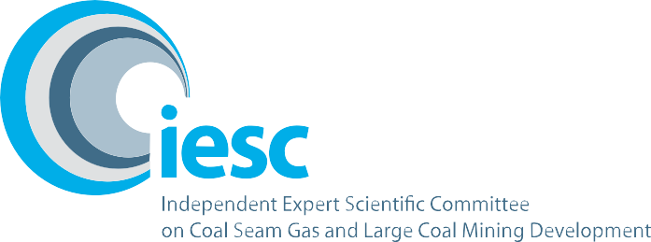

2016–2017

**Annual Review of Activities**

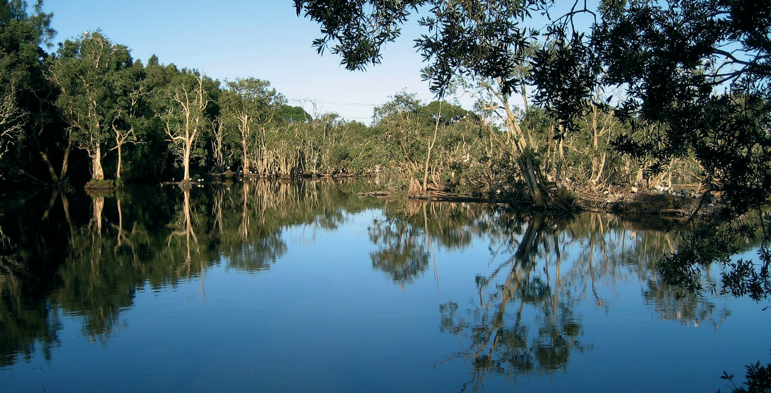An overview of the activities of the Independent Expert Scientific Committee on Coal Seam Gas and Large Coal Mining Development from July 2016 to June 2017

2 / This initiative is funded by the Australian Government Department of the Environment and Energy

##### Front Cover

*Reflections on the lake at the Hunter Wetlands Centre (Shortlands Wetland)*

**Location:** Sandgate Road, Shortland

**Copyright** © Department of the Environment and Energy (taken by staff)

**© Commonwealth of Australia, 2017.**

*Review of activities – July 2016–June 2017* is licensed by the Commonwealth of Australia for use under a Creative Commons By Attribution 3.0 Australia licence with the exception of the Coat of Arms of the Commonwealth of Australia, the logo of the agency responsible for publishing the report, content supplied by third parties, and any images depicting people. For licence conditions see: [*http://creativecommons.org/licenses/by/3.0/au/.*](http://creativecommons.org/licenses/by/3.0/au/)

This report should be attributed as ‘Independent Expert Scientific Committee on Coal Seam Gas and Large Coal Mining Development: Annual Review of Activities – July 2016–June 2017, Commonwealth of Australia, 2017’.

This publication is funded by the Australian Government Department of the Environment and Energy. The views and opinions expressed in this publication are those of the authors and do not necessarily reflect those of the Australian Government or the Minister for the Environment and Energy.

**Contact details**

For information about this report or about the work of the IESC, please contact:

IESC Secretariat

Office of Water Science

Department of the Environment and Energy

GPO Box 787

CANBERRA ACT 2601

The report can be accessed at [http://www.iesc.environment.gov.au/.](http://www.iesc.environment.gov.au/)

Contents

From the Chair 4

Executive Summary 5

The Committee 6

New Members 7

IESC Meetings 8

Coal Seam Gas and Large Coal Mining Development Proposals 10

Bioregional Assessments 12

Research 13

Stakeholder Engagement 14

This report outlines the activities of the Independent Expert Scientific Committee on Coal Seam Gas and Large Coal Mining Development (the IESC) for the period July 2016 to June 2017.

# From the Chair

I was honoured to be appointed as Chair of the Independent Expert Scientific Committee on Coal Seam Gas and Large Coal Mining Development (IESC) earlier this year and look forward to working with the Committee and key groups and organisations to continue to help protect and manage Australia’s water resources.

The Committee contributes to a strengthened decision-making framework for both the Australian and state government regulators of coal resource developments. The Committee continues to apply advances in scientific understanding to ensure governments have access to the best science to underpin regulatory decision making.

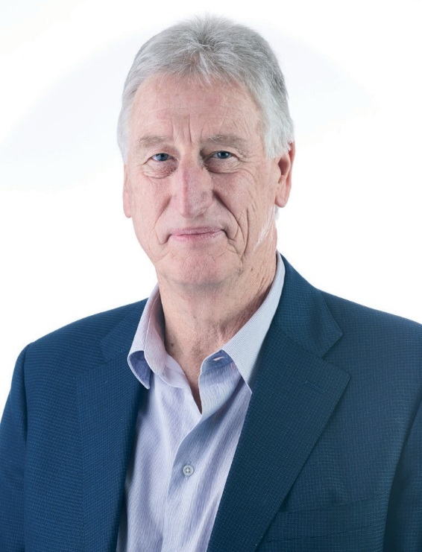I have met with a number of government agencies and environment, community and industry groups, and will continue this engagement into the coming year. The meetings have been positively received. They have provided another opportunity to improve the understanding among stakeholders of the Committee’s roles and responsibilities.

A highlight of the year was the Committee’s visit to Queensland in May 2017 to observe industry operations. The Committee visited an operational coal mine and coal seam gas operations facility. The Committee welcomed the opportunity to talk with agency and industry staff, observe operations and see first-hand how water resources are managed on these sites.

We welcomed two new members in September 2016, Professor Joan Esterle and Dr Wendy Timms, who both bring valuable geology and hydrogeology expertise and knowledge of mining and coal seam gas operations to the Committee.

I would like to thank and acknowledge the previous Chair, Dr Andrew Johnson, for his significant contribution to the work of the Committee.  
Dr Johnson resigned as Chair following his appointment as Chief Executive Officer and Director of the Bureau of Meteorology.

I also thank and acknowledge former members Ms Jane Coram and Emeritus Professor Peter Flood for their valued service to the Committee.

The Committee is ably supported by the Office of Water Science. On behalf of the Committee, I would like to thank the Office for its skills, knowledge and dedication, which strongly support the development of our advice.

The Committee looks forward to continuing to provide valued, independent scientific advice to the Australian and state government regulators in the year ahead.

###### Dr Chris Pigram PhD, FTSE, GAICD

IESC Chair

# Executive Summary

The Independent Expert Scientific Committee on Coal Seam Gas and Large Coal Mining Development is a statutory body established under the *Environment Protection and Biodiversity Conservation Act 1999* (EPBC Act). The Committee provides scientific advice to the Australian and state government regulators on the water-related impacts of coal seam gas and large coal mining development.

The Annual Review of Activities provides an overview of the work that the Committee has undertaken during the 2016–17 period:

### Providing independent expert advice to regulators

The Committee provided advice on eight coal projects in New South Wales and Queensland. The Committee will continue to engage with regulators to monitor how the Committee’s advice has been adopted in regulatory decisions and identify opportunities for continuous improvement.

### Committee research priorities

In light of the advances in scientific understanding and experience in providing advice on coal resource developments, the Committee felt it was timely to conduct a review of the research priorities. The Committee has identified scientific knowledge needs across three themes: hydrology, chemicals and ecology. Research examining the ecological responses to hydrological change has informed the Committee’s advice to regulators on development projects.

### Bioregional assessments

Committee members provided advice on a number of bioregional assessment (BA) technical products in 2016–17. This included water modelling products for the Hunter, Galilee and Namoi regions and ecological modelling and impact and risk analysis for the Gloucester and Hunter regions. The Committee also provided advice on how to communicate bioregional assessment results, including on the map-based BA Explorer.

### Engagement activities

The Committee continues to promote its important work by meeting with interested parties to ensure the role and function of the Committee is well understood. The Committee also commenced a series of workshops with regulators to understand how the advice has been adopted in regulatory decisions; these will continue into 2017–18.

### Site visit to the Surat and Bowen Basins

The Committee had the opportunity to visit both a coal mine and coal seam gas operation in Emerald and Roma, Queensland. The visit was an opportunity for the Committee to see on-the-ground mining operations relating to water resources.

# The Committee

The Committee consists of eight members with extensive scientific qualifications and expertise in the fields of geology, hydrogeology, hydrology, ecology and ecotoxicology.

Members are appointed by the Australian Government Minister for the Environment and Energy on a part-time basis.

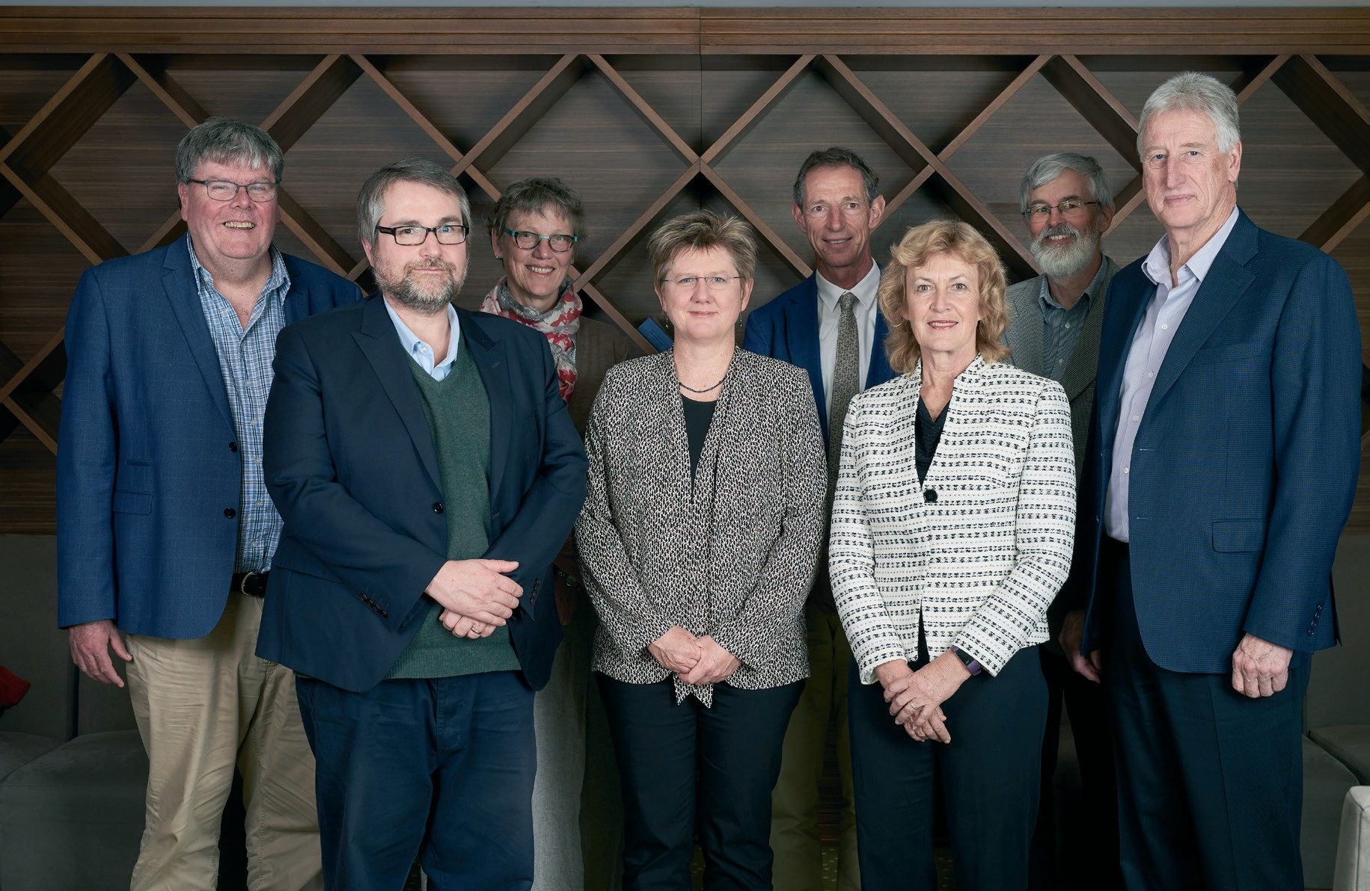

*Photo: Independent Expert Scientific Committee*

(L–R) Dr Glen Walker, Professor Craig Simmons, Professor Joan Esterle, Dr Wendy Timms, Dr Ian Prosser, Dr Jenny Stauber, Dr Andrew Boulton and Dr Chris Pigram (Chair).

### Individual expertise:

Dr Chris Pigram – Chair, Geology

Dr Andrew Boulton – Ecology

Professor Craig Simmons - Hydrogeology

Dr Glen Walker – Hydrology

Dr Ian Prosser – Hydrology

Dr Jenny Stauber – Ecotoxicology Professor Joan Esterle – Geology

Dr Wendy Timms – Hydrogeology

Further information: <http://www.iesc.environment.gov.au/iesc>

# New Members

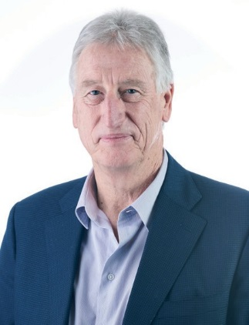On 31 March 2017, the Minister for the Environment and Energy, the Hon Josh Frydenberg MP, appointed **Dr Chris Pigram** as the Chair of the Committee.

Dr Pigram is a leader in research and management of minerals, marine and petroleum geoscience programs and geospatial and earth monitoring. Before his appointment to the Committee, he had recently retired as CEO of Geoscience Australia, where he held the role since 2010, after more than 30 years with the organisation. This experience has given Dr Pigram the ability to manage the interface between science and government and engage stakeholders. Dr Pigram has a PhD in Geology and is a Fellow of the Australian Academy of Technology and Engineering.

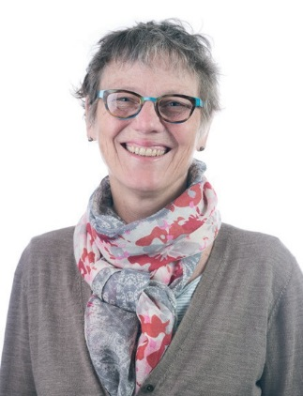The Minister also appointed two new members to the Committee on 17 September 2016:

**Professor Joan Esterle** provides 30 years of geology experience to the Committee. Professor Esterle’s research portfolio examines the geological controls underpinning coal and strata behaviour during mining, processing and utilisation, and more recently during coal seam gas extraction.

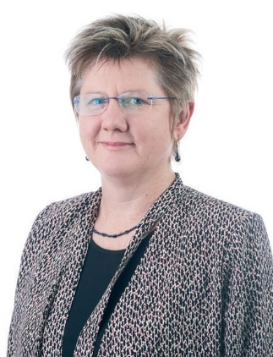**Dr Wendy Timms** is a geologist and engineer with 20 years of professional experience in government, research and consulting engineering, across both mining and agriculture. Dr Timms’s interdisciplinary experience includes hydrogeology, geochemistry and water engineering with specialties in aquitard flow barriers and mine site water use in a catchment context.

# IESC Meetings

The Committee held eight meetings during the 2016–17 period. The minutes from the meetings are available on the IESC website:

<http://www.iesc.environment.gov.au/committee/committee-meetings-and-workshops>

Meeting 37

1–2 August 2016

The Committee provided advice on the South Wambo Underground Mine Extension.

The Committee received an update on the Ecohydrological Research Project. This project focused on ecohydrological responses to variations in surface–groundwater interactions with coal seam gas and coal mining.

Arrow Energy Pty Ltd gave a presentation on evaluating potential coal seam gas impacts on the Condamine Alluvium.

#### Meeting 39

Meeting 38

31 August–1 September 2016

The Committee provided advice on the Wilpinjong Extension Project.

The Minerals Council of Australia gave a presentation to the Committee.

The presentation included a snapshot of the coal industry and industry research and development.

##### 12–13 October 2016

The Committee provided advice on the United-Wambo Open Cut Mine Project.

The Committee welcomed new members

Dr Wendy Timms and Professor Joan Esterle.

#### Meeting 40

##### 9 November 2016

The Committee provided advice on the Lake Vermont Coal Mine.

Committee member Dr Glen Walker led a discussion on addressing uncertainty in groundwater flow modelling predictions within Environment Impact Statements.

Meeting 43

2–5 May 2017

The Committee provided advice on the Hume Coal Project.

The Queensland Department of Natural Resources and Mines gave a presentation on water management issues including watercourse diversions, subsidence of watercourses and floodplains within mines.

Meeting 44

15 June 2017

The Committee considered ways it could increase engagement with key groups and organisations to create stronger links with the community, industry and regulators.

The Department of the Environment and Energy provided an update on the recently announced program of new bioregional assessments targeting unconventional gas resources.

The Committee held a workshop with the Commonwealth Regulator to discuss its advice on development proposals.

Meeting 42

22–23 March 2017

The Committee provided advice on the Grosvenor Coal Mine G200 Expansion Project and the Isaac Plains Mine Extension Development.

Dr Malcolm Roberts (APPEA) provided an update to the Committee on the current state of the industry, gas supply and research.

Meeting 41

12–13 December 2016

The Committee provided advice on the New Acland Coal Mine Stage 3.

Dr Dirk Mallants (CSIRO) presented the findings from the Bore Integrity Research project.

The Melbourne Law School provided a presentation on research into natural resources laws that regulate the cumulative environmental impacts of groundwater withdrawal in Australia.

# Coal Seam Gas and Large Coal Mining Development Proposals

## A primary role of the Committee is to provide expert scientific advice on the water-related impacts of coal seam gas and large coal mining development proposals to the Australian and state government regulators.

The Committee’s advice helps increase transparency and strengthen the scientific basis of regulatory decisions. In formulating its advice, the Committee draws upon the best available scientific information, including research products published by the Australian Government and reports published under the Bioregional Assessment Programme.

In the 2016–17 financial year, the Committee provided advice on eight open cut and underground coal projects. These projects included four in New South Wales and four in Queensland. The locations of these projects are provided in Figure 1. Seven of these projects were extensions of or modifications to existing mining operations.

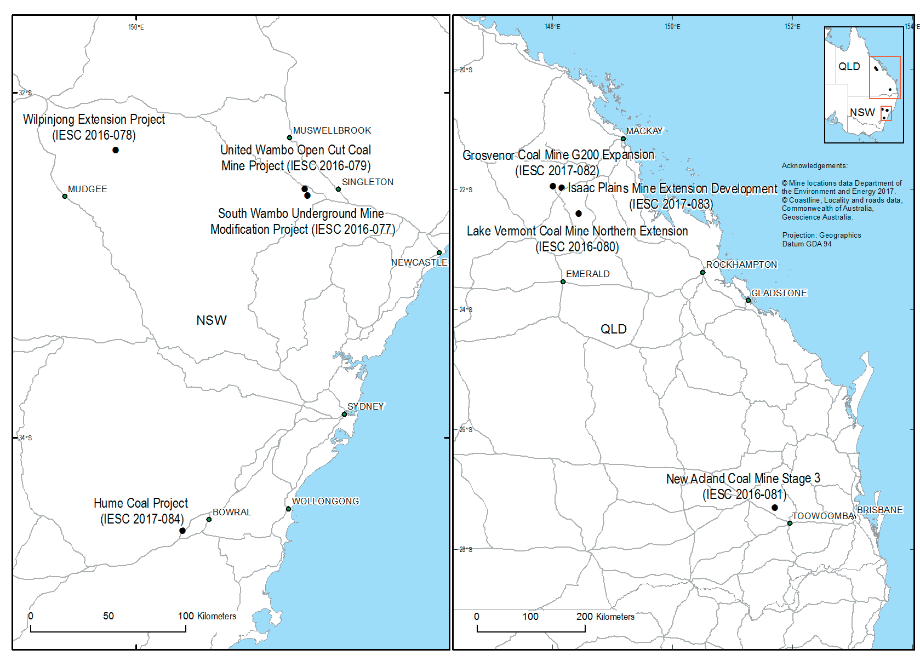

Figure 1: Development proposals considered by the IESC during the period July 2016 to June 2017

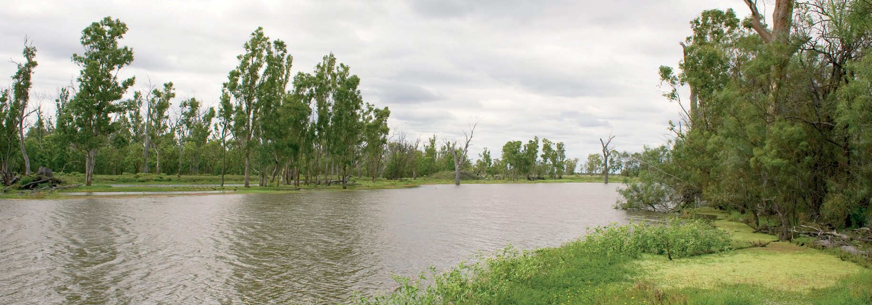

*Billabong on the Condamine River*

**Location:** near Cecil Plains

**Copyright** © Department of the Environment and Energy (Mostead, Arthur)

In its advice, the Committee identified a number of recurring matters within proponents’ assessment documentation of projects reviewed in 2016–17. These were:

* potential changes to the quantity and quality of groundwater and surface water resources and associated impacts on users of these resources (e.g. landholder bores, groundwater-dependent ecosystems, state and Commonwealth listed
* terrestrial ecological species and communities, and downstream ecosystems);
* potential impacts associated generally with groundwater drawdown and depressurisation;
* limitations in onsite water management including assessment of surface water discharges;
* lack of final void management actions; and
* the need to improve consideration of cumulative impacts.

The Committee’s advice during this period covered a range of matters specific to each project. However, matters consistently raised by the Committee as needing to be further detailed, discussed or justified by proponents were:

* baseline data collection and groundwater and surface water models;
* appropriateness of specific assessments (e.g. groundwater-dependent ecosystems, geochemical, final voids, faults etc.);
* risk assessments; and
* monitoring and management measures.

The Committee also noted that in many of the extension and modification projects there was limited provision, interpretation and incorporation of existing mine data. This data is essential to provide information about the existing environment and to inform the assessment of potential impacts.

The Committee’s Information Guidelines provide the minimum information required within assessment documentation to enable the Committee to understand, consider and provide advice on the potential impacts of development proposals on water resources. The Committee is seeing an increase in the use of the Information Guidelines in proponent documentation, but more can be done to ensure all requirements are met.

The Committee’s advice draws upon relevant available information, including products published under the Bioregional Assessment Programme and other research undertaken by the Australian Government. The Committee’s advice continues to play an important role in making regulators and proponents aware of this research and how it may be applied. The Committee’s advice strengthens the scientific basis of regulatory decisions in a number of ways, including by encouraging improved environmental impact assessments by proponents.

The Committee’s advice is published on its website within 10 days of providing it to the requesting regulator. All past advices are available here:

<http://www.iesc.environment.gov.au/> committee-advice/proposals.

# Bioregional Assessments

## The Committee provides advice to the Australian Government’s Bioregional Assessment Programme, which uses science to analyse the potential cumulative impacts and risks of proposed coal mines and coal seam gas projects on water availability

## and water-dependent assets such as wetlands and groundwater bores.

Bioregional assessments (BA) use a nationally and internationally peer-reviewed method. The Committee was involved in the development of this methodology, which provides guidance on how bioregional assessments should be undertaken.

Bioregional assessments are a source of information that the Committee can use to formulate its advice to regulators. The bioregional assessment findings are at a regional level and are useful in ‘ruling out’ areas that are unlikely to experience groundwater drawdown or changes in surface water flow as a result of additional coal resource development. Further studies are needed

to assess potential impacts at a local scale. The regional data and knowledge gaps identified by bioregional assessments can be used by the Committee to shape advice on what needs to be included in finer-scale environmental impact studies and future research.

Committee members provided advice on a number of bioregional assessment technical and ecological modelling products in 2016–17. This includes water modelling products for the Hunter, Galilee and Namoi regions, and impact and risk analysis for the Gloucester and Hunter regions. Committee members have also provided advice on associated submethodologies, which provide further technical detail and guidance to the scientists and researchers undertaking the assessments.

The Committee provided advice to the Bioregional Assessment Programme at a number of intervals throughout 2016–17, including:

* In **October 2016**, the Committee provided advice to the program on its communication and

engagement strategy, in preparation for the release of assessment results in 2017.

* In **December 2016**, the Bioregional Assessment Programme presented its approach to analysing the potential impacts on and risks to water-dependent assets. The Committee provided advice on how to communicate key impacts and risks, particularly to stakeholders within the assessment areas.
* In **March 2017**, the Committee advised the Programme on ways to display results from the assessments on the map-based BA Explorer. BA Explorer is scheduled for release in late 2017 and allows users to see where potential impacts from coal resource developments are likely to occur.
* In **April 2017**, Committee members attended a workshop that investigated methods used to predict potential cumulative impacts of coal mine subsidence on water resources and water- dependent assets across regions with extensive underground coal mining.

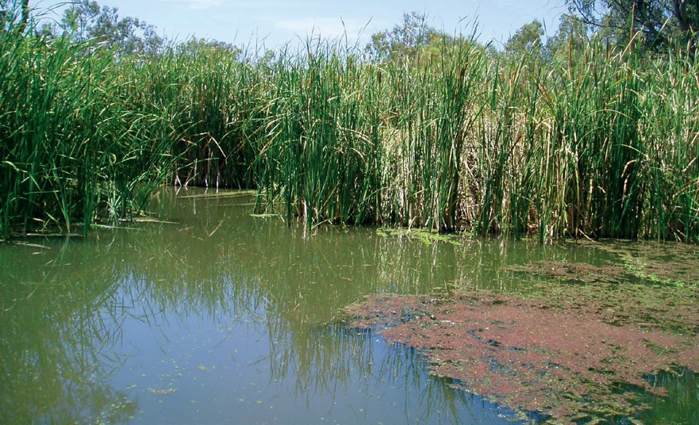

*Pristine wetland the North Macquarie Marsh*

**Location:** near Carinda

**Copyright** © Department of the Environment and Energy (taken by staff)

# Research

## The Committee provides advice to the Australian Government Environment Minister on priorities for research to improve understanding of the impacts of coal seam gas and large coal mining developments on water resources.

In 2013, the then chair of the Committee, Lisa Corbyn, wrote to the then Minister for the Environment, the Hon Greg Hunt MP, to provide advice on research priorities. Since 2013, the Committee’s priorities have served as a basis for research commissioned by the Office of Water Science in the Department of the Environment and Energy. This program of research has strengthened the scientific knowledge base that informs decision making on coal seam gas and coal mining developments.

In light of advances in scientific understanding and experience in providing advice on coal resource development proposals since 2013, the Committee has revised its advice on research priorities. This revision was completed under the leadership of Professor Craig Simmons as acting Chair of the Committee. The Committee’s Revised Priorities for Research takes into account current and emerging research and is informed by consultation with both Australian and state government agencies, industry, researchers and non-government organisations.

The Committee’s Revised Priorities for Research can be found on the Committee’s website as a resource that may inform research institutions, research funding bodies, government science agencies and industry in developing research plans and priorities.

###### Further information:

<http://www.iesc.environment.gov.au/research>

The Department of the Environment and Energy’s Office of Water Science finalised the report *Research to inform the assessment of ecohydrological responses to coal seam gas and coal mining*. This work was identified as a research priority by the Committee. The findings of this report will improve regulatory and industry

capability to predict, mitigate and monitor ecological impacts. This report provides new insights into the ecological impacts of groundwater drawdown, especially in semi-arid areas where many mining activities occur.

In August 2016, the Committee discussed the four research components of the project and how the work will strengthen the advice of the Committee. The research was presented at a special session of the Ecological Society of Australia conference in Fremantle, Western Australia, from 28 November to 3 December 2016, with Committee members present.

Prior to publication, workshops were held in Brisbane, Canberra and Sydney to show the Australian and state governments how the findings could be used to strengthen the scientific knowledge base that informs the regulation of coal seam gas extraction and coal mining in Australia. A representative from the Committee was present at each of the workshops.

Research findings on *Bore and well induced inter- aquifer groundwater connectivity: consequence modelling and experimental design* were presented to the Committee in December 2016. This research was commissioned by the Department of the Environment and Energy’s Office of Water Science on advice of the Committee and aims to determine the potential consequence of inter-aquifer connectivity caused by degraded or poorly constructed bores and wells. This research is useful to the Committee as such connectivity may need to be accounted for in groundwater models to enable accurate predictions of groundwater behaviour, particularly for systems under stress from groundwater pumping/depressurisation.

**Further information:** [http://www.environment.gov.](http://www.environment.gov/)au/water/coal-and-coal-seam-gas/science-research

# Stakeholder Engagement

## Collaborative relationships are especially valuable because the Committee is dealing with increasingly complex and interconnected issues that impact

## on communities, industry and Australia’s water resources.

In mid-2017, the Australian Government and the New South Wales, Queensland, South Australian and Victorian governments (National Partnership Agreement (NPA) states) released a joint government response to the 2015 Review of the NPA. The overarching objective of the NPA was to strengthen the regulation of coal seam gas and large coal mining development by ensuring that future decisions are informed by substantially improved science and independent expert advice.

In the government response, governments committed to:

1. **IESC advice to regulators:** review how the Committee’s advice has been adopted in regulatory decisions to enable improvements in framing advice in the context of the varying regulatory regimes of the Australian Government and NPA states; and
2. **IESC engagement:** increase the Committee’s engagement with peak bodies to encourage better understanding of its role, methodology and approach.

The Committee is acting on these recommendations and aims to improve the collective scientific understanding of the water-related impacts of coal seam gas and coal mining developments through an independent and transparent process that builds confidence in the science used in decision making.

In 2016–17, the IESC Chair held a number of meetings with regulators, government agencies, peak industry bodies and conservation and community groups to increase understanding of the Committee’s role and seek feedback on its operation. This engagement provided a forum for the Committee to demonstrate how information derived from the bioregional assessments is assisting the Committee in formulating advice on development proposals.

The Committee also commenced a series of workshops with regulators to understand how the advice has been adopted in regulatory decisions and where improvements can be made to the advice. The first workshop was held in June 2017 in Canberra with the Commonwealth regulator. These workshops will continue into 2017–18 with state regulators.

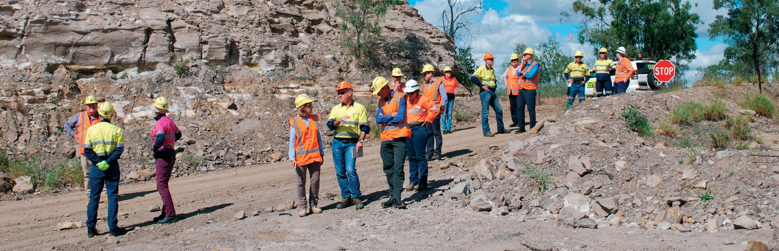

*Independent Expert Scientific Committee on Coal Seam Gas and Large Coal Mining Development site visit.*

**Location:** Emerald, Queensland.

**Copyright** © Department of the Environment and Energy

Site Visit to the Surat and Bowen Basins

The Committee travelled to Emerald and Roma in central Queensland to visit an open cut coal mine and a coal seam gas facility to gain a first-hand understanding of the sites’ operations. The site visits were very informative and assisted the Committee in its understanding of on-the-ground operations when carrying out its functions.

### Glencore’s Oaky Creek Coal Mine

“I appreciated the efforts by the on-site staff to explain their operations, to demonstrate their techniques for rehabilitation and mitigation and to answer our many questions about the day-to-day operations.”

*IESC Member*

Located in the Bowen Basin between Middlemount and Tieri, the Oaky Creek coal mine commenced open cut operation in 1982 and underground mining in 1989. The mine consists of two longwall mining operations and a coal preparation plant that produces medium volatile coking coal.

The Committee had the opportunity to inspect a reverse osmosis water treatment plant and hear a briefing by site staff regarding the plant process as well as the mine’s water storage and management operations. The Committee noted the extensive rehabilitation efforts across the site, including those made to previous open cut pits and subsidence areas.

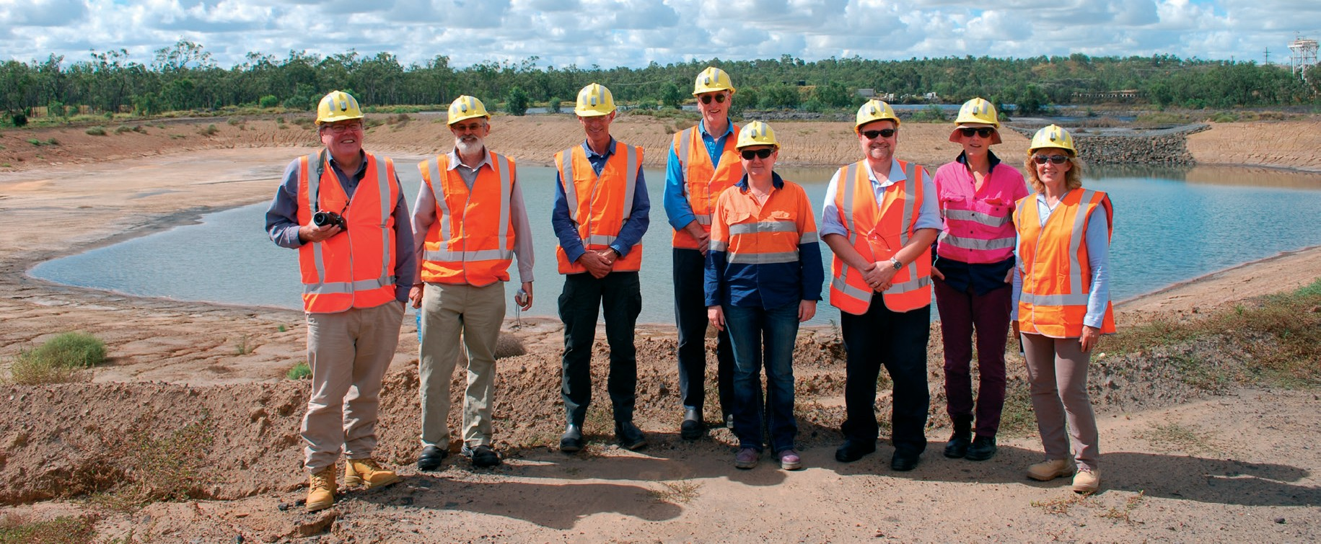

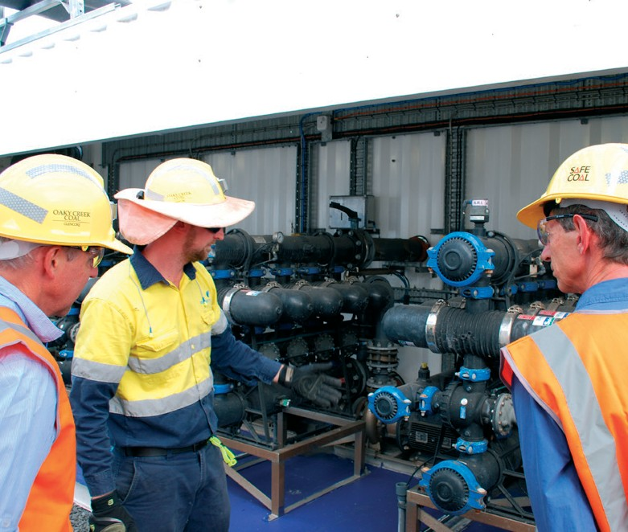 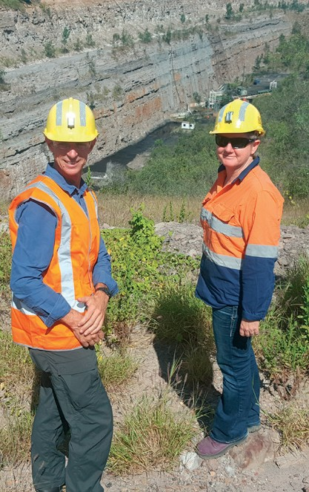 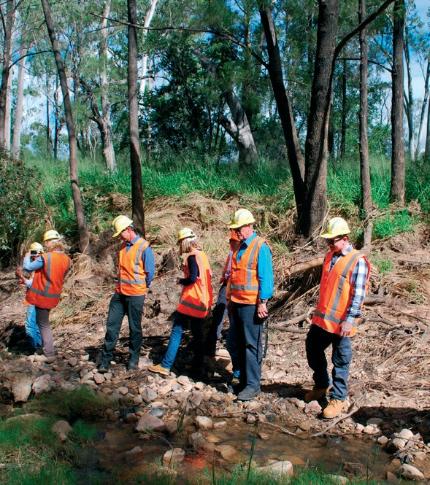

*Independent Expert Scientific Committee on Coal Seam Gas and Large Coal Mining Development site visit.*

**Location:** Emerald, Queensland.

**Copyright** © Department of the Environment and Energy

### Australia Pacific LNG Reedy Creek Coal Seam Gas Water Treatment Facility

“There is no substitute for seeing the actual operations in the field and having the opportunity to chat face-to-face with the mine’s staff about their experiences, concerns and suggestions. I know I shall be applying insights from this field visit to my inputs to the Committee’s deliberations in future.”

*IESC Member*

The Reedy Creek coal seam gas site is located north east of Roma in the Surat basin and hosts Australia’s largest treated water aquifer recharge scheme.

The Committee was shown some of the site operations with a focus on infrastructure relating to water resources and management. The Committee was particularly interested in the extensive onsite water treatment and aquifer reinjection facilities.

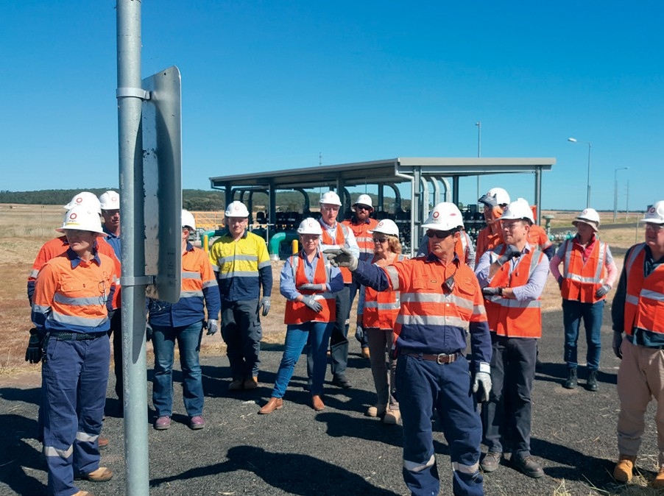 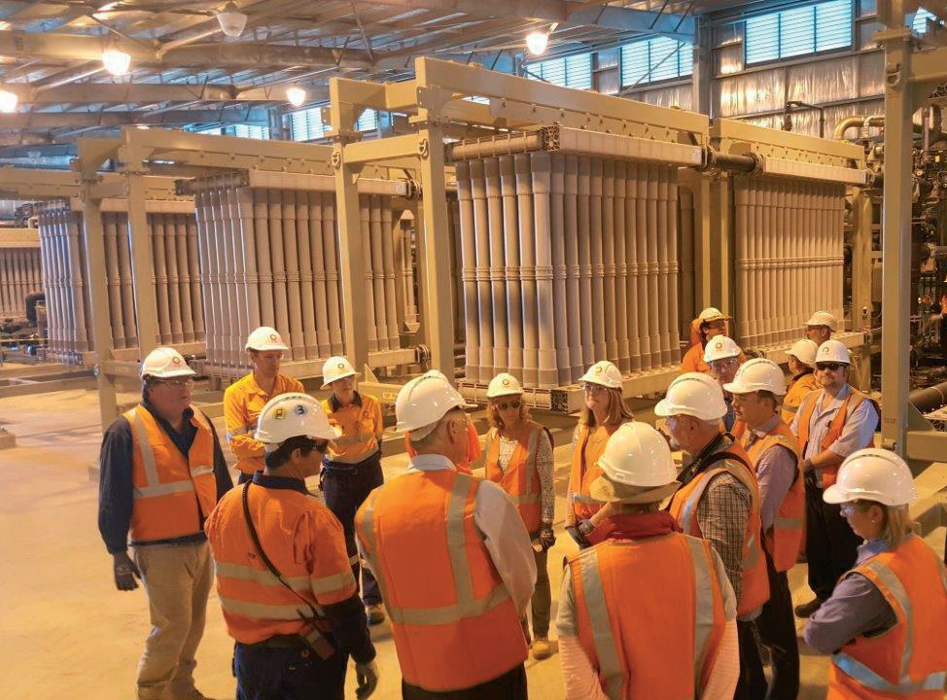

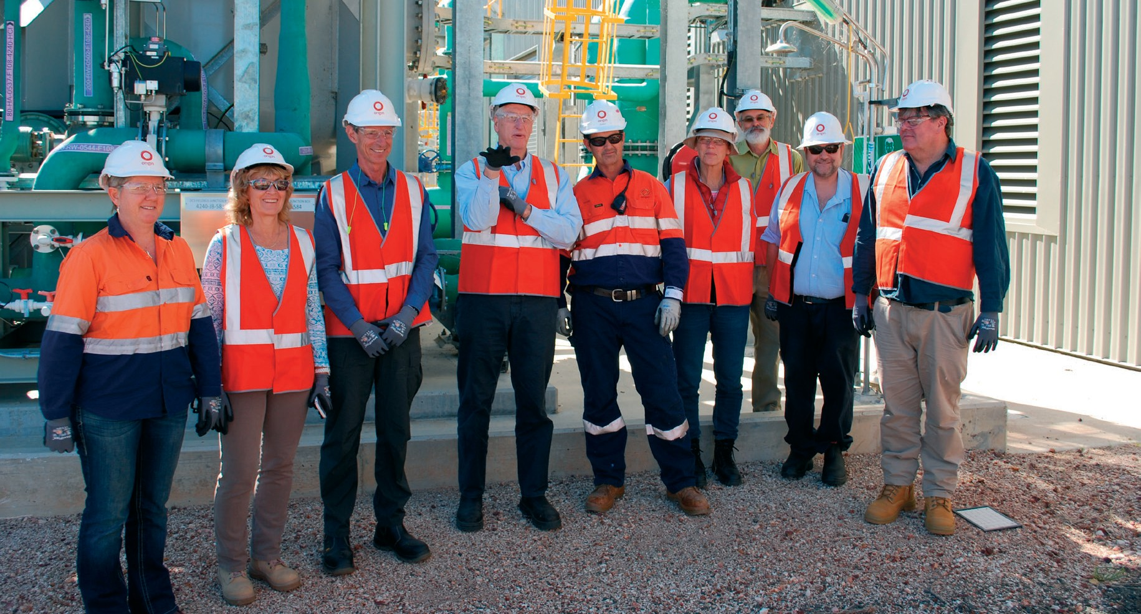

*Independent Expert Scientific Committee on Coal Seam Gas and Large Coal Mining Development site visit.*

**Location:** Roma, Queensland.

**Copyright** © Department of the Environment and Energy

The IESC would like to thank the onsite staff at Oaky Creek Coal Mine and Reedy Creek Coal Seam

Gas Water Treatment Facility for taking time out of their busy day to escort the Committee around the

site and answer questions.

##### Back Cover

*Pristine wetland at Burrima*

**Location:** near Carinda

**Copyright** © Department of the Environment and Energy (taken by staff)

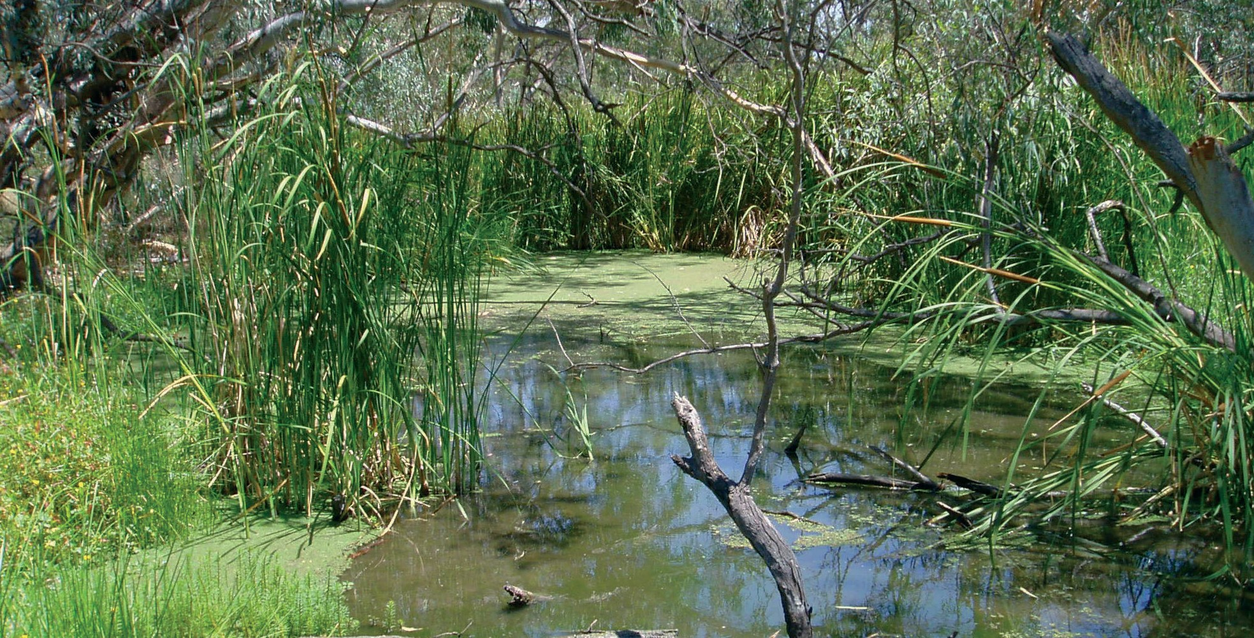

BIO592.0917.

#### **iesc**.environment.gov.au