

Independent Expert Scientific Committee on Coal Seam Gas and Large Coal Mining Development:

Annual Review of Activities

July 2015-June 2016

*An overview of the activities of the Independent Expert Scientific Committee on Coal Seam Gas and Large Coal Mining Development from July 2015 to June 2016*

© Copyright Commonwealth of Australia, 2016



*Review of activities - July 2015–June 2016* is licensed by the Commonwealth of Australia for use under a Creative Commons By Attribution 3.0 Australia licence with the exception of the Coat of Arms of the Commonwealth of Australia, the logo of the agency responsible for publishing the report, content supplied by third parties, and any images depicting people. For licence conditions see: <http://creativecommons.org/licenses/by/3.0/au/>.

This report should be attributed as ‘*Independent Expert Scientific Committee on Coal Seam Gas and Large Coal Mining Development: Annual Review of Activities – July 2015-June 2016, Commonwealth of Australia, 2016’.*

This publication is funded by the Australian Government Department of the Environment and Energy. The views and opinions expressed in this publication are those of the authors and do not necessarily reflect those of the Australian Government or the Minister for the Environment and Energy.

**Contact details**

For information about this report or about the work of the IESC, please contact:

IESC Secretariat

Office of Water Science

Department of the Environment and Energy

GPO Box 787

CANBERRA ACT 2601

The report can be accessed at www.iesc.environment.gov.au .

This report outlines the activities of the Independent Expert Scientific Committee on Coal Seam Gas and Large Coal Mining Development (the IESC) for the period July 2015 to June 2016.

Contents

**Foreword** 4

**1.** **Introduction** 5

**1.1.** **Key achievements** 5

**1.2.** **Appointment of new members** 5

**1.3.** **The IESC and the EPBC Act** 6

**2.** **Coal seam gas and large coal mining development proposals** 7

**2.1.** **Scientific advice on development proposals** 7

**2.2.** **Publication of advice** 8

**2.3.** **Application of advice** 8

**3.** **Bioregional Assessments** 9

**3.1.** **Scientific advice on bioregional assessments** 9

**3.2.** **Bioregions** 9

**3.3.** **Bioregional Assessments Information Platform** 11

**3.4.** **The future of Bioregional Assessments** 11

**3.5.** **Quality assurance and technical products** 12

**3.6.** **Case study: ‘Deep dive’ into the bioregional assessments** 12

**4.** **Research** 13

**4.1.** **Scientific advice on research priorities** 13

**4.2.** **Case study: Research to inform the assessment of ecohydrological responses to coal seam gas extraction and coal mining** 14

**4.3.** **Case study: Research to improve groundwater modelling and prediction of impacts from coal seam gas extraction and coal mining** 14

**5.** **Understanding and disseminating scientific information** 16

**5.1.** **Communication and publication of information** 16

**5.2.** **Stakeholder Engagement Priorities** 16

**Appendix A** 17

**Foreword**

**I am pleased to present the Independent Expert Scientific Committee on Coal Seam Gas and Large Coal Mining Development Annual Review of Activities 2015-2016.**



The IESC has provided over 90 pieces of advice to regulators on the water-related impacts of coal seam gas and large coal mining developments since its establishment in 2011.

Through the delivery of another year’s intensive work program, we have in 2015-16 continued to contribute to a strengthened decision-making framework for both the Australian and state government regulators. The IESC continues to apply advances in our scientific understanding to ensure environmental regulators are well placed to enable better informed decision-making.

Stakeholder engagement has been one of our priorities this past year, and will continue to be in the coming year. I have met with a number of government, agriculture, environment and industry stakeholder groups in Sydney, Brisbane and Canberra. I am also planning to meet with non-government environment organisations in the coming months. The meetings have been overwhelmingly positive and have provided an opportunity to improve the understanding among these groups of the IESC’s roles and responsibilities, and highlight the work being delivered by the Australian Government through the bioregional assessments and other priority research.

The IESC welcomed two new members in March 2016 - Dr Ian Prosser and Dr Glen Walker who are both recognised experts in the field of hydrology. Dr Prosser has 30 years experience with hydrology research and science. Dr Walker has 30 years of hydrology, groundwater and salinity research experience.

I would like to thank and acknowledge former member Dr Tom Hatton for his valued service to the IESC. Dr Hatton resigned from the IESC in October 2015 after accepting the role of Chairman of the Western Australian Environmental Protection Authority.

The IESC looks forward to continuing to provide valued, independent scientific advice to the Australian and state governments in the year ahead.



Dr Andrew Johnson FTSE FAICD

Chair

1. **Introduction**

**The Independent Expert Scientific Committee on Coal Seam Gas and Large Coal Mining Development (IESC) is a statutory body established under the *Environment Protection and Biodiversity Conservation Act 1999* (EPBC Act). The IESC provides scientific advice to the Australian and state government regulators on the water-related impacts of coal seam gas and large coal mining development.**

The IESC consists of eight members with extensive scientific qualifications and expertise in the fields of geology, hydrogeology, hydrology, ecology, ecotoxicology, natural resource management and environment protection. Members are appointed by the Australian Government Environment Minister on a part-time basis.

**Further information:** [www.iesc.environment.gov.au/committee/index.html](http://www.iesc.environment.gov.au/committee/index.html)

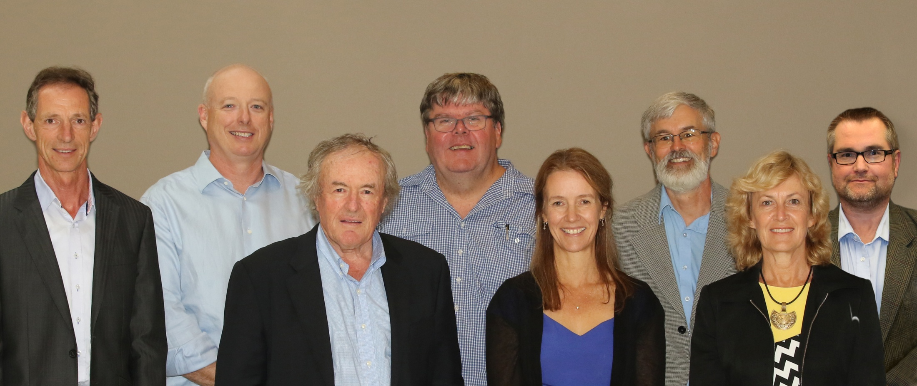

*Photo: Independent Expert Scientific Committee*

(L-R) Dr Ian Prosser, Dr Andrew Johnson (Chair), Emeritus Professor Peter Flood, Dr Glen Walker, Ms Jane Coram, Dr Andrew Boulton, Dr Jenny Stauber and Professor Craig Simmons.

* 1. **Key achievements**

The IESC has contributed to strengthening the science underpinning regulatory decisions on coal seam gas and large coal mining development proposals this year by:

* responding to nine requests from the Australian, New South Wales and Queensland government regulators for advice on the potential water‑related impacts of large coal mining development proposals; and
* providing advice to the Australian Government on bioregional assessments and other priority research.
  1. **Appointment of new members**

The former Minister for the Environment, the Hon Greg Hunt MP, appointed two new members to the IESC on 2 March 2016:

* Dr Ian Prosser – has experience with hydrology research and science. He is an author of over 150 scientific publications on a wide range of aspects of hydrology, lead author of   
  *Water: Science and Solutions for Australia* and led the hydrology analysis in CSIRO's Australian National Outlook 2015.
* Dr Glen Walker – has 30 years of hydrology, groundwater and salinity research experience. He is author of over 70 scientific papers in international literature and was involved in the preliminary risk assessment and development of priorities for science needs for coal seam gas for the Department of the Environment in 2012.

**Legislative functions of the IESC**

Under the EPBC Act, the IESC has several legislative functions. These include to:

* Provide scientific advice to the Australian Government Environment Minister and relevant state ministers on the water-related impacts of proposed coal seam gas or large coal mining developments.
* Provide scientific advice to the Australian Government Environment Minister on:
  + bioregional assessments being undertaken by the Australian Government; and
  + research priorities commissioned by the Australian Government Environment Minister.
* Publish and disseminate scientific information about the impacts of coal seam gas and large coal mining activities on water resources.
  1. **The IESC and the EPBC Act**

The EPBC Act is the Australian Government’s main piece of environment legislation, allowing the Government to join with the states and territories to provide a national framework for the protection of the environment and our biodiversity.

The EPBC Act focuses on the protection of matters of national environmental significance, while state and territory legislation focuses on matters of state and local significance. Matters of national environmental significance include ‘a water resource, in relation to coal seam gas development and large coal mining development’ as well as world and national heritage, wetlands of international importance and listed threatened species and ecological communities.

The diagram below outlines the relationship of the IESC and the environmental assessment process under the EPBC Act.

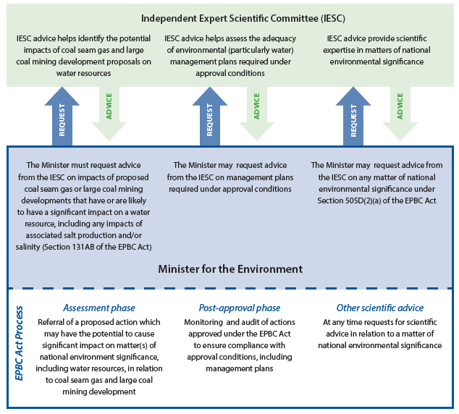

**Further information:** [**http://www.environment.gov.au/water/coal-and-coal-seam-gas/regulation**](http://www.environment.gov.au/water/coal-and-coal-seam-gas/regulation)

1. **Coal seam gas and large coal mining development proposals**
   1. **Scientific advice on development proposals**

A primary role of the IESC is to provide expert scientific advice on the water-related impacts of coal seam gas and large coal mining development proposals to the Australian and state government regulators to enable better informed regulatory decision-making. The IESC’s advice is intended to help increase transparency and strengthen the scientific basis of regulatory decisions. In formulating its advice, the IESC continues to draw upon the best available scientific information, including research products published by the Australian Government and reports published under the Bioregional Assessment Programme.

To date, the IESC’s advice has continued to highlight the need to provide adequate baseline information and to consider:

* development and application of appropriate conceptual and numerical models at multiple scales;
* potentially significant impacts to water resources and water-related assets, including upstream and downstream, direct and indirect impacts;
* potential impacts to groundwater-dependent ecosystems;
* site water and salt balances, and cumulative impacts from activities in the same catchment or region; and
* the effectiveness of ongoing monitoring, mitigation and management measures.

**Summary of development proposals considered by the IESC from July 2015 to June 2016**

The IESC responded to nine requests from the Australian, New South Wales, and Queensland governments.

* + Three requests from the Australian Government, four joint requests from Australian and New South Wales governments, and two joint requests from the Australian and Queensland governments.
  + Eight requests related to large coal mining development proposals. One request related to endangered swamps in the context of underground mining in the Western and Southern Coalfields of New South Wales (the Swamps Advice). No requests related to coal seam gas development proposals.
  + Five requests were for development proposals in Queensland, and three were for development proposals in New South Wales. The Swamps Advice request did not directly relate to a single specific development proposal, but applies to several underground coal mining operations in the Western and Southern Coalfields of New South Wales.
  + Three requests were for new mining developments and five were for extensions to existing mining developments.
  + The expected production of the proposed coal mining developments ranged from 4.2 million to 55 million tonnes per year, and represents a sum total of 122.7 million tonnes per year.

A list of development proposals considered by the IESC during the period July 2015 to June 2016 is provided at Appendix A.

* 1. **Publication of advice**

To enable communities to be better informed and have greater confidence in the regulation of coal seam gas and large coal mining developments, the IESC makes all of its advice on development proposals publicly available on its website: [www.iesc.environment.gov.au/advice/proposals.html](http://www.iesc.environment.gov.au/advice/proposals.html).

Amendments to the Environment Protection and Biodiversity Conservation Regulations 2000 that came into effect in July 2014 require the IESC to publish its advice within 10 business days of it being provided to the relevant regulator/s. Consistent with this requirement, the IESC routinely publishes its advice on the 10th business day ensuring that this statutory obligation is met.

* 1. **Application of advice**

The IESC’s advice is required to be taken into account by regulators in all relevant assessment and approval decisions. Explicit adoption of advice depends on the particularities of the advice provided and the proposed project. The IESC continues to be the principal independent source for the Australian and state government to identify the potential water-related impacts of coal seam gas and large coal mining development, where there is insufficient information to adequately determine the water-related impacts, and what additional research, including modelling of potential impacts, is required to deliver a better understanding of the impacts of the proposed development. The IESC’s advice is also a valuable source of information on knowledge gaps to inform research to further strengthen the science underpinning the assessment process.

The IESC’s advice draws upon relevant available information including products published under the Bioregional Assessment Programme and other research undertaken by the Australian Government. The IESC’s advice continues to play an important role in making regulators and proponents aware of this research and how it may be applied.

The IESC’s advice strengthens the scientific basis of regulatory decisions in a number of ways, including by encouraging improved environmental impact assessments by proponents. This year the IESC reviewed and updated its *Information Guidelines for the Independent 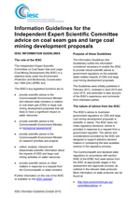Expert Scientific Committee advice on coal seam gas and large coal mining development proposals* (the Information Guidelines). These guidelines outline the information necessary to enable an assessment of the water-related impacts of a proposed development, and for the IESC to provide robust scientific advice to government regulators.

The draft revised Information Guidelines were released for public consultation on the IESC’s website in mid-2015, as well as being sent to specific regulators for feedback. The revised Information Guidelines were endorsed by the IESC and released in October 2015.

The Information Guidelines can be found on the IESC’s website: <http://iesc.environment.gov.au/publications/information-guidelines-independent-expert-scientific-committee-advice-coal-seam-gas>.

1. **Bioregional Assessments** 
   1. **Scientific advice on bioregional assessments**

The IESC provides advice to the Minister for the Environment and Energy on the Australian Government’s Bioregional Assessment Programme, and the science underpinning the methodologies used to prepare the assessments. The bioregional assessments are being delivered through a partnership between the Australian Government Department of the Environment and Energy, the Bureau of Meteorology, CSIRO and Geoscience Australia.

Bioregional assessments are regional-scale, multi-discipline scientific studies that assess cumulative impacts from coal seam gas and large coal mining developments. They draw together available information about a region’s ecology, geology, hydrology and hydrogeology to provide an integrated picture of water resources in the landscape. In regions where coal resource developments are proposed, this information is then used to develop regional surface and ground water models to assess where potential cumulative impacts on water and water-dependent assets are likely to occur, and also where impacts are not likely to occur.

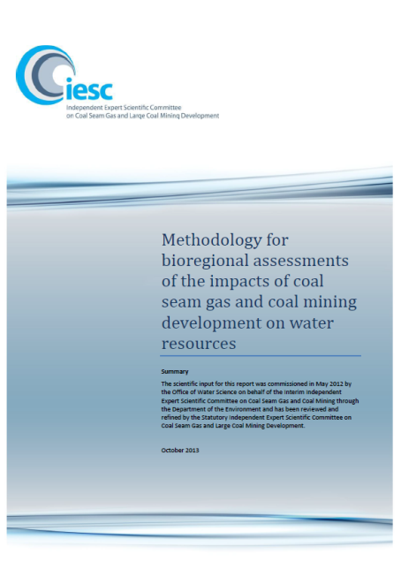An internationally peer-reviewed scientific methodology to guide bioregional assessments was released by the Australian Government Minister for the Environment in October 2013, following endorsement by the IESC. The methodology articulates the scientific and intellectual basis for a consistent approach to all bioregional assessments.

This year, the IESC has provided further advice on the development of 11 submethodologies, which describe in detail the processes to be followed under the overarching methodology. Two submethodologies have been released and are available on the Bioregional Assessment Information Platform (see 3.3). The IESC continues to draw upon these products as they become available to inform its advice.

* 1. **Bioregions**

Bioregional assessments are being undertaken across New South Wales, Queensland, South Australia and Victoria. The assessments focus on bioregions which are defined by landscape-scale natural features such as geological and river basins that support distinctive ecosystems.

**Lake Eyre Basin bioregion**

The Lake Eyre Basin bioregion covers an area of about 1.31 million square kilometres of central and north-eastern Australia, which is almost one-sixth of the country. It extends across parts of Queensland, South Australia, New South Wales and the Northern Territory and incorporates the whole of the Lake Eyre drainage basin.

**Northern Inland Catchments bioregion**

The Northern Inland Catchments bioregion is located west of the Great Dividing Range in eastern Australia and includes parts of the Murray–Darling Basin in northern New South Wales and southern Queensland. The bioregion was selected for assessment because of the likely coal seam gas and coal mining development and the potential for water dependent impacts on the environment and other water-using industries such as agriculture.

**Clarence-Moreton bioregion**

The Clarence-Moreton bioregion extends across north-east New South Wales and south-east Queensland. It contains large river systems and extensive wetlands, some of which are nationally important. Many of these wetlands are home to water-dependent plants and animals that are listed as rare or threatened under Queensland and Commonwealth legislation. The bioregion contains numerous national parks and forest reserves and includes sites of international importance for bird conservation.

**Northern Sydney Basin bioregion**

The Northern Sydney Basin bioregion is located east of the Great Dividing Range and is entirely within New South Wales. This bioregion contains two subregions: the [Gloucester subregion](http://www.bioregionalassessments.gov.au/assessments/gloucester-subregion) and [Hunter subregion](http://www.bioregionalassessments.gov.au/assessments/hunter-subregion). The subregions were selected because they are areas of significant current coal mining development.

**Sydney Basin bioregion**

The Sydney Basin bioregion includes Australia’s largest city, Sydney, as well as the cities and towns of Wollongong, Bowral, Moss Vale, Nowra and Lithgow. It also includes significant parts of the Blue Mountains, Wollemi and Moreton national parks.

**Gippsland Basin bioregion**

The Gippsland Basin bioregion is in south-eastern Victoria and includes the area between the foothills of the Great Dividing Range to the north, and the Bass Strait coast to the south, Warragul to the west, and Cann River to the east. Key rivers include the Latrobe River, Thomson River, Macalister River, Mitchell River and Tambo River. All key rivers drain seaward, many passing through nationally and internationally significant wetlands, such as Gippsland Lakes and Corner Inlet.

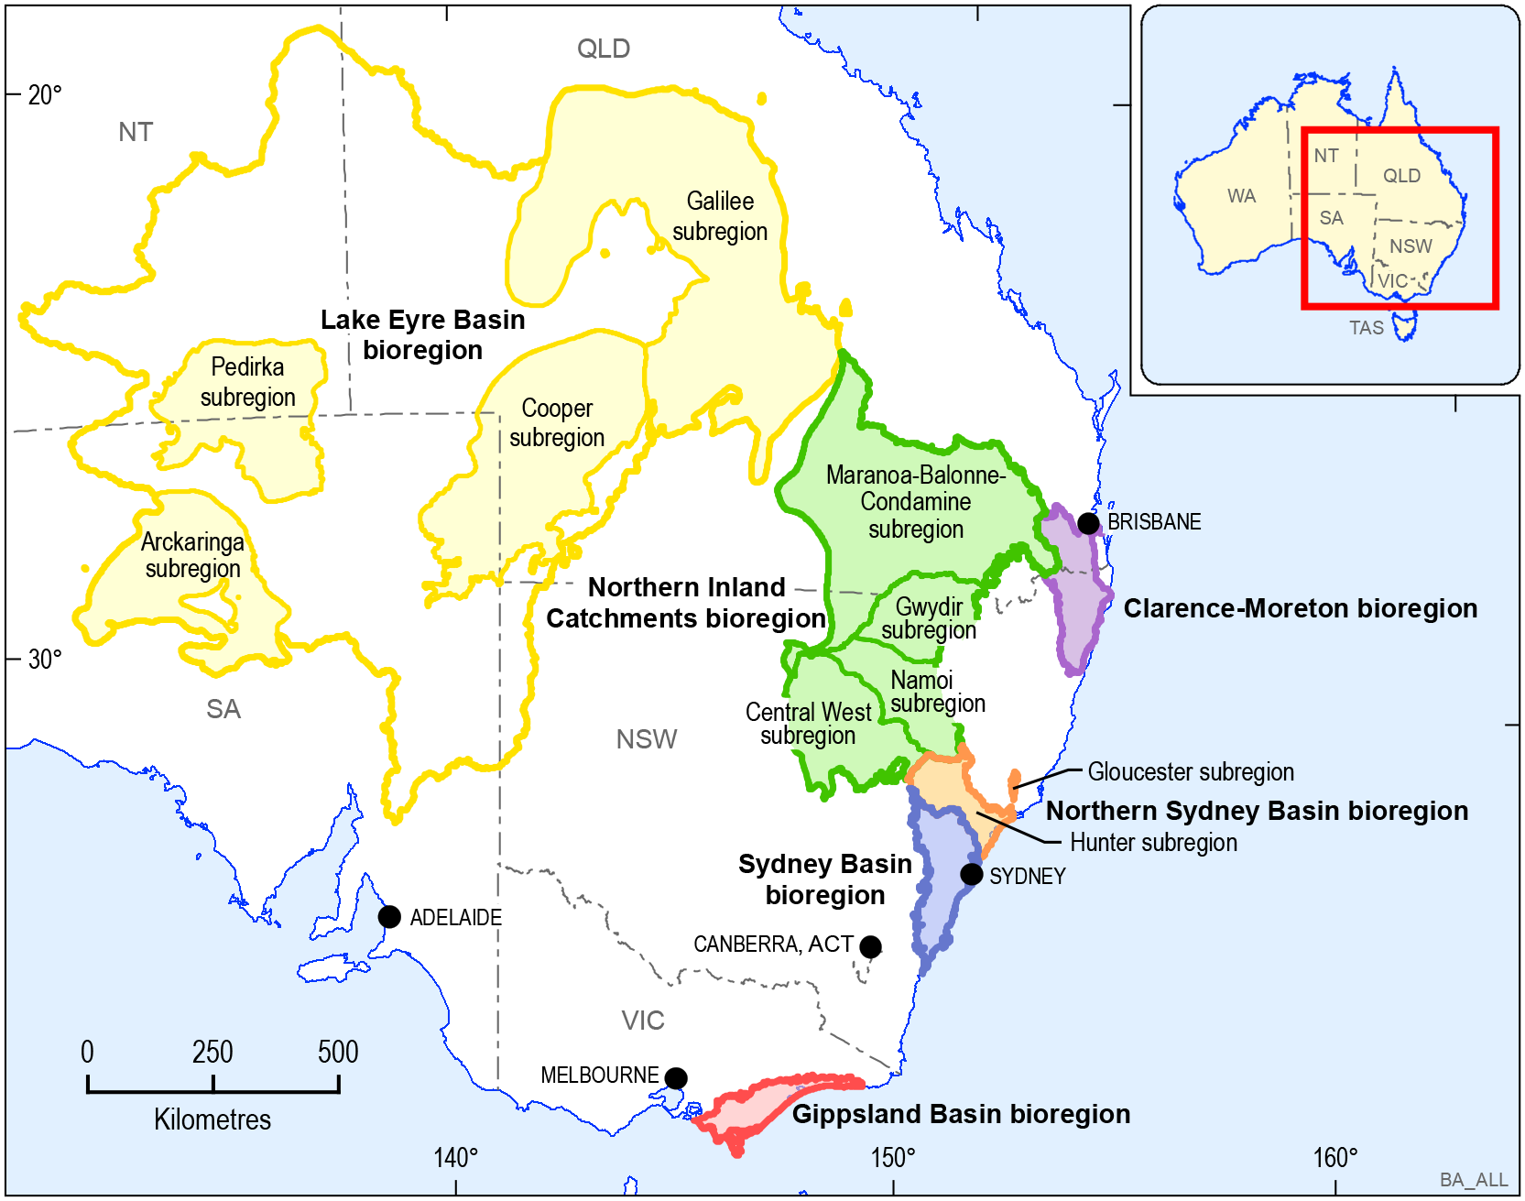

*Map: Bioregional Assessment Areas*

**Further information:** <http://www.bioregionalassessments.gov.au/assessments>

* 1. **Bioregional Assessment Information Platform**

In April 2016 the Bioregional Assessment Information Platform went live, marking a step change in the delivery of science that will allow governments, industry, natural resource managers, the IESC and other interested parties to easily access all assessment products, methods, maps, models and datasets.

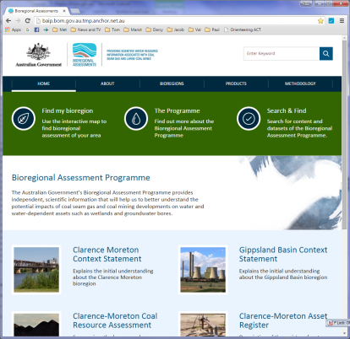Over 50 bioregional assessment products providing background scientific information and over 600 datasets across 12 regions have already been released. The final bioregional assessments are expected to be completed by mid 2017.

The Information Platform can be found at: www.bioregionalassessments.gov.au

* 1. **The future of Bioregional Assessments**

The Bioregional Assessment Programme’s analytical work has focused primarily on regions with the highest coal and coal seam gas development activity. It is expected that completed assessments for the Clarence-Moreton, Gloucester, Maranoa-Balonne-Condamine, Galilee, Hunter and Namoi regions will be published in the first half of 2017. In addition to being able to read the assessments, users will be able to visualise where potential impacts from coal resource developments are likely to occur through a map-based component on the online Information Platform and access the data and models that underpin the 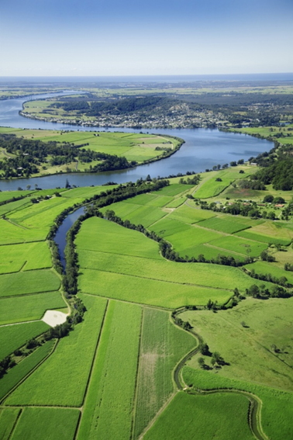assessments.

Fact sheets outlining assessment findings for the regions with low development activity will be released in late 2016. These include the Central West, Gwydir, Cooper, Pedirka and Arckaringa subregions. Assessment activities for the Gippsland and Sydney Basin bioregions are likely to be completed in early 2017.

Throughout 2016-17, the program is planning a staged engagement process to support the release and adoption of bioregional assessment products. This will ensure that stakeholders are kept up-to-date on progress with the assessments and gain an understanding of the products that are available and how they can be used. The program will work with the Australian, state and local governments, industry, natural resource management groups and peak representative bodies so they can understand the key findings of the assessments for the high development regions, to support their release during the first half of 2017.

* 1. **Quality assurance and technical products**

The IESC provides advice on quality assurance processes for bioregional assessments. This includes providing input into the assessments and reviewing bioregional assessment technical products.

This year, the IESC has continued to review background information and, importantly, has reviewed the first hydrological modelling products produced for the Gloucester and Maranoa-Balonne-Condamine regions. The IESC continues to provide thorough feedback to the program partners to ensure that the scientific process is clear and sound, with all assumptions specified.

In 2016, IESC members have participated in expert workshops to develop the assessments as well as workshops on ecological modelling for the Galilee and Hunter subregions.

The first component of work that brings together background information about each subregion or bioregion in reports and registers will be available as technical products are finalised through to mid-2016. Full results from the bioregional assessments are expected to start being released from late 2016 through to mid-2017. This will include products providing model-data analysis and impact analysis which will be jointly released with a synthesis of the full bioregional assessment.

**Further information:** [**http://www.bioregionalassessments.gov.au/**](http://www.bioregionalassessments.gov.au/)

* 1. **Case study: ‘Deep dive’ into the bioregional assessments**

In March and June 2016, the IESC held two workshops with Bioregional Assessment Programme partners to better understand the application of the bioregional assessments methodology. At the first workshop, the IESC stepped through the first three components of a bioregional assessment, including the hydrological modelling. At the second, the IESC focused on the last two components, with worked examples from the ecological modelling and the impact and risk analysis.

The workshops included discussions on the usefulness, limitations, rigour and degree of 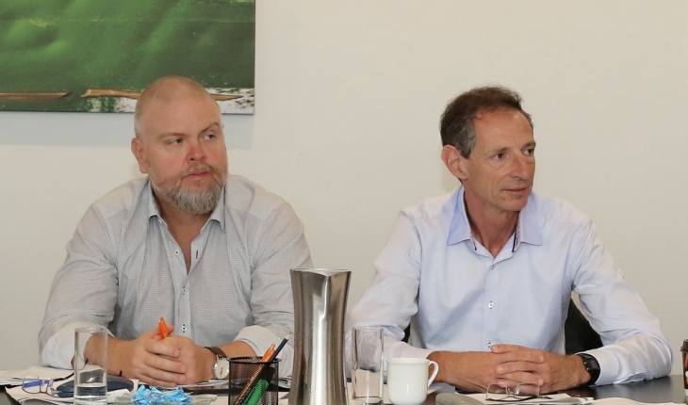uncertainty associated with assessment results. Communication of the complex messages arising from the program was also discussed. The IESC considered that the workshops were very worthwhile and reiterated its commitment to provide further advice to ensure that quality-assured, fit-for-purpose products are delivered.

*Photo: Anthony Swirepik (Department of the Environment and Energy) and IESC member Dr Ian Prosser attending ‘Deep dive’*

1. **Research** 
   1. **Scientific advice on research priorities**

The IESC provides scientific advice to the Minister for the Environment and Energy on priorities and projects for the Australian Government’s research into the water-related impacts of coal seam gas and large coal mining development. The research aims to strengthen the science underpinning regulatory decisions, including by informing the advice the IESC provides to regulators. For example, during 2015-16, the IESC cited Australian Government research products in its advice to regulators on peat swamps and management of subsidence due to longwall coal mining.

The IESC has previously provided advice on priorities for new research to address knowledge gaps. This advice concentrated on areas of high risk, significant knowledge gaps and where there was potential to produce outputs of national significance within three years. The IESC also took into account current and emerging research being undertaken in Australia and overseas.

This process identified research needs across three priority themes:

* Hydrology—improved scientific understanding and modelling of alterations to groundwater and surface water characteristics and processes.
* Ecosystems and water—strengthening knowledge of potential impacts on key species and ecosystems, as well as methods for monitoring and mitigating these impacts.
* Chemicals— improved scientific understanding of coal seam gas chemicals, their movement in surface and groundwater systems, and their toxicity.

Cumulative impacts are also of interest and form a cross-cutting issue that is informed by bioregional assessments and research in the priority themes.

The Australian Government Department of the Environment and Energy progressed priority research projects within these themes. Reports from 17 projects have been published. Given the progress made in the research program, the IESC has decided to undertake a review of its advice on research priorities. Preliminary consultation was carried out during 2015-16, and further consultation is planned. This review is expected to conclude in the 2017 calendar year.

The Australian Government has funded a series of research projects to address critical gaps in the current scientific understanding of water-related impacts of coal seam gas and large coal mining. This work is managed by the Department of the Environment and Energy.

Projects include a national assessment of the chemicals associated with coal seam gas extraction, and research into better representation of faults and aquitards in groundwater modelling, bore integrity, and ecological responses to hydrological change.

**Further information:** [www.iesc.environment.gov.au/research](http://www.iesc.environment.gov.au/research)

* 1. **Case study: Research to inform the assessment of ecohydrological responses to coal seam gas extraction and coal mining**

This two-year research program is focused on ecohydrological responses to variations in surface-groundwater interaction of the kind that might be expected due to coal seam gas extraction and coal mining developments. It is being carried out in two catchments, one in New South Wales and one in Queensland, in accordance with a detailed work plan agreed to by the IESC in 2015.

The program has four major research components:

* Ecohydrology of groundwater dependent terrestrial vegetation. The objective is to understand the impacts of altered groundwater regimes as a result of coal seam gas and coal mining developments on groundwater dependent vegetation in different biophysical settings.
* Ecological values of baseflow and surface water-groundwater connectivity regimes in non‑perennial streams. This component aims to quantify and describe the ecological values of non-perennial streams, the contributions from groundwater in maintaining those values, and the potential threats to those values resulting from altered surface-groundwater [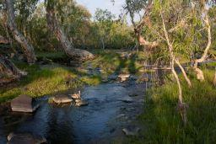](http://155.187.2.91/netpub/server.np?find&catalog=catalog&template=detail.np&field=itemid&op=matches&value=20188&site=evil-main)connectivity, including the ability for systems to recover from periods of altered groundwater-surface water connectivity.
* Hydrogeochemistry, biogeochemical processes and the hyporheos/stygofauna (groundwater fauna). The objective is to understand how changes in hyporheic exchange and biogeochemical conditions affect the ecological conditions for hyporheos and stygofauna.
* Composition and resilience of Great Artesian Basin spring communities. The aim is to conceptualise and quantify associations between the hydrogeochemical characteristics and hydrological connectivity of GAB discharge spring wetlands and their ecological community composition.

These projects are being undertaken for the Department of the Environment and Energy by researchers from Griffith University, University of New South Wales and Edith Cowan University.

* 1. **Case study: Research to improve groundwater modelling and prediction of impacts from coal seam gas extraction and coal mining**

An important consideration for the assessment of coal seam gas and coal mining development is the accurate prediction of impacts to groundwater systems, including propagation of impacts via groundwater to other parts of the environment (such as rivers and associated ecosystems). To provide accurate predictions, numerical groundwater models must realistically represent the range of pathways and barriers to groundwater flow in any given area.

Two research projects that have been underway since July 2015 and aim to improve the representation of groundwater pathways and barriers in numerical models are:

* Bore- and well-induced inter-aquifer connectivity (the bore integrity project), and
* Hydrology research to better include faults and aquitards in Australian regional groundwater models (the faults, aquitards and models project).

These projects are being undertaken for the Department of the Environment and Energy by CSIRO and research partners Flinders University and University of Queensland.

**Bore- and well-induced inter-aquifer connectivity**

The bore integrity project recognises that poorly constructed or abandoned water bores, exploration holes and coal seam gas wells are potential pathways for propagating impacts of deep groundwater extraction to shallower aquifers and surface environments. It defines a range of bore ‘failure’ types and explores numerical methods for quantifying flow through ‘leaky’ bores, and the potential impacts of such flows on predictions of groundwater flow and impact assessment.

**Hydrology research to better include faults and aquitards in Australian regional groundwater models**

The faults, aquitards and models project was developed to test and demonstrate methods for conceptualising faults and aquitards, and for representing them in numerical groundwater models. Aquitards, by definition, are barriers to groundwater flow, and within numerical models can have a large influence on predictions of impacts being transmitted from deep to shallow aquifers. However, due partly to their poor water supply potential, there is often a lack of data on their hydraulic properties. The project identifies, demonstrates and tests a range of methods for characterising aquitards and determining their hydraulic properties, using aquitard examples and data from the Gunnedah Basin, New South Wales.

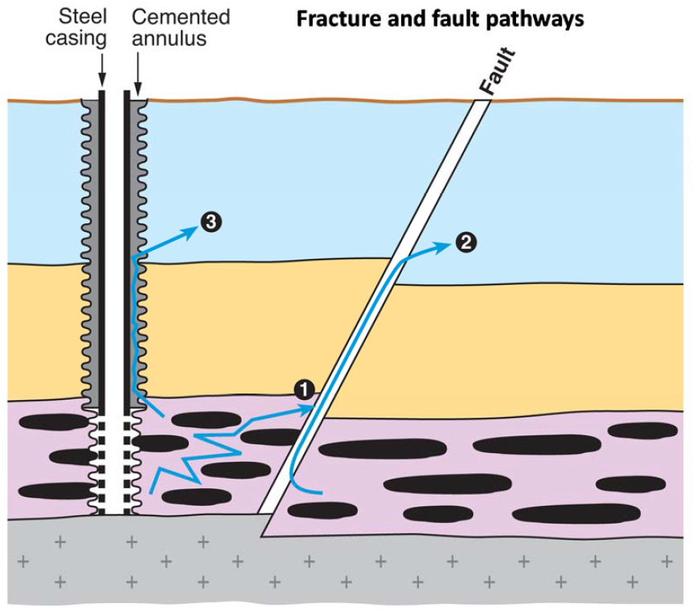Faults can have a range of properties, from being barriers to groundwater flow, conduits for flow, or both barriers to cross-fault flow and conduits for flow along the fault plane. However, whilst there is a significant history of fault conceptualisation and representation in models used by the petroleum industry, they are often dealt with in groundwater models by using simple but poorly supported assumptions on their properties. This part of the project identifies the current state of knowledge on faults, and demonstrates a range of methods for their characterisation and inclusion in numerical groundwater models, using example faults and data from the Gloucester Basin, New South Wales.

*Conceptual model of potential groundwater flow through*

*1) rock fractures; 2) a highly permeable fault zone and 3) a poorly sealed bore.*  *Diagram courtesy of CSIRO*



1. **Understanding and disseminating scientific information**
   1. **Communication and publication of information**

The IESC plays an important role in building public confidence in the scientific evidence which informs regulatory decisions on coal seam gas and large coal mining development. Throughout the year the IESC has worked to increase awareness of the availability of its advice, to inform both scientific dialogue on research and public discussion on the potential impacts of coal seam gas and large coal mining development on water resources.

To this end, the IESC makes all of its advice on coal seam gas and large coal mining developments publicly available within 10 business days of providing it to the regulator. As the advice is publicly available before decisions on development proposals are made, a high level of transparency and early access to the advice by all interested parties is ensured.

[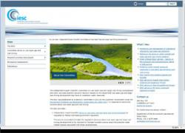](http://iesc.environment.gov.au/)The IESC’s website is an important tool for communicating and publishing information and is available at: [www.iesc.environment.gov.au](http://www.iesc.environment.gov.au)

The website contains:

* agendas and minutes for all meetings;
* all of the IESC’s advice on coal seam gas and large coal mining development proposals, and that of the Interim IESC;
* the Information Guidelines which outline the information considered necessary to enable the IESC to provide robust scientific advice to government regulators;
* information on the bioregional assessments and other priority research, including web links to further information on the Australian Government Department of the Environment and Energy and the bioregional assessment’s websites; and
* other publications, including fact sheets on key scientific issues associated with the water-related impacts of coal seam gas and large coal mining development.
  1. **Stakeholder Engagement Priorities**

Communication and engagement is an important part of the IESC’s role, informing stakeholders about the IESC’s work, with a key priority being to provide scientific information, advice and guidance on project proposals for coal seam gas and large coal mining development.

The focus for 2015-16 was highlighting and communicating the IESC’s role and activities, as well as the work being delivered through the Bioregional Assessment Programme. The Chair, Dr Andrew Johnson, met with stakeholders from the agriculture and environment sectors, regulators and industry peak bodies in Canberra, Brisbane and Sydney. The IESC will continue meetings with stakeholders in 2016-17.

**Appendix A**

**Development proposals considered by the IESC during the period July 2015 to June 2016**

| **IESC #** | **Project title** | **Location** | **Requesting regulator** |
| --- | --- | --- | --- |
| 2016-76 | Hillalong Coal Mine Project | QLD | Australian and Queensland Governments |
| 2016-75 | Wilpinjong Extension Project | NSW | Australian and New South Wales Governments |
| 2015-74 | Curragh Coal Mine | QLD | Australian Government |
| 2015-73 | New Acland Coal Mine Stage 3 | QLD | Australian Government |
| 2015-72 | Hail Creek Coal Mine Extension Transition Project | QLD | Australian Government |
| 2015-71 | Bylong Coal Project | NSW | Australian and New South Wales Governments |
| 2015-70 | China Stone Coal Mine Project | QLD | Australian and Queensland Governments |
| 2015-69 | Drayton South Coal Project | NSW | Australian and New South Wales Governments |
| 2015-68 | Further advice on swamps | NSW | Australian and New South Wales Governments |

A full list of development proposals for which the IESC has provided advice to regulators is available from the IESC website: [www.iesc.environment.gov.au/advice/proposals.html](http://www.iesc.environment.gov.au/advice/proposals.html).

Information on the projects considered by the Australian Government Regulator under the EPBC Act is available from the Australian Government Department of the Environment and Energy’s website: [www.environment.gov.au/water/coal-and-coal-seam-gas/projects](http://www.environment.gov.au/water/coal-and-coal-seam-gas/projects).

