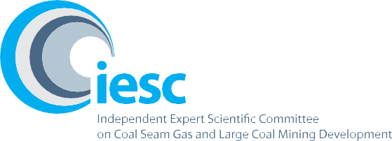

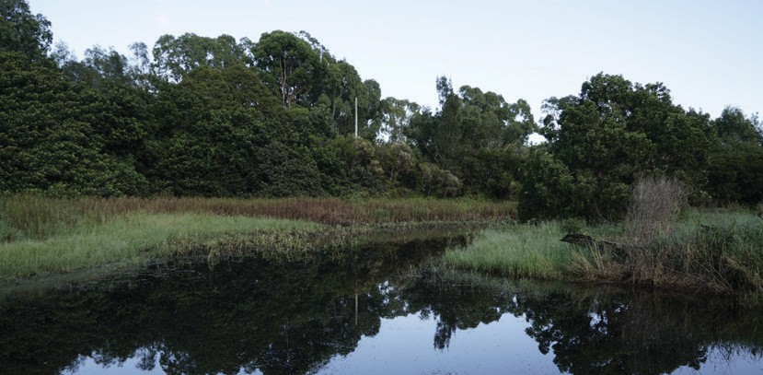

2020–2021

**Annual Review of Activities**

An overview of the activities of the Independent Expert Scientific Committee on Coal Seam Gas and Large Coal Mining Development from July 2020 to June 2021

© Commonwealth of Australia, 2021.



*Annual Review of Activities – July 2020 to June 2021* is licensed by the Commonwealth of Australia for use under a Creative Commons Attribution 4.0 International licence with the exception of the Coat of Arms of the Commonwealth of Australia, the logo of the agency responsible for publishing the report, content supplied by third parties, and any images depicting people. For licence conditions see: <https://creativecommons.org/licenses/by/4.0/>

This report should be attributed as ‘Independent Expert Scientific Committee on Coal Seam Gas and Large Coal Mining Development:

Annual Review of Activities—July 2020 – June 2021, Commonwealth of Australia’.

This publication is funded by the Australian Government Department of Agriculture, Water and the Environment. The views and opinions expressed in this publication are those of the authors and do not necessarily reflect those of the Australian Government or the Minister for the Environment.

**Contact details**

For information about this report or about the work of the IESC, please contact:

IESC Secretariat

Office of Water Science

Department of Agriculture, Water and the Environment GPO Box 858

CANBERRA ACT 2601

Email: [IESCSecretariat@awe.gov.au](mailto:IESCSecretariat@awe.gov.au)

The report can be accessed at <http://www.iesc.environment.gov.au/>

**Images**

Front cover: Creek flowing through the Hunter Valley Wetlands | © Copyright Department of Agriculture, Water and the Environment Back cover: Hunter Valley Wetlands | © Copyright Department of Agriculture, Water and the Environment

All other images © Department of Agriculture, Water and the Environment unless specified otherwise

# Contents

1. Message from the Chair 4
2. Highlights at a glance 5
3. The IESC 6
4. IESC meetings 8
5. Advice on coal seam gas and large coal mining development proposals 10
6. Information Guidelines and Explanatory Notes 12
7. Research 13
8. Engagement 14

# Message from the Chair

I am excited to present the Independent Expert Scientific Committee on Coal Seam Gas and Large Coal Mining Development (IESC) Annual Review of Activities 2020–2021.

Since the establishment of the interim IESC in 2012, we have now provided 139 pieces of independent scientific advice to regulators, including advice on eight coal development project proposals in 2020–21. The IESC continues to adapt the way in which it prepares its advice, meeting virtually nine times in 2020–21.

In June 2021, the IESC met with the Minister for the Environment, the Hon Sussan Ley MP. The IESC welcomed the opportunity to discuss the role of the Committee and our recent activities.

Dr Catherine Moore ended her time on the IESC in April 2021. On behalf of the IESC, I thank Dr Moore for her

time and commitment.

Following the departure of Dr Moore, the Hon Sussan Ley MP appointed Associate Professor Phil Hayes to the IESC. Associate Professor Hayes is a geoscientist, hydrogeologist and groundwater modeller with over 25 years’ experience in Australia, the UK and South America.

The IESC has developed a series of Explanatory Notes to supplement the IESC Information Guidelines. The Explanatory Notes provide tailored guidance and up-to-date robust scientific methodologies and tools for specific components of environmental impact assessments. In May and June of 2021, the IESC hosted a series of virtual masterclasses focused on its Explanatory Notes. The masterclass sessions, presented by each note’s authors, provided the opportunity to understand how each Explanatory Note can be applied and allowed participants to ask questions and share their own experiences. The virtual series was targeted at industry consultants and was well received by those who participated.

The IESC continues to improve scientific understanding of the potential impacts of coal seam gas and large coal

mining developments on water resources by funding research projects that align with our research priorities.

In 2020–21, we expanded our research program, commencing funding to explore the use of metagenomic approaches to evaluate the potential impacts of coal seam gas and coal mining on stygofaunal assemblages. Our research project on coal mine voids in Queensland continued to progress over the 2020–21 period. Both projects are expected to be completed in the second half of 2021 and we look forward to sharing the results with you at that time.

The Office of Water Science (OWS) within the Australian Government Department of Agriculture, Water and the Environment continues to provide secretariat support and scientific expertise to assist our work. On behalf of the IESC, I thank the OWS for its continued support and dedication.

The IESC looks forward to continuing to provide independent expert scientific advice to the Australian Government and relevant state ministers on the potential water-related impacts of proposed coal seam gas and large coal mining developments.



**Dr Chris Pigram AM, FTSE**

IESC Chair

4 / IESC | 2020–2021 Annual Review of Activities

# Highlights at glance



Held

**9**

virtual committee meetings

Provided

**5**

**8**

in Queensland

pieces of advice on coal projects

**3**

in New South Wales

IESC Chair meeting with **Queensland Gas Fields Commission**

**2** virtual regulator roundtables

* + Commonwealth Regulators
  + QLD Government Regulators

Virtual Explanatory Notes Masterclass Series

* **3** individual masterclass sessions
* Involving **59** industry consultants
* International attendees from USA, Canada and NZ

Public consultation period for draft **Characterisation and Modelling of Geological Fault Zones**

Funded research projects on **metagenomic research and minimum groundwater monitoring guidelines**

Progressed research study on **final mine voids in Queensland**

IESC | 2020–2021 Annual Review of Activities / 5

# The IESC

The IESC consists of a maximum eight members, appointed on a part-time basis by the Australian Government minister with responsibility for the environment. Each member possesses extensive scientific qualifications and expertise in geology, hydrogeology, hydrology, ecology or ecotoxicology.

|  |  |
| --- | --- |
|  | **New member in 2020–21** |
|  | Associate Professor Phil Hayes—Hydrogeology  Associate Professor Hayes is a geoscientist, hydrogeologist and groundwater modeller with over 25 years’ experience in Australia, the UK and South America. He has worked across sectors from water resource management and groundwater protection to impact prediction and mitigation for mining, oil and gas, contaminated land, infrastructure, and nuclear waste. He is Associate Professor of Water Resources at the University  of Queensland, leading research at the interface between reservoir engineering and  hydrogeology, and in groundwater modelling uncertainty analysis. |
|  | **Ongoing members in 2020–21** |
|  | Dr Chris Pigram – Chair  Dr Pigram is a geologist with over 40 years’ experience and is a leader in research and management of minerals, marine and petroleum geoscience programs, and geospatial and earth monitoring. Dr Pigram was formerly the CEO of Geoscience Australia, where he held the role for seven years. Consequently, he has extensive experience in managing the interface between science and government and in stakeholder engagement. He is a Fellow of the Australian Academy of Technology and Engineering. |
|  | Professor Craig Simmons—Hydrogeology  Professor Simmons is a leading international authority on hydrogeology and groundwater modelling. He is currently on secondment to the Australian Research Council as Executive Director from Flinders University, where he is the Matthew Flinders Distinguished Professor of Hydrogeology and Schultz Chair in Environment. Professor Simmons was the 2015 South Australian Scientist of the Year and the 2017 Australian Water Professional of the Year. He is a Fellow of the Australian Academy of Technology and Engineering. |

6 / IESC | 2020–2021 Annual Review of Activities

|  |  |
| --- | --- |
|  | Professor Wendy Timms—Geology and Hydrogeology  Professor Timms has extensive geology, hydrogeology and engineering expertise with over 25 years of professional experience. In 2020 she was the Distinguished Lecturer for the National Centre for Groundwater Research and Training, on Digg’n deeper— the state of mining hydrogeology. She has engineering project and research experience at coal, gas, uranium, metals and potash sites in Australia, Asia and Canada. Wendy is Professor of Environmental Engineering at Deakin University, teaching geology for geotechnical engineering and leading research in geological carbon sequestration, water tracer technology, and groundwater hydrology. She has published over 200 technical reports and more than 50 peer reviewed journal papers and until recently, served as Vice-President of International Association of Hydrogeologists. |
|  | Professor Jenny Davis—Ecology  Professor Davis has expertise in freshwater biodiversity and wetland conservation with more than 200 published papers and reports. She was awarded the Limnology Medal for excellence in freshwater research in 2006. Professor Davis co-chairs the Wetlands Working Group of the International Association for Ecology (INTECOL). She is a member of the Research Institute for Environment and Livelihoods at Charles Darwin University. |
|  | Professor Rory Nathan—Hydrology  Professor Nathan has over 35 years’ experience in engineering and environmental hydrology and is currently Professor of Hydrology and Water Resources at the University of Melbourne. He has made a substantial contribution to industry best practice in a range of engineering and environmental fields, particularly in the characterisation of  hydrologic risk, the assessment of hydrologic impacts, and hydrologic model development and application. |
|  | Dr Jenny Stauber—Ecotoxicology  Dr Stauber has 40 years of research experience in the fields of ecotoxicology, water quality, contaminant environmental risk assessment and human toxicology. She serves as an expert ecotoxicologist on a wide range of advisory panels for national and international agencies. Dr Stauber is currently a Chief Research Scientist in CSIRO Land and Water. She is a Fellow of the Australian Academy of Technology and Engineering and a Fellow of the Australian Academy of Science. |
|  | Dr Andrew Boulton—Ecology  Dr Boulton’s research spans river and groundwater ecology, especially in semi-arid areas, with 4 books and over 130 peer-reviewed articles. He has been on international and national panels to assess riparian zone policies, environmental flows, groundwater- dependent ecosystems and biodiversity of intermittent rivers. Dr Boulton is Adjunct Professor in Ecosystem Management at the University of New England and has held academic positions at other national and international universities. |

IESC | 2020–2021 Annual Review of Activities / 7

# IESC meetings

The IESC meets regularly to prepare its [scientific advice](https://iesc.environment.gov.au/advice/scientific-advice) in response to requests from the Australian and state government regulators. [Meeting minutes](http://iesc.environment.gov.au/about-us/meeting-minutes) are published on the IESC website following each meeting. Due to COVID-19 restrictions, the IESC continued to meet virtually in 2020–21, holding nine meetings in that time.

**December 2020**

**November 2020**

**August 2020**

**July 2020**

**8–10 December 2020**

* Advice on projects referred by government:
  + Narrabri Underground Mine Stage 3 Extension Project
  + Central Queensland Coal Project
* Discussion on the progression of the draft IESC Explanatory Note on the Characterisation and Modelling of Geological Fault Zones

**26–27 August 2020**

* Advice on projects referred by government:

– Isaac Plains East Extension Project

* Discussion on the IESC Operating Protocol
* Discussions with Professor Graeme Samuel, Independent Reviewer

of the *Environment Protection and Biodiversity Conservation Act 1999*

**5 November 2020**

* Presentation on managing cumulative impacts in the Surat
* Presentation on the Groundwater Dependent Ecosystems (GDE) Atlas
* Virtual roundtable discussion with Queensland Government regulators

**22–23 July 2020**

* Advice on projects referred by government:

– Fairhill Coal Project

* Discussion on the IESC’s future stakeholder engagement activities
* Discussion on the IESC’s future research project proposals

8 / IESC | 2020–2021 Annual Review of Activities

**June 2021**

**May 2021**

**April 2021**

**March 2021**

**February 2020**

**20 May 2021**

* Virtual roundtable discussion with Commonwealth Government regulators

**10–11 March 2021**

* Advice on projects referred by government:

– Mount Pleasant Optimisation Project

* Discussion on the IESC Explanatory Notes Virtual Masterclass Series

**22–24 June 2021**

* Advice on projects referred by government:
  + Ensham Life of Mine Extension Project
  + Saraji East Mining Lease Project

**15 April 2021**

* Discussion on the metagenomic research project
* Presentation on underground coal gasification

**4 February 2021**

* Advice on projects referred by government:

– Russell Vale Colliery Revised Underground Expansion Project

* Update on the coal mine voids scoping study

## Guest presentations

To increase the IESC’s collective scientific understanding of the potential impacts of coal and coal seam gas development proposals on water resources, guests from a range of areas are regularly invited to its meetings to provide presentations and updates on areas of interest.

### Guests in 2020–21

* + Bureau of Meteorology—Groundwater Dependent Ecosystems Atlas
  + Department of Agriculture, Water and the Environment—Coal Seam Gas Joint Industry Framework
  + Professor Graeme Samuel AC—Independent Review of the *Environment Protection and Biodiversity Conservation Act 1999*
  + Geoscience Australia—subsidence monitoring.

IESC | 2020–2021 Annual Review of Activities / 9

# Advice on coal seam gas and large coal mining development proposals

In 2020–21, the IESC provided eight pieces of advice on coal development proposals. Since the establishment of the interim IESC in 2012, we have provided 139 pieces of advice to government regulators.

IESC advice is designed to ensure that decisions by the Australian and state government regulators on coal seam gas and large coal mining developments are informed by the best available science.

In its advice, the IESC considers all the potential impacts of coal seam gas and large coal mining proposals on water resources. This includes the proposed project’s effects on groundwater, surface water, water quality and quantity, ecosystems and ecological processes.

A full list of development proposals for which the IESC has provided advice is available on its website. IESC advice is published on its website within 10 business days after providing it to the relevant government regulator.

The IESC does not make decisions about whether to approve a development proposal. The Australian Government

and relevant state government regulators have this responsibility

### Figure 3 Development proposals considered by the IESC since establishment in 2012



**139** Development proposals

considered by the IESC since 2012

*includes 23 pieces of advice provided by the interim IESC

proposals

in **QLD**

**57** coal mine proposals

**12** CSG proposals

**69**

proposals

in **WA**

**2** coal mine proposals

**2**

**67**

proposal

in **SA**

**1** CSG proposal

**1**

proposals

in **NSW**

**60** coal mine proposals

**6** CSG proposals

**1** other development proposal

10 / IESC | 2020–2021 Annual Review of Activities

|  |  |  |  |  |
| --- | --- | --- | --- | --- |
| **IESC**  **reference** | **Referring government** | **Project location** | **Project name** | **Date of IESC advice** |
| [2020-11](https://iesc.environment.gov.au/system/files/iesc-advice-fairhill-2020-115.pdf)5 | Australian | QLD | Fairhill Coal Project (EPBC 2019/8549)— New Development | 27 Jul 2020 |
| [2020-11](https://iesc.environment.gov.au/system/files/iesc-advice-isaac-plains-2020-116.pdf)6 | Australian | QLD | Isaac Plains East Extension Project (EPBC 2019/8548)—Expansion | 31 Aug 2020 |
| [2020-11](https://iesc.environment.gov.au/system/files/iesc-advice-central-queensland-2020-118.pdf)8 | Australian  and QLD | QLD | Central Queensland Coal Project (EPBC 2016/7851)  —New Development | 11 Dec 2020 |
| [2020-11](https://iesc.environment.gov.au/system/files/iesc-advice-narrabri-2020-119.pdf)9 | Australian  and NSW | NSW | Narrabri Underground Mine Stage 3 Extension Project (EPBC 2019/8427)—Expansion | 15 Dec 2020 |
| [2019-1](https://iesc.environment.gov.au/system/files/iesc-advice-russell-vale-2020-120.pdf)20 | Australian | NSW | Russell Vale Colliery Revised Underground Expansion Project (EPBC 2020/8702)—Expansion | 8 Feb 2021 |
| [2019-1](https://iesc.environment.gov.au/system/files/iesc-advice-mount-pleasant-optimisation.pdf)21 | Australian  and NSW | NSW | Mount Pleasant Optimisation Project (EPBC 2020/8735)—Expansion | 15 Mar 2021 |
| [2019-1](https://iesc.environment.gov.au/system/files/iesc-advice-ensham-2021-123.pdf)23 | Australian  and QLD | QLD | Ensham Life of Mine Extension Project (EPBC 2020/8869)—Expansion | 29 Jun 2021 |
| [2019-1](https://iesc.environment.gov.au/system/files/iesc-advice-saraji-east-2021-122.pdf)22 | Australian  and QLD | QLD | Saraji East Mining Lease Project (EPBC 2016/7791)  —Expansion | 30 Jun 2021 |

### Figure 4 Locations of proposed developments considered by the IESC in 2020–21

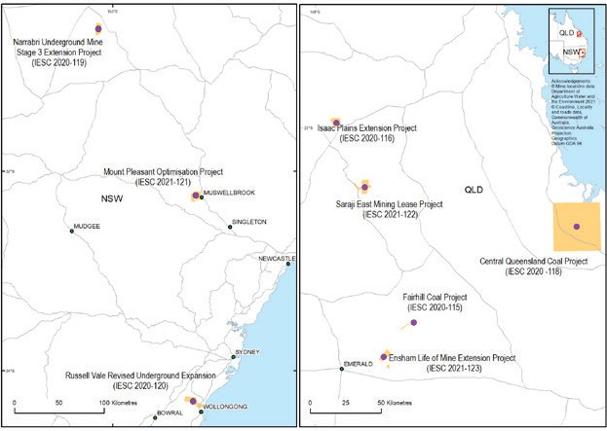

* Approximate EPBC Act project referral areas are indicated in orange in the above map

IESC | 2020–2021 Annual Review of Activities / 11

# Information Guidelines and Explanatory Notes



Information guidelines for proponents preparing coal seam gas and large coal mining development proposals

May 2018

The IESC has developed a suite of resources to assist industry and regulators with environmental assessments. The resources provide guidance on the suggested information and data to be included in an environmental impact assessment. [Information Guidelines](https://iesc.environment.gov.au/system/files/resources/012fa918-ee79-4131-9c8d-02c9b2de65cf/files/iesc-information-guidelines-may-2018.pdf) developed by the IESC outline the information considered necessary to enable the IESC to provide robust scientific advice to government regulators on the water-related impacts of coal seam gas and large coal mining development proposals.

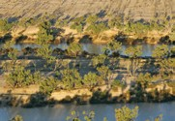

For some topics, Explanatory Notes have been written to supplement the IESC Information Guidelines, providing tailored guidance and up-to-date robust scientific methodologies and tools for specific components of environmental impact assessments of coal seam gas and large coal mining developments.

Explanatory Notes have also been applied across a range of other resource industries, including the iron ore sector. To date, the IESC has published three Explanatory Notes on its website.

[Uncertainty analysis—Guidance for groundwater modelling within a risk management framework](http://iesc.environment.gov.au/publications/information-guidelines-explanatory-note-uncertainty-analysis) identifies tools and methods to help proponents understand the range of available approaches to uncertainty analysis in groundwater modelling. It is designed to be used across a range of regulatory regimes.

[Assessing groundwater-dependent ecosystems](http://iesc.environment.gov.au/publications/information-guidelines-explanatory-note-assessing-groundwater-dependent-ecosystems) reviews tools and methods for groundwater-dependent ecosystem assessment to help proponents choose the most effective approach.

[Deriving site-specific guideline values for physico-chemical parameters and toxicants](http://iesc.environment.gov.au/publications/information-guidelines-explanatory-note-deriving-site-specific-guidelines-values) introduces the use of a water and sediment quality management framework to assist with the design of appropriate monitoring programs for measuring physico-chemical parameters and toxicants from which site-specific guideline values can be developed.

## Explanatory Note in preparation

The IESC has continued to develop a fourth Explanatory Note: Characterisation and Modelling of Geological

Fault Zones.

Characterising geological faults within and near coal seam gas and large coal mine projects is important because the faults may potentially impact the groundwater flow connection between the extraction target and key assets such as aquifers, springs and other groundwater-dependent ecosystems. This Explanatory Note is a guide to assist proponents preparing Environmental Impact Statements to address the risks posed to water-related assets by geological faults acting as pathways of or barriers to groundwater flow. The Explanatory Note discusses important features of faults, including key definitions for characterising geological faults and for the risk assessment process.

In early 2021, targeted consultation was undertaken on the draft Explanatory Note. Feedback was sought as part of a peer-review process, ensuring that the Explanatory Note was fit for purpose and met the needs of proponents and regulators.

Following completion of the peer review, the Explanatory Note was released for wider public consultation through

the IESC website. Public consultation closed on 18 June 2021. The IESC would like to thank those who made

a submission.

The Explanatory Note on Characterisation and Modelling of Geological Fault Zones is expected to be published on

the IESC website in the second half of 2021.

12 / IESC | 2020–2021 Annual Review of Activities

# Research

The IESC sets [research priorities](http://iesc.environment.gov.au/research) and funds research in targeted areas to improve understanding of the potential water-related impacts of coal seam gas and large coal mining developments. The IESC has several ongoing research projects.

## Research projects in 2020–21

### Coal mine voids in Queensland

The IESC’s existing research pilot project to increase understanding of coal mine voids in Queensland progressed throughout 2020–21.

The study aimed to identify the location and potential impacts of these mine voids in the landscape.

The project has been successful in:

* + developing a database of current and proposed open coal pits (that have environmental assessment records) to

identify and map their location within the landscape

* + analysing void dimensions and associated risks through four case studies
  + developing a high-level approach to assessing risks posed by coal mining voids within the landscape for consideration by the IESC.

The study is expected to be finalised in late 2021.

### Improving understanding on how changes to groundwater quality arising from coal seam gas and large coal mining developments might affect the biodiversity and function of phreatic fauna and microbes

In late 2020, the IESC funded a new research project under its Chemical and Ecology research priority themes.

The project will explore metagenomics approaches to improve understanding on how changes to groundwater quality arising from coal seam gas and large coal mining developments might affect the biodiversity and function of phreatic fauna and microbes.

This study aims to assess associations between groundwater quality and the composition of stygofaunal

and phreatic microbial assemblages. It will also assess the effectiveness of various sampling protocols (e.g. sampling unpurged versus purged bores, and different volumes of sample to find an optimum for estimating stygofaunal assemblage composition) and the likely feasibility of metagenomics approaches for routine groundwater biomonitoring.

### Minimum groundwater monitoring guidelines

In 2021, the IESC commenced a new project to develop guidance material which aims to review and standardise groundwater monitoring requirements across Australia.

This project is in its early stages and is expected to be completed in 2022.

The IESC looks forward to sharing the results of its research projects as they are finalised.

IESC | 2020–2021 Annual Review of Activities / 13

# Engagement

The IESC continued to meet with key stakeholders in 2020–21, meeting virtually to update them on its work and to

invite their feedback on its scientific advice and other publications.

## Chair meetings

The IESC Chair continued to meet with interested parties to promote the role of the IESC and to learn more about how the IESC’s advice is used, to seek stakeholder views on the IESC Information Guidelines and Explanatory Notes, and to discuss any areas of mutual interest.

In November 2020, Dr Pigram met virtually with representatives from the Queensland Gas Fields Commission.

## Government regulator roundtables

The IESC regularly meets with government regulators to discuss and seek feedback on the IESC’s scientific advice and the IESC Information Guidelines and Explanatory Notes, and to discuss items of mutual interest.

The IESC held two virtual regulator roundtables in 2020–21:

* + November 2020, the IESC hosted a virtual roundtable discussion with regulators from various Queensland

Government agencies.

* + May 2021, the IESC hosted a virtual roundtable discussion with various Australian Government regulators.

## EPBC Act review

In August 2020, the IESC met virtually with Professor Graeme Samuel AC to discuss the Interim Report on the independent review of the *Environment Protection and Biodiversity Conservation Act 1999* (EPBC Act). The IESC discussed their statutory role and the EPBC Act review process with Professor Samuel .

The IESC provided a response to the online survey for the Interim Report of the Review of the EPBC Act. Professor Samuel’s Final Report of the Independent Review of the EPBC Act was publicly released in January 2021.

## IESC Explanatory Notes Virtual Masterclass Series

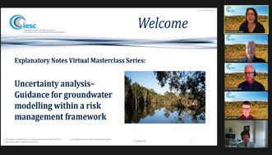

In May and June of 2021, the IESC hosted a series of virtual masterclasses. The virtual series, targeted at industry consultants, included masterclasses based on each of the IESC Explanatory Notes. The masterclass sessions, presented by each note’s authors, provided the opportunity to describe how the methods in

each Explanatory Note can be applied and to answer questions from the participants.

The series comprised three masterclass sessions:

* + 26 May 2021—Uncertainty analysis–Guidance for groundwater modelling within a risk

management framework

* + 2 June 2021—Assessing groundwater-dependent ecosystems
  + 9 June 2021—Deriving site-specific guideline values for physico-chemical parameters and toxicants

14 / IESC | 2020–2021 Annual Review of Activities

The masterclass series was strongly supported by industry consultants, with 59 individual attendees from 17 different organisations attending throughout the series. Attendees joined the virtual event from locations throughout Australia as well as from the USA, Canada and New Zealand.

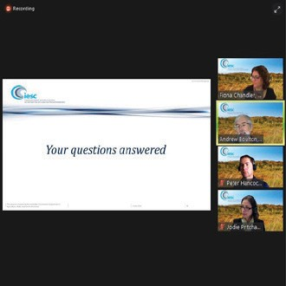

The series was well received by attendees, with approximately 90% of participants across the masterclasses reporting that the objectives of the masterclasses were met to a high or very high degree.

The IESC would like to thank Hugh Middlemis (HydroGeoLogic), Luk Peeters (CSIRO), Peter Hancock (Eco Logical), Jodie Pritchard (CSIRO), Dustin Hobbs and Trang Huynh (Hydrobiology) for presenting masterclass sessions. The IESC would also like to thank Fiona Chandler (Alluvium) for facilitating throughout the masterclass series.

The masterclass sessions were recorded and will be made available on the IESC’s website.

‘The online IESC Masterclass series provided a very useful overview of the intent of the Explanatory Notes and facilitated great in-depth discussion with the authors of the notes.

The online platform was very accessible and allowed great collaboration and discussion. I mentioned the series to other colleagues and clients, who were very interested in the events and keen to be a part of them in future.’

*Claire Stephenson, Umwelt (Australia) Pty Limited*

IESC | 2020–2021 Annual Review of Activities / 15

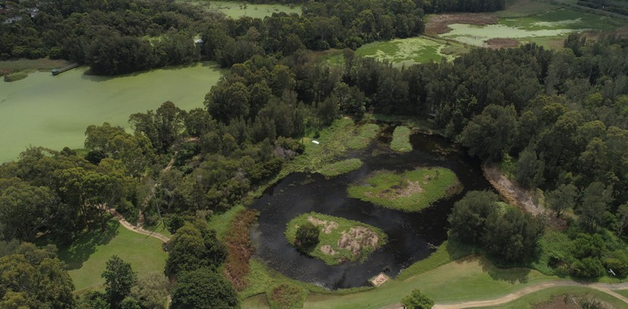

BIO762.0721

 



[**www.iesc.environment.gov.au**](http://www.iesc.environment.gov.au/)