Characterisation and modelling of geological fault zones

Background
Geological faults are displacements within otherwise intact rock material that can form flow barriers, preferential flow paths, or both conduits and barriers. A fault may exhibit more than one of these characteristics along its length and these may alter over time.

Changes to surface and groundwater systems that occur during coal seam gas (CSG) and large coal mining (LCM) projects depressurize coal seams or excavations, and can create or alter flow connections between the project site and key water assets such as aquifers and groundwater-dependent ecosystems (GDEs). The characterisation of faults within and near project developments allows risks to be assessed and managed.

In some cases, geological, hydrogeological and ecological assessments indicate that risks to assets from the proposed development (in relation to faults) are minimal or at an acceptable level. However, in other cases, assessments may indicate that the proposal is likely to significantly alter areas from their pre-developed state – sometimes disruptions to hydrology and associated GDEs may be permanent, particularly in shallow perched aquifers, or persist long after a project’s closure and rehabilitation.

Context
The Environment Protection and Biodiversity Conservation Act 1999 (Cth) protects matters of national environmental significance, including water resources in relation to CSG and LCM developments. Guidance on what is considered a significant impact, including to surface and groundwaters, is available through the Significant Impact Guidelines 1.3.

CSG and LCM environmental impact assessments often predict surface and groundwater changes through numerical models. However, fault behaviour is seldom considered in detail, and may vary spatially or change during a coal development project. This often leads to an assumption that a fault is a hydraulic barrier, where supporting evidence is required to support this claim.

To supplement the IESC Information Guidelines (2018), the IESC has developed an Explanatory Note on characterising and modelling geological fault zones. In the context of faulting, this Explanatory Note provides additional guidance to proponents undertaking an impact assessment of risks to key water assets and GDEs. It outlines a logical framework for undertaking the assessment and suggests some data sources, tools and techniques that may be useful during the assessment.

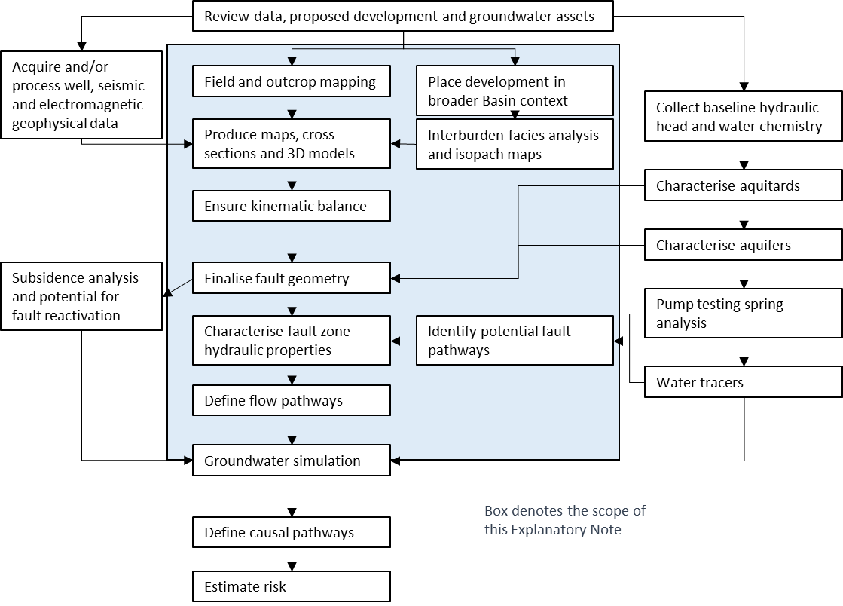
Figure 1: Flow diagram for the geological assessment and the geological/hydrological assessment of fault related flow for a
CSG or LCM development. The Explanatory Note focusses on the areas within the highlighted box.

Key Recommendations
This Explanatory Note presents several recommendations. The key ones include:
- an environmental impact statement should specifically assess the likelihood that faults could be a connective flow pathway, and assess the potential consequences on groundwater assets and GDEs.
- to realistically assess the risk of coal development projects, a geologically consistent 3D model of the position of the major assets, fault zones, aquifers, aquitards, and the proposed excavations or wells should be developed.
- a complete assessment of the pre-development, development and the post-development flow pathways is required to fully understand the risks from the development.
- the risk assessment should consider uncertainties in the 3D geometry model, the hydrogeological model (including uncertainties in the predicted rates and magnitudes of flow), and the characterisation of flow paths that were selected for analysis.
- representation of fault zone hydrogeology in numerical models ranges from simple to complex. While different types of modelling approaches can be used to represent faults, history matching and quantification of uncertainty should be part of the modelling process.

Table 1: Case studies/scenarios that illustrate differing situations and fault risk character
Case studies | Diagnostic for scenario | Fault flow groundwater phenomena | Site-based evidence and geological products to justify the choice of this scenario | Suggested approaches for characterisation of uncertainty for risk
Scenario A-1: Faults are unlikely to affect groundwater flow | There are no faults | - No faults and/or few faults with negligible displacement | - Documentation of flat-lying or essentially undeformed stratigraphy, represented by a series of cross-sections parallel and perpendicular to strike, that illustrate the relative lack of faults  - Provide complementary data (e.g. potentiometric maps that display presence or absence of anomalies) | - Assess the likelihood that faults exist that have not been observed  - Explore alternative interpretations, then use one of the following scenarios to characterise the probability of critical repercussions of an unobserved fault on predicted impacts to environmental receptors
Scenario A-2: Faults are unlikely to affect groundwater flow and impact assessment due to an aquitard | There is a regional aquitard separating the groundwater asset or aquifer from the coal seam or excavation, and this aquitard is not breached by faults. No primary juxtaposition of flow units across the faults is present | - An aquitard separates the groundwater asset from the coal seam or excavation  - Vertical fault offset (throw) is smaller than the thickness of aquitards and any slip along strike is minimal  - Faults are therefore unlikely to form vertical causal pathways | - Geological, hydrogeological and geochemical evidence for a regionally extensive valid aquitard  - A set of regional cross-sections showing faulting that is geometrically and kinematically consistent  - A comprehensive description of the aquitard, including, if possible, a description of the depositional environment  - Fault statistics, including length and throw ratios/distributions  - Systematic analysis of fault displacement profiles, stress regime  - Structure contour maps for the top and base of the aquitard  - Isopach map of all regional aquitards | - Risk assessment of potential aquitard breach through analysis of the likely range of fault offset relative to aquitard thickness. A range of 1D, 2D and 3D techniques can be used to assess the probability that the aquitard has, or has not, been breached  - Should a significant probability of this be shown then an uncertainty analysis based on scenario C would be required  - Baseline geochemistry and pressure data from above and below aquitard
Scenario B: Faults are potentially relevant to impact assessment within aquifer systems | There are no regional aquitards in the development region that segregate the groundwater asset or aquifer from the coal seam or excavation | - Flow parallel to faults may be enhanced laterally and vertically in fault damage zones that contain fractures  - Drawdown impacts may be greater or lesser in the presence of a fault barrier, depending on the relative placement of the development compared to the fault | - Site-based hydrogeological characterisation of damage zones with multiple lines of evidence  - Displacement analysis assessing lateral continuity of faults  - Analysis of the significant uncertainties that arise from the character of the fault damage zone(s), including the thickness and continuity of the damage zones, fracture density and effective fracture transmissivity within given stress regime  - Analog studies of similar faults in outcrop, documenting damage zone architecture, fracturing and any fault rocks  - Characterisation of the mechanical stratigraphy of the aquifers and thus their propensity to fracture during dewatering/depressuring | - Stochastic modelling may be used to model the probability that an identified fault or an unidentified fault intersects an asset  - In the case of a fault intersecting an asset, a stochastic modelling approach that represents the potential repercussions of the fault on the groundwater flow system, potentially based on Cubic Law assumptions, can be used to derive distributions of the conservative estimates of flow from a source depressurisation effect, as an initial check on the potential significance of the fault(s) on an impact assessment  - Ideally this approach would be validated through monitoring of a long-term pumping testing in the vicinity of key groundwater assets  - If faults are identified as being material to the impact assessment, ensure any numerical groundwater modelling accounts for the repercussions of the fault presence, using information from the above assessments along with other hydrologic information. Stochastic or worst case numerical modelling approaches would be required to allow uncertainty of impacts to be considered in the risk assessment
Scenario C: Faults are important to impact assessment within aquifer−aquitard systems | Faulting displaces regional aquitards, thus connecting the asset or aquifer to the coal seam by generating primary juxtaposition | - Flow may occur across faults between aquifers through juxtaposition windows  - Depressurisation at the coal seam or excavation may draw down shallower aquifers that would otherwise be separated by aquitards  - Aquifers may be fully juxtaposed with aquitards to form primary juxtaposition/no-flow barriers | - A set of regional cross-sections showing geologically consistent faulting kinematics, architecture and the deposition environment of the aquitard  - Depth structure contour maps for the top and base of aquitards  - Isopach map for the aquifers and aquitards  - As with scenario A-2, description and assessment of all aquitards. Quantitative juxtaposition analysis of aquifers, seams and aquitards across faults should document the locations of juxtapositions and then estimate the areas of these juxtapositions  - For the case of ‘no-flow’ fault barriers, juxtaposition analysis and extensive site-specific pumping tests from both sides of the fault and along strike of the fault. Studies using hydrochemistry and water tracers (e.g. helium and radon) may be useful  - Baseline geochemistry and pressure data | - Fault juxtaposition occurrence and area are the key uncertainties in this scenario. The construction of Allan Maps for key faults is encouraged, or else generating a series of cross-sections orthogonal to each fault  - Stochastic fault analysis can be used to assess the probability of juxtaposition  - Distribution of aquifer juxtaposition areas, and thus distributions of likely cross-fault flow  - Probabilistic analysis of across-fault flow should then be used to define fault transmissibility in groundwater flow models  - While the existence of a cross-fault seal (membrane seal) provided by a fine-grained fault core material is possible, extensive evidence of the likely efficiency and character of any membrane seals should be presented  - Pumping tests and/or environmental tracer tests should be done to support the conceptualisation and provide an analogue of possible drawdown changes caused by the development  - If faults are identified as being material to the impact assessment, ensure any numerical groundwater modelling accounts for the repercussions of the fault presence, using information from the above assessments along with other hydrologic information. Stochastic or worst case numerical modelling approaches, including fit-for-purpose geomechanical models, would be required to allow uncertainty of impacts to be considered in the risk assessment
Scenario D: Differential subsidence may lead to increased flow along existing or new fractures | Differential movement reactivates faults and fractures or develops new pathways in previously unfaulted or unfractured strata. This scenario is most likely to apply to underground mines but does occur in CSG and could also occur in open cut mining | - Observable depletion of near surface aquifers (and potentially surface waters) through fracture or fault networks caused by project development | - Required for mines with significant differential subsidence  - Characterisation of the geometry of near-surface faults and their associated damage zones as the first-order features  - Surface and base aquitard structure contour maps illustrating the faults and their displacement  - Analysis of in situ stress and the effect that excavation may have on stress and the change in stress required for fault reactivation  - Water isotopes/tracers for conceptualisation of flow pathways  - Geologically valid cross-sections that illustrate the linkage from the seam level to the surface | - Baseline studies of hydrogeological properties of faults are required to characterise their influence on hydrogeological systems  - Stochastic modelling may be used to model the probability that an identified fault or a suspected fault provides a pathway that intersects an asset  - In the case of a fault intersecting an asset, a stochastic modelling approach that includes discrete fracture flow can be used to derive distributions of the conservative estimates of flow from a source depressurisation effect  - Field evidence, such as environmental monitoring, tracer and/or pumping tests, is required to support the conceptualisation  - Combined geomechanical and groundwater flow modelling consistent with mine design is encouraged within the hydrogeological risk assessment to identify focus areas for specific assessment. Stochastic or worst case numerical modelling approaches would be required to allow uncertainty of impacts to be considered in the risk assessment

